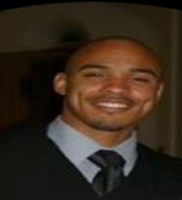
I am Bartell Keithley Jr. I am grateful to reach the moment where I can offer you an event like this. My life has pointed to this event in so many ways; from being able to visit the continent of Africa on numerous journeys, to my desire to improve myself and follow my dreams. For me to be able to bring you to introduce you to “Celebrating Black History | In Costume”, is among my highest accomplishments.

I have also taken Chicago youth to Africa as well. These students have gone on to become responsible adults, tenured professionals, and of course world-travelers. Professionally, I am a licensed boiler engineer with Local 399 and my graduate studies are in an African-centered discipline known as Inner-City Studies. I blend my care for my culture with a commitment to scholarship to bring you quality, inspiration, and well-deserved entertainment.

I want people to love who they are and from where they come from. I want people to see the importance of reciprocity and the spirit of Ubuntu. I think this is important for self-awareness and confidence. Get ready to have fun on this day, you deserve it. It is long overdue.

This event is making history for African-Americans with it being the first ever Costume Ball for Black History Month. From this point history is made. Attendees will be better people from it. Take care.

