Sunday 10th February 2019
Today at 11 o’clock the bus from Aguilar de Campoo went to Santander airport. There was a lot of turbulence on the plane. When we arrived at the airport we greeted the Dutch and I went to the McDonald’s. I didn’t understand anything of what they told me. They had to use a google translator. Then we had dinner at Tyra’s house, it’s the name of the Dutchman. She lives with her grandparents, Finy and Frans, and her mother, Many also her stepfather, Germán. Apart from the hamburger the fish was rich, I took a shower and went to sleep.

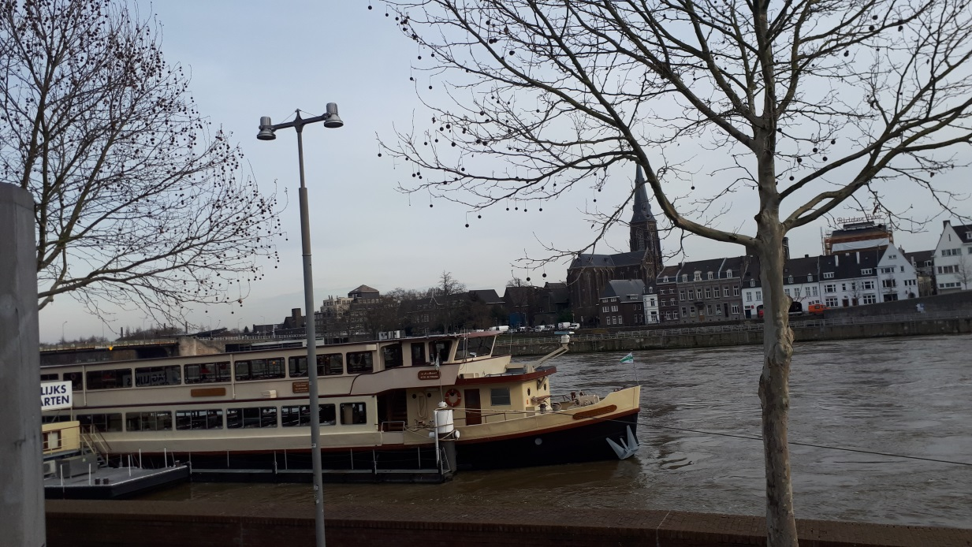

Monday 11th February 2019
Today I had breakfast milk with bread and jam and butter; they gave me 3 sandwiches one of chorizo and the other two of nutella, some grapes a zumo and some cookies. At 8:30 we went to the school, gave us a talk about how many there are people, clases… After that they took us to see the school, we saw some experiments, the teacher’s room… we walked to the courthouse where they gave us a video of the origin of the Netherlands they gave us a glass of coca cola and a sponge cake. Then we had lunch and we did orientation. When the orientation ended we went home to dinner. I had mashed potatoes a salad that I don’t know what it was and a few kinds of meatballs and dessert yogurt was and all very rich. When we finished we went to deliver newspapers to some house, we played table games, I took a shower and went to sleep. I slept with the honda and ate at 12, dinner at 6 or 6:30 is rare in Spain.

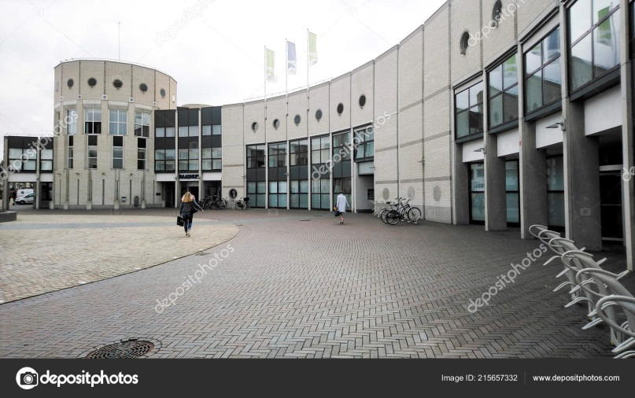
Tuesday 12th February 2019
Today I had breakfast the same as yesterday. Then we went to the ice ring kit was fub I fell down once. We had a break and they gave us hot chocolate and a sponge cake. After the break we went to the hockey and soccer courts and they separated us boys played football and girls played hockey but some Spaniards complained and they were mixed. There were also Germans. When we finished we went to the school that my Dutch has private. We ate rice with chicken. We went to the space jump after dinner. I had a lot of fun then we went to eat an ice cream and home to shower and sleep.

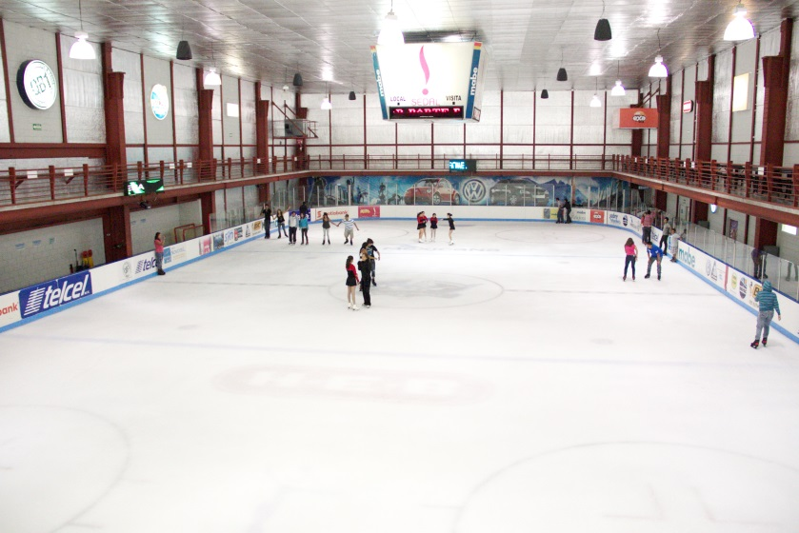
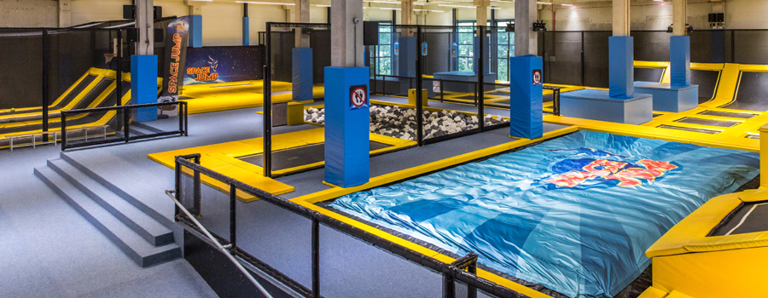
Wednesday 13th February 2019
Today I got up, I had breakfast I went to the school they told us a story and they made us make a face on a mountain. Then we went to the city walk fortification of Maastricht, Basilica of our lady, the hell gate and city park. They gave us free time and we went to eat at the Burger, after I waited for my Dutch like yesterday. We had tuna salad, cooked potatoes, pork, vegetables and for dessert vanilla yogurt and chocolate with very rich cream mall for dinner. I took a shower and went to the Dutch house of Emma, we were playing wii and we went home to sleep.

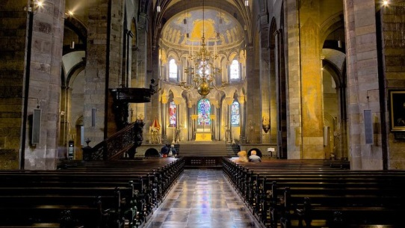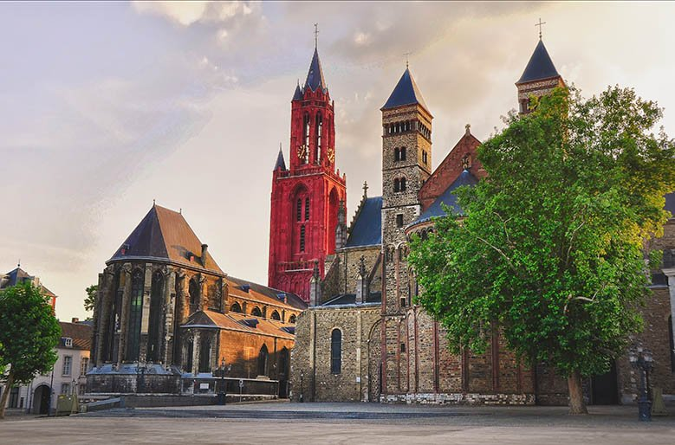
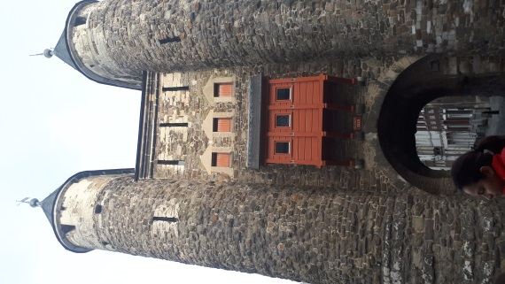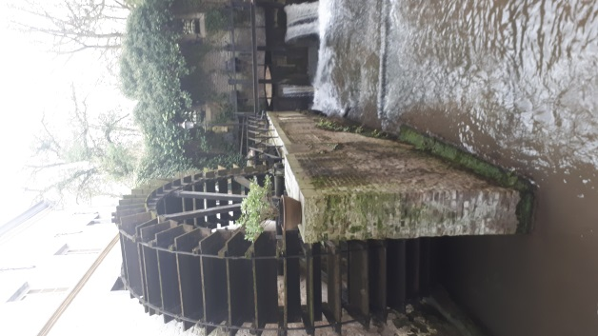

Tursday 14th February 2019
Today I got up breakfast I was told happy valentine I went to the school, a man told us a story then we went to do korfball we ate there. In groups we answered some questions about the korfball then to the school to wait as Ii always went home I had lasangan and juge to the ps4 finally they made a party where we were 11 people of the Exchange. They played at the bottle and then at home where they gave me a gift that is two perfumes and a farewell card we took pictures and went home at 11:30 to sleep.

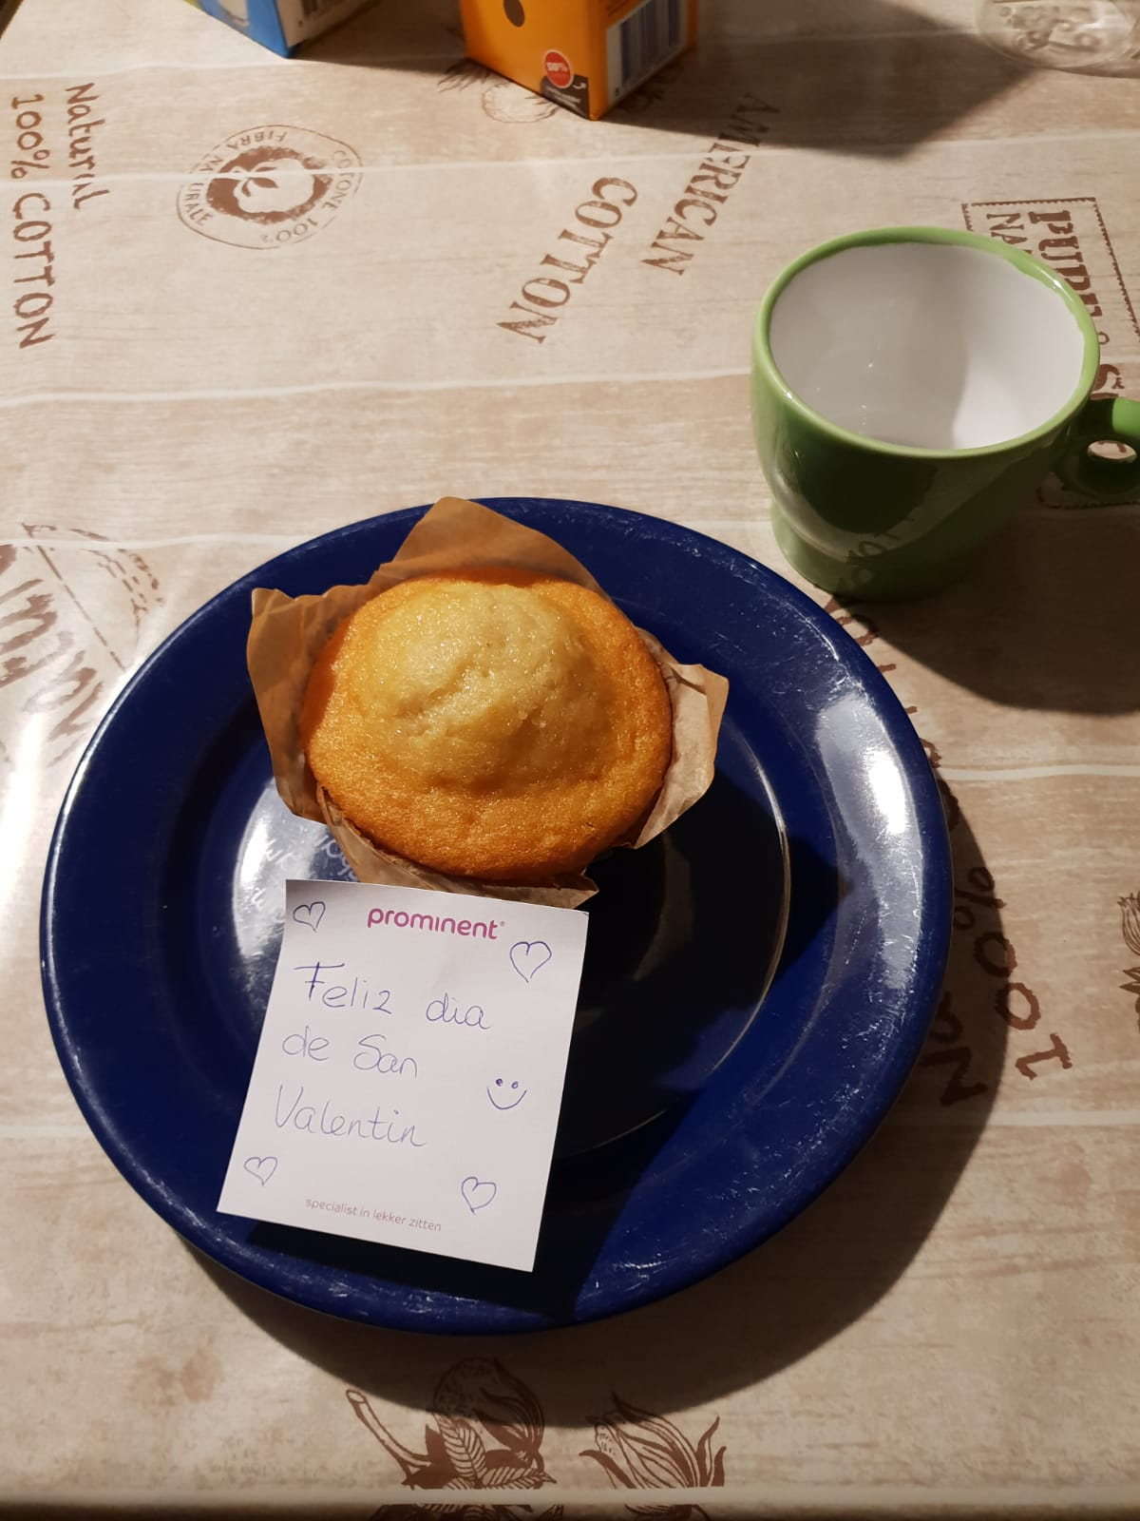
Friday 15th February 2019
Today Ii woke up, I had breakfast the family said goodbye to me went to the school we did the work we finished it and the Spaniards did a questionarie a bout the exchange the we went to Brussels to see the Atomiun that I love after we went to the main square where there was a kind from castillo i thought it was amazing they gave me some free time and I bought some souvenirs for my family, then I ate goffre, which was very good, it was a pissing boy who is very famous in Brussels, then we wentto the airpot and we said goodbye to the Dutch some were crying one hour late we arrived at 1 in the morning I went to mu house to sleep.
