Newsletter 07/2023
Dear Friends
Greetings in the sweet name of our Lord & Saviour Jesus Christ. Once again, we are so pleased to update you with what is happening in India.

KIDS EVANGELISM & baptism
The Bible teaches us to do more & more his work & great commission, The VBS was conducted in our local church during the last week of April to the first week of May. Children from different backgrounds joined us in the 10-days program. From the day one, the number of children kept increasing from 400 to 700 approximately. It creates an environment where children spend maximum time in learning the scripture through songs, stories, theme, skills etc. It moulds the spiritual foundation of children, which will help them to serve the Lord in future. By the grace of God, we could also help local poor homeless people with rice & given out New Testaments. We appreciative your faithful support.
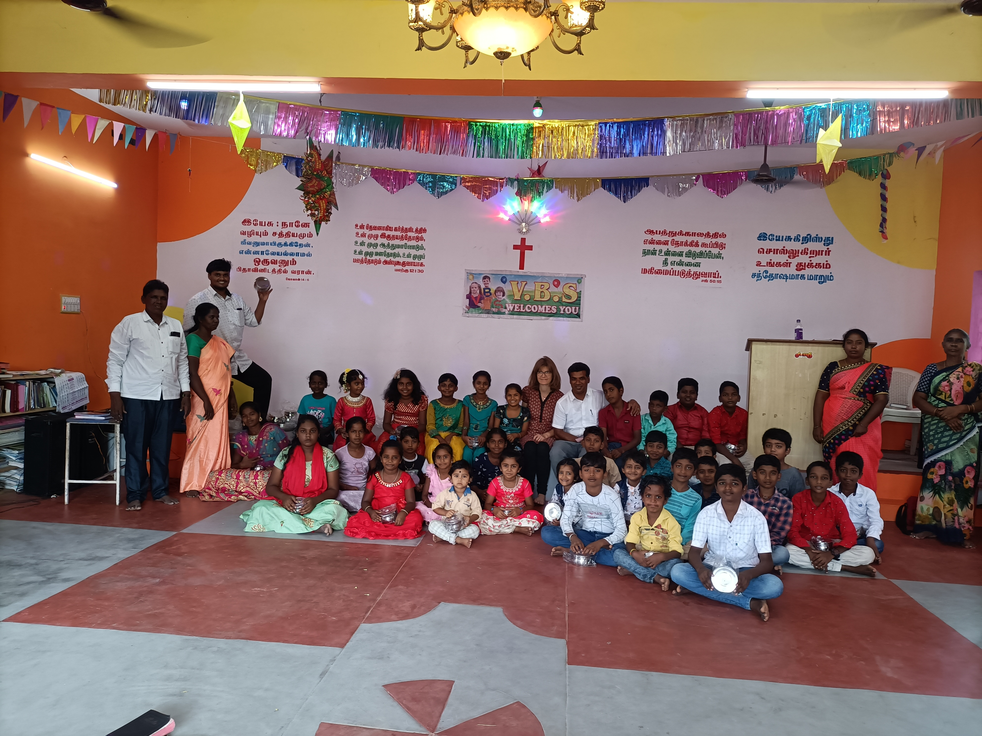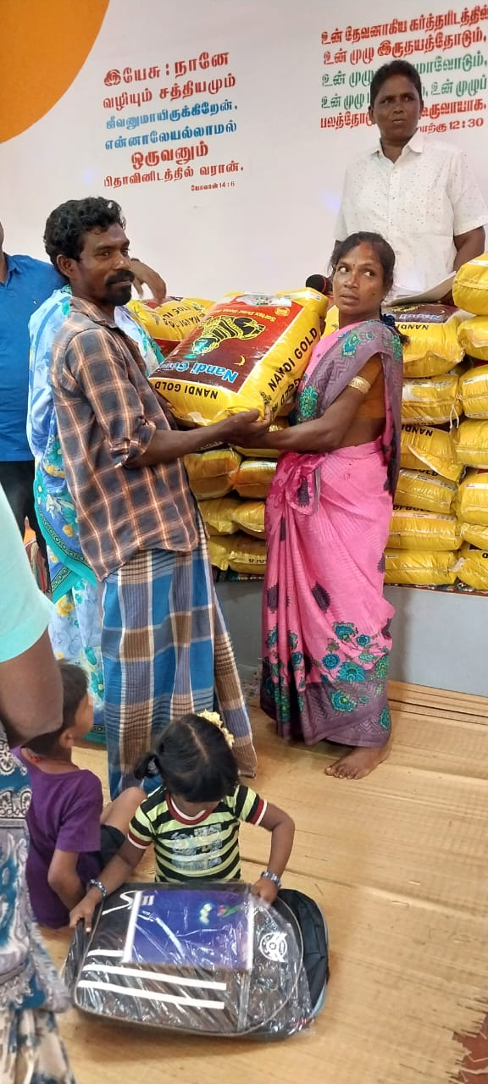
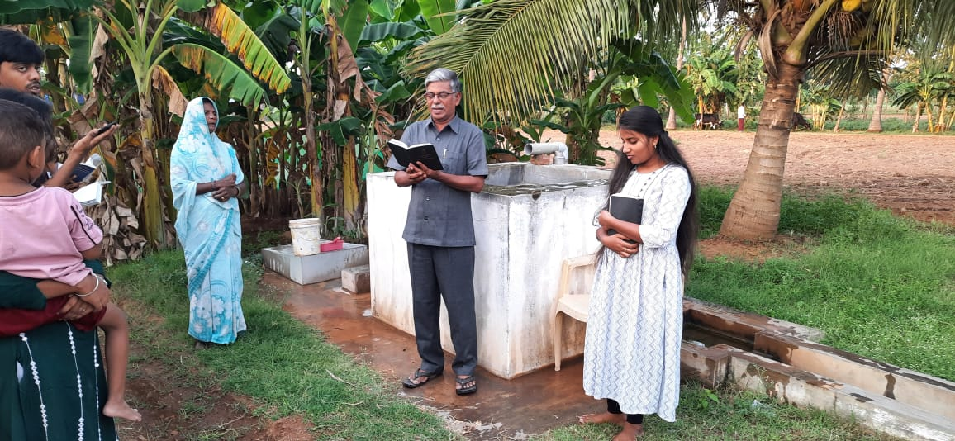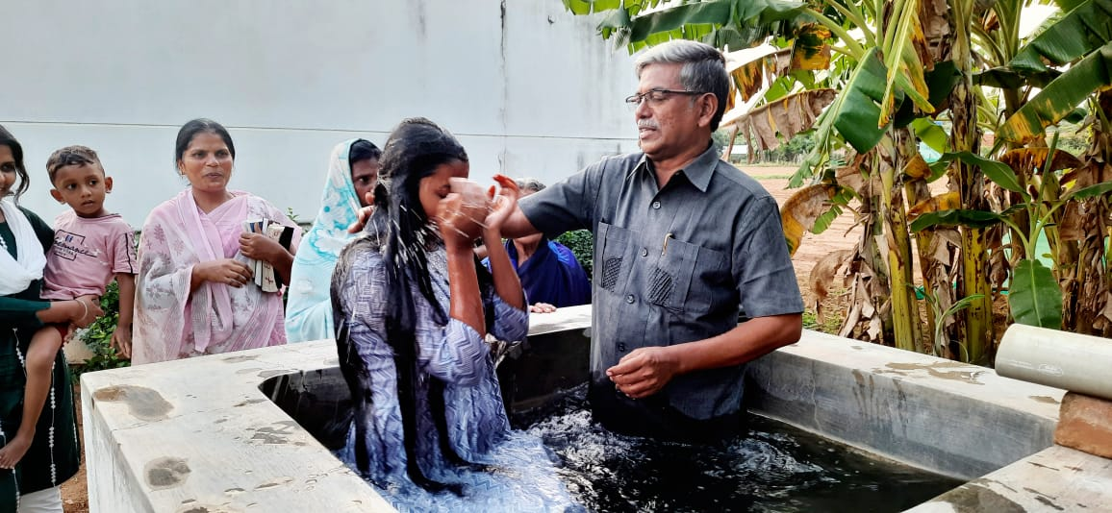By the grace of God, in our Local Church we could give baptism to 7 people. By one hand it is a fest, by the other hand it is also dangerous for the pastor and the baptised one. The persecution takes place in small and big ways. Nevertheless, in the midst of all this difficulties, God is building his kingdom.

There is a church in our area, which has to be completed. They worship the lord in an open building. The rain & wind and sun is coming in, it is not safe. We praise God for this believer’s faith grown in God.
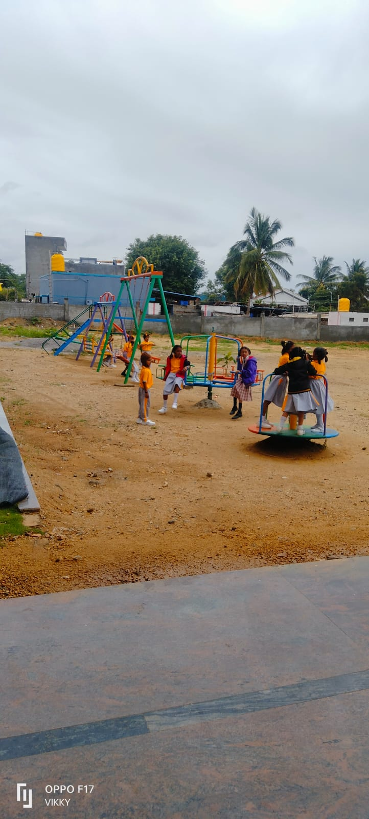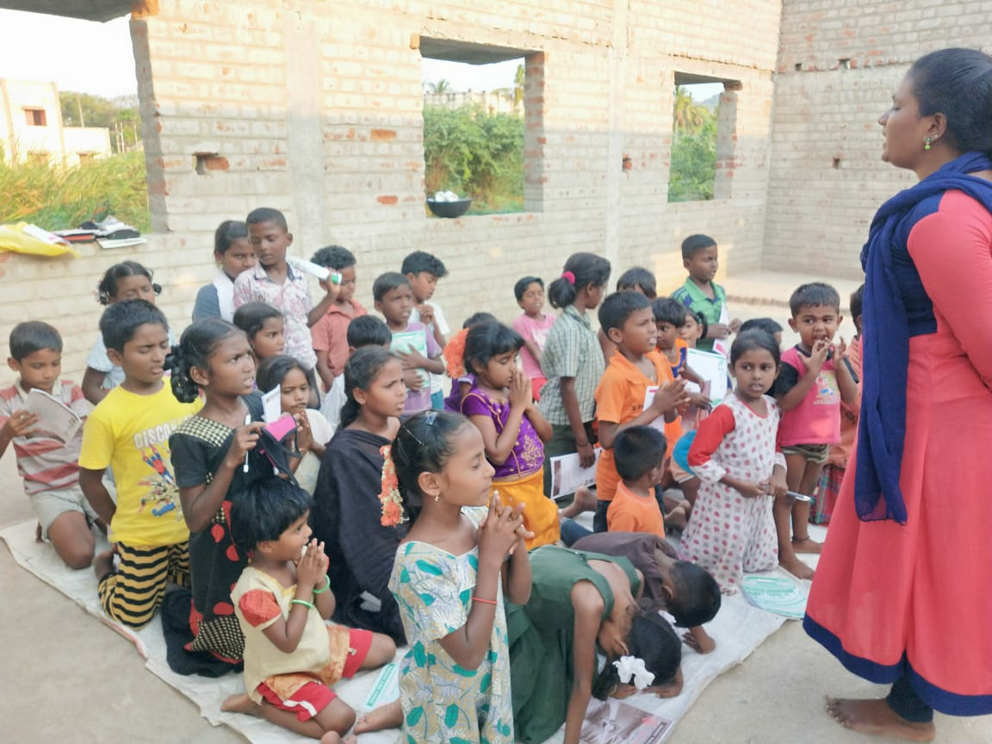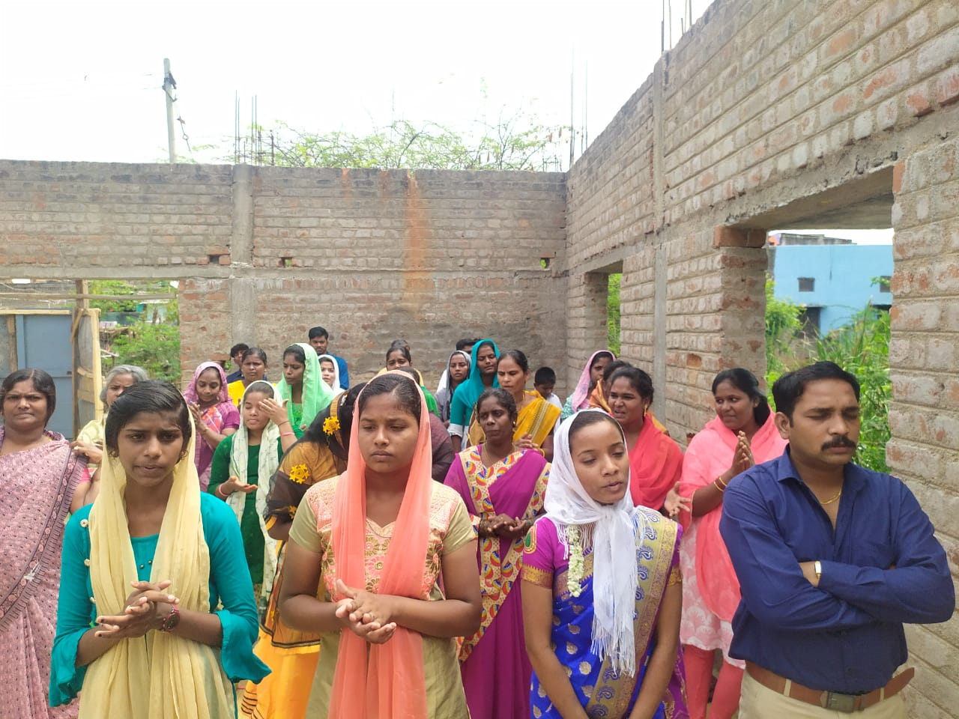

our kids
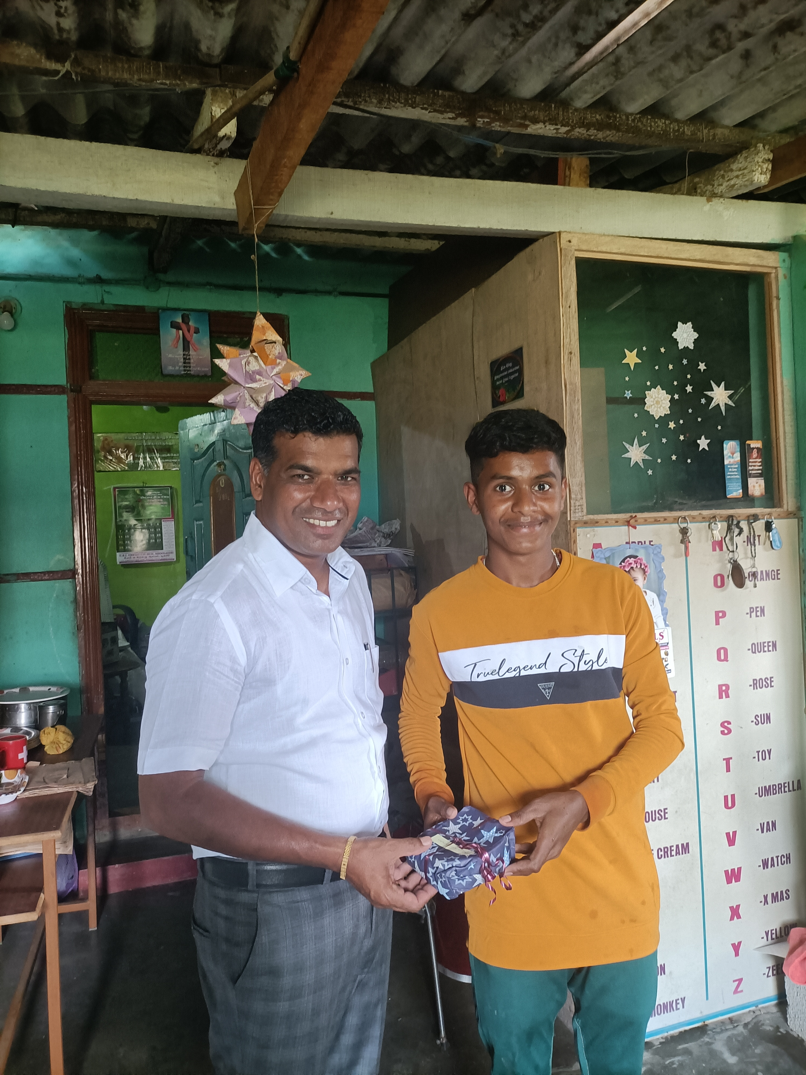Our boys are back to Grace Home after summer holidays. They are studying well, 12th & 11th, 7 -5th Standard. The Lord is helping them each day. We are appreciate your faithful prayer & financial support. Muni Krishnanan is going to start his study in Pharmacy (D.Pharm) in August. Nagaraj is going for a further study (MCA) Master of Computer Application.
We really like to build up and invest in their lives, seeing, how these boys will study and become professionals in a job and having deep faith in Jesus Christ.
School
The Rainbow school re-opened after summer holidays on the 14th June. This year 82 new kids joined, we have now total 164 boys & girl studying in our school, coming from surrounding villages. Soon we like to buy busses, to bring even more kids from far to the school. We pray the Lord will provide new buses the coming days.
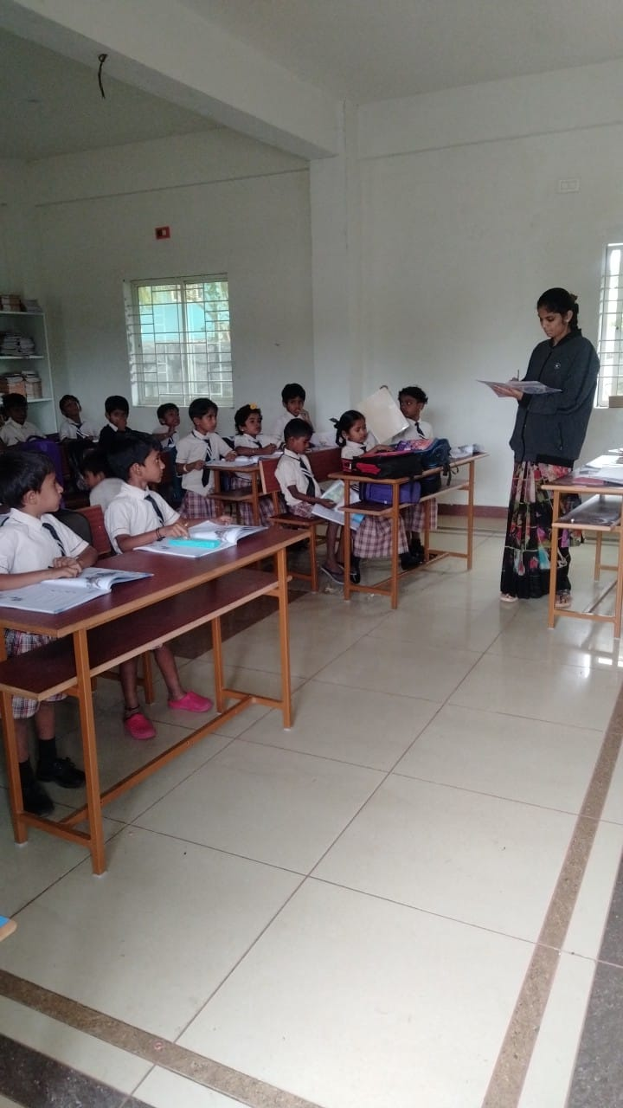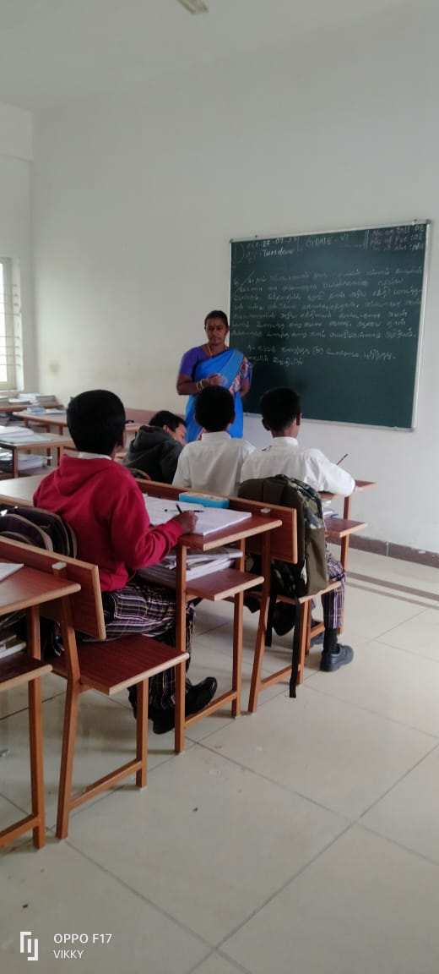
Local Church is being attacked
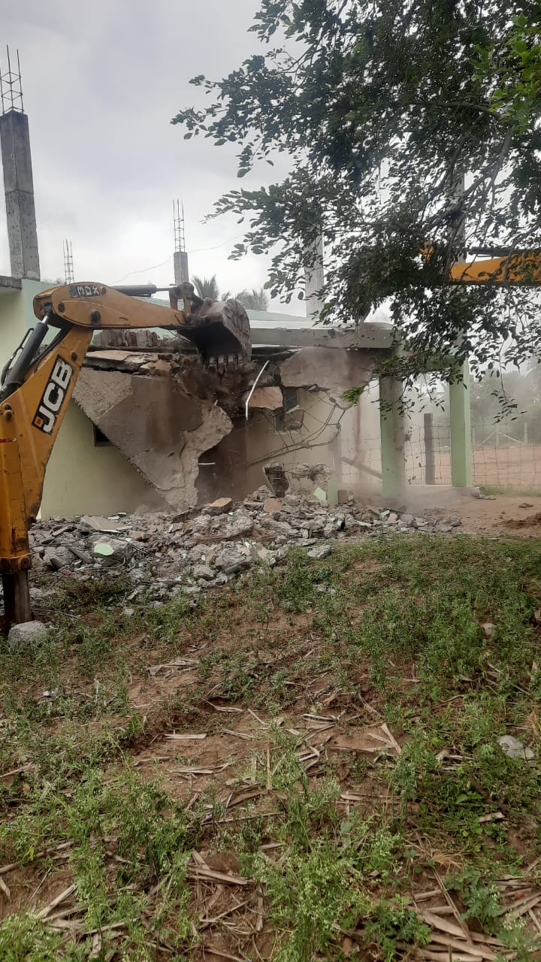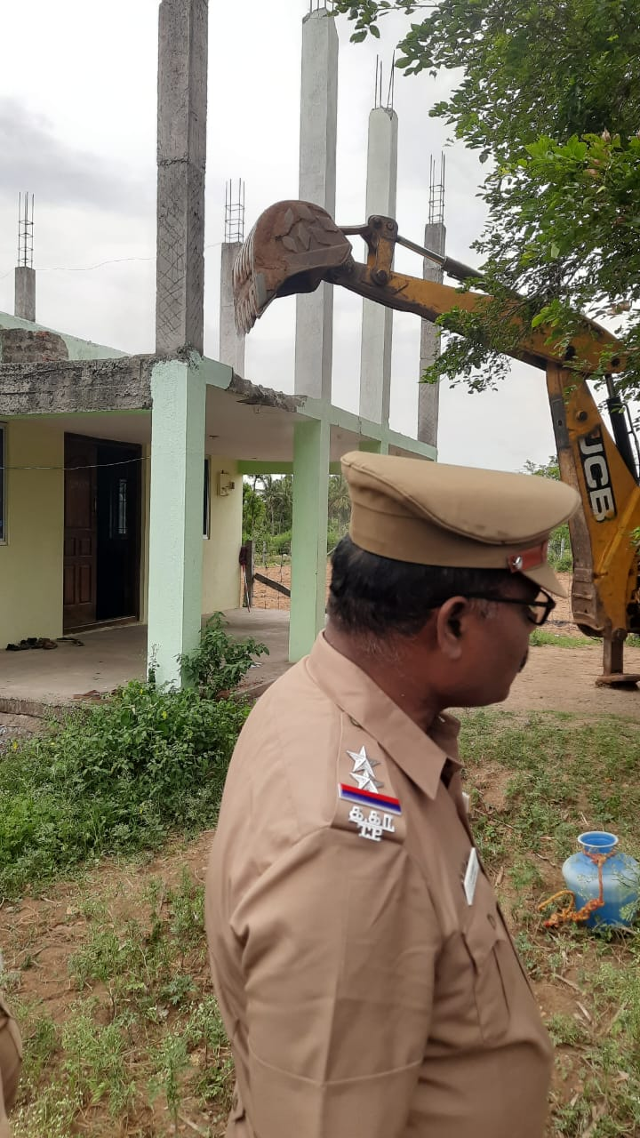One of our local village pastor is serving the lord the past 9 years among the Dalit’s people. Today Hindu fundamentalist destroyed his Church. We are very sad to see that, it was a nice church building. They work this way against Christians. The church members had no power to negotiate. The fundamentalists do not like to see Dalit’s become Christians. We never give up our faith the cross is before us the world is behind us. No matter what happen. Please pray for the safety of the Christians. Many are so much suffering.
Miracle of God There were five families meeting regularly. Slowly the village people heard about the healing power of Jesus Christ through prayer. Ravichandran, a man who was searching for a miracle to cure his wife’s sickness. At this point Nehru Bhai’s wife told him how her son was healed trough Jesus Christ. “My 12 years old son Balya, couldn’t walk any more properly after an accident. We had not enough money to do a proper surgery. Other people told me from the prayer meeting. However, I had the confidence of getting help for my son. Therefore, we attended the meeting. Believers, elders and evangelists prayed for my son. Their prayers healed him. Then we started to believe in Jesus Christ and joined the Church at Jittandhalli. The scripture says, “Whoever believes in him will not be disappointed.” Romans 10; 11

Now we like to say thank to you for your valuable financial help and prayer support. Without you and God’s Grace, we could not do this work.
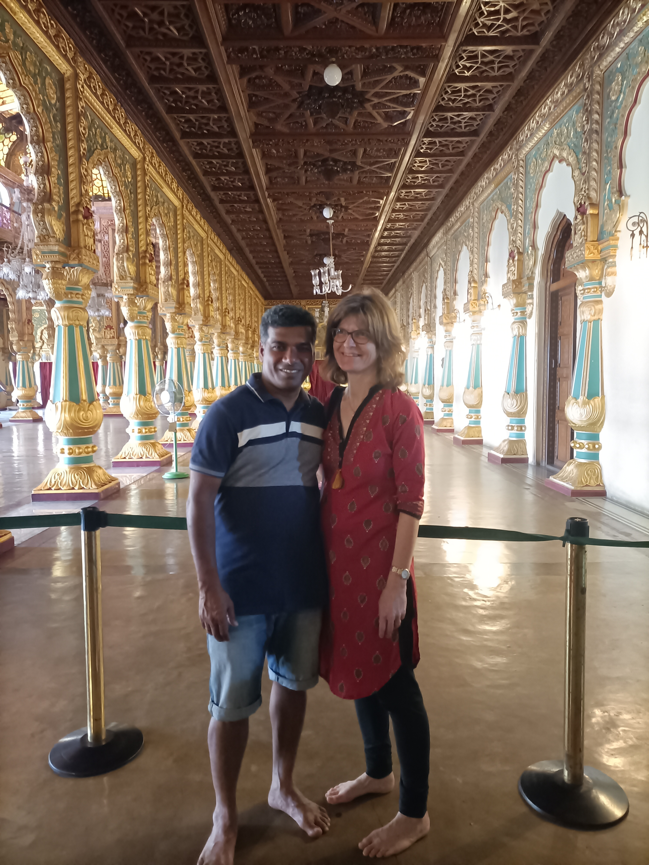God bless you
Love from
Anbu & Barbara
we praise god for
* the VBS Childrens Ministry.
* the Baptism of local people
* the New School admission of total 164 students
* the Believers strong faith in Christ.
* for Miracle in Our Ministry
* our boy Muni Krishnan can go to the college
prayer requests
* our school students, we can share the gospel
* for the christians, who lost the church building
* for the Hindus which destroyed the church.
* for our 6 boys, for health and good education
* for safety of the christians in India

