August 2021 report
Migmar Bhuti Lama
Teaching in Hile Nigale
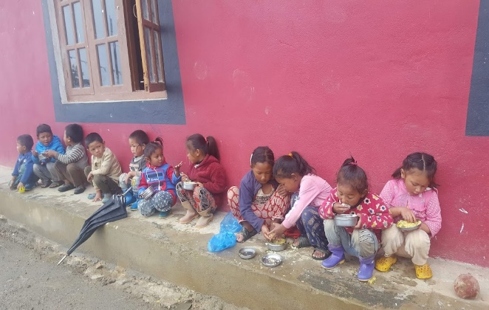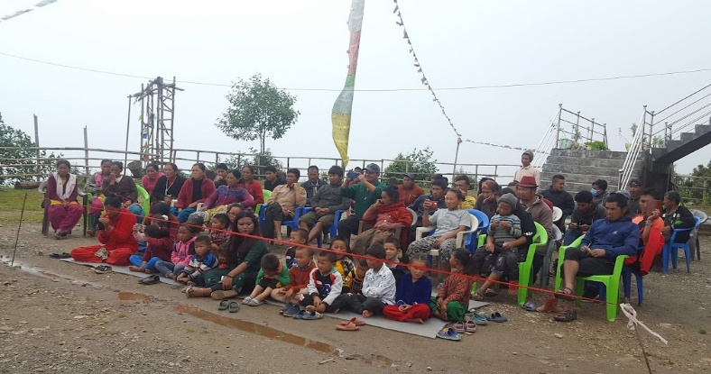
Lunch time at community center Drama presentation Day
In August, the common flu in Hile Nigale is decreasing and we started to run the community center.
- Regular classes
We resumed our community center in August even though the pandemic is biting everywhere. This time I focused on rhymes (Tibetan, Nepali and English language), painting, and storytelling. Children were small and they love to listen to the story. They imagined it and question me. Most of the time I read stories for them. I believed kids learned new vocabulary and increase their listening capacity. Additionally, I taught painting and coloring on different themes like animals, birds, and flowers. Sometimes, kids do have their creative drawings and color on them. Rhymes help our kids to improve their language and learn new words easily. Besides, we do have reading and writing sections on daily basis. Children love to do those works.

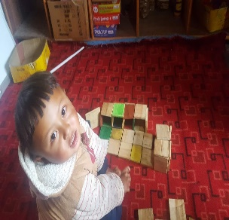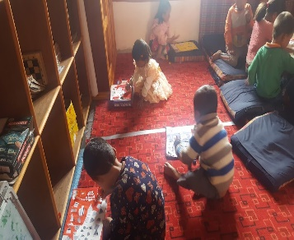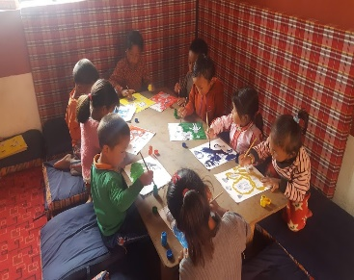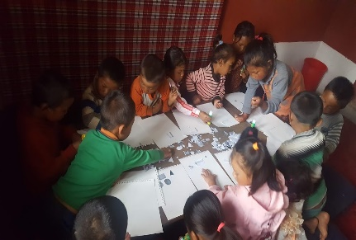
Small kids’ classroom
- Drama
We have a different activity on monthly basis and this month we had a drama show. So, I took half an hour to practice drama after class. I accompanied one drama for adults with actions, narrating and the scripts. I believed that this drama plays a vital role to improve reading, speaking and vocals. Moreover, they learn to act and encourage to present in public. We organized the program formally that we started with a welcome speech, songs and chief guest speech. We invited all the parents and villagers. At the end of the program, the public voted for the best presenter based on well acting, clear voice and characters. We also handover the gifts for the best actor. Finally, our program ended with a big smile on all the audience face and they inspired us with the great compliments. All the parents were surprised to see their child improvements.
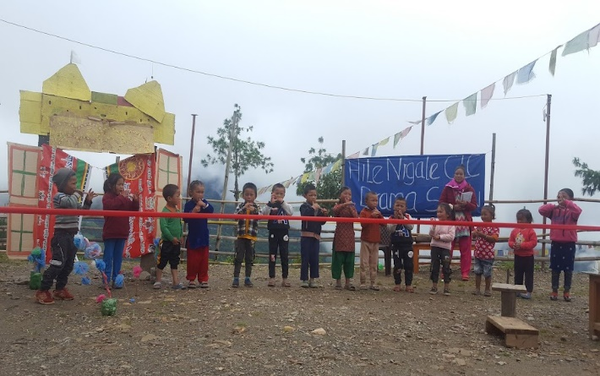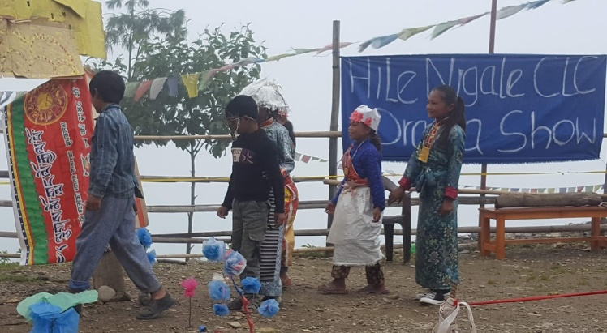
Kids presenting rhymes Drama show
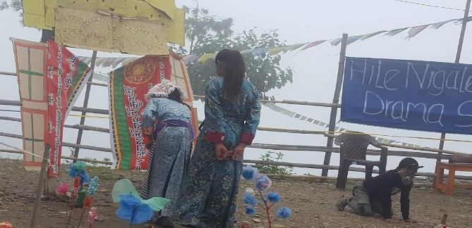
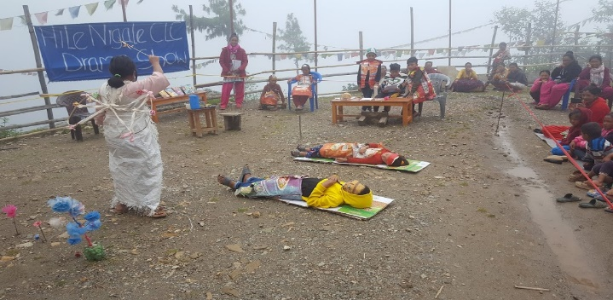

- Parents meeting
Just after the drama, we gather parent's meeting. In the meeting, firstly we gave a presentation on the Importance of education in modern life. Secondly, we discussed on child needs and how we can improve children's performance at school. Thirdly, we conclude and agreed that we will have parents and teachers meeting once in a two month. In that meeting, we will discuss more on each child with an individual parent and sometimes, we will take an hour’s class on parenting and teach about what the parents like to learn from us.
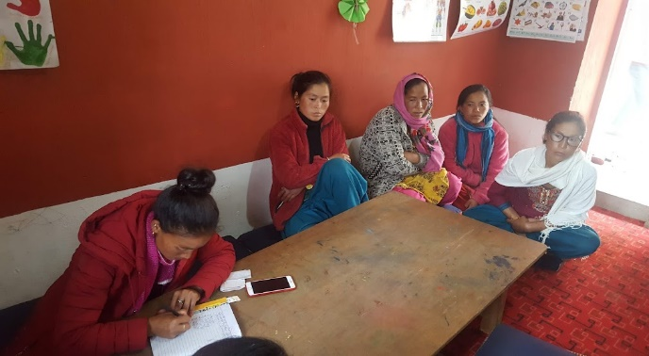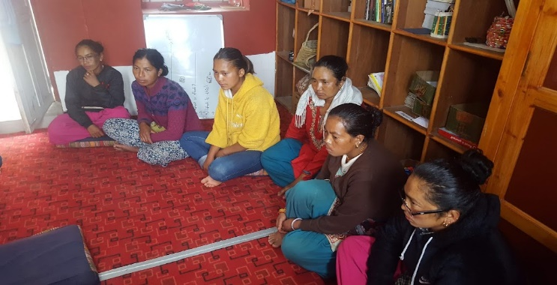
Parents meeting

Plan September 2021
- Regular class
- Evaluation test (Speaking, reading, writing, and singing)
- Excursion in tea farming
- Workshops on Child psychology and child development for the parents
- Preparations for International teachers’ day

