MY DIARY
OLATZ SALCEDO
Sunday
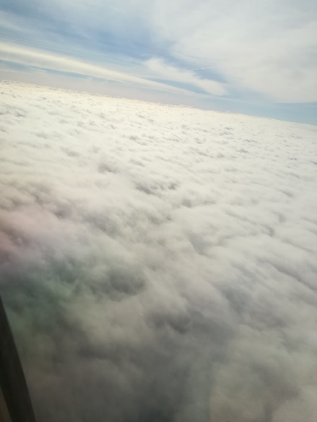
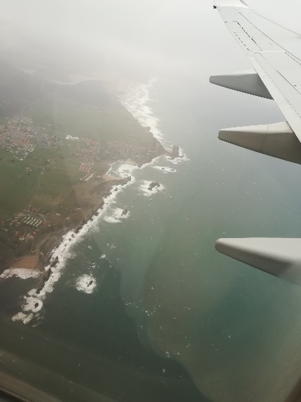
- I was very nervous when we got on the plane but I relaxed as we approached. When we arrived at the airport, all the Dutch mates were waiting for us and I didn’t recognize my match, it was very different from how I had imagined her. Then we took the bus for two long hours and we arrived at the town. I got into the car with Isa and her parents, her parents talked to me and they asked me many things, they are very nice. For dinner we had chips and nuggets, then I went to sleep.

Monday
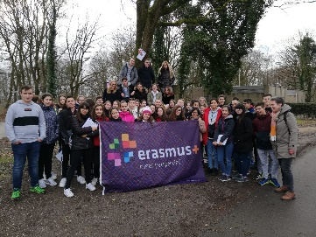
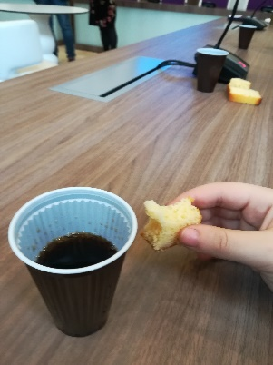
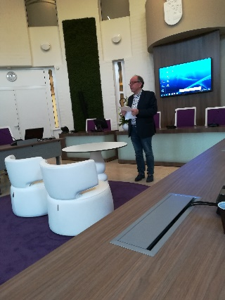
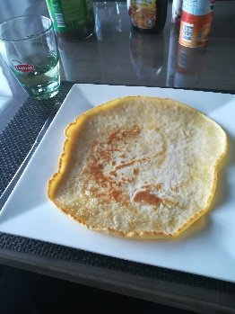
- This day I got up and I went downstairs to have breakfast; there were many types of bread and things to spread on it. There was also orange juice and milk then I went upstairs to get ready and then I took my food. Then we went to school by car, we were welcomed and introduced to Holland, then we went to the laboratory and did some experiments, it was very funny. We had some time for lunch, we went to the city hall where they gave us a piece of sponge cake and something to drink. We watched a video and finally they gave us a backpack with a pen, then we went back to school to have lunch. Later we went orienteering with the Dutch, we spent about 2 hours walking on the mountains looking for beacons, then we went back to town. I went home with Isa where we ate a giant pancake, then I went to see her practice artistic gymnastics for three hours; when we came back home, I took a shower and I went to sleep.

Tuesday
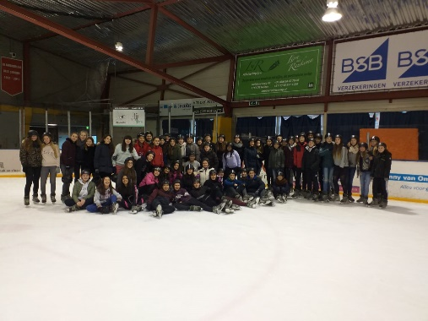
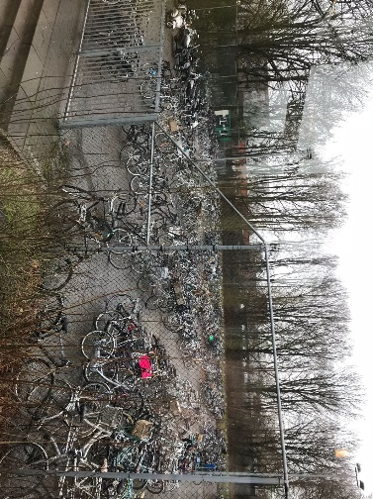
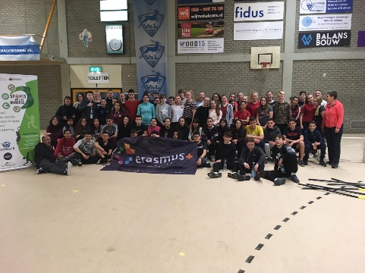
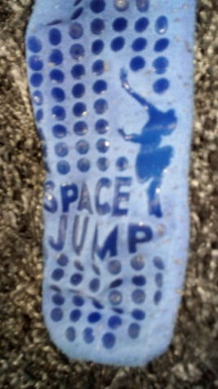
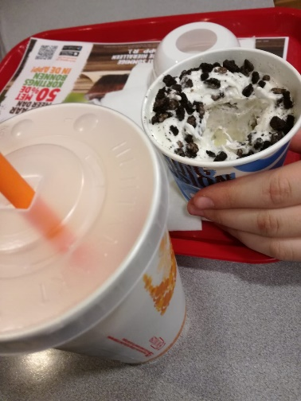
- That day I went to class by bike, it’s about 25 minutes from school. I was impressed that there were bike lanes everywhere and that people didn’t wear a helmet and everyone respects the bikes. When we arrived at the school, they led us to a class where a teacher talked about the time when he was in Salamanca, then we took a bus and we went ice skating, they gave us some lessons to learn and to improve our skills. After the skating class they gave us some time to skate on our own. Then we went to have lunch. After the meal we went to play floorball we didn’t like that we couldn’t play with guys so we went to complain. After a while, we were able to play football with boys I had a great time, it was a good moment. When we finished playing, we had a drink that was like a lemonade, we took the bus and we went to school to get the bikes to go back home where we had dinner. Then we went to the space jump, it was super fun, I had a great time. After two hours, to recover our strength we went to the burger king for a drink and then I went home to have a shower and go to bed.

Wednesday
- This day we went to another class where the same teacher told us a story about a mountain, then we drew a face on a mountain. We went to Maastricht; only the Spanish students went sightseeing the city and then we had free time to have lunch and to do other things. When we returned home, I went to a pizzeria for dinner with my host family, I ordered one of four cheeses and it was a very big pizza, I was very full and I ate a lemon ice cream for dessert. Then we come back home and Isa, her boyfriend and I played table games, we had a great time and I taught them the numbers and they taught me the colours in Dutch.
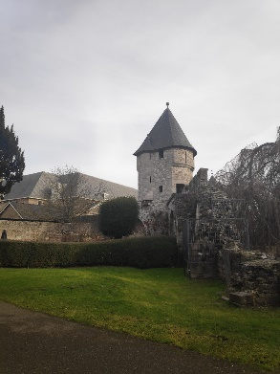
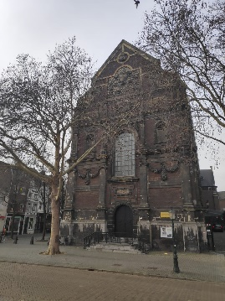
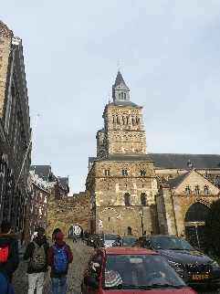
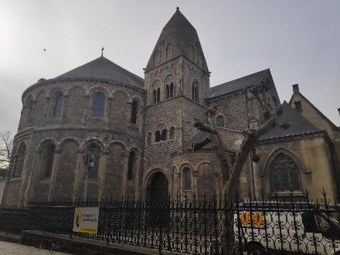

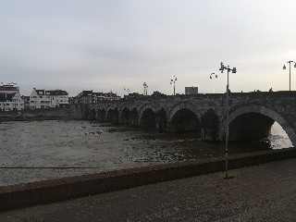
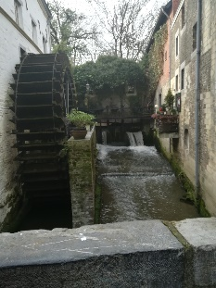
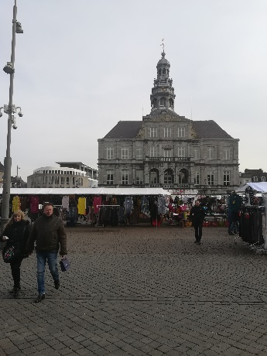
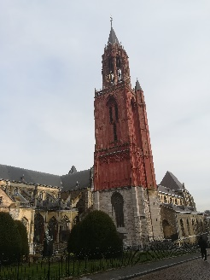
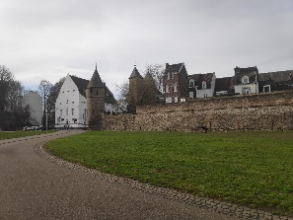
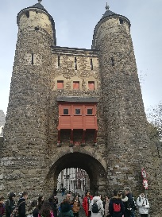

Thursday
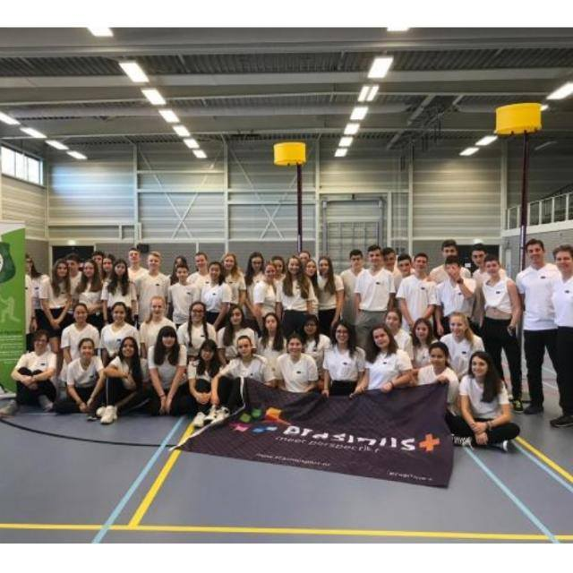
- That day we went again to another class where the teacher told a story of a clown in Spanish, I really liked these stories that we had in the mornings, the stories were very interesting and funny, then we went to play korfball, I liked it because it is similar to basketball. After that we had luch and in groups, we had to answer some questions about korfball, then we went to visit to Drielandenpunt (“three country point”) and we went up to a tower to see the views on top. When we returned home, we had dinner and I went to a “party”.
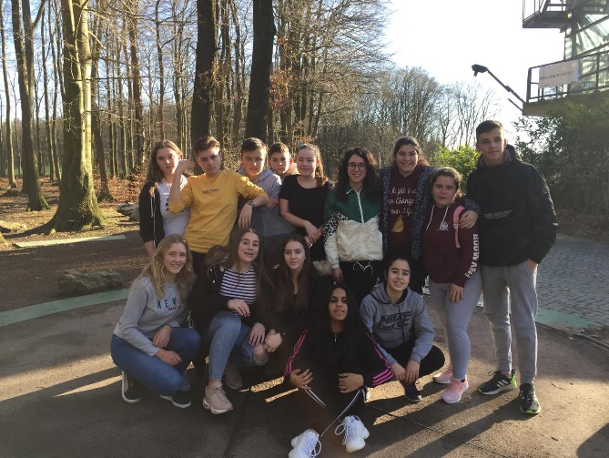
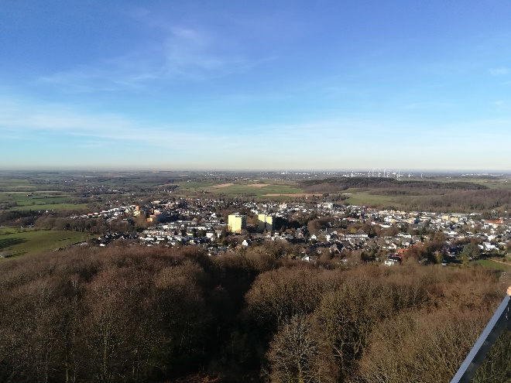
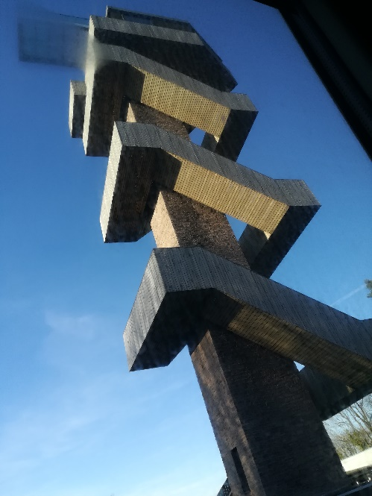

Friday
- This day we continued to answer the questions of the previous day with the computer at the school. After that, we went to Brussels, we saw the Atomium which was amazing, it was very cool, then we went on a tour on the bus, then we got off the bus and went to see the main square and had free time; then we went to the airport where we said goodbye to our Dutch colleagues and took the plane, then the bus and finally we arrived home.
