EXCHANGE

THE

NETHERLANDS

INÉS ALONSO

SATURDAY
The plane took off in Santander at 15:00 and we arrived at Brussels at 16:30. In the airport we met with our matches and we departed by bus to Landgraaf. The road was two hours until we arrived.
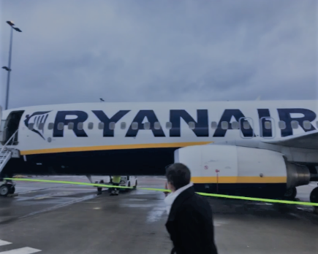
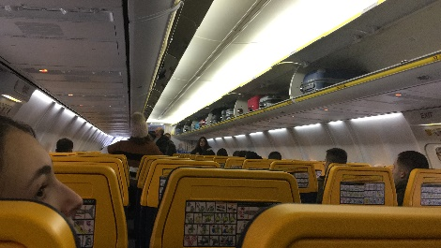

MONDAY

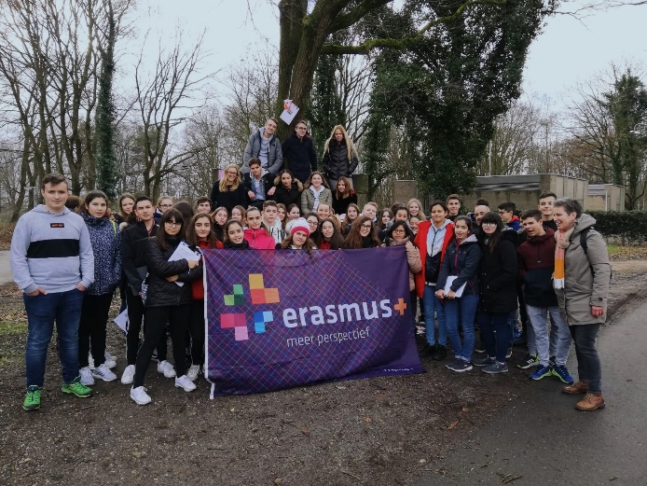
In the morning, we went to the school where the English teacher introduced us what the school was like, the country and a little of its culture. Then the chemistry teacher showed us the laboratory of the school and did some experiments. After this, we went to the town hall of Landgraaf where we saw an interesting documentary about the town. We went back to the school and we took the bus to do orienteering on a route. In the afternoon I went with some people to the bowling alley and there we spent a great time until it was night.

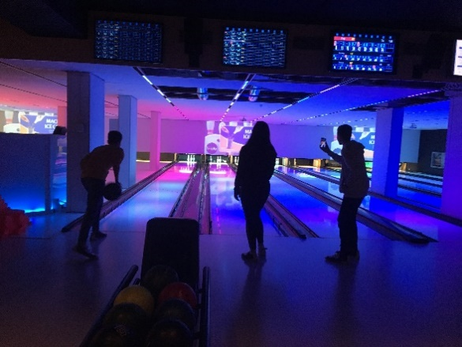
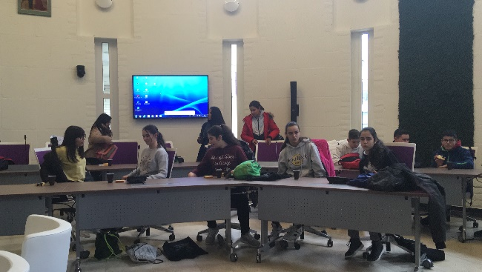

TUESDAY
We went by bike to school and we took the bus to go to practise ice skating. Some instructors give us classes and then we had free time. When we finished, we ate a prepared lunch and after this we started playing floorball and soccer with the other two schools from England and Germany. They separated us into girls and boys and that did not seem so well to me but in the end, they mixed us. In the afternoon my match took me to a site of elastic beds called “Space jump” and we went back home.
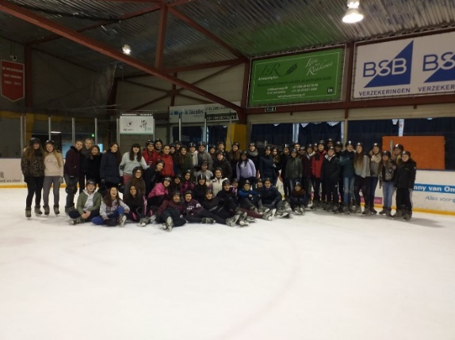
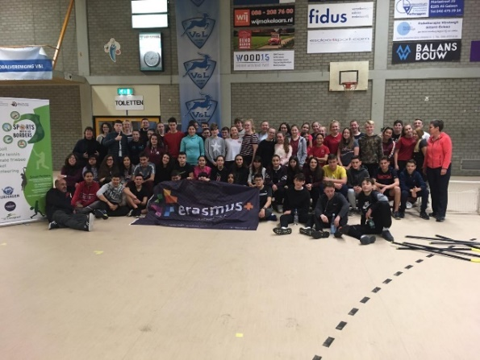

WEDNESDAY

WEDNESDAY
In the morning, Mr. Rutten told us stories about the travel he did to Spain, to learn Spanish. Then, only the Spanish students went to visit Maastricht. We did a city Walk, seeing important places or monuments and we had free time to visit the city.
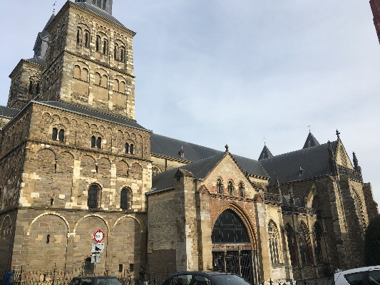
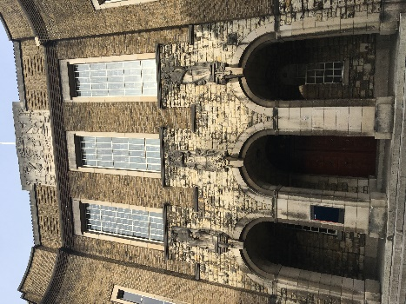

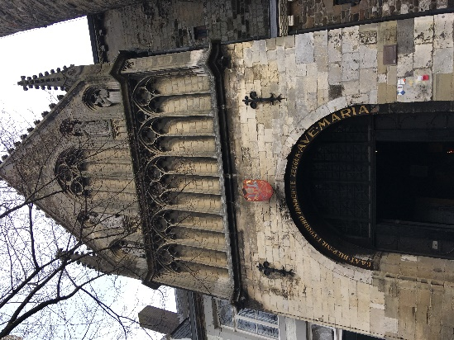
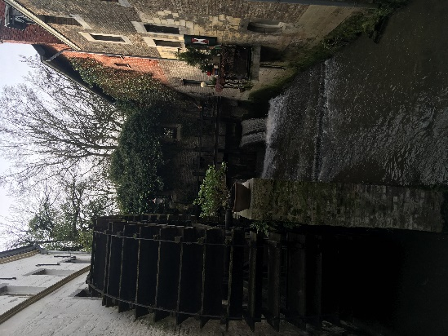
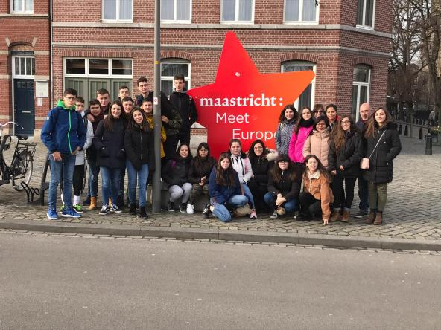

THURSDAY

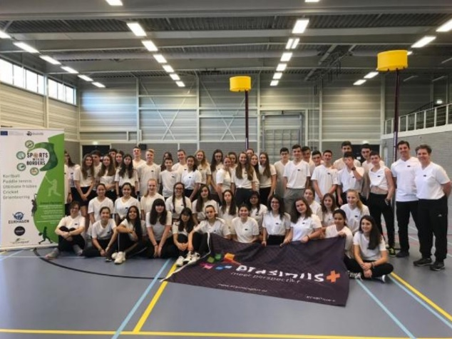
In the first hour we had a workshop. Then we went to a sports center to practice korfball. There gave us classes André Kuipers, a professional player. When we finished we ate and did a group work with the Dutch students about the sport. Before going back to the school we went to Drielandenpunt, a place where three countries are joined: Germany, Belgium and the Netherlands. At night, we went to a small party.

FRIDAY

We were at school finishing our project until 11:30, when we left by bus to Brussels. When we arrived we visited the Atomium and then we saw the grand place in Brussels. At 18:30 we said goodbye to the Dutch students and our flight took off at 9.00 o’clock.
