KORFBALL
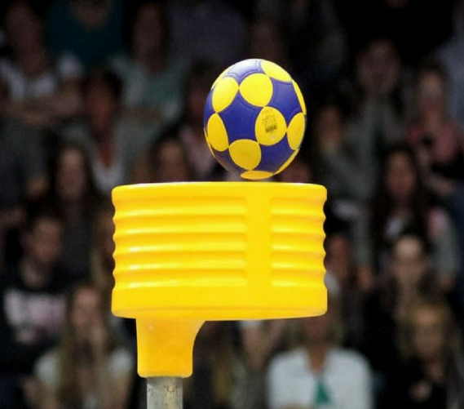
Korfball (Dutch: Korfbal) is a ball sport, with similarities to netball and basketball. It is played by two teams of eight players with four females and four males in each team or with eight players in each team. The objective is to throw a ball into a bottomless basket that is mounted on a 3.5 m (11.5 feet) high pole.
The sport was invented by Dutch school teacher Nico Broekhuysen in 1902. In the Netherlands, there are around 569 clubs and over 100,000 people playing korfball. The sport is also very popular in Belgium and Taiwan, and is played in many other countries.
History

In 1902 Nico Broekhuysen, a Dutch school teacher from Amsterdam, was sent to Nääs, a town in Sweden, to follow an educational course about teaching gymnastics to children. This is where he was introduced to the Swedish game 'ringboll'. In ringboll one could score points by throwing the ball through a ring that was attached to a 3 m pole. Men and women played together, and the field was divided into three zones. Players could not leave their zone.

Broekhuysen was inspired and when he returned to Amsterdam he decided to teach his students a similar game. He replaced the ring with a basket (for which the Dutch word is korf or mand), so it was easier to see if a player had scored or not. Broekhuysen also simplified the rules so children could also understand and play it. Korfball was born. The main idea was the same as ringboll, but it now stood on its own.

The oldest still existing korfball club never haS merged with any other club is a Dutch korfball club H.K.C. ALO from The Hague, Netherlands. H.K.C. ALO was founded on 1 February 1906.

At first there was considerable controversy about the sport, because the players were of both sexes. Several sports journalists refused to pay even the slightest attention to the new sport. Korfball players were accused of being immoral. Even the sportswear was criticized, because the women were showing bare knees and ankles; one newspaper wrote that "Korfball is a monster that spreads its claws to all sides". Yet korfball was featured as a demonstration sport in the Summer Olympics of 1920 and 1928.

The International Korfball Federation was founded in 1933.

Korfball is played in over 60 countries including: United States, United Kingdom, Ireland, Australia, New Zealand, the Czech Republic, Poland, Greece, Serbia, South Africa, Zimbabwe, India, the Netherlands, Belgium, Russia, Germany, Taiwan, Turkey, Hong Kong, Portugal, Pakistan, Sweden, Hungary, the Philippines, Indonesia, Italy, Spain, France and Romania. It is growing in popularity in the UK and in a unique reference to the sport, is featured in a song by the band Half Man Half Biscuit entitled "Joy in Leeuwarden (We Are Ready)" on their 2011 album 90 Bisodol (Crimond).

Korfball has been played in the World Games since 1985. IKF World Championships have been held every four years since 1978. The leading nations are Belgium and the Netherlands.

Hong Kong hosted its first international tournament, the Asia Oceania Championship in 2006. New Zealand hosted the Asia Oceania Youth Championships in 2007.

Rules and regulations

A. Equipment:
Korfball is played inside in winter and outdoors in spring and fall.
The size of the indoor court is 20 m × 40 m (22 yd × 44 yd), outdoor courts are 30 m × 60 m (33 yd × 66 yd). The new outdoor courts size is 40 m x 20 m. The court is divided into halves called zones. In each zone is a 3.5 m (11 ft) tall post with a basket at the top. This is positioned two-thirds of the distance between the center line and the back of the zone.

B. Team:
A korfball team consists of eight players; four female and four male.

C. Match:
A korfball match typically consists of two periods, with the length varying depending on the competition, but typically between 25 and 30 minutes, with a break between periods.
Four players of each team are in one zone, and the others are in the other zone. Within each zone, a player may only defend a member of the opposite team of the same gender.

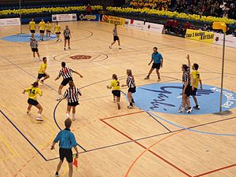
At the beginning of the match one team chooses one-half of the court. That half will be their defending zone, with 'their' basket in it. Players score by throwing the ball through the opponents' basket. After two goals, the teams change zones: defenders become attackers and attackers become defenders. In between those zone-changes, attackers cannot set foot on their defending zone or vice versa. At half-time teams swap halves.

The rules prevent physical strength dominating the game. Blocking, tackling and holding are not allowed, as well as kicking the ball. Once a player has the ball, one cannot dribble, run or walk with it, however, one can move one foot as long the foot the player landed on when they caught the ball stays in the same spot. Therefore, tactical and efficient teamwork is required, because players need each other to keep the ball moving. A player may not attempt to score when defended, which occurs when the defender is in between the opponent and the basket, is facing his/her opponent, is within arm's length and attempting to block the ball. This rule encourages fast movement while also limiting the impact of players' height compared to their opponents.

