Yelizaveta Ivakina
Position: Opposite Hitter, Middle Blocker
Gender: Female
Date of birth: 31/12/2004
Graduation date: June 2023
High School: First Language School, Varna
Club team: Varna DKS
Languages: Russian, Bulgarian, English
Height: 183 cm., 6ft.
Video Analysis:
https://www.youtube.com/watch?v=MZu5rhexWVQ

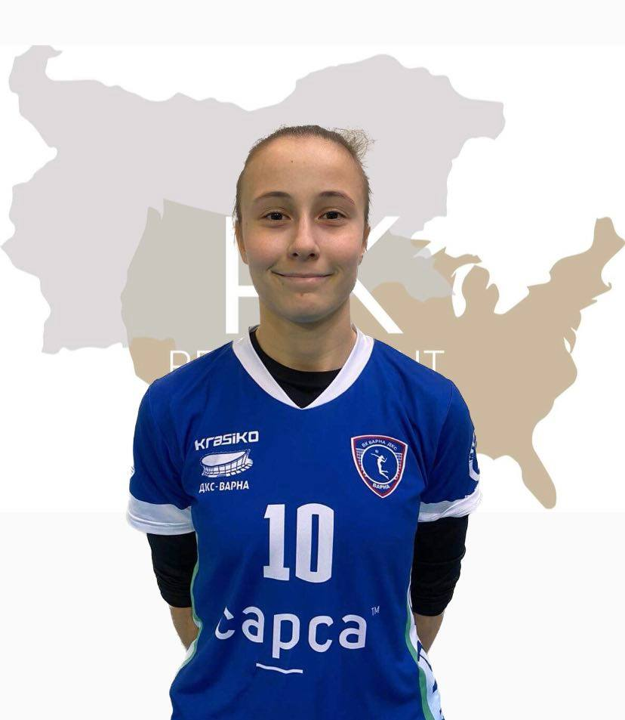
Weight: 65kg.
Reach: 238 cm.
Approach high jump: 295 cm.
Standing block jump: 277 cm.

Academic achievements:
- Middle School: Multiprofile Gymnasium #79 Almaty, Kazakhsta. With profile: Music. Piano. Chore.
- Participant in the Republican Piano competition of young musicians-debutants «Almaty music Start »
- Participant in the annual performances of the choir each year
- The "Baiterek" choir of the Almaty gymnasium No. 79- Won 1st place in the "Children's Choir" Nomination and 2nd place in the "Sacred Music" category. The head of the choir is Elena Baiysbayeva.

Desired degree:
Major: Asian Studies; Japanese; Drama.
Minors: Drama/Theatre/Film; Japanese; Asian and Pacific Ocean cultures; Linguistics; Writing; Music; Photography.

SAT and TOEFL grades: TBA

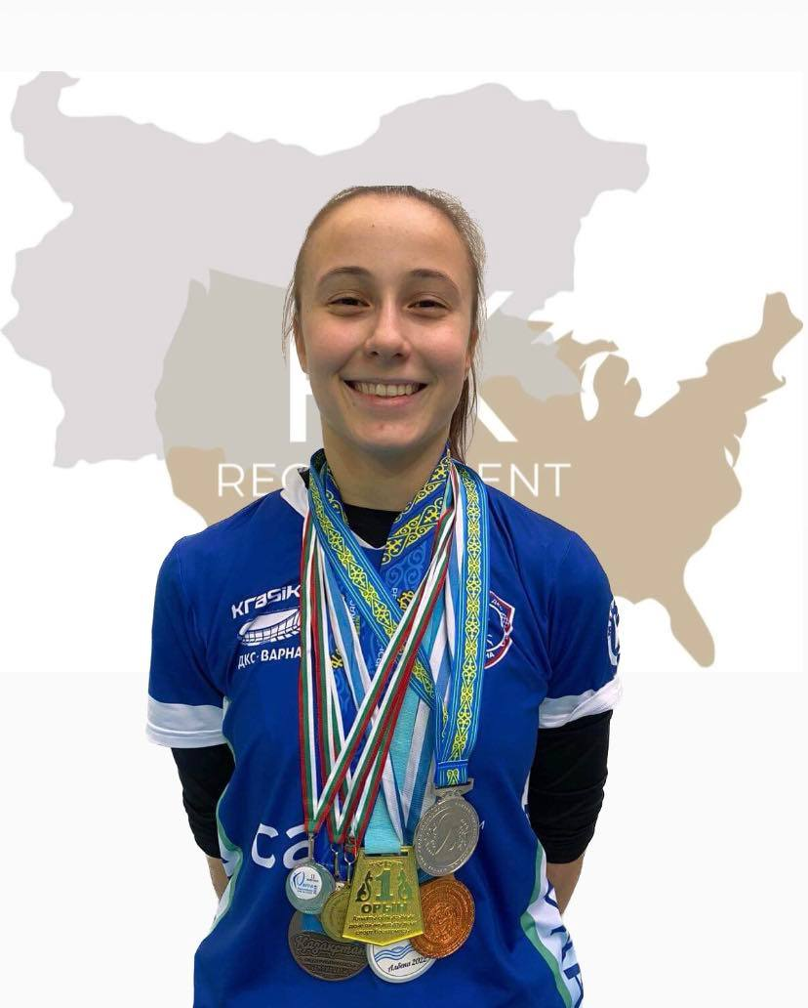

List of participation in athletic events:
Tournaments in Kazakhstan:
- Physical education and sports center. Kazakhstan / =2016/2017=3rd place
- Physical education and sports center of Almaty region=2016/2017=2nd place
- Academy of sport -Taldykorgan /volleyball tournament/girls=3rd place
- Physical education and sports center of Almaty region tournament =autumn=2017-2018=1st place
- Academy of sport -Taldykorgan /volleyball tournament/girls=3rd place
- Physical education and sports center of Almaty region= adolescent=2016/2017=2nd placе
- Physical education and sports center of Almaty region= adolescent=2016/2017=2nd place
- Ministry of Culture and Sports of the Republic of Kazakhstan/ Finals- 3rd place

Tournaments in Bulgaria:
- International Club volleyball tournament for the mayor's cup, 2018- 1st place
- International Club volleyball tournament for the mayor's cup=2019-1ST PLACE
- International Club volleyball tournament for the mayor's cup=2020=2nd place
- International Club volleyball tournament for the mayor's cup –MVP-2020
- Best athlete of the club- Varna DKS, 2020
- Olympic Talents volleyball tournament- 18-19.12.2021- 1st place

High School Tournaments:
- High School Regional Tournament, 8-10th grade, 2018/2019- 3rd place
- High School Regional Tournament, 8-10 grade, 2019/2020- 1st place
- High School Regional Tournament, 11-12 grade, 2018/2019- 2nd place
- High School Regional Tournament, 11-12 grade, 2019/2020- 1st place
- Student Cup Varna, 8-10 grade, 2019- 2nd place
- Students Cup Varna, 8-10 grade, 2019- 1st place

Beach volleyball:
- Varna municipality Girls' beach volleyball tournament- 8-10th grade-2019- 1st place
- National Beach Volleyball Championship- 2nd place
Season 2022:
- Bulgarian Olympic Talents- Albena Beach 2022- 2nd place
- 17th June- Saint Vlas Tournament Rank- National Tour Teammate: Ivanova Rank:5
- 1st July- Varna Tournament Rank- National Tour Teammate: Ivanova Rank:5
- 29th July- Burgas Tournament Rank-National Tour Teammate: Ivanova Rank:5
- 12th August- Biala Tournament Rank- National Tour Teammate: Ivanova Rank:9
- 26th August- Varna Tournament Rank-National Tour Teammate: Katsarska Rank:5
- Ranking CEV Beach volleyball /Team Women/Rank=511 /72points/Ivakina+Ivanova
- Ranking CEV Beach volleyball/Team Women/ Rank=533/Points:70/ Ivakina- Katsarska
- Ranking CEV Beach volleyball/Player Women/Rank=562 /36points

Interview:
Describe yourself with a few sentences:
I am energetic and positive to this life, and I like people, like to help them, and want to understand them more. My classmates see me as a creative person, energetic, who can take the responsibility for the actions, diligent, analytic. My team said that they see me as supportive partner and friend as well as calm person who takes things in hands when it is needed. I like tasty food, music, deep conversations, my family, and my kitten. I do not like being late, upset my parents, boring books, and cold tea in the winter.
What does volleyball mean to you?
When I was young, I was playing tennis on court, was going to the swimming pool but I quit everything in the end. I did not like those sports. But when for the first time I went to play volleyball, I said to myself that THIS is the sport that I am going to finish and enjoy till the end. I like action, sweating, demanding work that is bringing results, teamwork in the court. After hard school day when I am entering the court, it feels like all problems are left behind the door and I can learn to fly. I do not know how to express this feeling in more accurate way.
What does your education mean to you?
I like to develop myself as a person in all ways. Education is an important part of me growing as an individual, good one, who will understand people and will help them. I like to learn new cultures and languages, because through this you can reopen the world to yourself repeatedly. Education can give me new opportunities as travelling around the world, meet new people and friends, work hard, and enjoy my life.
What are your main goals as a student-athlete in the USA?
I want to learn new skills, develop physically and mentally as a person. I want to play for a long time, professionally. I want to become a professional player and become strong, not being afraid. I want to do what I like and do this with challenging work, passion, and discipline. USA Universities allow this as well as they will give me opportunity to get a degree that I will love to study. This is the best combination for me.
· The goals are to become stronger, more skillful in volleyball.
· To learn more about this world. To work hard and play hard.

Photo Gallery:
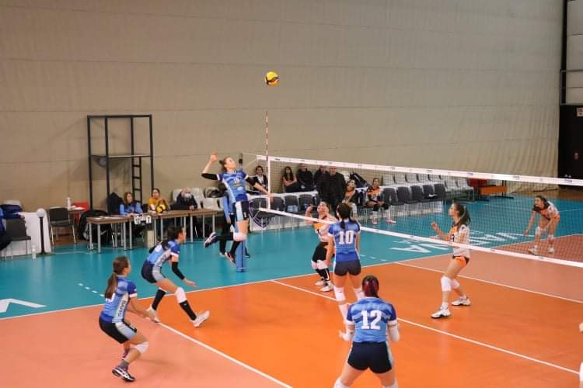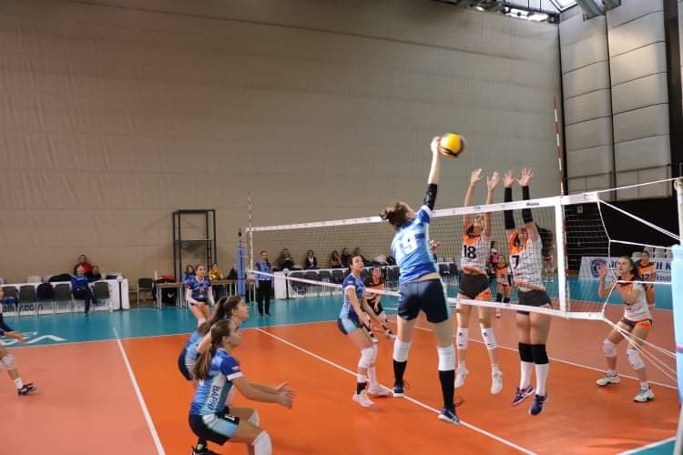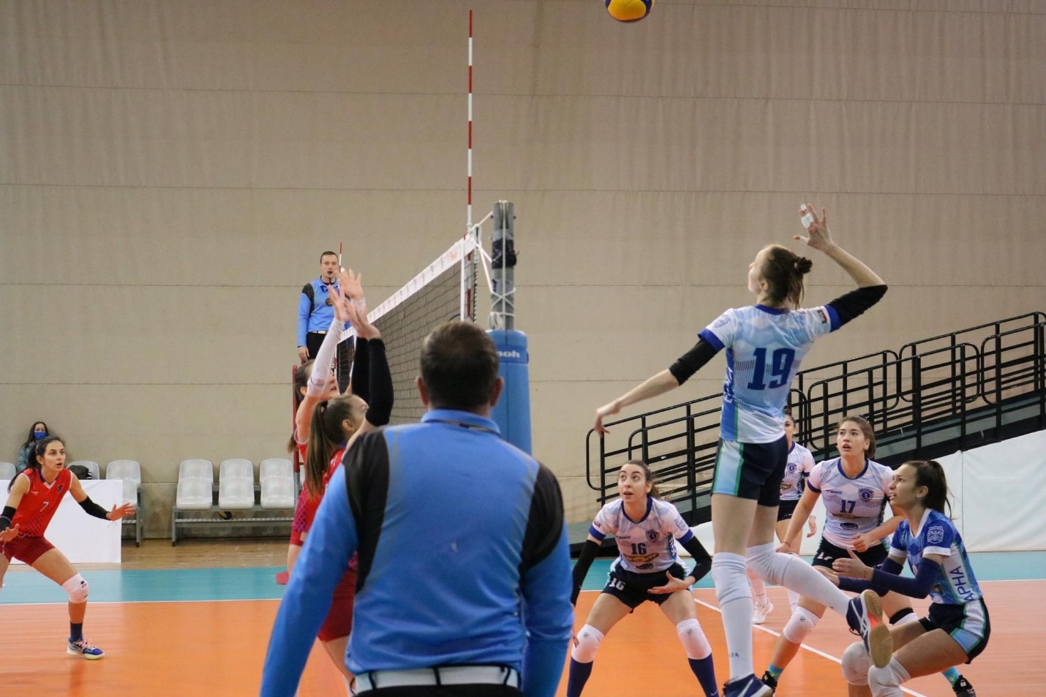
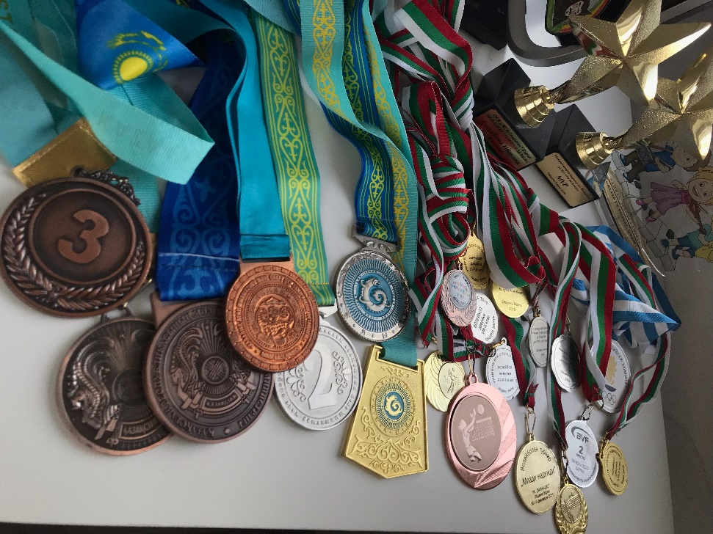
www.pkrecruitmentagency.com
Facebook: Popov&Kalchev Recruitment Agency
Instagram: @pk_recruitment
E-mail: pk.recruitment.agency@gmail.com
Cell phone: Radi- +359888407740, Dimitar- +359894646069

