

Sensors, calibration tables and info

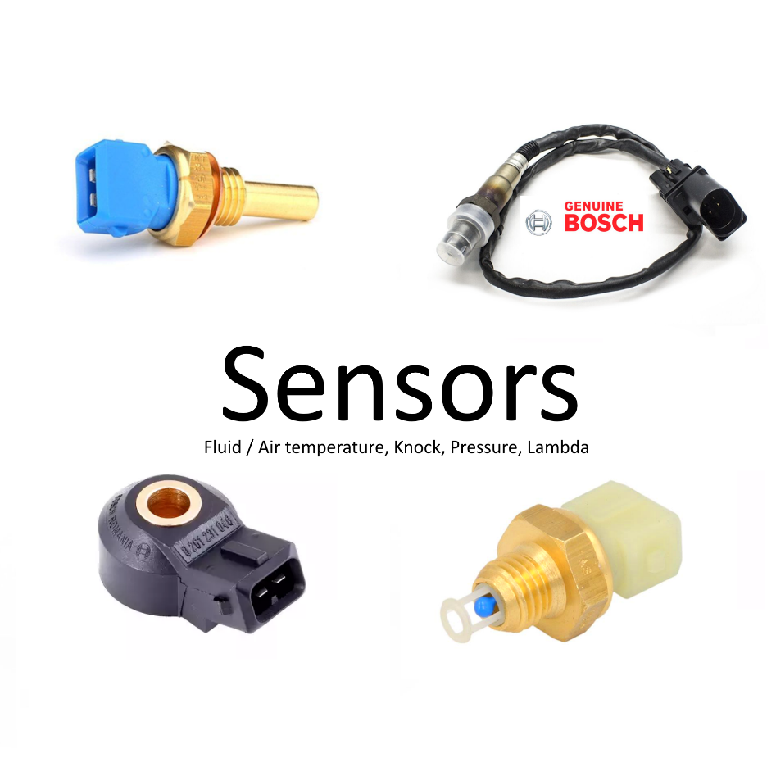
Table of Contents
3-Pin pressure sensors 3
Pullup resistor calibration/ calculation (2-Pin sensors) 4
2200 Ohm resistor example 4
Wiring pullup resistor (2-Pin sensors) 5
Setting up 2D tables (2 Pin sensors) 6
ME221 / ME442 HRT: 7
Warranty / safety note 8

3-Pin pressure sensors
These are the easiest sensors to setup:
Wiring is 3 pins. Power, ground and signal.
The signal pin outputs a voltage (often 0 – 5 volts)

Wiring setup:
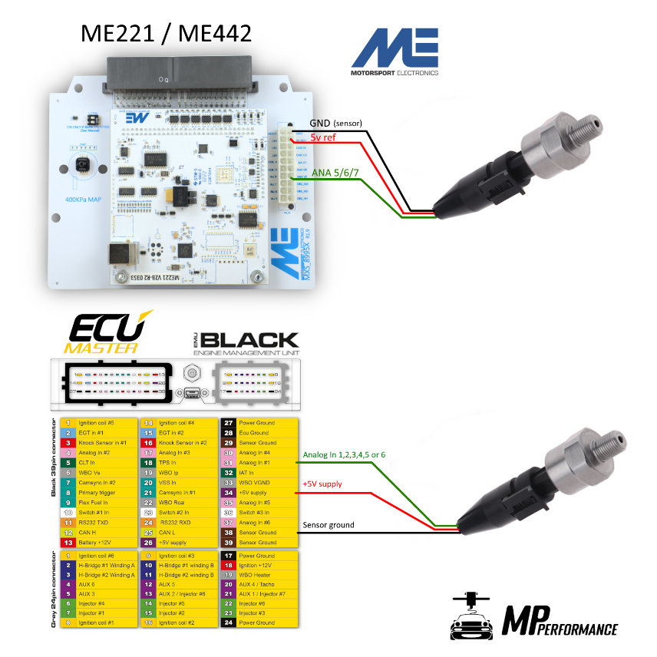

2D table or “HRT” setup in ECU Master software
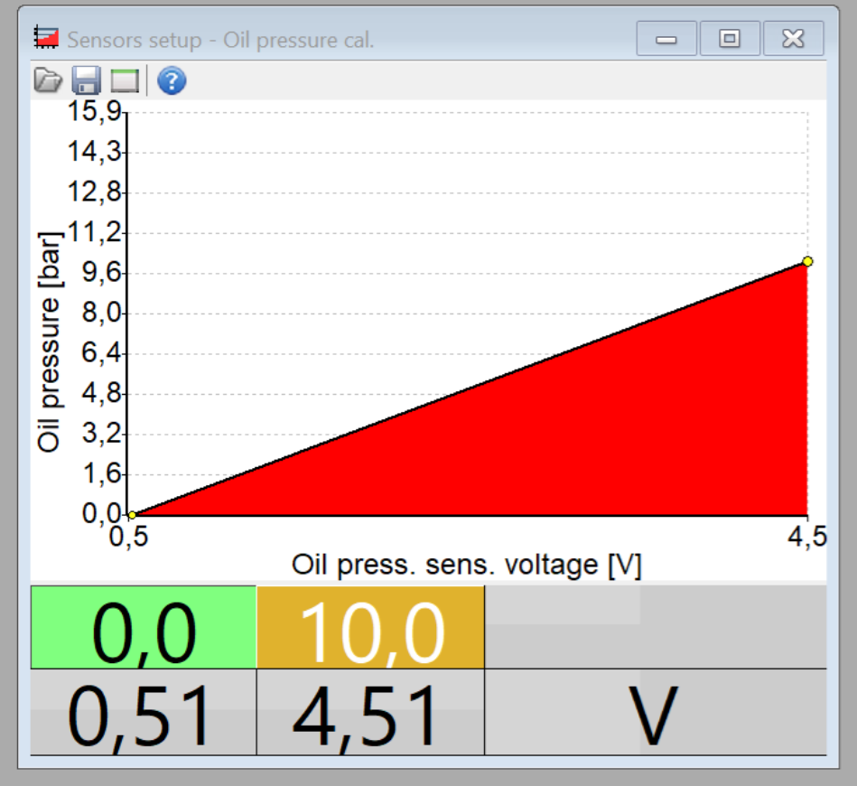

Pullup resistor calibration/ calculation (2-Pin sensors)
Depending on you sensors resistance range different pullup resistors are necessary. If the voltage difference is small but the temperature difference at these voltages is high at these temperatures the output temperature read by the ECU will vary and will not be very accurate.
We recommend certain resistors with certain sensors, but this is unfortunately not always the case.
We offer a pullup resistor calculator on our website:
https://www.mpperformance.nl/instructions-manuals/

2200 Ohm resistor example

Some ECUs have built in pull-up resistors that can be toggled on in the software.
An example is the IAT sensor with the ECU Master EMU series.
Here’s an example:

Enabling 2200 Ohm pullup:
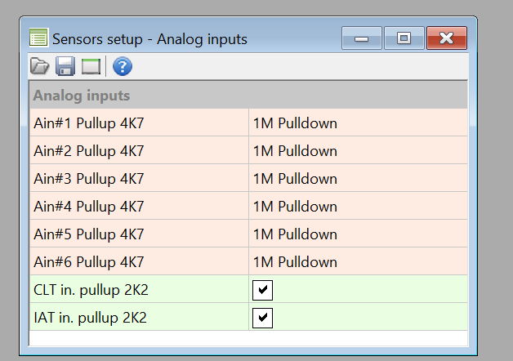

Wiring pullup resistor (2-Pin sensors)

Pull-up resistor wiring diagram:
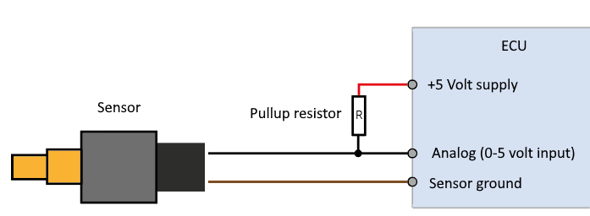

Setting up 2D tables (2 Pin sensors)

Generally every sensor uses a 2D table to assign a temperature to a voltage input. Some standalone ECU’s offer a wizard to instantly set up a sensor table. This is unfortunately not always the case.

Every sensor 2-pin temp sensor has a temperature to resistance table. The ecu input voltage is dependent on this resistance and the resistance of your pull up resistor
Calculating Temperature to Voltage using calculator
(https://www.mpperformance.nl/instructions-manuals/)
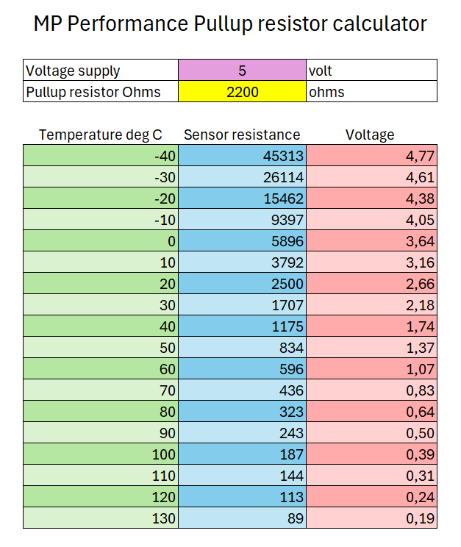

Inserting the values into the software
Ecumaster 2D table:
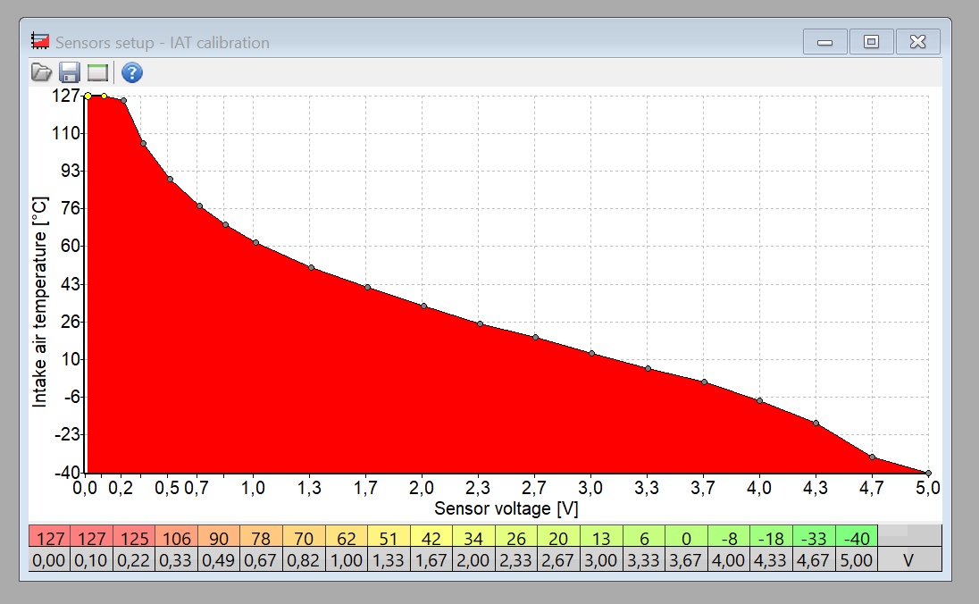

ME221 / ME442 HRT:
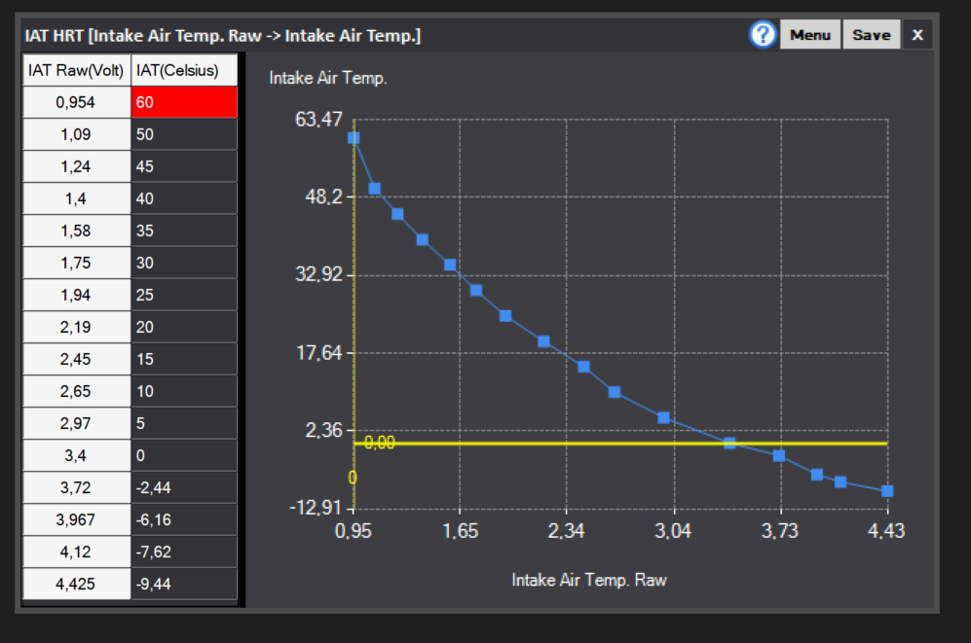

Warranty / safety note
Overvolting a sensor may result in defects to the sensor, ecu or other electronics. Please check the sensors rated voltage. Often this is only a couple of volts. MP Performance is not responsible defective electronics as a result of overvoltage or sub-par installation.

