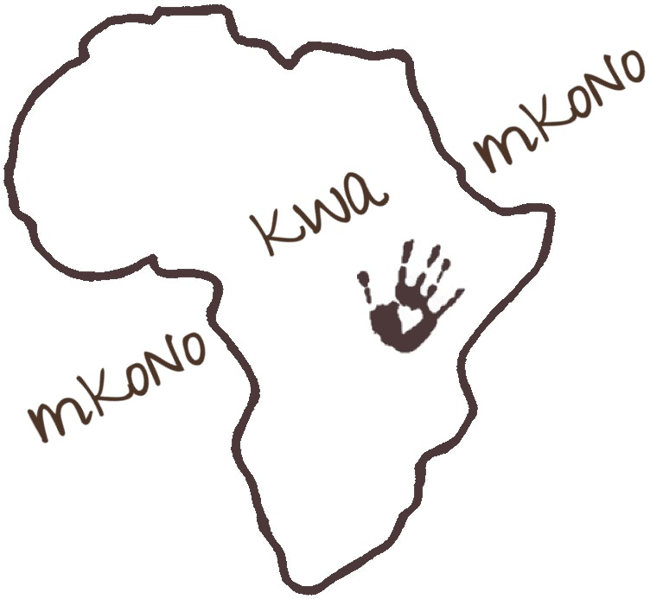

Volunteer Application Form

Thank you for your interest in mkono kwa mkono e.V. Tanzania. We are pleased that you want to join us in working alongside local people and communities in Tanzania as they seek to promote sustainable development of their communities.

Please complete the application form below and return it electronically to the following email address along with a copy of your CV: info@mkonokwamkono.de

- Contact Information

First Name
Last Name
Date of Birth
Nationality
Current address
Email address
Mobile number
Skype ID
(if holding a Skype account)
Passport country
Passport number
Passport expiring date
Preferred dates for volunteering with us

- Education

Volunteers that wish to apply to mkono kwa mkono e.V. for a placement must have a specific educational background to apply (f.ex. teaching, early childhood development, psychology, social work, missionary work or any other related degree). Furthermore, you do need to be hard working with drive and commitment to work with people in a developing country.

 | Name of school | Main courses studied | Additional comments
2nd Level Education
3rd Level Education
Post-graduate level
Other
Other

Please also list any kind of courses / trainings you have undertaken which may be useful during your time with mkono kwa mkono e.V. (eg. First Aid training, computer courses etc.)

Placement Interests

What skills do you currently have that you feel are applicable to our programmes?

What skills do you hope to acquire through your experience with mkono kwa mkono e.V.?
- Motivation for volunteering

- Relevant experience

- Have you ever lived outside Europe for a longer period? Please give details and experience.

- Have you ever experienced culture shock and what are / could be possible ways of dealing with it?

- How do you expect to work with kids from another country and culture? What needs to be considered?

- Do you have any food allergies or dislikes? Are you able to eat local food during your stay?

- Fundraising -> We would appreciate any amount you could contribute to mkono kwa mkono e.V. through a private fundraising activity. This is not a must, but highly appreciated. What could be a possible fundraising activity you could organise?

