Pemba Sherpa's
Report of June and July 2021
In June, due to the pandemic, the school was closed again. However, I kept myself occupied with some social work in the community for the needy family. My colleague and I organized a fundraising. We collected money to bring financial support for a particular family whom we witnessed in a critical condition. Fortunately, I am very happy as it was a successful campaign. We were able to bring them some financial support from Doris and her friends and also a Chinese friend of mine. Now they have warm food to eat and some chickens for their source of sustainable income.
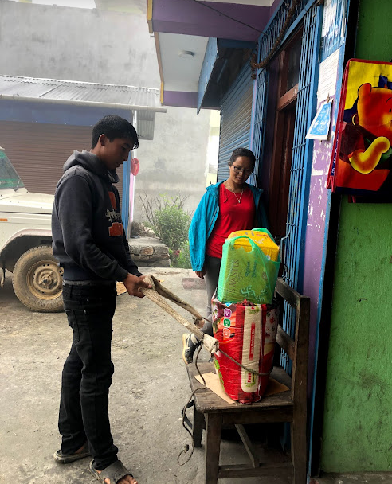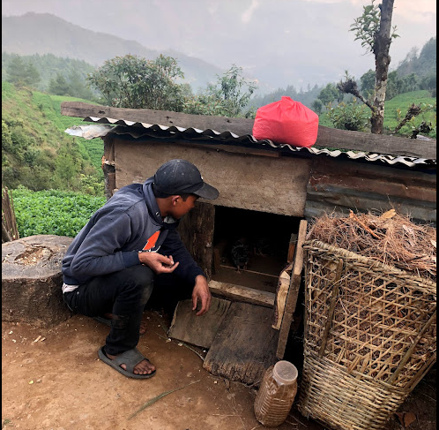
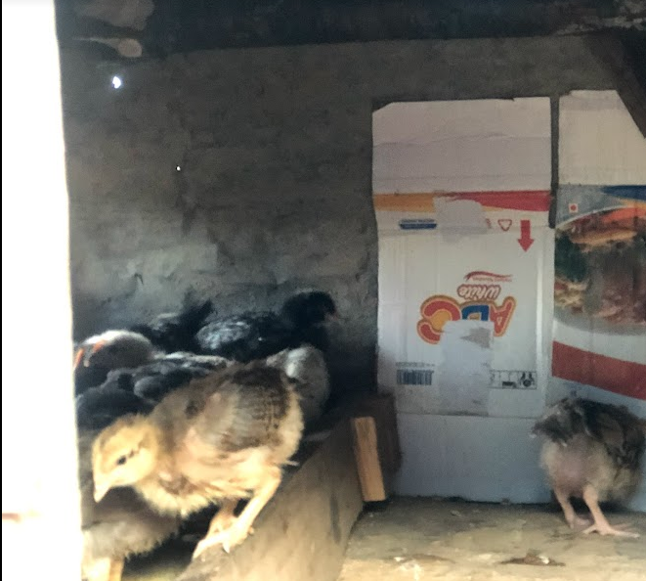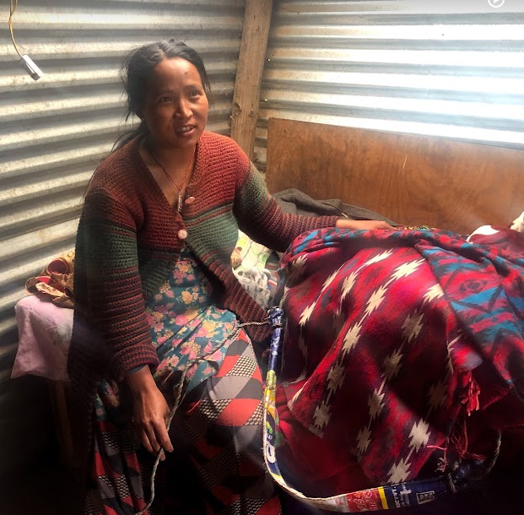
Pictures of a family with their chickens and monthly needed food
Meanwhile, apart from that, I took some free online courses on education, life lessons, and English for my personal development. And to cover the gaps and lacked much knowledge to improve me.
Apart from that, I made some teaching materials for my children. More specifically, I made a Monopoly board game intending to teach and guide students on calculative or business base knowledge.
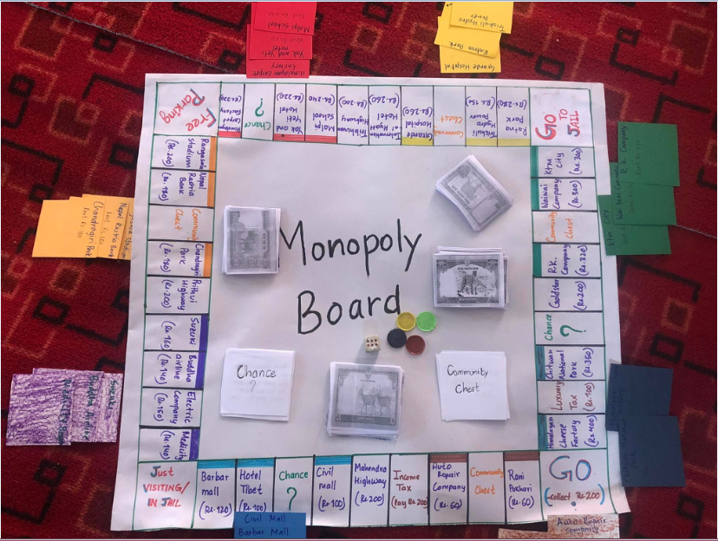
Picture of the Monopoly Board game
Furthermore, I decided to implement CAS (Creativity, Action and Service) activities which I have learned in International Baccalaureate's curriculum. It gives students the opportunity to engage in creative endeavour, an activities and services which benefits their community.
Moreover, it helps students learn life skills, like taking the initiative making decisions, and problem-solving. They are given great opportunities to get accustomed to social values, sympathetic and healthy habits. Therefore, I felt crucial to get young students accustomed to social and moral actions.
Now, how does it works with the activity or the curriculum? I have listed the different activities on three different categories of CAS. Each student has to choose the activities from three different sections. They will have to carry out the activities for a month and have to write a reflection of each activity. For instance, there is a collecting dry leaf on the Action section, likewise, there is tutoring neighboring friends on the Service section and learn 50 new words in English, etc. By the end of the month, students have to reflect on each activity.
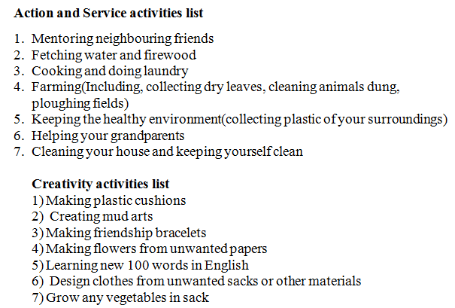
Reference: CAS activities

In July, we resumed school for ten days. During that ten days, I guided students with Drama scripts on “Beauty and the Beast” as the monthly activities.
Besides that, I accompanied students in preparing the greenhouse. With excitement, we collected dry leaves from the Jungle to make compost manure. I believe students enjoyed carrying mud and leaves in the drizzling rain.
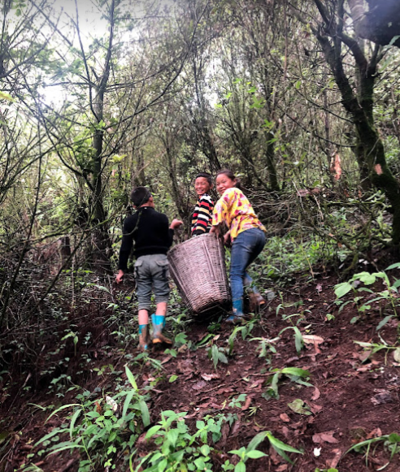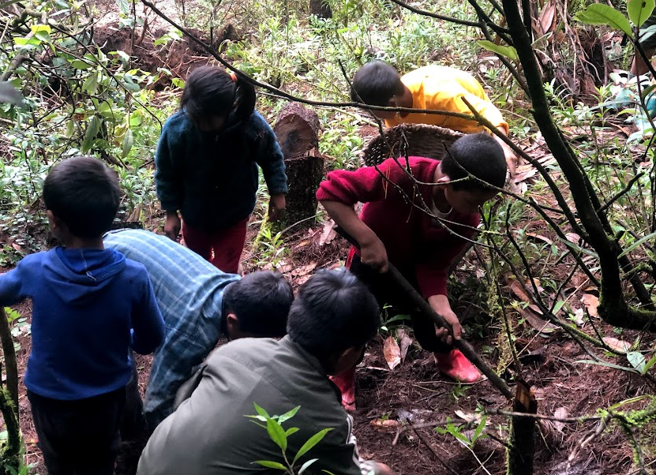
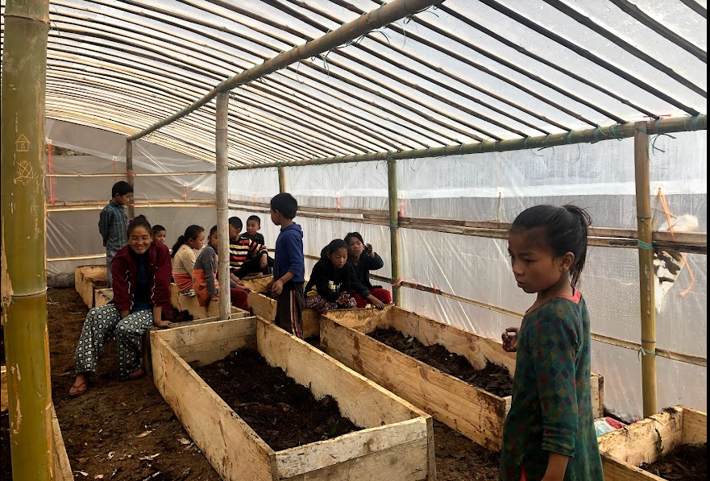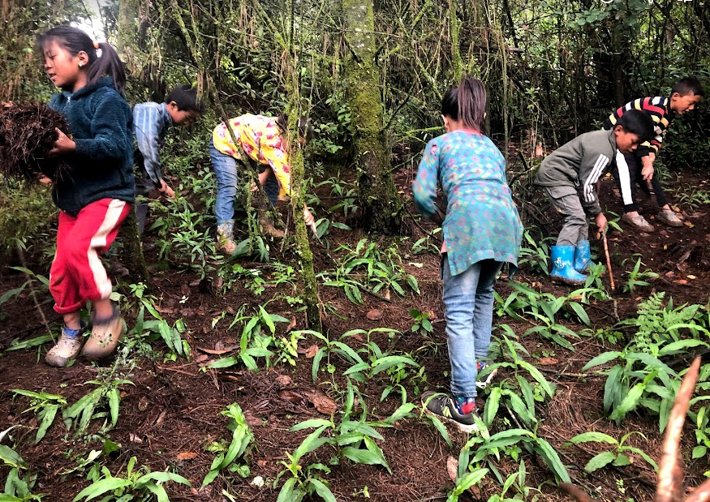
Pictures of students collecting dry pine leaf

Meanwhile, I attended the online "Early Childhood Education” teacher training for eight days with a diploma at the end. Regarding the trainers, they are well-known trainers in Nepal.
I found it quite worthwhile and productive to gain some new skills. Moreover, it provided me time to realize gained knowledge on various teaching methods. All in all, I would say it was something great to do during this listless pandemic period. I am grateful that Doris paid and made it happened for me.

