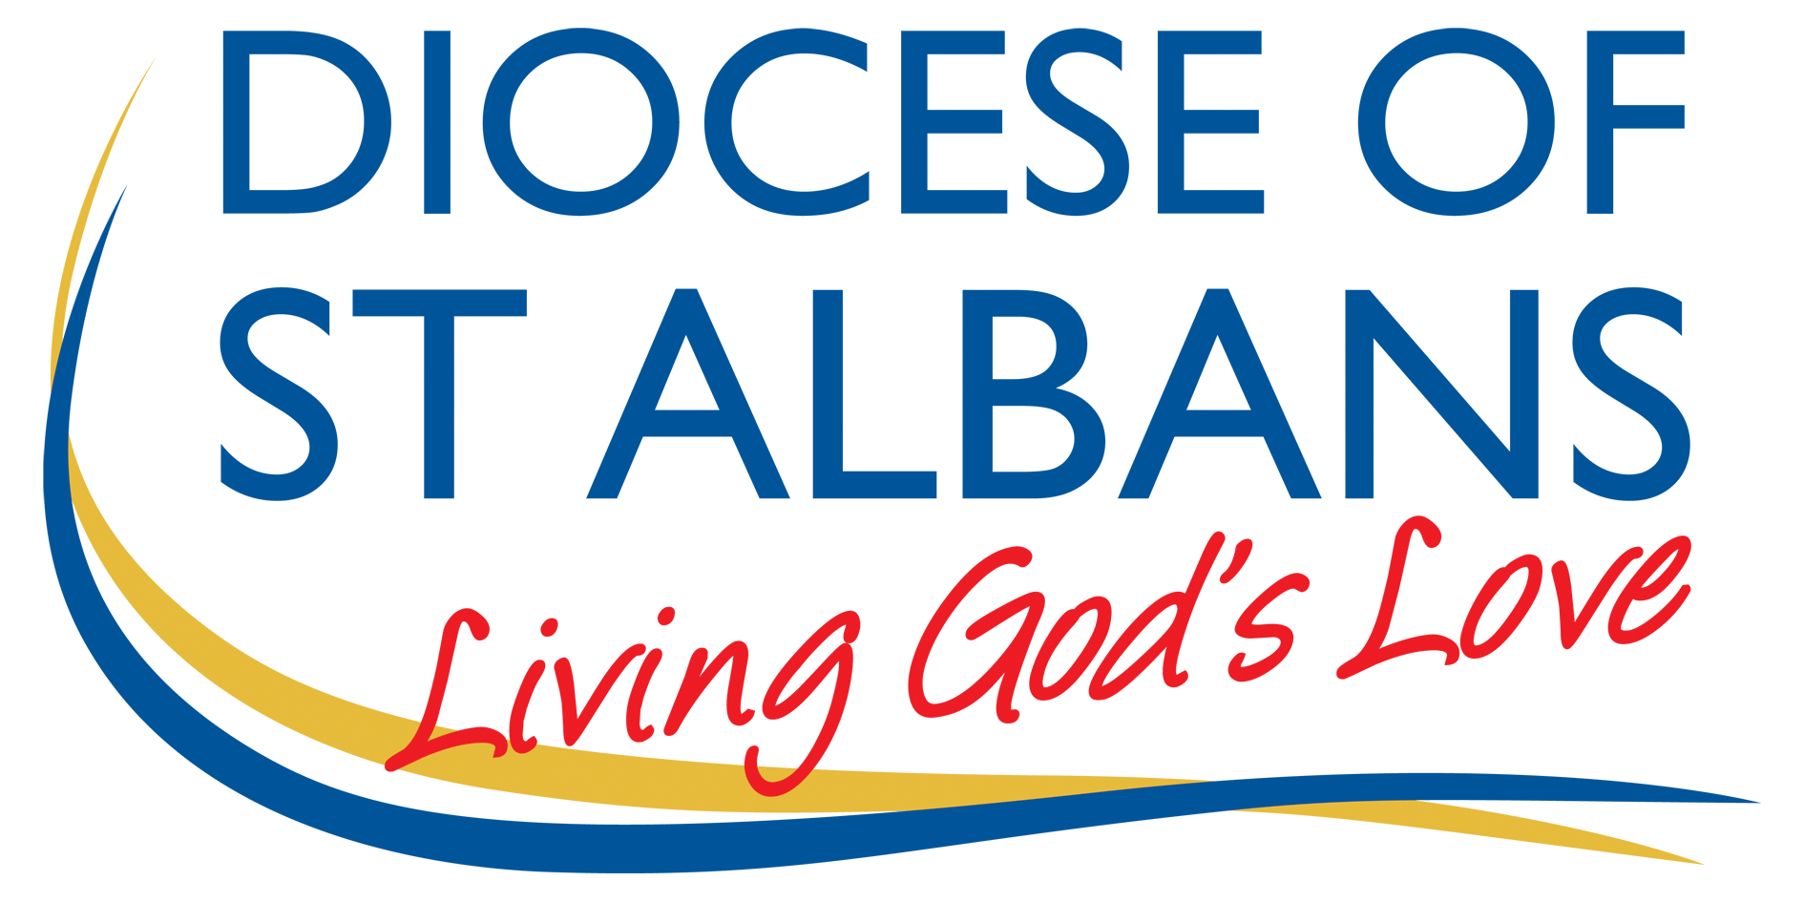**Dean of Women’s Ministry (DWM)**

The DWM reports directly to the Bishop of St Albans. This is a voluntary position, with an expenses budget annually - currently £400.

**Key Purpose**

* The promotion of gender equality and the inclusion of ordained women at every level of ministry and life in God’s Church.
* To be an advocate for the ministry of clergy women in the diocese, enabling them to reach their full potential and flourish in ministry.

**Role Description**

* To maintain the network of women clergy, to signpost resources and to organise gatherings that promote spiritual and leadership wellbeing.
* To work with senior staff in supporting ordained women in the diocese in their ministry; identifying where the contributions of women are constrained by the existing culture, habits and structures of the Church and working to effect change in those areas.
* To support, along with senior staff, the outworking of the Church of England’s Five Guiding Principles for mutual flourishing across the diocese and challenging discriminatory behaviour towards ordained women.
* To be an advocate for women in ministry and the issues that affect the development and practice of their ministry at diocesan, regional and national level.
* To maintain awareness amongst the senior staff of matters of general concern to women clergy and ensuring that women’s insights are brought to bear in theological reflection and decision-making in the diocese.
* To be proactive in encouraging ordained women to play a full part in the life of the diocese and to encourage balanced representation within diocesan structures.
* To work with the Director of Mission and Ministry and Deputy Director to develop opportunities and training that enable women to reach their full potential in ministry and leadership.
* To work with the Vocations Team, especially in encouraging women under 30 and BAME women to explore a vocation to the ordained ministry.
* To contribute as a member of the National Association of Deans and Advisers in Women’s Ministry (NADAWM) at a national and regional level. <https://www.nadawm.org/>
* To encourage and promote mentors for women clergy to support their ministry development and growth into senior roles.

January 2021