July 2021 report
Migmar Bhuti Lama
Teaching in Hile Nigale community center.

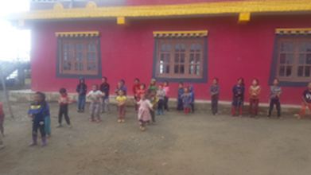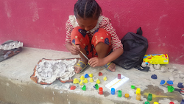

Pictures of resuming day at community center

In July, it seems that pandemic is decreasing around the village. So, we resumed school for ten days, I revised what we have learned before. I guided them with new rhymes and words since they are small and everything learns through songs and games. I also help bigger kids with drama scripts on ''Three sisters''.
Meanwhile, we had a common cold flu spreading in the village and were forced to lockdown again.

Due to the pandemic, our school was closed. However, I keep myself busy with some good vibes by visiting different villagers' houses and help them in need. I talked and counsel with kids what they do and how they feel during the holiday at home. I guided one adult for an hour a day to learn English with me. Besides, I prepared some teaching materials and games for the kids.

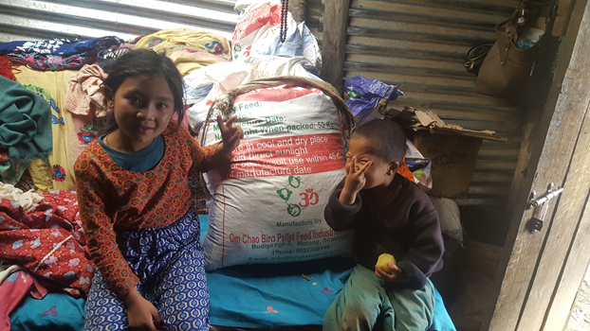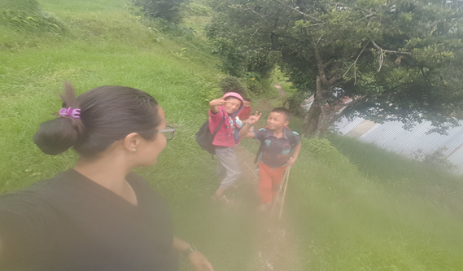
Home visit pictures with kids

Currently, I felt delighted that the flu is over. Our class resumed yesterday.

