Germany–Spain Exchange

Sunday, 19.01.2020:
On Sunday evening our exchange students arrived in Übach-Palenberg. After that we went home and ate Schnitzel because Jimena my exchange student wanted to try a Schnitzel. My family got along very well with her. After dinner we went to bed because we both were really tired.

Monday, 20.01.2020:
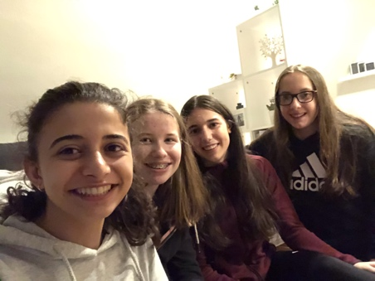
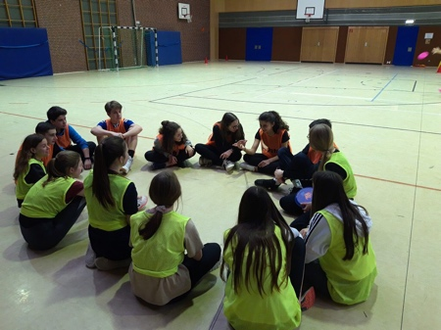
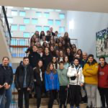
On Monday we got up and went to the kitchen and ate our breakfast. Jimena ate milk with biscuits and I ate sometimes Cornflakes or a sandwich. Then we got ready for school. When we arrived at school I showed her our “old” school and our new containers. In the first lesson we talked about if there are any problems. In the second and third lesson we had our normal lessons which were physics and german. After that we made orienteering. So we had a piece of paper and there were questions which our exchanges or we had to answer. After we answered all the questions we went back to class and checked if everything was right. At 13:15 pm Jimena, Philo, Paul, Louis, Irene, Adrian and Manuela and me went to subway to eat lunch. After lunch we went back to school and played ultimate frisbee in different groups. After school, Jimena, Philo, Irene and I went to my house and hung out. We played different games like truth or dare or never have I ever. It was really funny. When Philo and Irene got home we went downstairs and my sister and I layed the table and we ate Spaghetti Bolognese. After dinner we cleared the table up and then we went upstairs, made a shower and went to bed.

Tuesday, 21.01.2020:
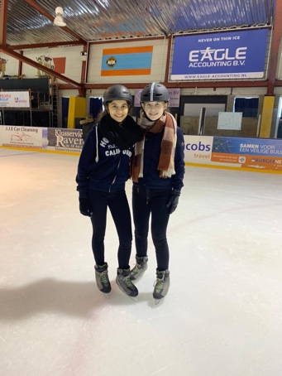
On Tuesday we got ready for school, ate breakfast and went to the parking lot from the school. The bus was supposed to be there at I think 8.30am-8.45am but it came later. When we were in the bus we drove to the Netherlands, Geleen there we met students from England and Netherlands. There we played different sports like tournament floorball, soccer and we went there ice skating. It was really funny because there were like professional ice skaters who teached us ice skating. Then I tried to do a spin but I fell down every time but someone teached me a spin. But my group from tournament floorball and soccer didn’t want that the girls play with them or they didn’t pay attention to us but at the end it got better. Before ice skating we had a break and we got free chips. We were back at school at 3pm and at 4pm Philo, Irene, Jimena, Paul, Louis, Manuela and I met by Philo and we went to netto to buy the ingredients and then we made pizza by ourselves and it was very delicious. We also played some games. At 10.30 my mom picked us from Philo up. We were very tired and went to bed.

Wednesday, 22.01.2020:
On Wednesday we all met at the train station and drove to Aachen. There we first went to a bakery and ate breakfast and then we went to the cathedral and had a leadership. After that we went to the vielharmonie to eat. Afterwards we went to an escape room. I think my group had the most difficult room but we solved it. Next we had free time so Philo, Paul, Louis and I went to the Aquis Plaza and ate something and went a little bit shopping. We were home at 7pm and my mom made gyros with tzatziki. Then Jimena called her parents and we went to bed.

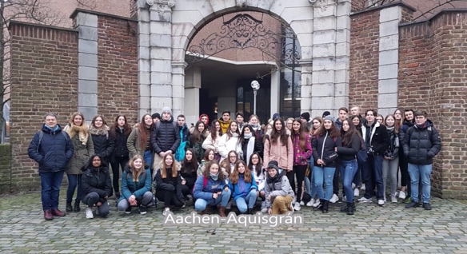
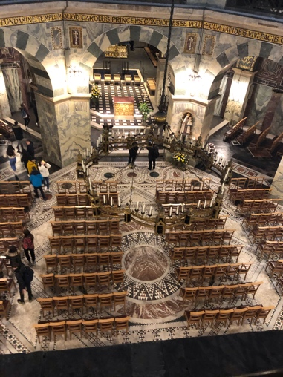
Thursday, 23.01.2020:
On Thursday we made a trip to cologne. There we made a leadership in the cathedral and then we had free time. Philo, Paul, Louis, Manuela, Adrian and I went to the Cathedral tower. It was very exhausting because it has 533 steps. But it was worth it because the sight was really beautiful. Afterwards we went to Vapiano to eat something, it was very delicious. Then we ran to the next train station to get to the bowling center. When we arrived at the bowling center we got bowling shoes. We gave ourselves funny names and it was very funny. After bowling we drove home and had to clear something up because there was a misunderstanding. Then Philo, Irene, Paul and Adrian came to my house but actually there was a party at Julian’s house but our parent’s didn’t allow it. We had real fun. When Philo and Paul and their exchange students went home Jimena and I packed our bags for the next day, went showering and went to bed.
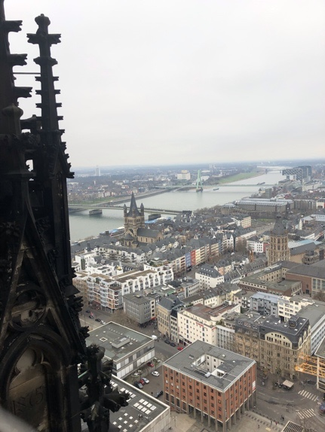
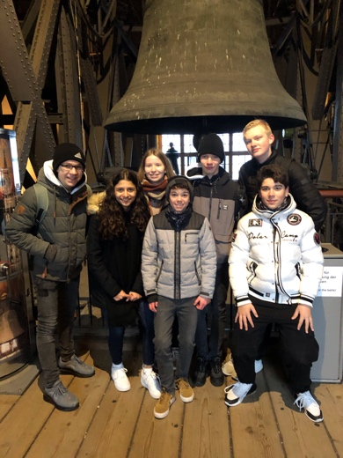
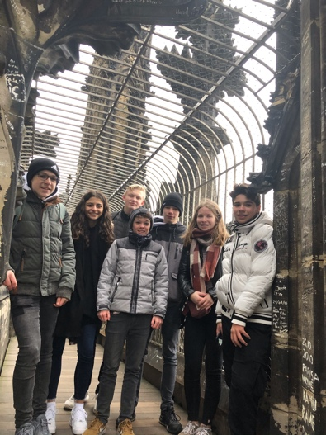
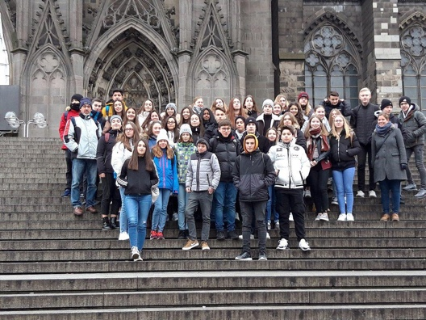

Friday, 24.01.2020:
On Friday we went to school and mrs. Lothmann told us who won the frisbee games on monday but unfortunately we did not win. Then the bus came and we drove 2 and a half hours to Brussels. We arrived in front of the European Parliament and went to the parlamentarium. It was very cool at the parlamentarium because there was a room where a film played but it was 360° so all around the room. Afterwards we had free time and Philo, Paul, Louis, Katja, Pascal, Selina, Charline and I went to the subway to get to the center. When we arrived at the center we went to mc Donald’s and ate something. Then we went to some shops and took photos at the “place du Luxembourg”. When we all met again at the European Parliament we drove to the airport where we had to leave the Spanish students. I was very sad that they had to go because all of them were very friendly. Afterwards we drove back home and in the bus Philo and I watched a film.

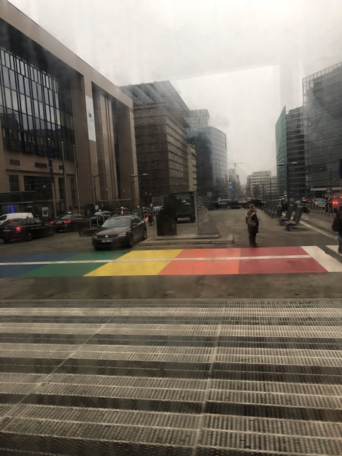
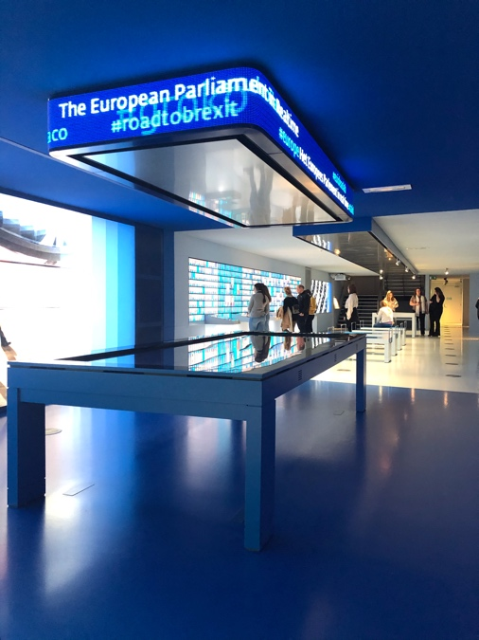
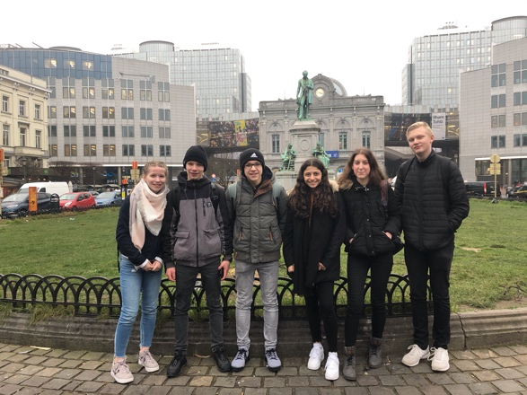
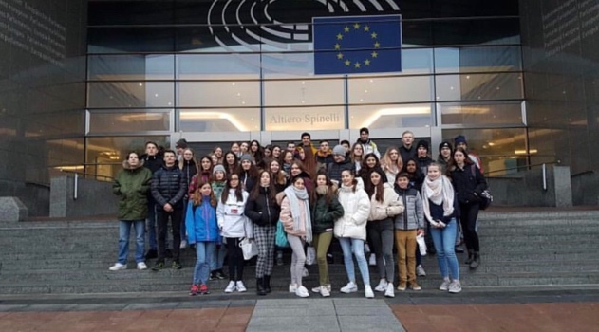

Diary 19.01.2020
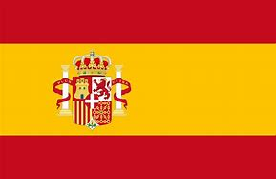
Dear Diary,
Today my exchange student, Clara, arrived. She had
a good flight, but she was really tired. We went to McDonalds. There we met with the other and talked. Then we just drove home and fell asleep.
Good night ! See you soon
Leonie

Diary 20.01.2020
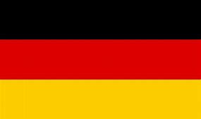
Dear Diary,
Me and Clara stood up at 7am, ate breakfast and went to my school.
There we met with the other, talked with them and showed our exchange students around our school.
Then we had two lessons; Math and History. Then we took part in a
rally. After that we ate lunch and played Ultimate Frisbee.

It was a funny, but my team lost. We all played fair.

In the evevning we met at Brianna, talked, ate and laughed a lot.
Then we walked home. We were really tired.

Good night ! See you soon
Leonie

Diary 21.01.2020
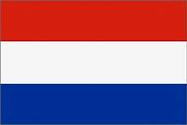
Dear Diary,
Today we drove to the Netherlands to play the sport with no borders.
We made teams with English, Dutch, Spanish and German people.
My team was very motivated. We played football, hocekey and did ice skating. For Lunch we had fries.

When we got back home, me, Clara, Zoe, Sofia, Jessica and Lucia met at my house. Here we ate Raclette and played Charade. It was a very nice journey.

Good night ! See you soon
Leonie

Diary 22.01.2020

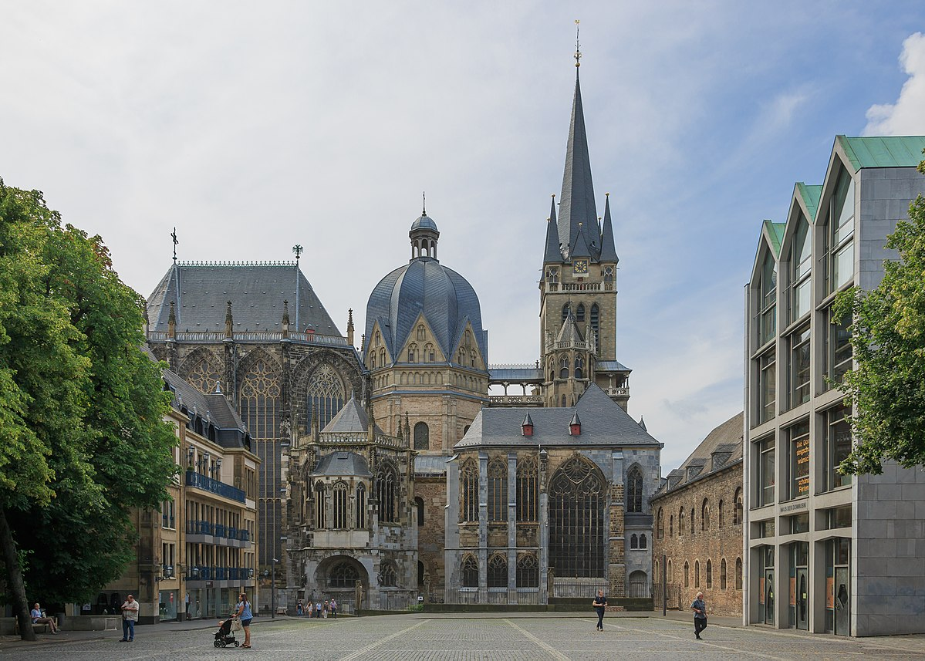
Dear Diary,
Today we drove to Aachen by train. At first we visited the cathdral and ate breakfast at „Nobis“.

Then we had some free time. We went shopping and ate lunch with all the others. After that we went to the Escape room.

In the evening we ate diner and watched some Netflix, before we went to bed.

Good night ! See you soon
Leonie

Diary 23.01.2020

Dear Diary,
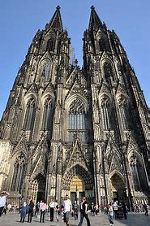
Today we visited Colonia by bus. At first we visited the cathedral.

Then we had some free time, in which we did some shopping and had lunch. I are a Burger with fries at a restaurant.
After that we took a train to the bowling center. We played bowling in four groups. It was really funny. I was the third.

In the evening we met at Julian. There we listend to music, talked, played games and laughed a lot.

Good night ! See you soon
Leonie

Diary 24.01.2020

Dear Diary,
Today was the last day for my exchange partner, Clara, in Germany. We drove together to Brüssel in Belgium by bus . There we visited the Parlament of Europe. Then we walked to the cnetre by foot. Brüssel is a very nice city with beautiful buildings. I hope, that I can go there one more time.

In the city me and my friends, Brianna and Simon, had lunch and ate Burgers with fries. Then we did some shopping, before we met with the others to drive to the airport.

At the airport we had to say „Good Bye“ to our exchange students. Some of us had to crie, but we will see each other again in March. I am really excited to fly there and to get to know their culture and cities.

Good night ! See you soon
Leonie
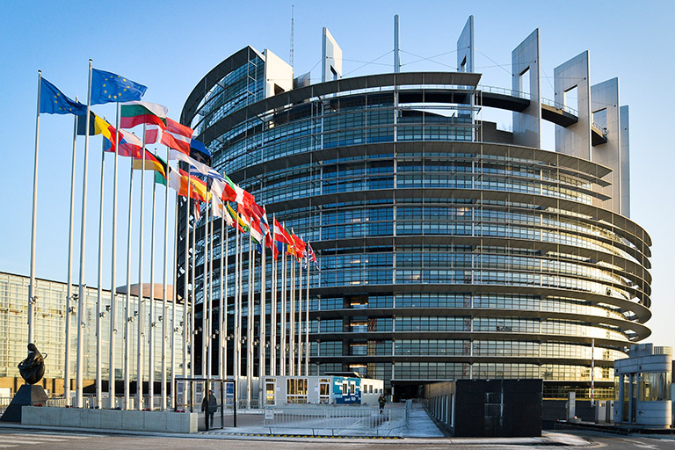

My journal about the exchange

Sunday (19.01.):

The exchange students arrived at 8 o`clock at the evening. The students came from Spain. They arrived in Brussels by plane. Later they took there the bus to the train station in Übach- Palenberg. When the students arrived, I went home with my exchange student. At home we made a dinner. The first evenig was a bit funny, because you didn`t always know exactly what to say. After the dinner we went sleep.

Monday (20.01.):

On Monday we woke up at 6:15 a.m. My exchange student was shock that we got up so early because they don`t wake up so early in Spain. After that we made breakfast. Later, at 7:30 a.m. my mother drove us to school. After meeting with the other exchange students, we had two lessons. The subjects we had were German and Physics. Later we had met us again. Then we did a rally through Übach Palenberg in small groups. The rally consisted of questions about Übach Palenberg.
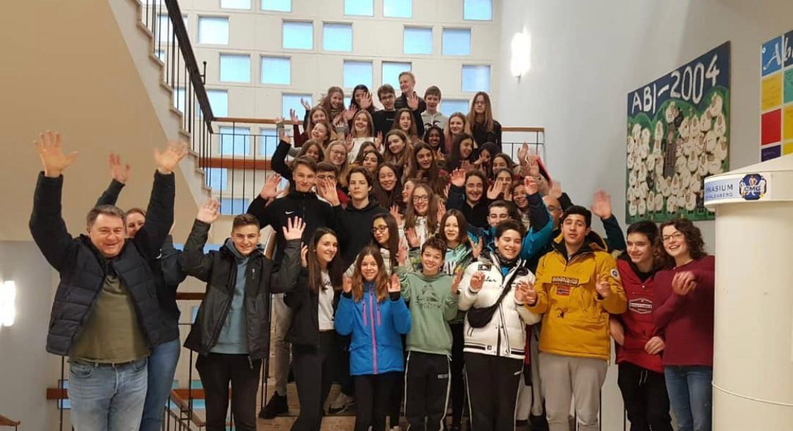
Afterwards we had leisure time, so my friends, me, and our exchange students went to Subway to eat something.
At Subway you can eat sandwiches.
After we had eaten something, we went back to school. There we showed the exchange students our sport. Our sport was Ultimate Frisbee. At four o'clock we were able to go home.

So my best friend and I with our exchange partners went to a trampoline park named „Die Halle“ in Aachen. This was very funny and our exchange studends had a lot of fun. Then my mother drove us home. There we had dinner. Later we went sleep. It was a great day.
Tuesday (21.01):
On Tuesday we got up at half past six and we made us ready for the day. At a quarter past seven we took the bus to school. When we got to the school, we met us again with the other students. At 8:30 the bus finally came, which had brought us all to the sports center in Geelen (NL). There we met with the students from England and the Netherlands. The students showed us the sport they had learned. We played soccer and floorball.
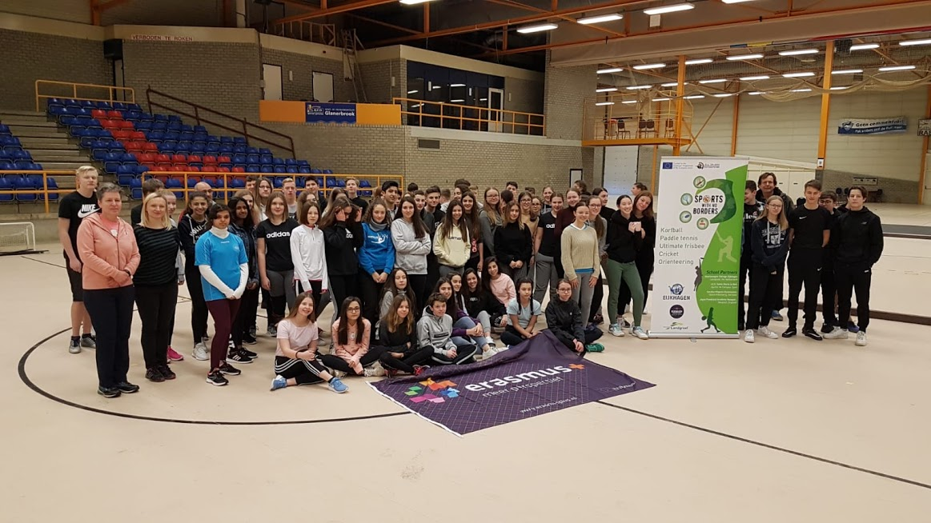
After we did sports there was lunch. Later we went ice skating together. It was so great and so much fun. After ice skating, the bus brought us to the school. We arrived at the school at three o'clock.
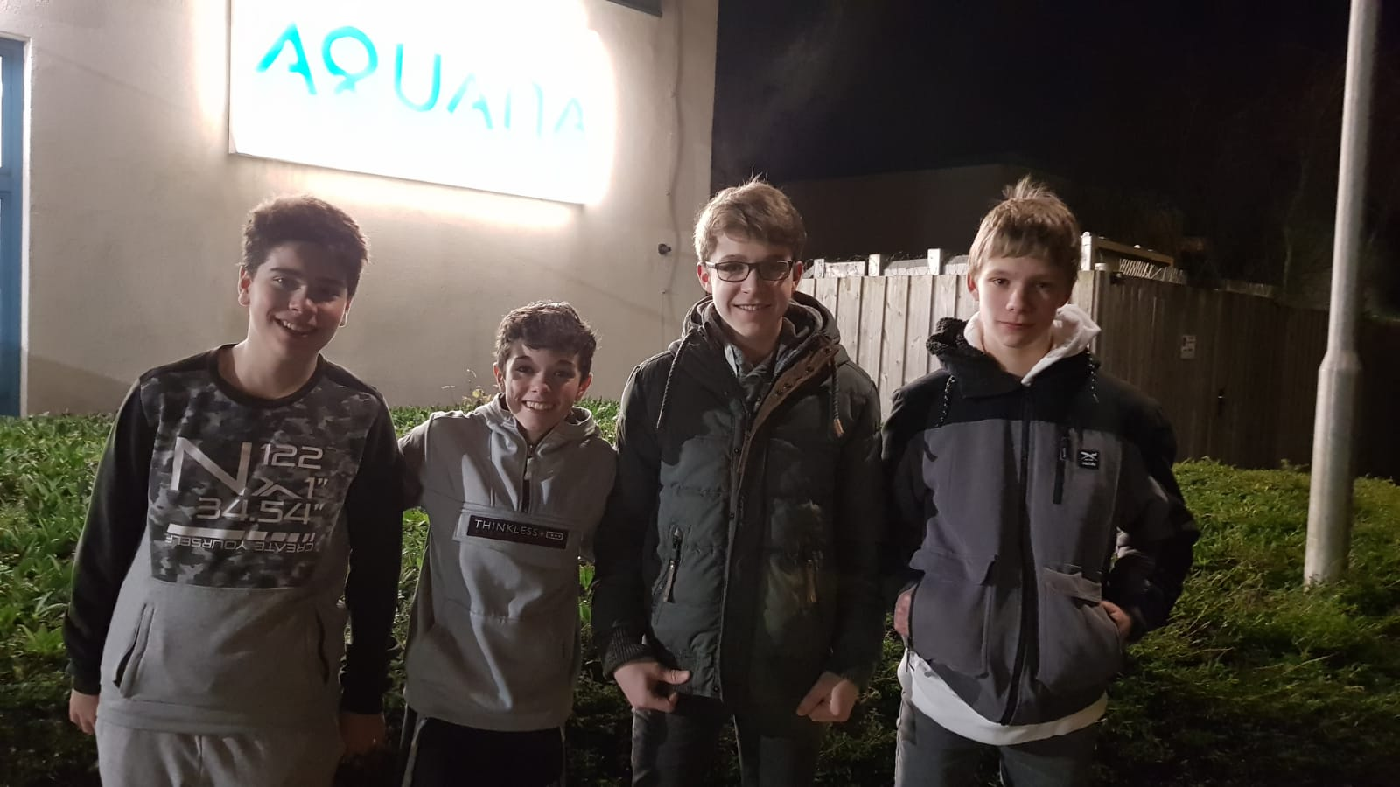
Later my best friend and our exchange partners went to an big swimming pool named “Aquana”. It is very large and there were a lot of water slides. We stay there for more than three hours. It was very fun.
Then the mother from my best friend drove back and we met us with two other students and their exchange students.
So we were a group of eight people. We all made pizza together. It was very funny and we laught a lot. After this everyone went to their house and I and my exchange students went to sleep.
Wednesday (22.01):
On Wednesday we woke up at 6:30, then we had showered. Later we had breakfast. Then we take the bus to the train station in Übach Palenberg. Because we arrived there too early we bought a hot chocolate at the bakery. At 8 o`clock we met us with the other students and at 8:20 the train arrived that brought us to Aachen. After the train arrived we took an group photo:
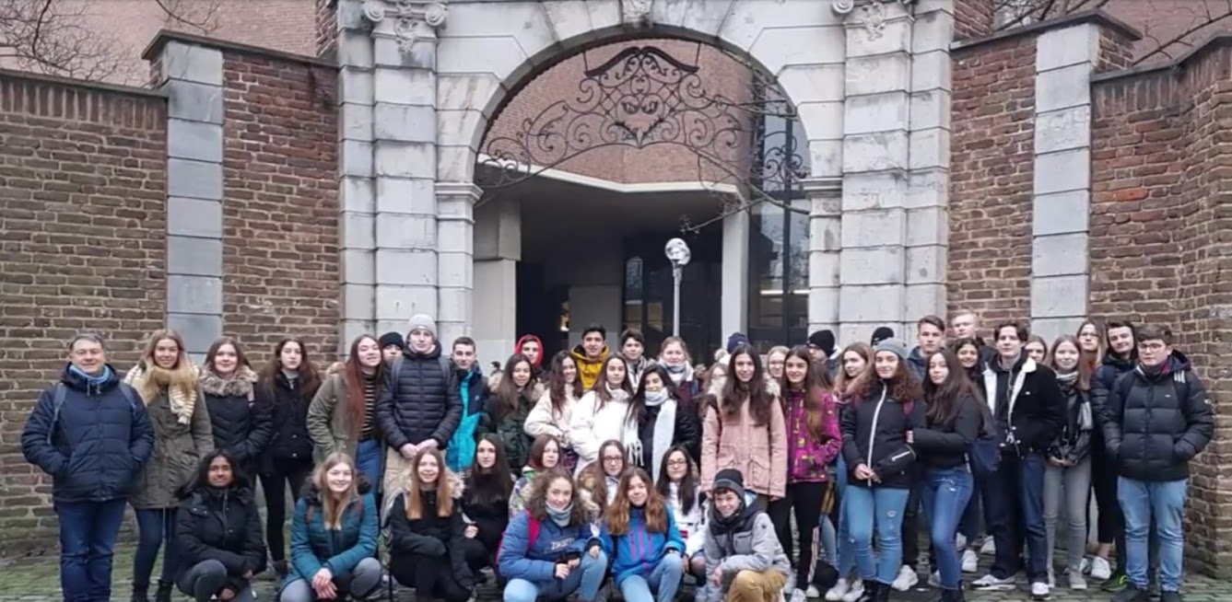
At 9 o`clock we arrived in Aachen and walk to the cathedral. We had an guided tour trough the cathedral and the treasury. It was very interesting and we learned much thinks we don`t knew about the cathedral. After that we had lunch in a restaurant. The lunch was delicious. Then we had 2 hours leisure time in Aachen so we went to the big shopping mall. Afterwards we went to the escape room in Aachen. The escape room was great and the riddles were very diffucult. At 17:00 we took the train back to Übach Palenberg. After we arrived at the train station we drove back to my house, and had dinner. Later we went to sleep because we were very tired.

Thursday (23.01.):
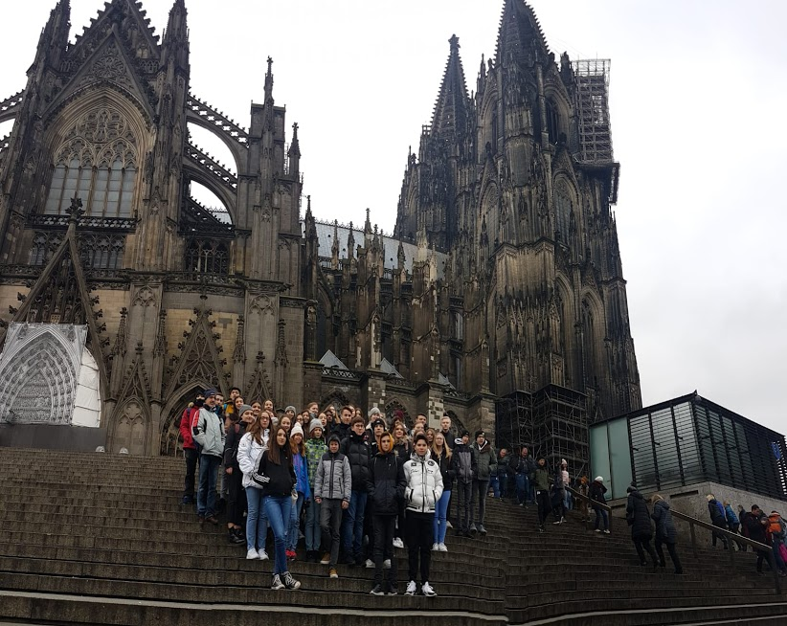
On Thursday we woke up at 8 o`clock. Then we had breakfast. We were a little bit tired from yesterday. After we got ready for the day my mother drove us to the school. At 9 o`clock the bus came which brought us to cologne. At quarter past ten the bus arrived in Cologne. At first we took a groupfoto and then we visited the cathedral all togehther. The cathedral was so impressive. After that we were going in small groups of eight people and had leisure time.
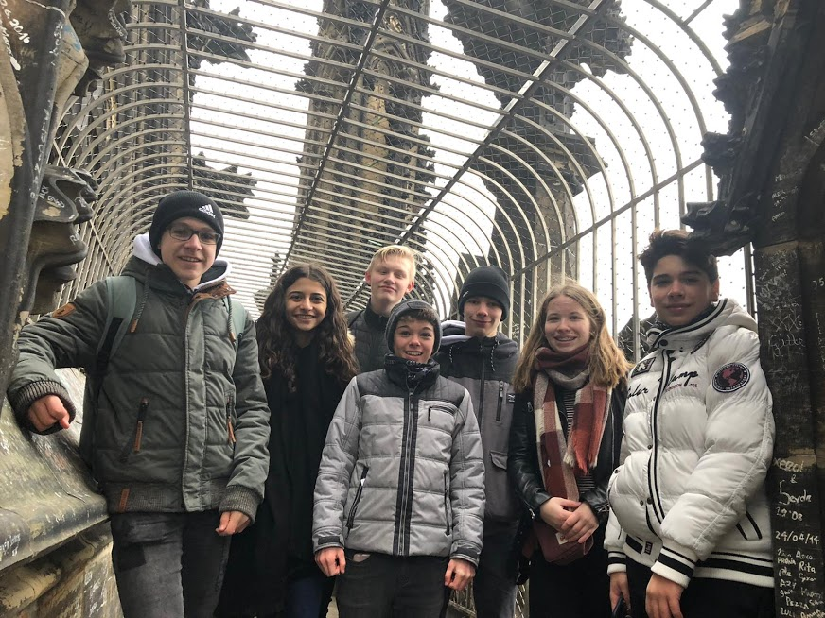
My group of five Germans and two Spanish students went first to eat in an Italian restraunt. The food was very good. Then we went to the tower of the cathedral. We were able to go up to the top. From there we had an impressive and gigantic view over the whole city. It was so great. As we went down again we could even see the bells of the cathedral.
Later we went to the main station we took the train there, which had taken us to the bowling alley. The journey took 5 minutes. There we played two hours of bowling. It was fun and it was also good that we were all together. From there the bus picked us up and took us back to school. My exchange student and I went then to my home. And there we got fresh because in the evening was a party where everyone was invited. The party was very funny and we were all together. The party lasted until 10 p.m. After that we went home and went sleep because we are very tired. This was an great day.

Friday (24.01):
On Friday we got up very early because my exchange student had to pack her suitcase. After that we had breakfast and got ready for the day. Then my mother drove us to the school again. From there, the bus brought to Brussels. The journey took about two hours. Then we arrived in Brusseles. There we want to visit the european parliament.
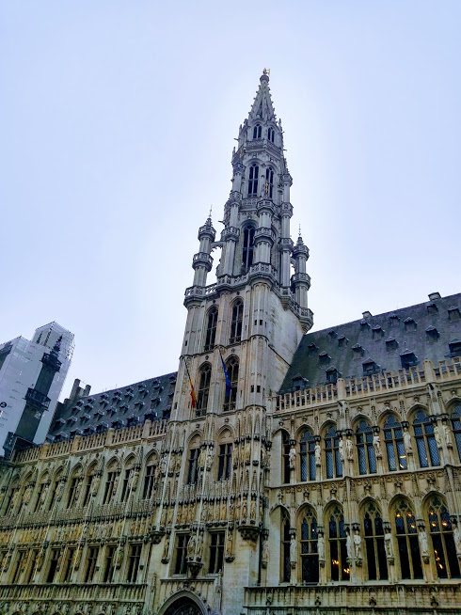
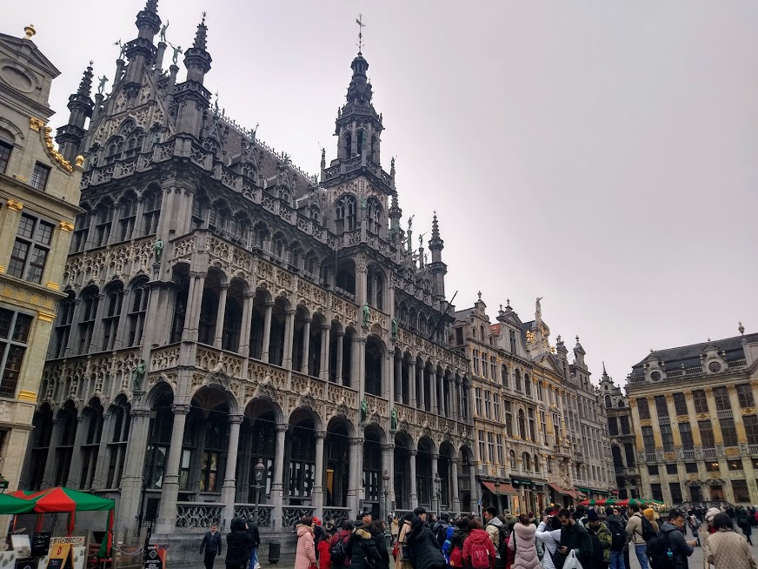
We actually had a guided tour, but it was cancelled and we visited a museum from the Parliament instead. The museum was also very interesting. Then we had leisure time so we were going in small groups again into the city centre. Because the parliament was outside from the city center we had to take the subway to the city centre. When we arrived in the city centre we first went to MC Donalds for something to eat. Later, we visited the Grand Place in Brussels. Last we ate an original Belgian Waffle.When the free time was over, we went back to Parliament by subway. There we took one last group photo:
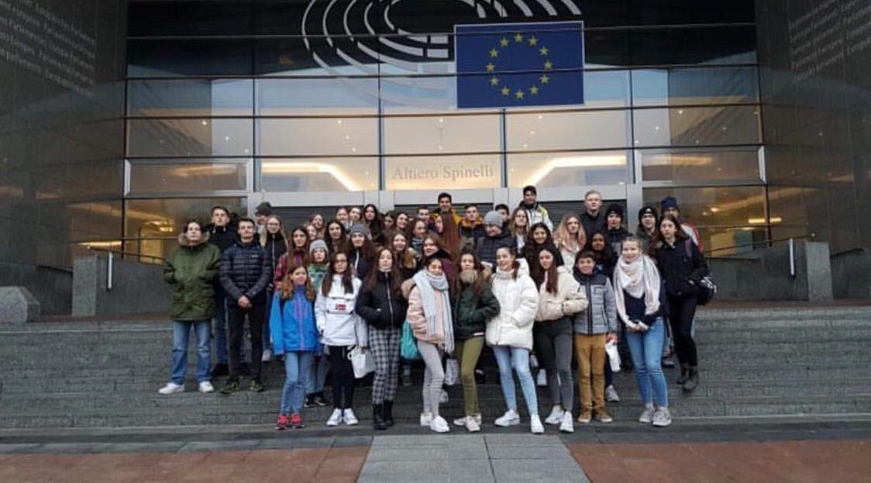
Afterwards we took the exchange students to the airport. There we had enough time to say goodbye to them. It was very sad.
After that we drove home by bus. It's been such a great week. And we both had a lot of fun together. We both understood each other very well. Another advantage is that my English has improved a lot through the exchange.

Journal
-Sunday-
Sunday was the first day oft he german-spain exchange. I was quite exited because today was the day where I was able to see my exchange partner for the first time. The weeks before wem et eachother, we texted us mostly every day what made te situation even more exciting.
My father and me drove to Übach-Palenberg at about 7pm where our exchange partners should arrive. We had to wait quite long but after a while the bus with the spanish students arrived and I saw my exchange partner Lucia for the first time. Lucia and me did not really know what to say at the beginning because we were quite shy but right as we drove home I made her familiar with our home and after that we drove to McDonalds and met the most of the other exchange students. It was really funny there because we got to know the spanish exchange students better and laughed quite much together. At 10pm my father picked us up and we drove home to go to sleep.
All in all I already was looking forward tot he following five days and hoped that Lucia and me would become friends during the week.

-Monday-
We had to get up very early because otherwise we would miss the bus. I got up at 5.45am and waked Lucia up at 6am so that she had enough time to get ready. We went to the kitchen and had breakfast together.
We packed lunch for school and at 7.10am we went to the bus station. There we met Jette and her exchange partner Luna. As we arrived in school, the german students showed the school to the spanish students and after that we went to a classroom where we worked on the project. Then we had classes where our exchange parteners accomplished us and got an image of the classes in germany.
Furthermore, we made a rallye through Übach-Palenberg where we had to go to different places and answer questions. After that the school day was already over but we had about one hour freetime until we had to met again for playing ultimate frisbee. Lucia and me spend the time with a couple of other exchange students because we were not able to go home. We bought food and ate together and then we started walking back to school where we played ultimate frisbee. It was very nice and weh ad a lot of fun.
As we were back home, we played cards together with my mum and after an hour my father drove us to Brianna because there we met all of the other echange students and had a good time together.
The day ran over really fast and I really enjoyed this day.

-Tuesday-
The next day we slept longer because Jette´s parents drove us to school with their car. We met behind the school because we went tot he netherlands were we should also met the english and the netherland exchange students.
As we arrived a woman clarified us about some rules and we were split into groups. At first I was in a group which played soccer and it was really cool to play soccer with people of other countries. I was really surprised that it worked so well and we were a very good team because everybody seemed to be respectful.
The next round we were split into new groups and played floorball. I already played it last year but this year it was as cool as last year and I really liked it. After that we had break for lunch and ate fries.
The next two hours we went ice skating and it was very difficult in the beginning but after a while it became easier and we drove faster.
As we arrived at school, Lucia and me went with Emma and her exchange partner Maria to Emma and after a while most oft he other exchange students came and we played games like activity or UNO together and listened to music.
Later, back home we ate together and afterwards we went to bed because it was very late.

-Wednesday-
Today wem et at 8.30am at the train station and rode to Aachen. The ride only took 15 minutes an das we arrived, we went a bit through Aachen and then tot he cathedral of Aachen where we made a guided tour. It was very interesting, especially for the spanish students and their teachers because it was the first time for them visiting our cathedral.
After that we went through the city and went in a restaurant where we all ate lunch together. Before we went tot he escape room, we were allowed to go through the city of Aachen and go shopping or something like this.
As the time for shopphing was over, we went to the escape room where a man split us into different groups. In my group only were girls but for me it did not matter. We were a good team and tried our best but because the time went over too fast, we were not able to escape.
Because of the fact that we were the last group, we went back to the train station afterwards. At home, Lucia and me cooked together and played a lot of games. It was the first day where we really talked much and I enjoyed the time with her. We talked till 11pm but because we had to get up very early in the next morning, we finally went to bed.
.
-Thursday-
Thursday was the day where we should ride to Cologne and I was really excited. As we arrived in Cologne we went to the cathedral and were allowed to take a look inside by ourselves. We spend about 30 minutes there and after that we were allowed to spend time in the city till 2.15pm. That was quite long so weh ad enough time to go shopping and have lunch.
Me, Lucia and about ten other german students and their exchange partners met in front of the cathedral at 2.15pm to go together to a place where we should play bowling together. We were a little bit too late because the way took about 30 minutes and weh ad to use google maps to find it.
It was really enjoyable there and I had a lot of fun. The time ran over really fast an das we arrived in Übach-Palenberg Lucia, me and a couple of other exchange students went to Julian because we wanted to spend the last evening before the spanish students had to go, together. The others arrived about ten minutes after us and the evening was full of action, fun and grief but all in all I really enjoyed it and was quite sad as weh ad to go home because I knew that this was the last evening.
Back home we ate something, talked and went to bed so that the week was almost over.

-Friday-
The last day oft he exchange was emotional. We got up like almost every day at 6am. We had breakfast together and my family said goodbye to Lucia. As we went out of our house to drive to school we were really sad that the time was already over.
At school we evaluated the project and the german students accompanied the spanish students to Belgium where we first vistied the parlament of Europe and then had time to vistit the city which is really beautiful.
After about three hours we drove with the spanish students to the airport and finally had to say goodbye which was a really hard thing to do. A couple of students cried and I was also really sad that the spanish students and especially Lucia had to leave but I already looked forward to march where we would fly to spain to see them again.

Sunday
The Spaniards arrived on Sunday evening. The bus was a little delayed and after arrival the luggage was invited directly. We went home where I had shown him my exchange partner his bed. He slept under my sleeping porch on a mattress. We got along equally well and that's easy to come by. We treated one other like a good friend. He wasn't hungry so we let out the dinner. On the first night much it was hard for both of us to fall asleep but that changed with time.

Monday
On Monday we had to get up at half past seven which was very early for him. we got ready and ate breakfast. We were driven to school and had a short meeting with all participants. after that, the Spaniards came to class for two hours. When this was forbei we had an hour off. we went to Subway and ate lunch there. After that we showed them ultimate frisbee in our gym. we held a little tunier and had fun. after that we were driven home and spent some time in my room. we talked and were also a bit on the phone. He called his mother and wrote a little bit with his friends. then we ate dinner and went to bed. falling asleep was much easier for us and our relationship with each other improved from day to day.

Tuesday

on Tuesday we had to get up so early again, but this time we took the bus. We all met at the school and drove to holland. there the other countries showed us their sports. we played a kind of hockey and football. but the best thing about this outing was that we all skated together in the end. it was fun for all of us but also very exhausting. since the day was relatively fast and we had a little more time Louis decided to drive our exchange partners and I to the swimming pool aquana. for the Spaniards this was a great experience because in Spain the swimming pools are rather more boring and they were amazed by this type of swimming pool. In the evening philo christina and their exchange partners and our swimming pool group at Philo have arranged to make pizza. we made and ate pizza and it was a nice evening.

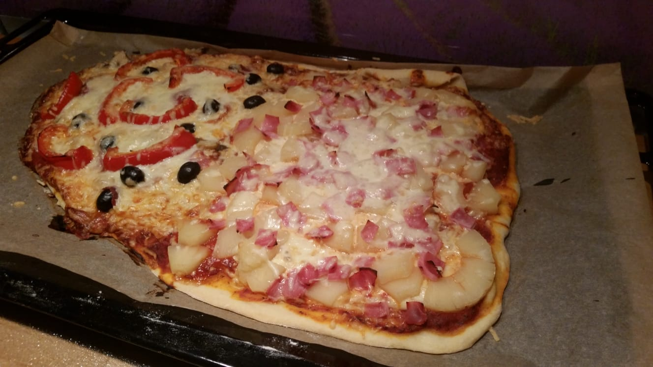
Wednessday
On Wednesday we made a trip to Aachen. We went there with the train and first visited the Dom with its treasury. I found it very interesting but some found it very boring as the tour through the cathedral took a long time. After the tour we had some free time and together with everyone we went to a restaurant which was not so delicious. Then we had about 3 hours of free time, which we spent in the Aquisplaza. after that we went to an escape room which was a lot of fun. We split into different groups and had to find out from different rooms. It was heavier than we thought and we needed an extra minute. When everyone finished with their rooms, we went home by train. At home we eat some gulasch with Spetzle and we went to bed early because it was a busy day.

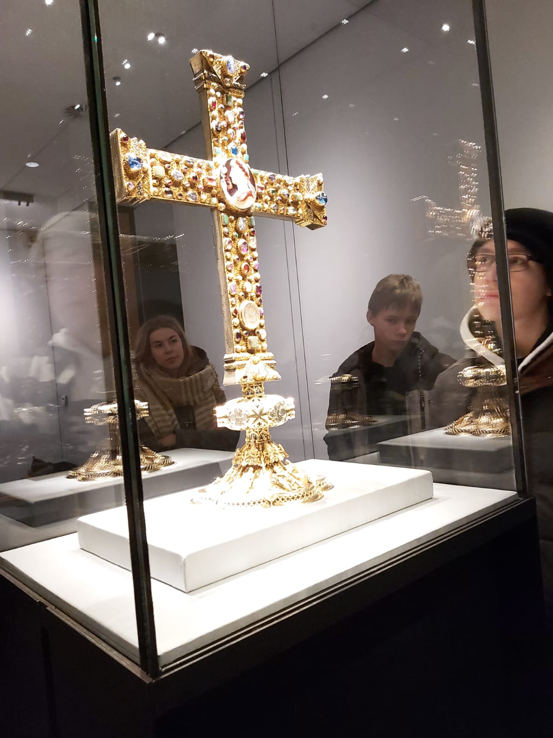

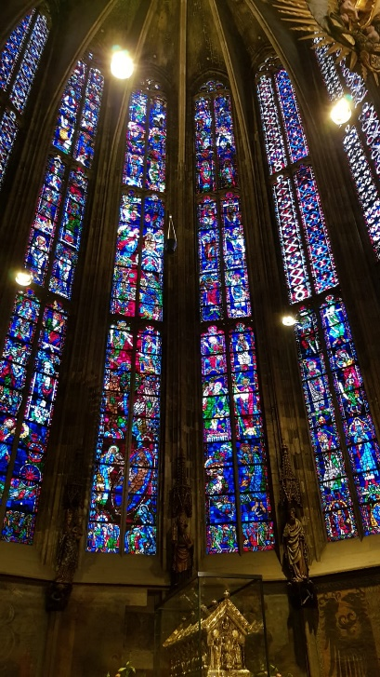
Thursday
On Thursday we had to get up again at the same time and then went with everyone to cologne. there we went first to the cathedral but there was no leadership. we only walked around there once and after that we had a lot of free time. In this time, we walked around with about the same group as at the pizza meeting. the others just walked through the city without a trace but we wanted to show them a bit so we walked up the doom and even heard the bell people. we went to eat in the VA piano and then had to go to a bowling centre which was located in another part of the city. we took the move but we didn't have enough time to buy a ticket. Because of this, we unfortunately had to drive without a ticket. the bowling was very nice only the music was a bit too loud. after that we went home again and had a nice evening. we went to bed quickly because the day was very exhausting.

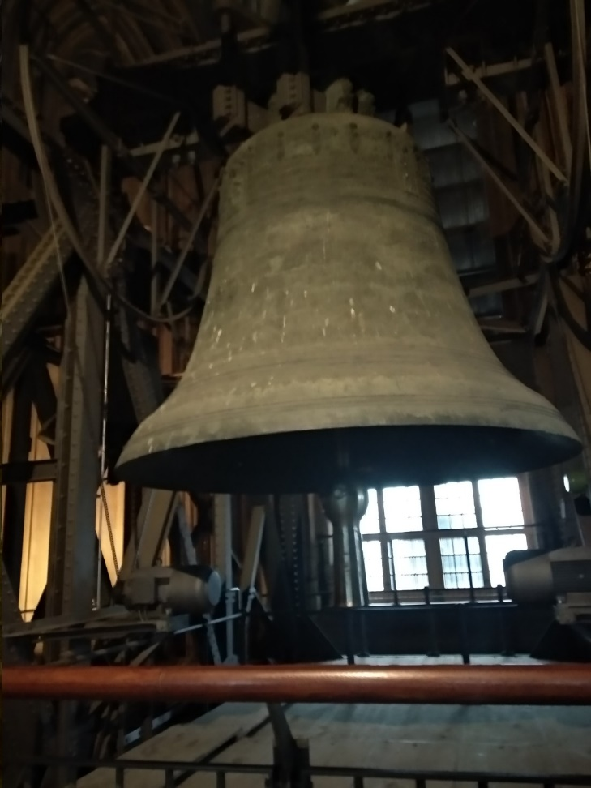

Friday
On Friday, unfortunately, was already the last day of the exchange. Finally, we went to Brussels and spent the day there until the departure of the Spaniards. We visited the museum of the European Parliament and then we went through the city in small groups. Unfortunately, we didn't have enough time to visit the Atomium as it is a bit outside. So we just strolled through the shopping street and had to go to the airport. The farewell was sad and many cried. the Spaniards arrived after a relaxed flight.

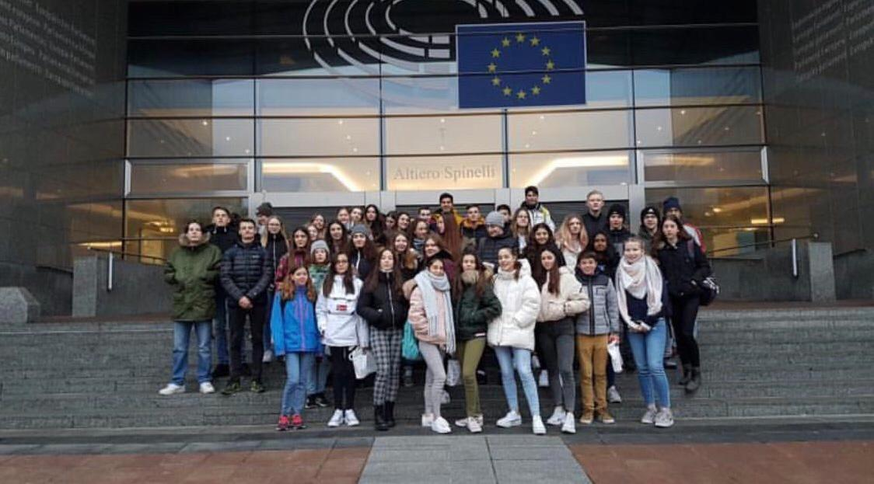

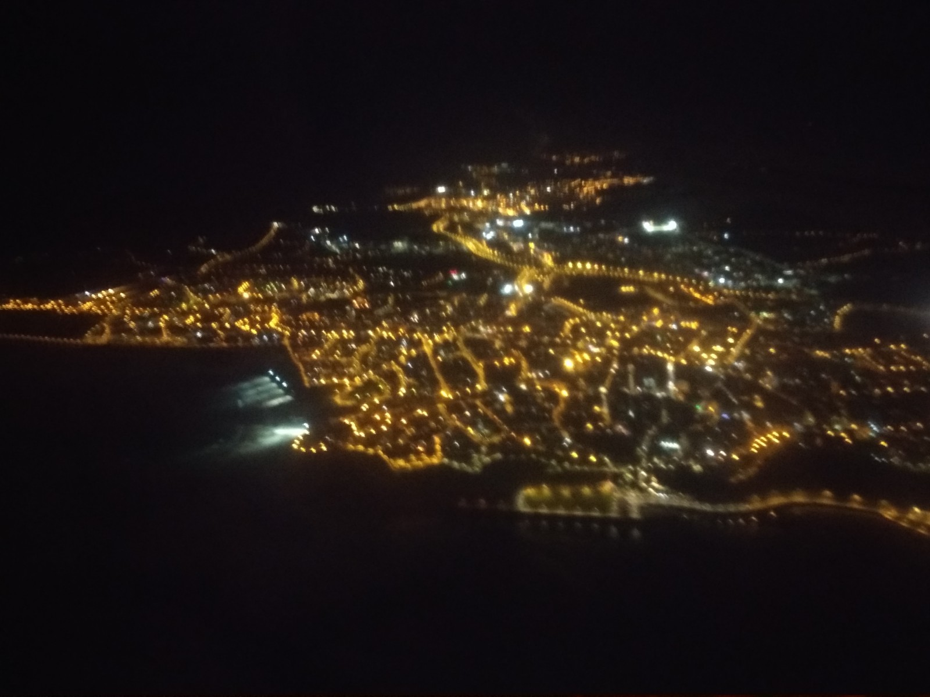

SPAIN
GERMANY

Sunday:
On Sunday in the evening we welcomed the spanish people with the whole family. After that we drove to the netherlands and got fries there to show my exchange partner how close we live to the border and to show the typical delicious fries from the netherlands. After dinner we got to know each other a little bit better and then we went to bed.
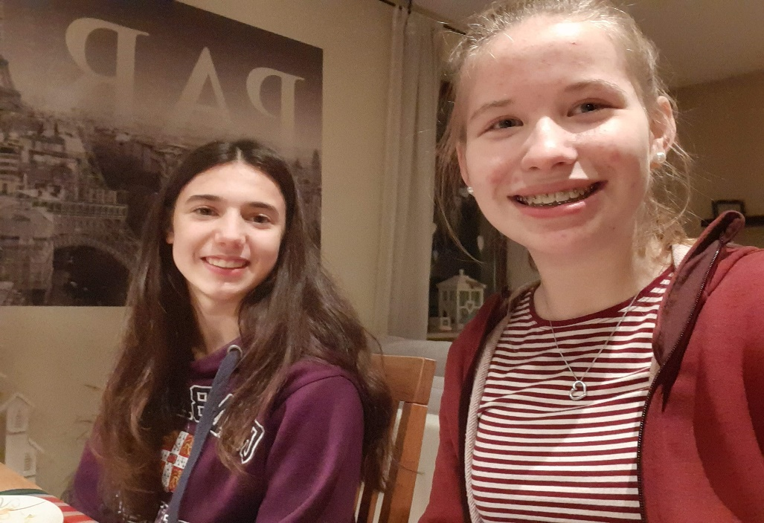

Monday:
On Monday we showed the spanish people our school first. Afterwards they accompanied us in two lessons, namely in physics and german. From the fourth lesson onwards we did a relly in Übach-Palenberg and then went to the subway during our lunch break. In the afternoon we were in the sports hall and all played Ultimate Frisbee together. After school, Irene and I went to Christina and Jimena and we spent time together.
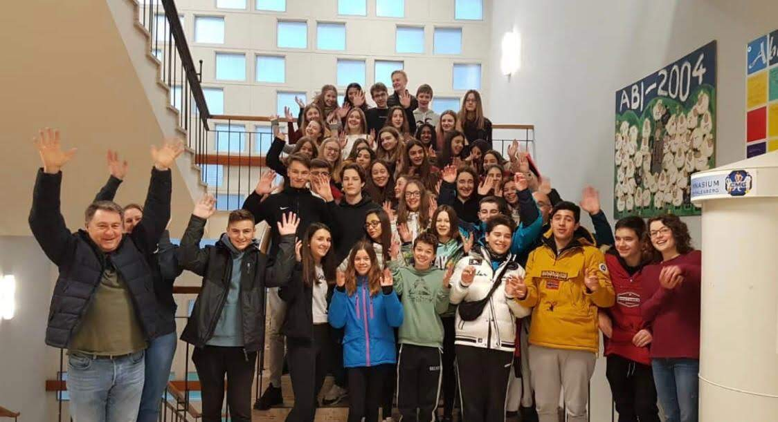

Tuesday:
Tuesday was one oft he most exciting days, we drove to the sports center in geelen and met the English and Dutch exchange students. Mixed with all four countries we played football and floorball. Later we went ice skating. When we were back home we all met Christina, Paul, Louis and their exchange partners at my house and made pizza. It was a nice and fun evening.
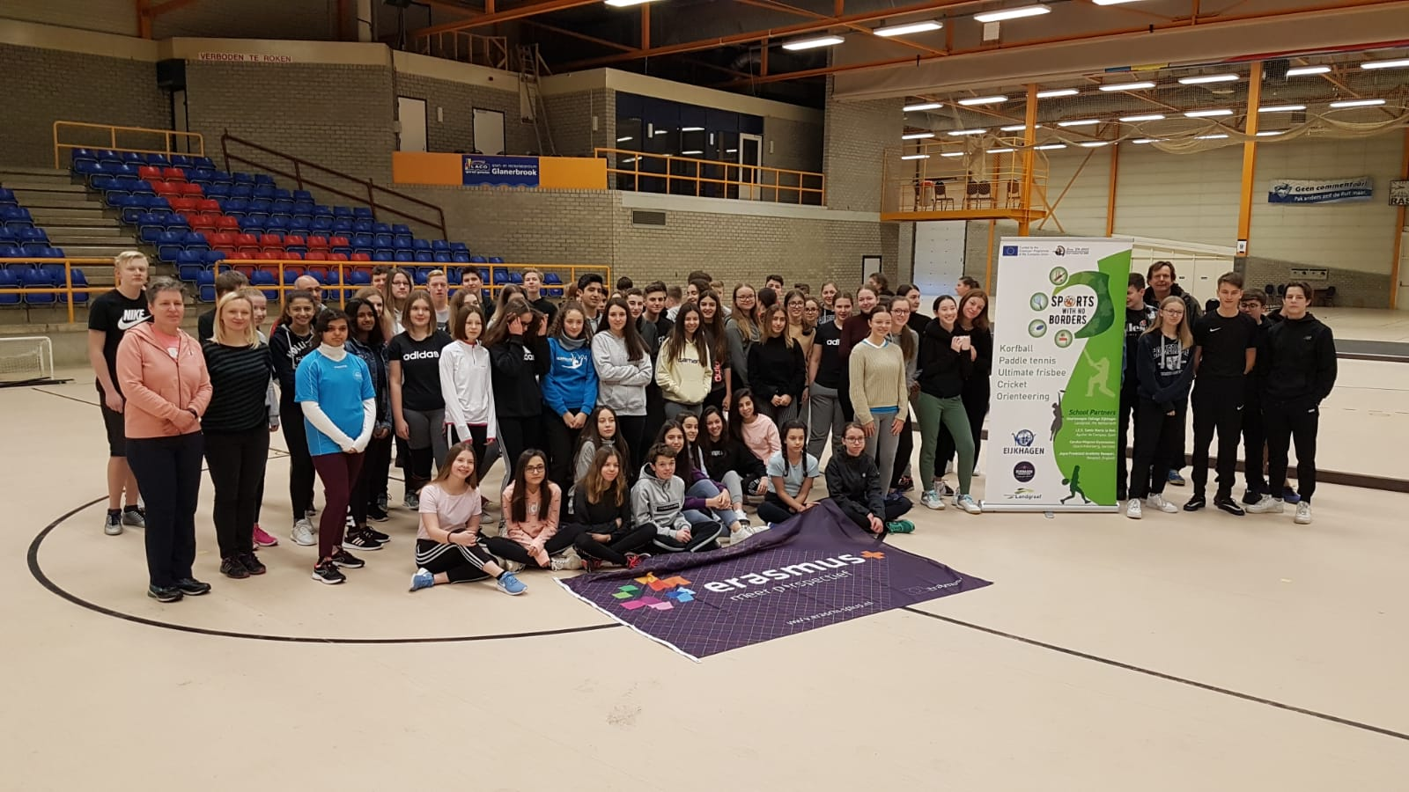

Wednesday:
On Wednesday we took the train to aachen, where we had a tour of the cathedral. And then we all went out to eat. After that, we were divided into two groups. We went to an escape room and had to solve the respective puzzles, then we had free time in aachen and in the afternoon we all went back home together.
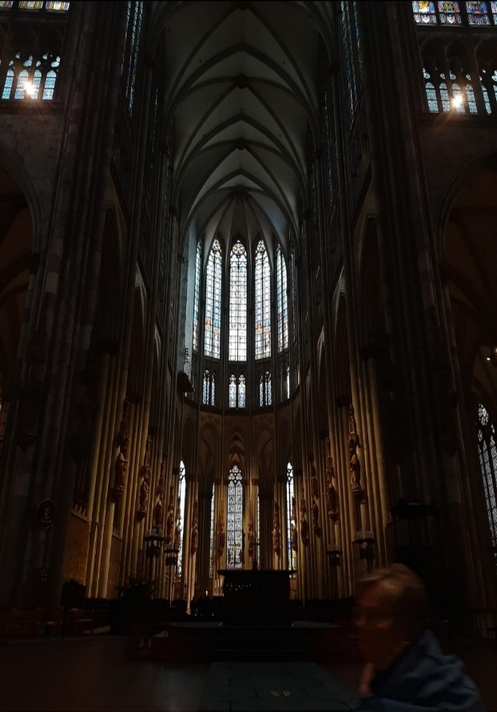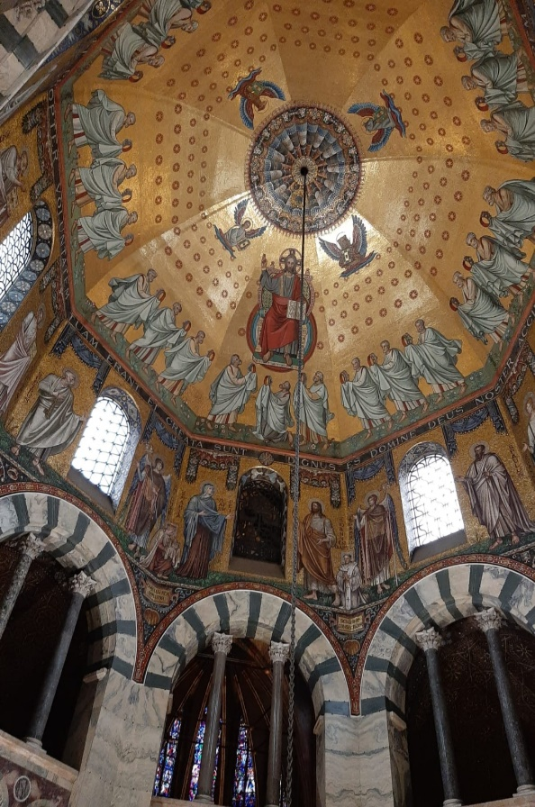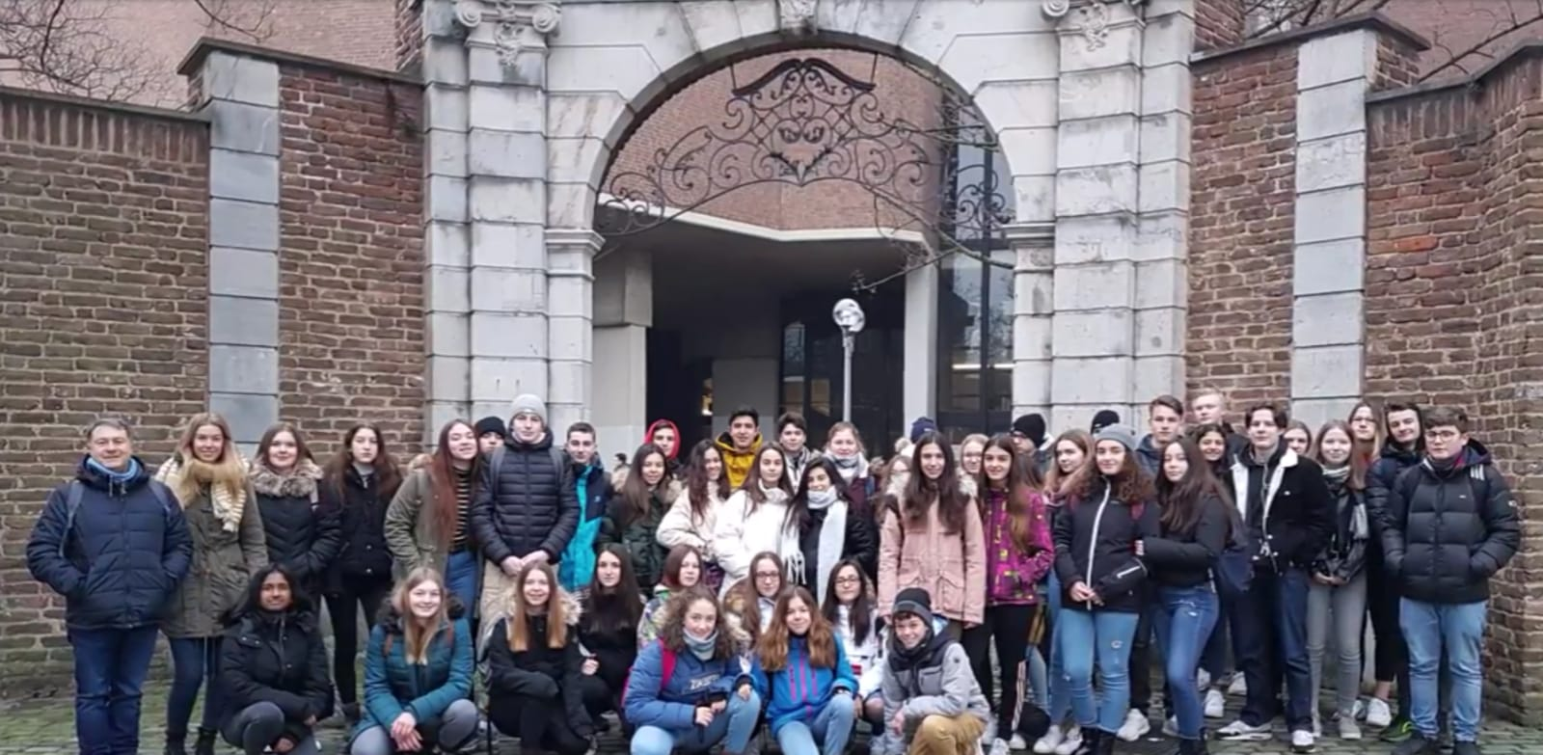

Thursday:
On Thursday we took the bus to cologne, the first thing we looked at was the cathedral. After that we had free time, where Christina, Paul, Louis, Pascal, Manuela, Adrian and I went to the tower of the cathedral, so we could show cologne the best. After the beautiful view of cologne we went to the vapiano for dinner and then we went out with all the bowls. In the evening we met Paul and his exchange partner at Christina and had a nice last evening.
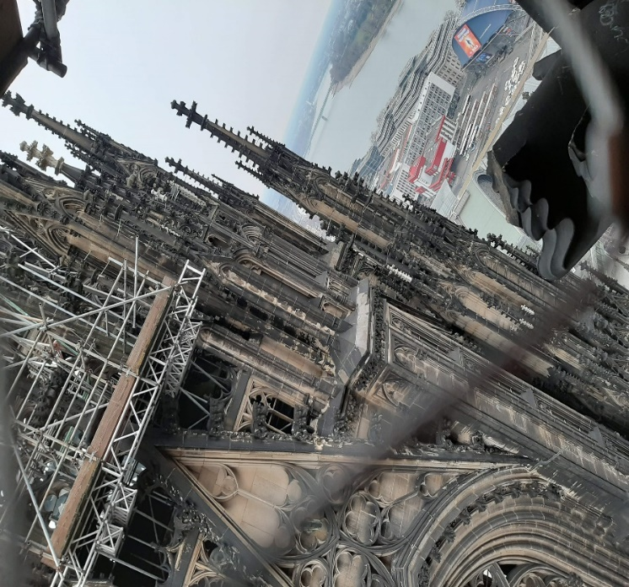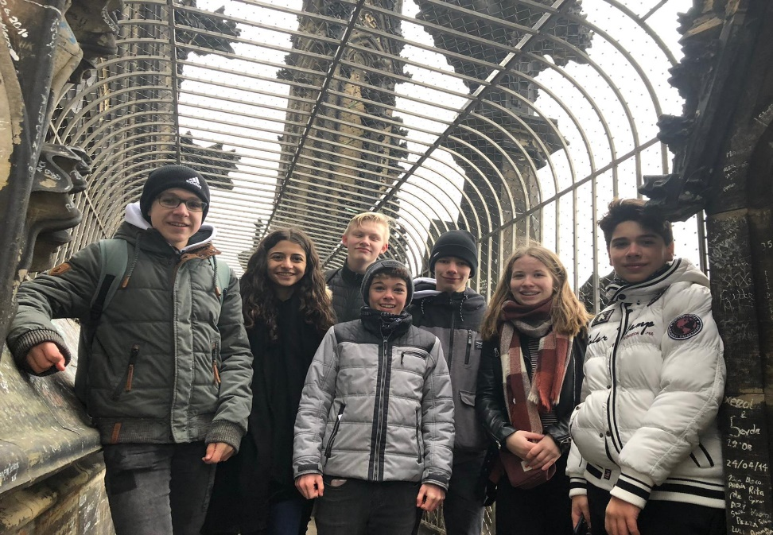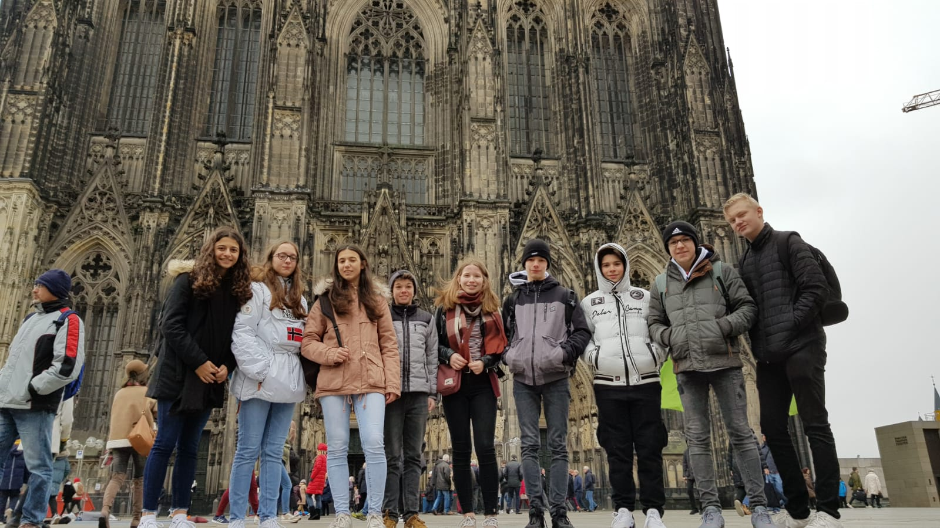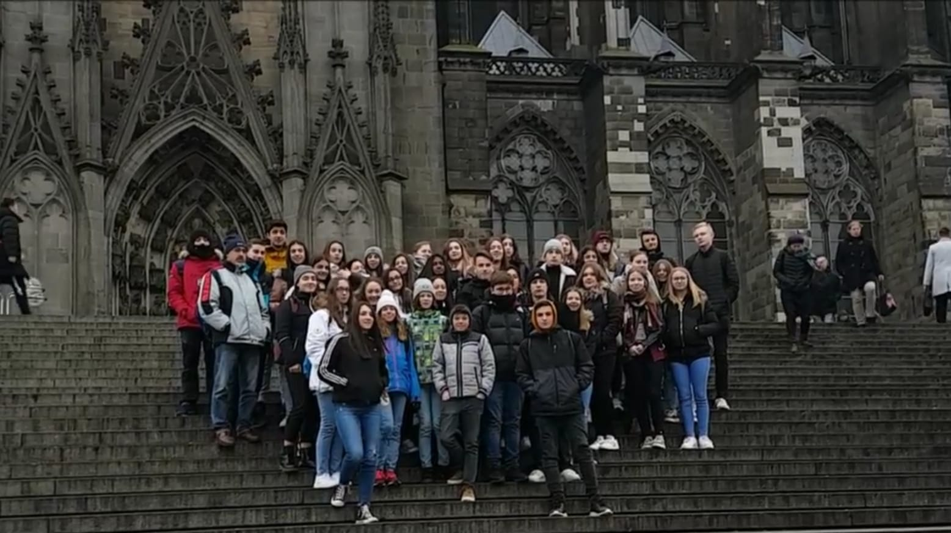

Friday:
Friday was our last day. We went to Brussels together, where we first looked at the european parliament and the museum. After that we had free time, where we took the subway to the city center. There we walked around a bit, looked at the typical places of brussels and then went to the old city. For example Grand Place in Brussels. What could not be missing, of course, was to try the belgian waffle. Then we all drove to the airport together and then we had to say goodbye. It was very sad. All in all it was a really nice week where you could collect a lot of experience.
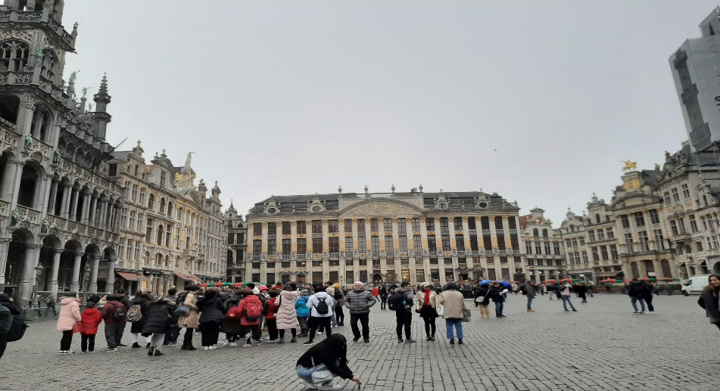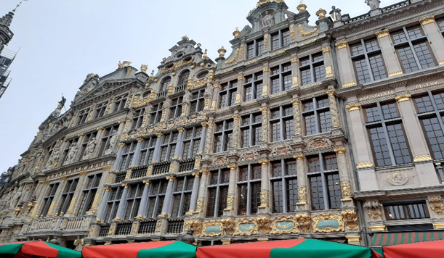

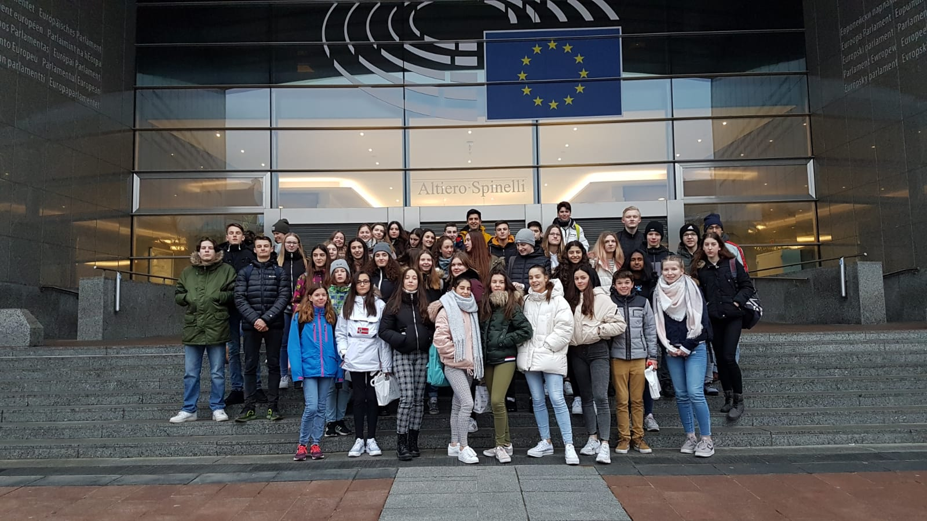

Thank you!

Montag
On Monday we met in our school at 8 o'clock with the exchange partners. Then we had one lesson to ask some questions but there was not any questions. In the next two lessons we had our normal lessons but the exchange partners went whit us in our classes. Then we made a little quiz about our city and our school. There for we made groups of four or five people. After that we went in our gym and play ultimate frisbe. It was a very cool day.

Tuesday

On Tuesday we met at 8 o'clock and drove to the neederland and played there the two games. Floorball and soocer. It was cool to met other people from other countries and i think that was the best thing. Then after we played these cool games we ate something and then we went to the icehall. It was very cool.

Wendsday
On wendsday we drove to Aachen an visited the ,,Aachener Dom“ After that we went together to a restaurant and ate there something. After that we went to a escape room. With 5 people we went into the escape room ,,Lords of rings" we finished the escape room before the 60 minutes were less. Then we went shopping in the city.

Thursday
On Thursday we made a trip to Köln. We visited the ,,Kölner Dom" and after that we went shopping in small groups of 4 or 5 people. At 17 o'clock we went bowling together. This was one of the best days in this week because it was very cool to play or talk with all people.

Friday
Friday was the last day. At 8 o'clock we met in our school for spoke about the events of the week and how much we like the week and so on. Then we drove to Brüssel. It was a long drive but it was okay. In Brüssel we made a short visit in the parlament and then we went shopping. At 16 o'clock we met us for drive to the airport and said goodbye.
Student Exchange 2020
-Spain and Germany-
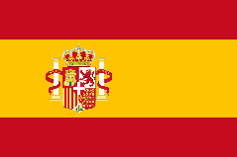
Sunday, the 19. 01. 20

Our exchange students arrived at 19:50 pm. After this, we have free time in our families, because the Spanish students have to relax and sleep a little bit. So on the first day, I showed mx exchange stundent, named Juan, Our house. Then we ate something and after this we met the other Spanish and german students in MC Donalds. All in all it was a very nice first evening and it was very interesting, to speak with the Spanish students English or to learn some Spanish words.

Monday, the 20. 01. 20

On Monday, we visited our school and after this, the Spanish students attended two lessons. From 10:40 to 13:15 we talked over the project and we maked a town walk. After this 2,5 hours we had a break, where we went to a supermarket and to a restaurant. From 14:30 till the end we played our game “Ultimate Frisbee”. It was very funny, because all students played this game. At the end, my Team loosed this game, but the sport was very helpful to make new friends and to communicated with the other students. In the evening we met at Brianna`s house.

Tuesday, the 21. 01. 20

On Tuesday we drove with the bus to the Netherlands, because we met there all four nationalities. We met the English and Netherlands students at a big hall, where skated, played floorball and football. It was very interesting to play with Netherlands-, English- and Spanish Students in one team, because we have to talk only in English and this was in the first ten minutes very hard. Finally it was a very exhausting, but a also very funny and interesting day.
Wednesday, the 22. 01. 20

On Wednesday we drove with the train to Aachen, where we visited the cathedral of Aachen. After this we had free time, to go shopping or to do other things. After the free time we went to a restaurant, called “Vielharmonie ” , where we ate something. Then we went to an Escape room. It was very funny, but also very difficult. In the evening we drove with the train to Übach -Palenberg. After this trip we met at Emma`s house, where we played all together some games.

Thursday, the 23. 01. 20

On Thursday we drove with the bus and with Ms. Wolf and Ms. Kuhl to Cologne. The first thing we did, was to take a picture. After this we visited the cathedral. Then we had free time and after the free time we went to a Bowling club, where we bowled two hours. After the bowling we drove with the bus home. In the evening we met all students at Julian`s house, where we did a little party.

Friday, the 24. 01. 20

On Friday we met at 8 o` clock at the school, where we talked over the week and over the project. Then we drove all together with the bus to Brussels. In Brussels we visited the “ Parlamentarium”. Then we had three hours free time. We went shopping and we ate a little bit. In the evening we drove to the airport and then we had to say: GOOD BYE!!!

On Sunday evening our Spanish exchange partners arrived. First we went home so that my exchangepartner Roberto could settle in. During this time we exchanged ideas abut our mutuaal interests and what he would likee to have for dinner. Af his wish we got pizza and talked with my family at dinner until late in evening.
On Monday we both got up at six o'clock in the morning, got ready and had breakfast until we had to go to the bus. Arriving at the school we immediately talked to the lessons for two hours until the city rally started. After the rally we explained our sport Ultimate Frisbe to the Spanish and then played it. Im the evening Roberto my brother and I went to Landgraaf and played Lasertag and Glow Golf with him. At home we watched a movie and then went to sleep.
On Tuesday we went with all the other exchange partners to Holland to play Floorball, football and skates. In the afternoon we met up with friends and spent the day togehther.
On Wednesday we drove to Aachen to visit the Aachen Cathedral, which most of us didn't like too much, and to go to an escape room.
After we had finished with all of them, we were allowed to walk through Aachen in groups with our partners. In the evening we went to play some billiards and darts.
On Thursday we went to Cologne we visit the Cologne Cathedrale and has free time until afternoon, we went up the Cologne Cathedrale with a small group and took some pictures. Afterwards we went to Vapiano for dinnner and then we met at the bowling hall and when we arrived home in the evening we got ready and went to a farewell party where most of us went.
On Friday morning we all went to Belgium and visited the European Parliament.

Journal
Monday: My first day i was there was Monday. We were all in a class room and talked with the teachers. Then we did a really about Übach-Palenberg. When we finished it, we went back in the class room and we compared our answers. All body were very good so it was difficulty. After this we went tot he gym and played ultimate frisbee. It was very cool that we mixed the teams with spanish students.

Tuesday: Tuesday we went to the netherlands and we played a few game. First we played footbal and floorball. There were also mixed teams and we all liked it. At floorball my team won every game but at football we did not have any chance. As we finished it, we went to a party to Brianna and had a lot of fun.

Wednesday: Wednesday we was at Aachen. We went to the Dom in which we had a tour. It was very interesting and i liked it. After the tour, we went to a restaurant and we all ate something. After this me and my group had free time till we must go to an ‘‘Escape Room‘‘. We liked it but it was very difficulty. We needed very much tipps and a bit extra time. After this we went home an slept because we all were tired.

Thursday: Thursday we were at Colone and seen the Dom. After we was inside weh ad a lot of free time and we went shopping. After finished that we went to a bowling center and we played bowling. Some of us took pictures and we all had fun. We went home and this day i gave a party at my fathers house because the spanish students wanted that we do a party with all people, but not all sadly came. Weh ad a lot of fun and all said that it was the best party oft he exchange.

Friday: Friday was the last day and we went to Brüssel. We went to an museum and then we had a bitt free time. We all had a good time and the adoption was very hard. We hugged each other and then we went home.

The exchange
A few days before the exchange we cleaned up the room of my exchange partner,so we decided to sleep individually,because we both prefer it,to have our own space.But we still had a great time together.
When they arrived,Inwas a bit excited.Their bus arrived at the train station and we all hugged.At home,I showed my partner her room.We went to mcdonalds with a lot of other german and spanish students.It was much fun.Than,the day was already over.We went to sleep and I know that the week would be good.
At the first day we had normal school and we showed our school to the spanish students.My family met my exchange student and weh ad lunch.After that,a friend of me and her partner came over and we talked and went outside and had much fun.
I think the best day was day two.We went tot he netherlands and did some sport,I liked one sport,hockey the best.Many of my friends said it was exhausting,but I think it was super.We had lunch and did iceskating,the spanish and german students were separated the most time on the ice.We went back to our school.In the bus,me and a friend slept,because the day was very long.
We came back and went to bed.I was happy because they were all very friendly and kind.
At the next time we went to aachen and were allowed to go shopping.I think it was great because i shopped many clothes.But the group I was in wasn´t so good.I don´t get along with all human like every other too.But nevertheless we didn´t got into a fight and enjoyed the trip.We eat lunch together and went tot he escape room.I think it was very cool and funny.
The day after that we were in Cologne.We visited the dom and had a nice trip in the city.The bowling was fun too.I had the feeling that we were all the same and that we were all one.
My partner and me talked at the evening much and we got great along with each other.
The last day was sad.We accompanied our partners to Brussels to take them later to the airport.We visited the parliament and were allowed to go shopping in small groups again.The drive was sad because we all knew we would only see each other in two months again.
At the airport,a few students cried.Me and my exchange student hugged each other and I also hugged other students because I became friends with many other spanish,german students too.
When we arrived at home,I hugged my mom because I was sad.We two cleaned up the room my partner slept in.Than I texted my partner to have a save fly and that we will see each other again soon.
The week was so great,I hope the week in Spain will be great too and I think so!
Katja

Sunday
(The arrival)
After Luna arrived, we first drove home and ate Sauerbraten. I showed her everything and then we went to bed.

Monday
We took the bus to school at 7:18 and then the teachers asked in the first lesson if there were any problems. Then we were 2 hours in normal class. After that we did a city rally in mixed groups. After a break we went to the gym and did a frisbee tournament together. In the afternoon we all met together.

Tuesday
We all went to the Netherlands together and first of all we all (Dutch, English, Spanish, German) played floor ball and football together. After we had all fries we went skating and then we went back again. Then I went with Luna to the stable for my riding participation.

Wednesday
On Wednesday we went to AAchen and had a guided tour of the cathedral. Then we had dinner together and then we went directly to the Escape room. It was a little bit harder, but still pretty funny. Afterwards we had free time. In the evening we went back by train.

Thursday
We were in Cologne and looked at the cathedral alone, later we had free time. Because it was unfortunately a bit uncoordinated we had a bit of time pressure to come to the bowling. The lanes were very full and it took a long time to get back on. Then we went back by bus.

Friday
Friday we went to Brussels and visited the museum of the Parlamenarium. Afterwards we had free time. Shortly after that we went to the airport and said goodbye. After the farewell we went back.

Thursday
At Thursday we met us at 9 pm at our school where our bus was waiting for us. When we were all in it we drove to colone. First we went tot he cathedral and admired the famous window of a really famous artist. After that we had freetime during we went shopping, ate and talked. At 7 am we drove to Übach-Palenberg so we were at 8 am back.

Friday
We have to met us at 8 pm in a room to answered some questions of our sport that we teache the spanish exchange students. When we did it, they drove to Brüssel and say goodbye to our exchange students.

First day Sunday 19. 1.2020 The Arrival
19:00 planned, 20:00 arrived
20:00 meating with all colleagues at McDonald's and eaten
Second Day Monday 20.1.2020 School day
At 8 we were at school CMG
School tour
Take 2 classes IT and Religion
Went around the school and city and answered at questions about the city
Had a 1 hour break
Went back to school and played ultimate Frisbee until 16:30
Went home for 2 hours
At 18:30 we went all to Brianna at home and hang out, eaten..
At 22:00 he went home and slept
Thirth day Tuesday 21.1.2020
Woke up and get to the school at 8. There we waited for the bus and drove to Netherlands to..
There were students from Netherlands and from England as well
We then made 6 teams and played football. We always switched so we can play against all of them.
Afterwards we played floorball, the same way.
Then we hat a break when we eated fries.
Then we went ice skating.
We turned back in Übach at 15:00 and then went to Emma at home and we all eated and played games. At 21:00 we went home.
Fourth day Wednesday 22.01.2020
Went to the train station in Übach-Palenberg at 8:00 where we all meet.
We drove to Aachen and got a tour of the Aachen cathedral from 10:00 to 12:00
Then we went to Vielharmonie, a restaurant where we all eated.
And then until 15:30 we went shopping and after that to escape room. We all have been spited up in more groups in different rooms.
It was hard but hard.
At 17:00 we finished and went to the train station and got the train back to Übach-Palenberg.
After that we got home and went sleep because we were tired.
Fifth day Thursday 23.01.2020
We woke up and went to the school at 9:00 were we all meet and toke the bus to Köln.
When we arrived the firt thing we did was to visit the Cathedral.
After that we had free time until 14:30 where we went shopping and eat something.
And at 14:30 we went to play bowing. We played for two hours and then got the bus back to übach where we all meet at Julian's home and played games, danced and eated until 22:00.
Last day Friday 24. 01.2020
We woke up and went to school at 8:00.
The first hour we have Benn in a classroom and completed a questionnaire about ultimate Frisbee.
Then took the bus from the school to Bruxelles.
The first thing we did in Bruxelles was to visit the European parliament.
Then we could go by ourselves in the city where we eated and seen the streets and buildings of Bruxelles.
At 16:00 we went back to the bus and then drove to the airport where we said goodbye to our exchange students.
After that we drove back to Übach-Palenberg and arrived at 20:00.

