Pneumatic swing door pump manual

Jinhu County Gore Bus Door System Co.

Pneumatic swing door pump manual
- Door Pump Assembly Diagram
1. Swivel arm assembly (including swivel arm assembly, column assembly, upper support, balance bar, upper and lower angle iron, locking block, etc.)
2, door pump and the corresponding control devices (hand-dialed bleeder valve, solenoid valve, anti-clamping, etc.) composition.
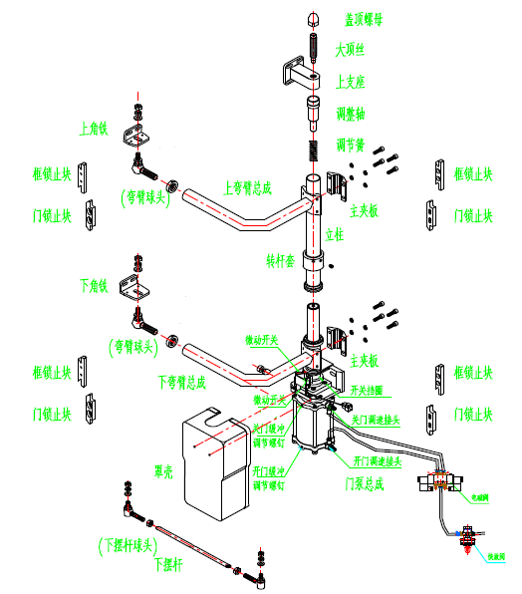
- Door pump structure diagram
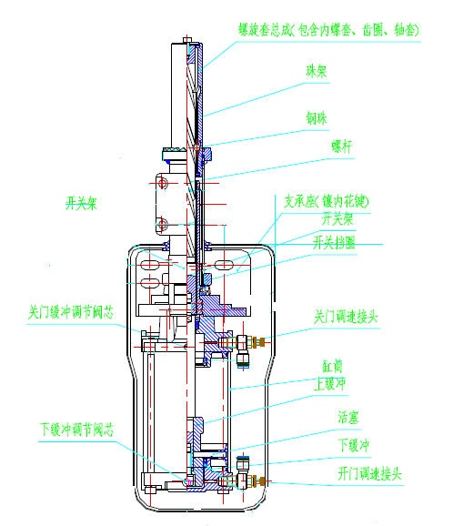
- Pneumatic swing door pump assembly basic function (rear door opening)
Press the door closing switch, the cylinder piston rises, so that the spiral sleeve assembly together with the rotating arm drives the door to rotate counterclockwise, after the door and the frame fit together, the spiral sleeve assembly together with the rotating arm stops rotating, the cylinder piston continues to rise, the door rises, and the locking block on the side of the door is inserted into the frame locking block, and the door closes tightly.
Press the open door switch, the cylinder piston descends, the door descends to exit the self-locking, the cylinder piston continues to descend, the spiral sleeve assembly together with the rotating arm rotates clockwise, and the door opens.
Fourth, the basic parameters of the air pump
Control voltage: 12V, 24V
Working air pressure: 0.4-0.8Mpa
Rotation: left, right
Maximum angle of rotation: 140°
Load capacity: not less than 1000N
V. Door pump working principle
The pump body is divided into two parts, the lower half is a cylinder with a cushion and the upper half is a set of screw mechanism.
Lower half: When the piston in the cylinder completes the push work of the switching door when rising and falling, the air pressure will be driven by the piston movement to realize the action of the switching door through the movement of the column rotary arm linked by the screw.
Upper half: when the door is closed, compressed air enters the cylinder from the lower inlet and pushes the piston upward, which rotates the spiral sleeve through the screw, thus driving the rotary arm to rotate and close the door. When the door and the door frame fit, can not continue to rotate, because the piston continues to rise, the screw rises, the spiral sleeve blocked by the door from the rotary movement into a rising movement, the rotating arm and the door along with the same rise, the door locking block inserted into the frame locking block so that the door locking. When the door is opened, compressed air enters the cylinder from the upper inlet to push the piston downward, so that the screw, the inner spiral sleeve, the rotating arm and the door descend together, firstly unlocking the self-locking. Then reverse the rotation so that the door flat turn outward swing to the side of the door frame to open the door.
In the closing process of anti-clamping, such as clamping people or objects, the door can not continue to rotate, under the action of the piston, driven by the spiral sleeve assembly together to rise, so that the installation of anti-clamping retaining ring on the inner spiral sleeve assembly contact with the steel ball, touching the microswitch, so that the solenoid valve commutation, the door is opened.
Six, pneumatic swing door installation and commissioning
(A) Door frame profiles; door frame adhesive tape installation
Install the door frame profile on the door frame with self-tapping screws according to the arc of the door opening; apply lubricant to the assembly surface of the door frame profile and the adhesive strip; drive the adhesive strip into the door frame profile with a small hammer.
(ii) Installation of door panels, door panels, and other parts of the balance bar
1. Name of components: door panels, air pump assembly, swivel arm assembly, column assembly, and auxiliary parts.
2. According to the dimensions of the drawing, install the pump body on the side elevation of the body doorway body through the three mounting length holes on the pump body of the air pump assembly.
3. According to the drawing size, install the column on the support
4. Install the column assembly on the output shaft of the pump body and tighten the nut, and at the same time, install the column parts (compression spring, support shaft, sheath) and use the top wire to connect to the column support.
5. Install the upper and lower arm on the column according to the rotating direction of the door and the size distance of the upper and lower angle iron hangers of the door, and tighten the clamp screws to fix the position of the arm in the maximum open state.
6. Install the door panel upper and lower angle iron support installed, hang the door to the rotary arm, pre-tighten the link screws in all places.
7. Trigger the door by hand to open and close the door, observe whether the gap between the two sides of the door and the upper end of the door and the door frame of the pre-door hole is suitable, and tighten the fixing screws of the corresponding links after precise adjustment. Pay attention to whether the rubber strip interferes when closing the door.
8. Adjust the balance bar to the designed length and link the door with the car body. Open and close the door under manual condition, observe whether the door and the car body are parallel when the door is opened and closed at the two limit positions, and adjust the length of the balance bar can be realized.
9. Install adjustable locking blocks on both sides of the door and the door frame, and the gap between the two corresponding locking block vertices is about 4mm.
10. According to the design of the air circuit to connect the air source of the door pump, according to the design of the electrical principle to connect the circuit.
11. Adjust the inlet and outlet adjustment valves on the air pump to debug the opening and closing speed of the door under the state of sufficient normal air supply; at the same time, adjust the cushioning of the door opening and closing state to the appropriate and optimal opening and closing state.
12. Debugging whether the electrical function is complete. Step light, open the door button light is synchronized. Whether the door anti-pinch function can be used normally, after adjustment, check whether the relevant fasteners are tight.
VII. The role of several adjustable parts in the bent arm assembly
1. Angle iron (door plate upper and lower hangers), ball head can adjust the relative position of the door and door frame, to achieve the door and door frame close fit, pressure uniformity, door and door frame gap uniformity.
2. Balance rod Balance rod in the door switching movement with the rotation of the rotating arm and the rotating arm together with the door according to the adjusted trajectory movement, adjust the pendulum rod at both ends of the positive and negative threads can be adjusted under the pendulum rod center distance, the effect of the adjustment should be to make the door open and close freely, by the door pump on one side of the door side of the door closed after the door in, open the door first, and at the same time to adjust the door after the door panel opened and the car body is parallel or not.
3. Adjustment spring In the upper end tube of the arm column, the top wire can adjust the amount of spring pressure. When the door closes and rises, the lifting force added to the piston by air pressure overcomes the gravity of the door and the arm. The friction between the door and the rubber strip, and the spring pressure rises to lock. When the door is opened, the gravity of the door and the arm, the spring pressure and the downward pressure on the cylinder piston make the door drop and exit the self-locking.
VIII. After the commissioning of the product, all the solid parts will be checked once, in order to prevent loosening.

