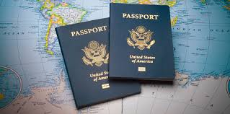
Whitefish Bay Public Education Foundation
2020-2021 Passport
From October to April, check our website https://www.educatethebay.info/events/ for the activities of the month. Record your activities here with a photo. Post your photo on your Twitter, Facebook, Intsagram, Tik Toc or other social media with the hashtag below and/or share your photo at educatethebay@gmail.com and we will post it on the Foundation Facebook page and website. Passports are due by April 16th to educatethebay@gmail.com
Stay tuned for the virtual Run the Bay in May! Thank you and have fun!

Date | Activity | Picture (post on your social media with  #WhitefishBayPublicEducationFoundation  #WFBPEFPassport or  #FundingInnovation

Date | Activity | Picture (post on your social media with  #WhitefishBayPublicEducationFoundation  #WFBPEFPassport or  #FundingInnovation

