DIARY
10th
This morning I have woken up at 9:00 to prepare my lunch, because we are going to travel to the Nederlands. At 10:00 we have left the bus station to go to the airport of Santander to take our flight at 14:45. When the plane left the land I felt very nervous, so I decided to chill out with the MP3 music. At 15:00 we arrived at the Charleroi Airport and we met our matches, mine was very nice!!! After travelling 2h by bus we arrived at our destination, Landgraaf. We went to Eijkhagen School because the parents of our matches were there. Then we went to Seven´s house. On her house I met her beautiful fantastic dog and her hilarious parents. We had dinner at 20:00 and after it we watched a hilarious movie. Then we went to sleep.
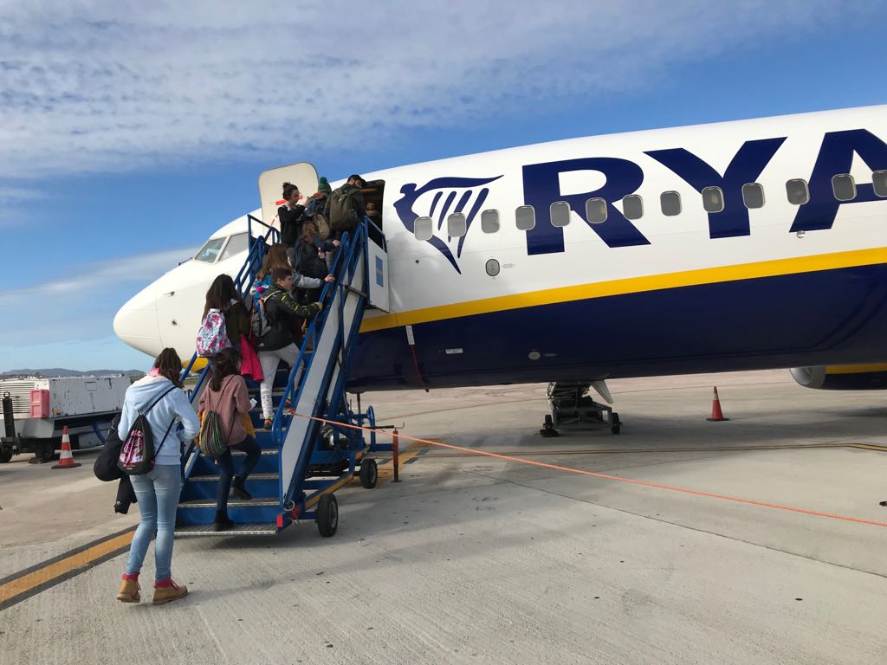
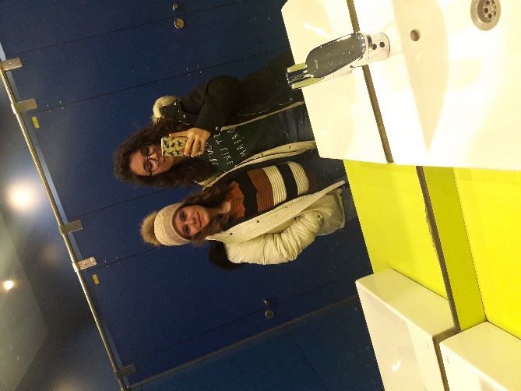
11th
At 7:00 I woke up, I made my school lunch and then I ate 2 nutella toasts with sprinkles, it was the typical breakfast there. At 8.30 the school classes started so we left home at 8.00 and we went by car, because it was my first day in the Nederlands. At 8:30 the principal, Mr Van Eyk welcomed us, he was very nice. Then he returned to work so we had class with Ms Sterk the English teacher at school. She gave us a bag and a notebook with a pen to write our experiences. After an hour, we had a workshop lesson with Mr. Rutten, he told us some traditions and stories of the country. I learned some new interesting things. After that we had a 30 min break. Then at 10:00 we visited the town hall of Landgraaf, and the Alderman `education and culture´ welcomed us. They gave us a biscuit and an orange juice, it was so good!!! We watched a video about the culture of the town. At 12:00 we had another break. At 13:00 we went to Brunssummerheide with our matches, and we were divided into small mixed groups to go orienteering, I had a lot of fun, and I met new friends. Then at 16.15 we went back to school. At 18:00 the family and I had dinner. Then we went to a town near Landgraaf because Seven had to practise Taekwondo, It was so difficult. Then at 21:00 we went to bed.
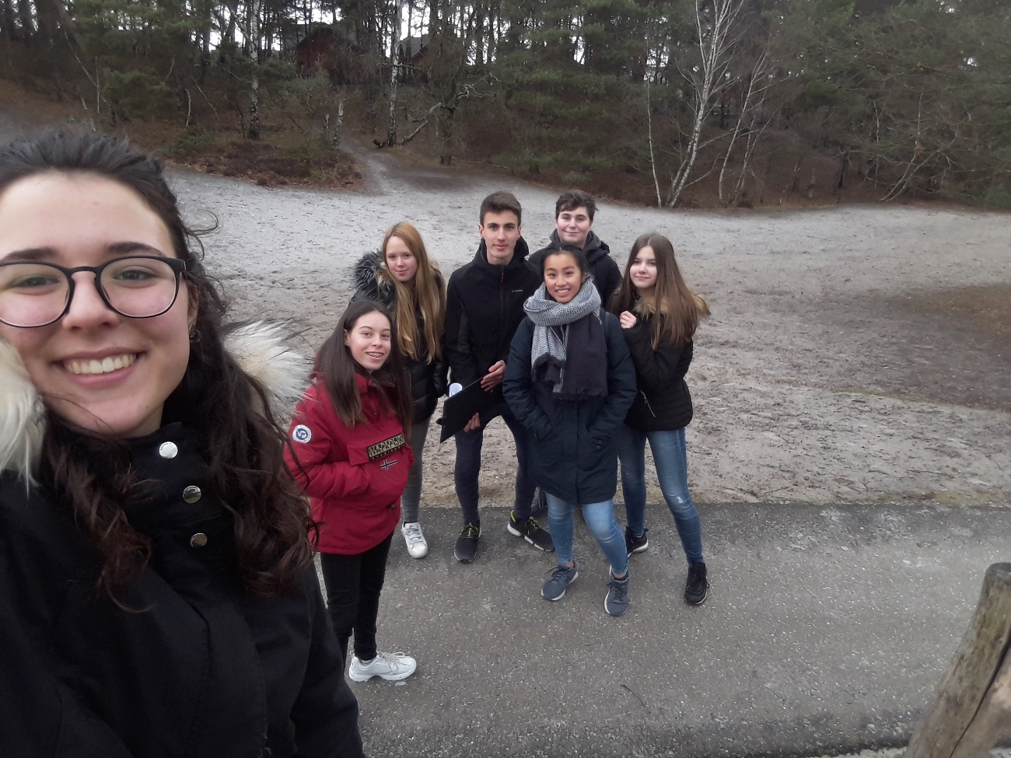
12th
Today is my birthday!!! So I am very excited. At 7:15 I woke up, at 7:30 I had breakfast, 2 toasts of nutella and a birthday cake. Then Seven gave me a present for my birthday, a super cute bracelet with a silver heart. At 8:15 we went to school by bike, and then at 8:30 we took the bus to Laco Glanerbrook in Sittard-Geleen. Then at 10:00 we were practising ice-skating with a school of the UK and Germany, and a teacher was teaching us how to do it. Then we had some free time to go ice-skating, I love it!!! At 12:00 we had lunch, a crocket with some frites, I like it a lot. After lunch at 13:00 we have practised floorball, but only the girls because the boys were playing soccer. It was very unfair because we wanted to join in with the boys to play soccer and to have mixed groups. But Mrs. Van Buren said that we can´t, so we get angry about that. After it Mrs. Van Buren said that to it was an experiment to see how we would react. I didn´t like it so much. At 16:30 we went back to school, and we went back home. Then we had to go to the supermarket to buy fish for the dinner, we had to hurry up because at 19:00 we were going to go to the Space Jump. When we were having dinner the fish I told Seven that my dish was frozen, HAHAHA, so we got later to finish it. At 19:00 we went by car to the Space Jump, It is a place with mats and trampolines so that people can do pirouettes and backflips. We went with other people of the exchange and we had a lot of fun there!!! We were there like 2h, it was amazing. After it we went back home and we went to bed.
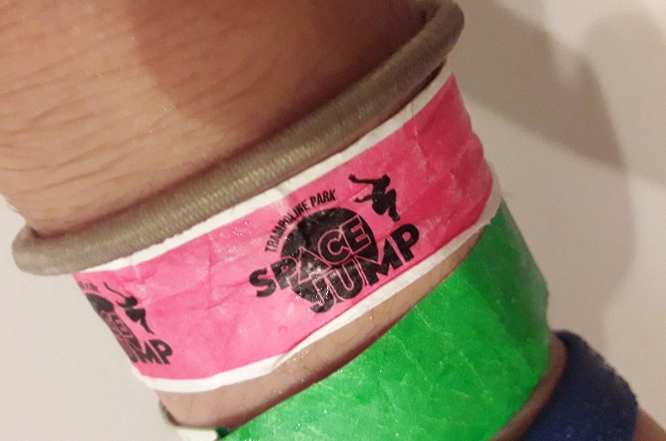
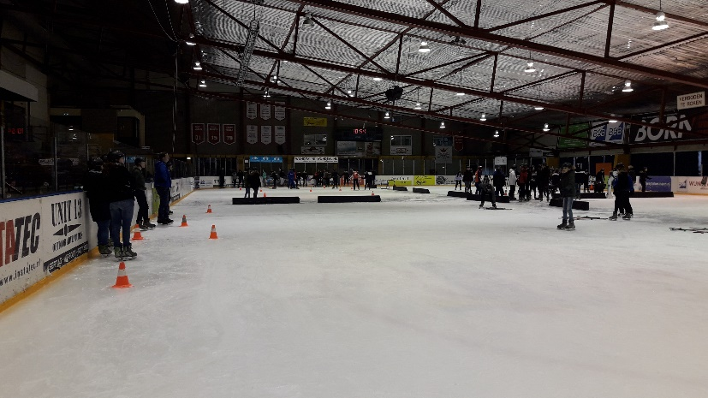
13th
At 7:00 I woke up, I made my school lunch and then I ate 2 nutella toasts. At 8:15 we went to school by bike with Sara’s match, and then at 8:30 we had a workshop lesson with Mr. Rutten, he told us that he had lived in Spain, in Salamanca, also he told us a legend of giants that were rocks living in nature, then we had to draw a giant rock for the legend with my mates. At 10.10 we had a break, so we were playing Spanish cards. At 10:30 we went by bus to Maastricht, we had visited the Fortification, the Basilica of our Lady, the Hell Gate and City Park, it was so beautiful to see! Then at 13:15 to 15:00 we had some free time, so we went to have lunch to Domino’s Pizza Marina and me. After lunch we went shopping and to see this entire amazing city. At 15:15 we went back to school and we arrived at 16:00 back home. My mate asked me if I could makeup her, so I said yes. She said that I really can do lovely makeup. After our beauty session we went dinner. This was a special dinner, because I had never eaten taboule and a kind of chopped potato and carrot dish. It was so good and tasty!!! Then Seven told me that we were going to practise bowling!!! I really love it!!! We met other students there; I really had a good time. Then at 21:00 we went back home and we went to sleep.
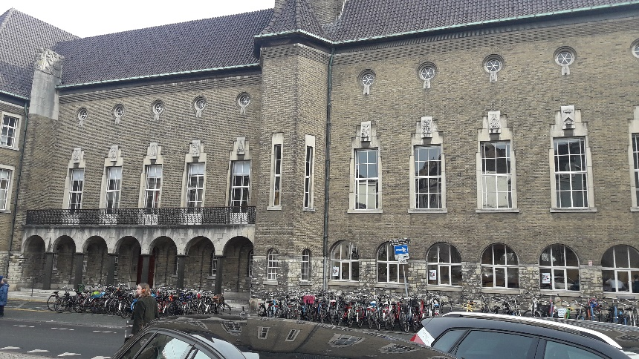
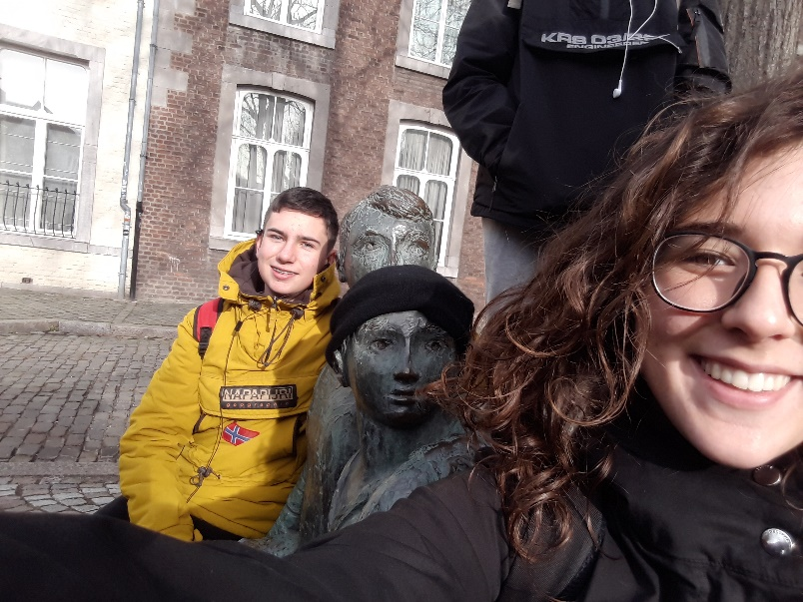

14th
At 7:00 I woke up, I made my school lunch and then I ate 2 nutella toasts with a cake piece. At 8:15 we went to school by bike with Sara’s match, and then at 8:30 we had a workshop lesson with Mr. Rutten, he told us another story, but this one was sadder than the others, so I didn´t like it so much. At 9:30 we went with the Nederlands to spots centre Citta Fit in Vaals. At 10:30 we had a Korfball lesson by André Kuipers, an old player of the official team of Korfball, also another player come with him, but he was younger. We had a nice and happy time practising it, I learned a lot about this sport. After it at 12:30 we had lunch, we ate a sandwich of ham and cheese, and with a piece of fruit and a yogurt. I like it. At 13:15 we worked on assignments in small mixed groups, we were working on questions about korfball. It was so funny. At 15:00 we left the sports centre to visit the Drielandenpunt “three country point”. We went on the top of a tower and we take some amazing pictures with my friends. Then at 16:00 we went back to school, and then to home by bike. Then at home Seven advised me that we are going to a party so maybe I wanted to dress up smart. So I decided to dress up with a new outfit that I had bought on Maastricht. Then at 18:00 we had dinner, and after it we did our makeup and then we went to the party at Alba´s house. They had got 2 dogs, 3 cats, 5 snakes, 1 lizard, and some fishes. They love animals. I like too animals so the father lent me to took a snake. Marcos took a lots of pictures about it. Then all the people came and we put some music, and snaks on the table. Then we played twister, it was very amusing. After the party we go back home and we go to bed.
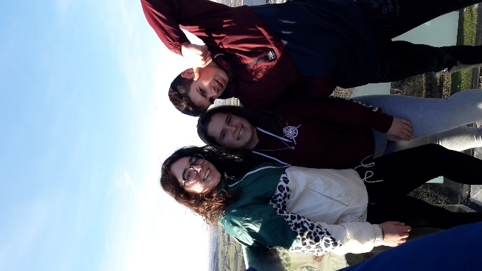
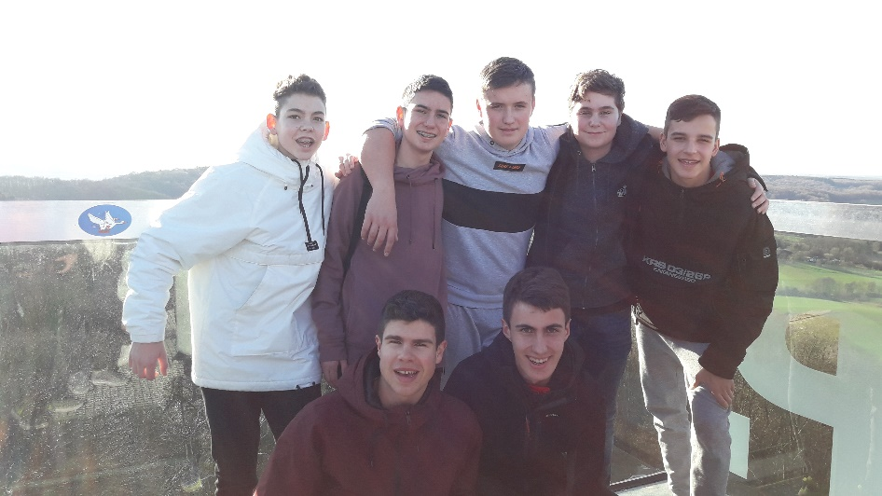

15th
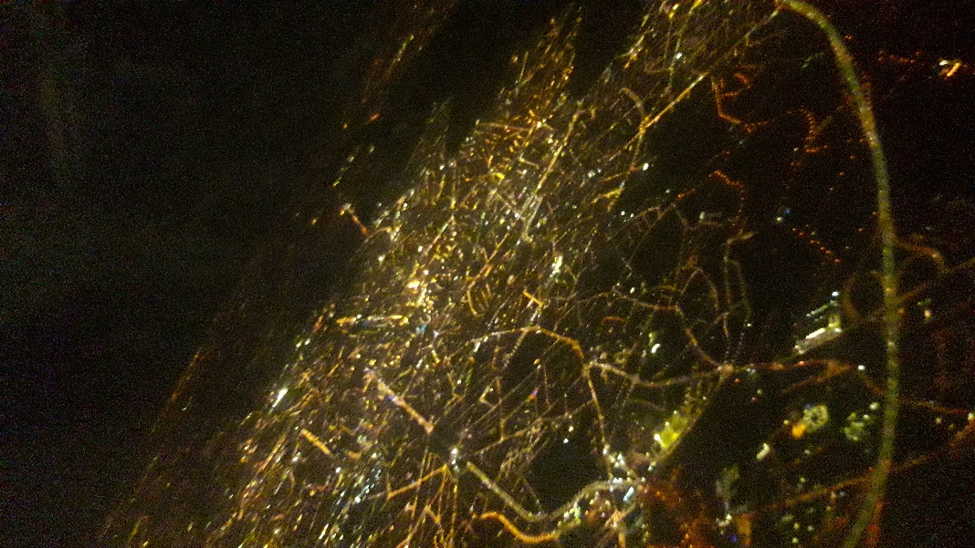
Today I woke up earlier because I had to pack my luggage. At 8:00 I was taken away from all the family so nice and kind that I had. Then we went to school by car with my wallet. We left all the luggage in a class and we went to the computers room to finish our work in small mixed groups. After finishing it we left at 11:30. At 13:30 we visited the Atomium, inside and outside. We also took some pictures about the experience. At 15:30 we had a guided tour Brussels to Grote Markt, Manneken Pis and in the freetiem I bought a nutella waffle. It was so sweet. At 17:30 we went to Airport Brussels Zaventem. We said goodbye to all the matches and we went to our flight. Then we came back to Spain. 