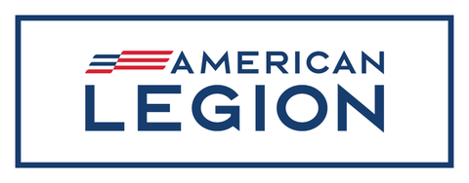

January

2024

**Dear American Legion Family members and friends,**

**This week ushers in the most special time of the year with the spirit of Christmas and a brand new Year.**

**It’s a time when we joyously express gratitude, give thanks for all our blessings, and are more motivated to help others.**

**This holiday season my wish is that the desire to help others will spread beyond a few weeks and become a priority throughout the entire year. I know there are dedicated American Legion Family members who give their time in a plethora of ways all year long and understand both the power and satisfaction of servant leadership.**

**They are the unsung heroes of the Post and in their local communities.**

**They donate their time and talent to those in need.**

**They perform honor guard duties.**

**They visit senior citizen centers in the community.**

**They perform Buddy Checks on fellow veterans, who may need nothing more than to hear a friendly voice or see a familiar face.**

**Let’s take the goodwill we feel in our hearts now, capture it and seek opportunities to serve our veterans, our military members, their families, and the communities in which we live.**

**No opportunity is too small, no challenge too large.**

**Join me in expanding the servant leadership we embrace this holiday season and extend it throughout 2024.**

**If you are in the area, please stop by and say hello. We are always looking to make new friends. If you are a member and have not been to the Post in a while stop in and see what is new. I promise either way you will be delighted.**

**For God and Country,**

**Darwin Bush**

**Commander Post**

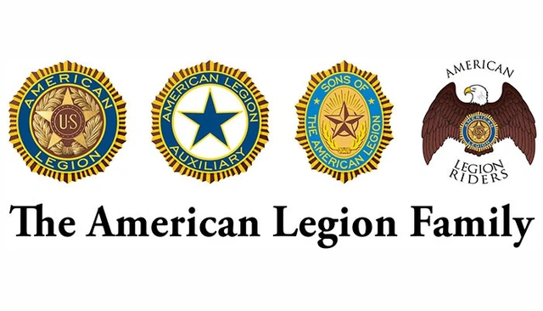**Next General Membership meeting will be held on 1/28/2024 at 2:00 pm**

**There is a Legion workday coming up on 1/20/2024 at 8:00 am. We invite everyone to come out and lend a hand.**



**The next Sons of the American Legion Meeting will be held on 1/21/2024 at 2:00 pm.**



**The next Auxiliary meeting will be held on 1/16/2024 at 6:30 pm.**



**The next Legion Riders meeting is 1/6/2024 at 12:00 pm.**

**12/9/23 The group Christmas party was decorated by the Auxiliary, we thank them for the work and effort put into it! A huge thank you to post Commander Darwin Bush for cooking the gumbo for the party and everyone kind enough to bring a side or dessert! Members from every group were in attendance during this busy time of year, it was a great night of fellowship and fun!**

**12/16/23 Busy day for the post! The toy drive was a great success. Toys were given out to 230 kids, 50 food baskets were given out, 500 sandwiches were served, and it was all done in 1 hour and 12 minutes. This same day Wreaths Across America was taking place at Fairview Cemetery some of our veterans were able to participate in this outstanding event.**

**12/20/23 The Riders distributed donations to the food bank, animal shelter, Towers Nursing Home, and distributed the leftover toys to CASA from the toy drive.**

**12/23/23 Many of our members went to Silver Pines to visit with the veterans for Christmas. Our members brought hats, coins, and cakes representing each branch of the military.**