Report of Pemba Sherpa, August 2021
English Drama show
The English Drama show was happened to be the monthly activity in August. The English Drama show was organized with the intention to improve English interaction skills.
I wrote a script for "Beauty and the Beast" and Migmar Bhuti wrote the script of the "Three sisters".
The main objective of having two different shows was that every child could get to play or act at least a single character.
I encouraged and accompanied every student to bring up their costumes, props, set including staging, dialogues etc.
Students consumed time to prepare their dialogues. I guess it was because of the irregularity of the school timing due to the pandemic.
All in all, we were able to present the show pretty satisfactory. Many of the Chief guests and the audience were amazed to see students' talents and English improvement.
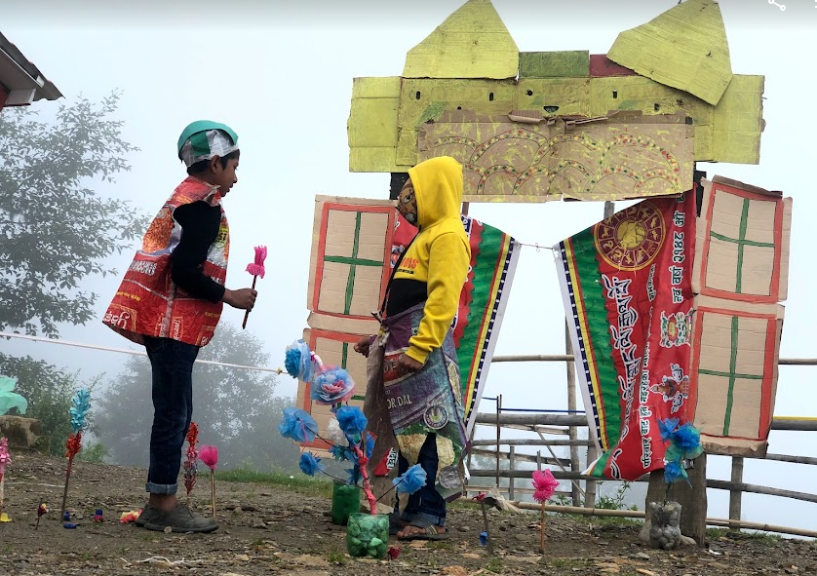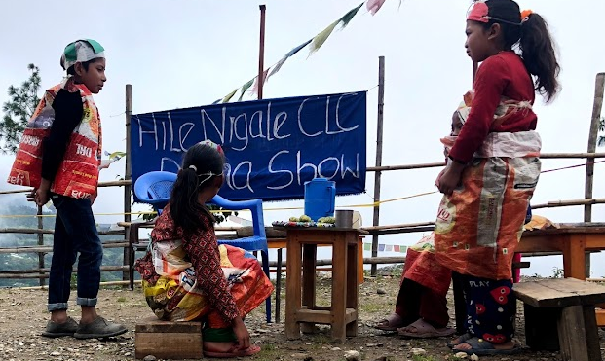
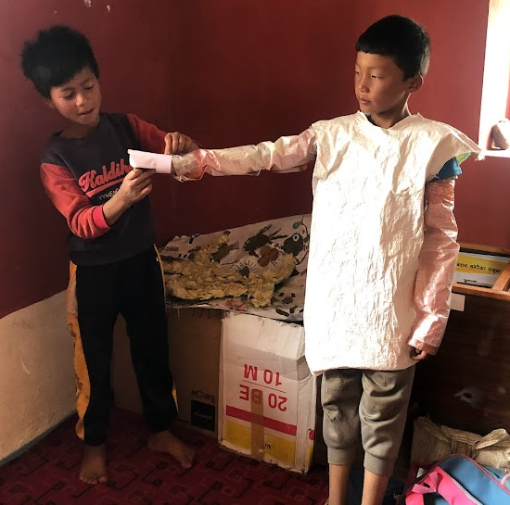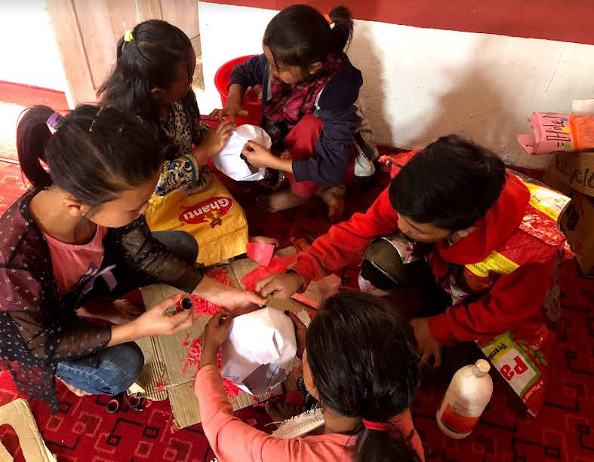
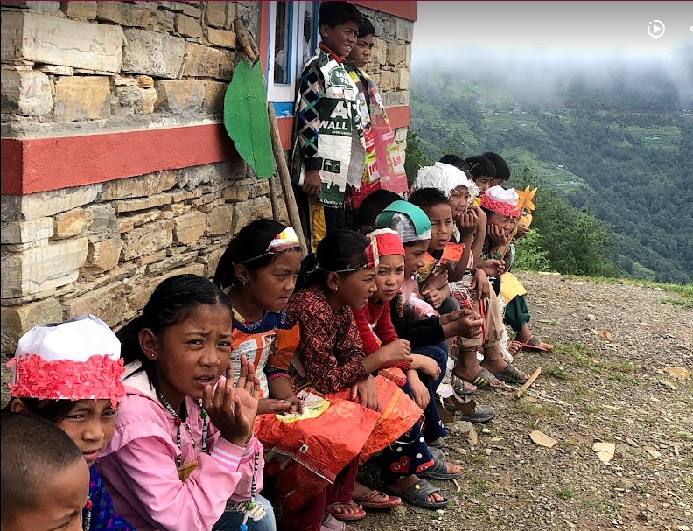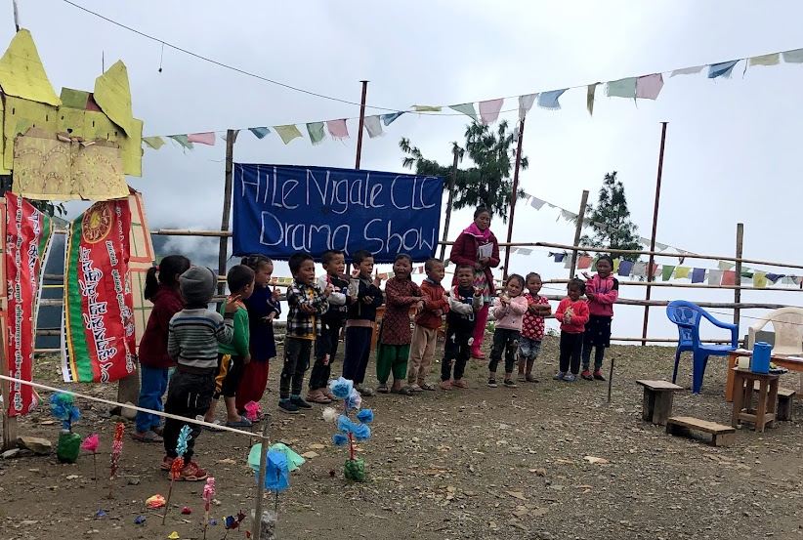
Parents' Meeting
Starting this August 2021, Migmar and I decided to have parents and teachers meeting in the journey of build every child better way. There was a negotiation of having parents and teachers' meeting once every two months. We witnessed many improper parenting issues. Therefore, we thought it is good to enlighten the parents.
We are educating parents on a topic like child psychology and the modern way of guiding children.
Extra-Classes for students of grade 3-5
Due to the pandemic, the Community Learning Centre was closed for almost two months. Therefore, I felt that students learning time were taken unproductively. Consequently, I started taking 1-2:30 hours of extra classes- to cover up their taken time. Especially, reading books, revise English, Tibetan, and Computer courses, etc.
DIY Challenge
There was a DIY (Do it yourself) video competition among the schools in Nepal. It was organized KAARYASHAALA on online.
https://www.facebook.com/Kaaryashaala All together, there were 11 schools participants with 52 candidates from all over Nepal.
Migmar and I encouraged and supported some of our students to participate in the contest. Fortunately, among six of our participants, one of them won the challenge base on her video originality. The prize was delivered here through Sonam Dai. Honestly, it was a proud moment for both teachers and students.

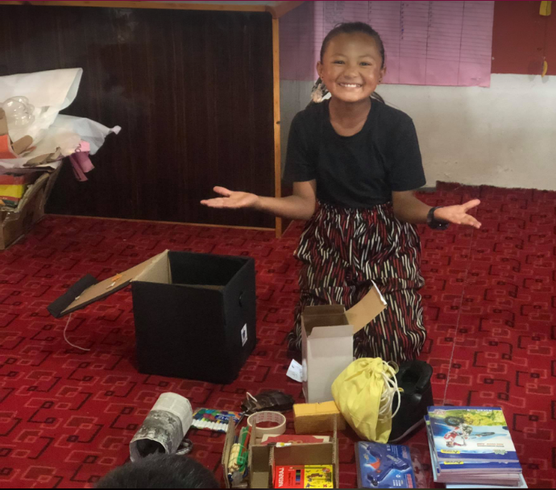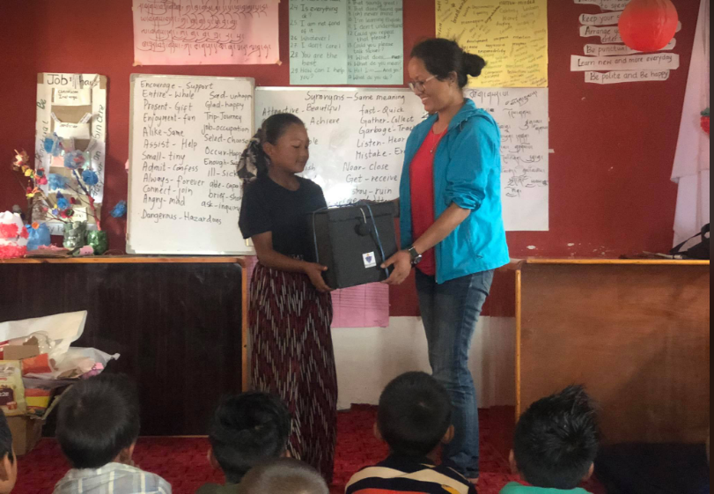
September Goals
- Excursion to Tea farming
- Evaluation test
- Presentation to parents on child psychology
- Preparation for International Teachers' Day celebration

For my Personal and Professional Development purpose
I have motivation to take Cambridge Celta English course. Here is the link what I have look through.
https://oxfordtefl.com/courses/cambridge-celta
https://oxfordtefl.com/courses/pre-tefl/online-tefl-starter/

