October 2021 report
Migmar Bhuti Lama
Teaching in Hile Nigale

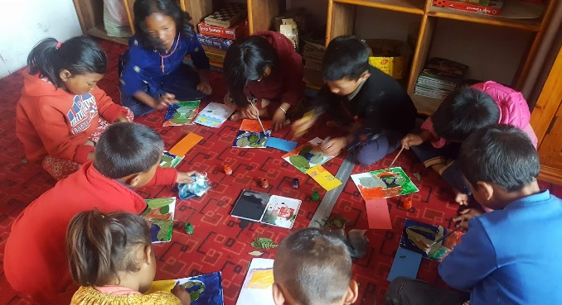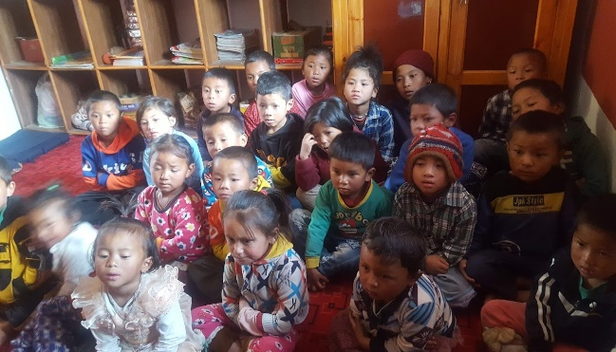
- Regular class
This month, I went through simple sentences since we have learned lots of different naming words. I used those naming words and differentiate the singular and plural forms. It is a kind of revising the lessons with different methods. I felt glad to see kids creative in making simple sentences by using this, that, those and these. Also, we went through some rhyming words and rhyme songs too.

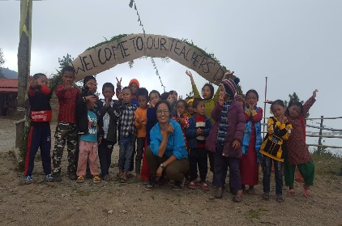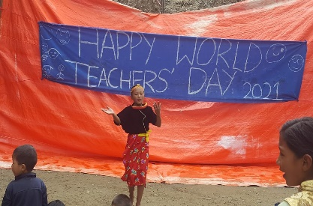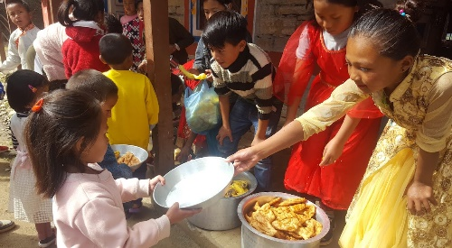
- Teachers Day
We celebrated international teachers’ day from 9:00 am to 3 pm in the hope that students will get a chance to learn by organizing different programs. We (teachers) guided and handed over all the responsibilities to the students. Children took all the initiatives like decorations, games, food, dance and other formal programs too. Finally, I believe kids built good communication skills and built a strong team to make this program successful. Children got an opportunity to experience many things from the first-time organizing program by themselves. Somehow, kids experience the important components of problem-solving and job distributions or management skills.
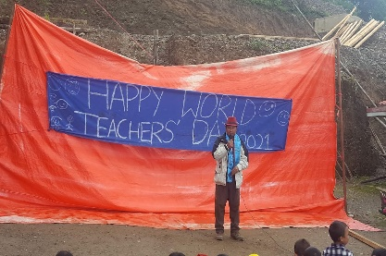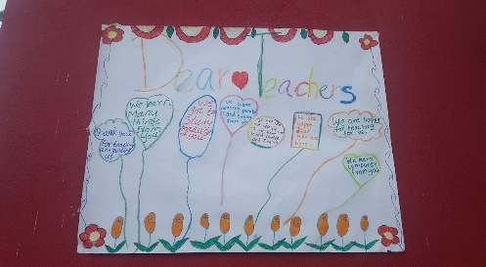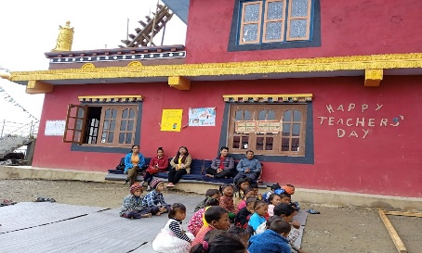
Teachers’ day pictures
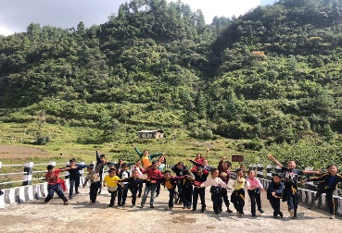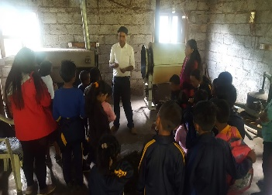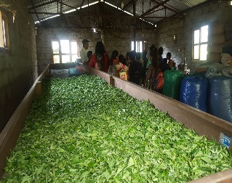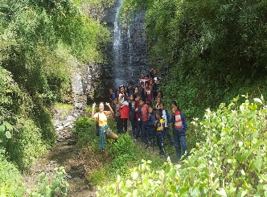
- Excursion (Tea farming)
I believed that experiential education is very important in our modern life. It is the education that uses all seven senses. The tea garden is a bit far from our community and we have to walk a bit. So, we selected students from grades one and above. We reserved a microbus and started to walk from 9:30 am. We arrived in the tea garden after an hour. We visit the tea field and kids explored the tea plants. We had snacks in the beautiful green garden and visited the nearest waterfall with a great scene. In the afternoon, we visited the tea factory and extent the tea-making knowledge. We learned about fertilizers, temperature, soil, harvesting time and process of making tea and also types. We had the opportunity of drinking tea with the manager. It was very informative and vividly to learn about tea farming.

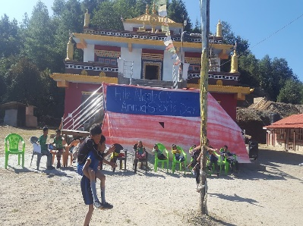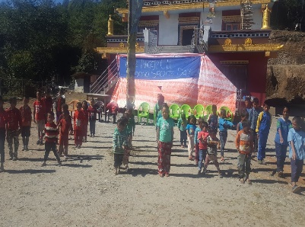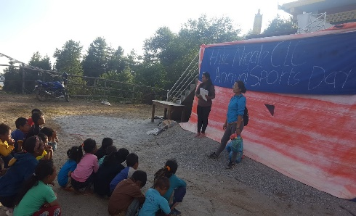
- Sports Day
I believe that sports play a vital role to the development of children’s accountability, teamwork, self-confidence, responsibility, self-discipline and chance to face the challenges in life. So, on the 30th of October, we organized a sports day. We divided the kids into three different houses and included all the kids in different games. We offered lots of games including football, high jump, long jump and etc. We organized formally and serially with all games. During breaks we distribute snacks and juices to all the participants. We nominate the position holders and gave a prize for reinforcement. It lasted for almost a whole day. I hope the children learned a lot and had a good time on this sports day.

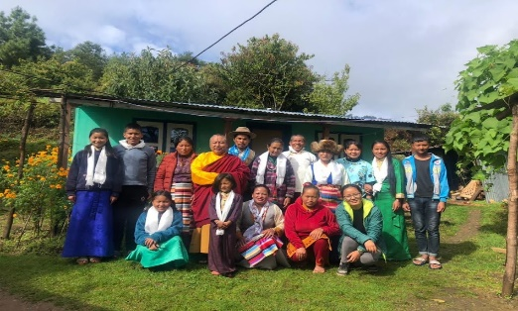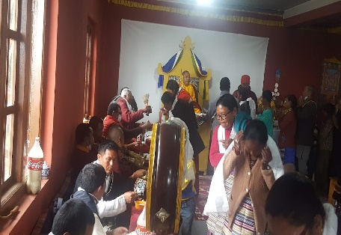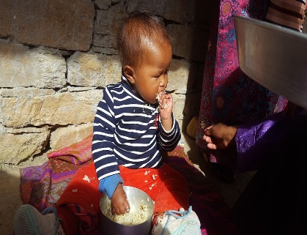
- Community peace prayer
Hile Nigale community organized a four days community peace prayer. The main focus of this prayer is to release the spirits that are roaming in the community and give trouble in the community. Since it is believed that few villagers died but their spirit is still alive in the village. These spirits take form in others bodies and ask for their satisfaction which they cannot fulfill while they were alive. The prayer ceremony took almost a week to prepare. In the beginning, there were lots of unusual acts and dramatic scenes in the prayer hall. It’s because the spirit take form in other bodies and started to show their anger, dissatisfactions and their needs. It was a very scary time for most of us. In the end, all the patients got well and prayers go well with long life empowerment from a high Lama. Everyone felt delighted and gave a great farewell to the lamas who came from Kathmandu.
It was quite busy to help them in the prayer preparations and attend the prayers.

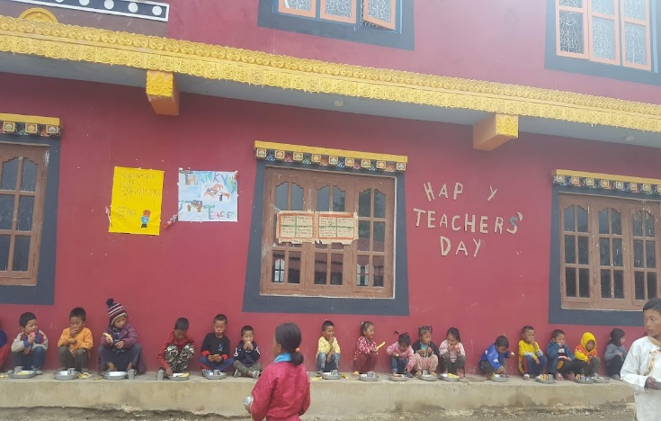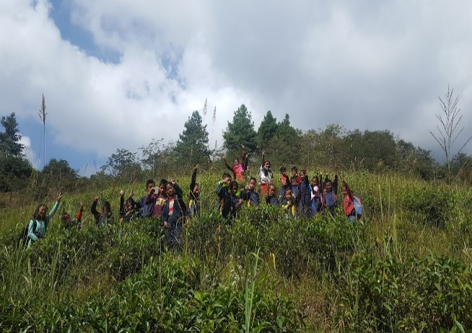
Lunch time during the teacher’s day Tea Garden

November plan 2021
- Regular class
- Arts and crafts
- Children day

