**LED Controller**

**XH-CM301**

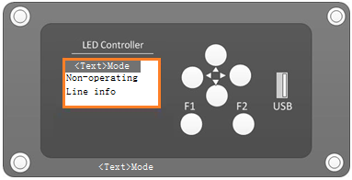

**Characteristics:**

**●Dual RS485 interface with protection**

**●OLED display device, low temperature resistant**

**●U disk import line data**

**●Manually switch bus lines**

**●Manually switch the uplink and downlink**

**●RS485 communication interface, connecting LED signs**

**●Convenient embedded installation**

**●Wide voltage power supply DC24V**

**1、Schematic diagram**

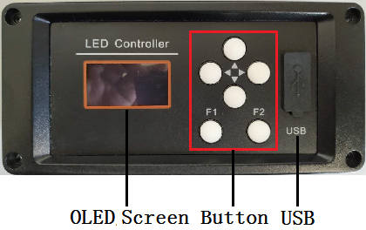

The front view

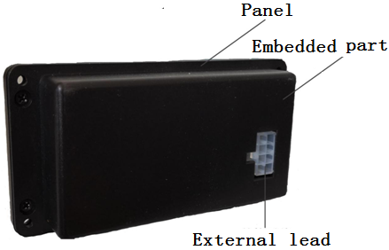

The back view

**2、Operating**

**2.1 Power on and off**

Power on: Turn on the power and turn it on, automatically enter the line selection interface or the state before power off

Standby: No operation after 30 seconds after power on, the backlight will automatically go out and enter the lock screen state; press any key to backlight, press and hold any key to unlock

Power off: Shut down when power is off

**2.2 Import of data**

a. Edit the line data of the “LEDController” through the “mBUS route editor” software.

b. Export the configuration data to the USB flash drive;

c. Insert the USB flash drive into the USB port of the “LEDController”;

d, "LCD screen" of the " LEDController " appears on the reading interface, the data is read, enter the main interface

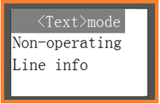

**2.3 Non-operational information**

Non-operational information is used to display special information such as “Out Service”, “Under Repair”, and “Fuel filling”. Select “Non-operational information” by pressing the UP Button ([︿] Button) or the Down Button ([﹀] Button), press the F2 Button (Confirm Button) to enter the non-operation information selection interface, and then press the Up or Down Button to select the specified information. Press the F2 Button (Confirm Button) to send the data, and automatically return to the non-operational information interface after the transmission is completed. As shown below:

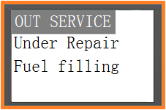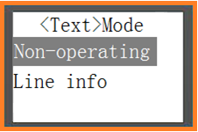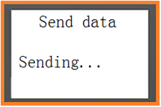

**2.4 Line selection and uplink and downlink switching**

Press the UP Button or the Down Button to select “Line information”, press the F2 Button to enter the line information selection interface, and then press the Up or Down Button to select the specified line and uplink or For downlink information, press F2 Button to send data, and automatically return to the uplink and downlink selection interface after the transmission is completed. As shown below:

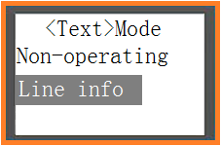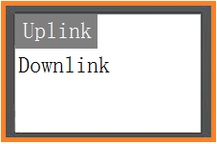

**2.5 Data forwarding**

a, The LED Controller RS485 receiving end, receiving the station;

b, The RS485 transmitter of the LED Controller and the RS485 bus of the led sign;

The LED Controller can receive the line switching, uplink and downlink switching or station data sent by the station, and automatically forward to the led sign.

**3、Technical indicators**

|  |  |  |  |
| --- | --- | --- | --- |
| **Item** | **Symbol** | **Date** | **Unit** |
| Uplink communication interface | Com1 | RS485-1 |  |
| Downlink communication interface | Com2 | RS485-2 |  |
| Lines | Lines | 30-200 | Item |
| Supply voltage | Vin | DC 24 | V |
| Power | P | 1 | W |
| Storage temperature | Tstg | -40～+85 | ℃ |
| Operating temperature | Topr | -40～+70 | ℃ |

1. **The definition of external leads**

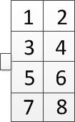

|  |  |  |
| --- | --- | --- |
| Pin | Definition | Features |
| Pin1 | GND | GND |
| Pin2 | VCC | DC 24V |
| Pin3 | SOS- | External switch |
| Pin4 | SOS+ | External switch |
| Pin5 | RS485-A | The RS485-Aof the host |
| Pin6 | RS485-A | The RS485-Aofled sign |
| Pin7 | RS485-B | The RS485-bof the host |
| Pin8 | RS485-B | The RS485-Bofled sign |

**5、Dimensions**

