Names students:
1 Pablo Guerrero
2 Emma Bay
3 Olatz Salcedo
4 Salma Salim

Questionnaire korfball
- Have you ever heard of this sport before? Yes
- Have you ever seen this sport on TV? No
- Have you ever attended a match of this sport? No
- Are you familiar with the most important rules of this sport? No
- Can you also play this sport at an older age? Yes
- Do people play this sport indoors or outdoors? Outdoors
- Is this sport only available for men, or also for women? Both
- Are there mixed teams in this sport? Yes
- Is this a technically difficult sport? No
- Is this a physically demanding sport? No
- Which club in your country is the best at this sport? Answer: we think that our country doesn't have a club
- Do you know who won the most recent European Championships for this sport? Answer: No
- Do you know who won the most recent World Championships for this sport? Answer: no
- In which countries is this sport popular do you think? Answer: Netherlands
- Is this sport similar to another sport you’re familiar with? Yes If so, which one? Answer: basketball
- Do you know anyone famous who plays this sport? Answer: no
- Do people in your country play this sport? No
- Do you know anyone who plays this sport (friend/family etc.)? No
- Would you like to play this sport yourself? No
- Do you think you would be talented at this sport? No

======================
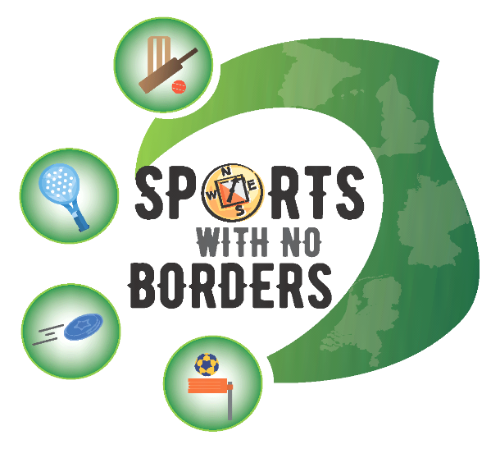

Names students:
1.Nicolás Vélez
2.Lucas Maté
3.Pablo Salamanca
4.Marina García
5.Marina Alarcos

Questionnaire korfball
- Have you ever heard of this sport before? Yes / No
- Have you ever seen this sport on TV? Yes / No
- Have you ever attended a match of this sport? Yes / No
- Are you familiar with the most important rules of this sport? Yes / No
- Can you also play this sport at an older age? Yes / No
- Do people play this sport indoors or outdoors? Indoor / Outdoors
- Is this sport only available for men, or also for women? Men / Women / Both
- Are there mixed teams in this sport? Yes / No
- Is this a technically difficult sport? Yes / No
- Is this a physically demanding sport? Yes / No
- Which club in your country is the best at this sport? Answer: club Castellbisbal
- Do you know who won the most recent European Championships for this sport? Answer;The Netherlands
- Do you know who won the most recent World Championships for this sport? Answer: The Netherlands
- In which countries is this sport popular do you think? Answer : belgium and netherlands
- Is this sport similar to another sport you’re familiar with? Yes / No If so, which one? Answer: Basketball
- Do you know anyone famous who plays this sport? Answer: no
- Do people in your country play this sport? Yes / No
- Do you know anyone who plays this sport (friend/family etc.)? Yes / No
- Would you like to play this sport yourself? Yes / No
- Do you think you would be talented at this sport? Yes / No

======================

Names students:
1.Nicolás Vélez
2.Lucas Maté
3.Pablo Salamanca
4.Marina García
5.Marina Alarcos

Questionnaire korfball
- Have you ever heard of this sport before? Yes / No
- Have you ever seen this sport on TV? Yes / No
- Have you ever attended a match of this sport? Yes / No
- Are you familiar with the most important rules of this sport? Yes / No
- Can you also play this sport at an older age? Yes / No
- Do people play this sport indoors or outdoors? Indoor / Outdoors
- Is this sport only available for men, or also for women? Men / Women / Both
- Are there mixed teams in this sport? Yes / No
- Is this a technically difficult sport? Yes / No
- Is this a physically demanding sport? Yes / No
- Which club in your country is the best at this sport? Answer: club Castellbisbal
- Do you know who won the most recent European Championships for this sport? Answer;The Netherlands
- Do you know who won the most recent World Championships for this sport? Answer: The Netherlands
- In which countries is this sport popular do you think? Answer : belgium and netherlands
- Is this sport similar to another sport you’re familiar with? Yes / No If so, which one? Answer: Basketball
- Do you know anyone famous who plays this sport? Answer: no
- Do people in your country play this sport? Yes / No
- Do you know anyone who plays this sport (friend/family etc.)? Yes / No
- Would you like to play this sport yourself? Yes / No
- Do you think you would be talented at this sport? Yes / No

======================

Names students:
1…………………………………………
2…………………………………………
3…………………………………………
4…………………………………………

Questionnaire korfball
- Have you ever heard of this sport before? Yes / No
- Have you ever seen this sport on TV? Yes / No
- Have you ever attended a match of this sport? Yes / No
- Are you familiar with the most important rules of this sport? Yes / No
- Can you also play this sport at an older age? Yes / No
- Do people play this sport indoors or outdoors? Indoor / Outdoors
- Is this sport only available for men, or also for women? Men / Women / Both
- Are there mixed teams in this sport? Yes / No
- Is this a technically difficult sport? Yes / No
- Is this a physically demanding sport? Yes / No
- Which club in your country is the best at this sport? Answer:the catalan club
- Do you know who won the most recent European Championships for this sport? Answer: the Netherlands
- Do you know who won the most recent World Championships for this sport? Answer: the Netherlands
- In which countries is this sport popular do you think? Answer:Belgium,Germany,England and Netherlands
- Is this sport similar to another sport you’re familiar with? Yes / No If so, which one? Answer:it´s similar to the basketball
- Do you know anyone famous who plays this sport? Answer:Mr.Ludo Wils
- Do people in your country play this sport? Yes / No
- Do you know anyone who plays this sport (friend/family etc.)? Yes / No
- Would you like to play this sport yourself? Yes / No
- Do you think you would be talented at this sport? Yes / No

======================

Names students:
1Amador García López………………………………………
2Sara Balmori de Julian………………………………………
3Rodrigo Muñoz Calderón……………………………………
4Cristina Ruíz Ledesma……………………………………

Questionnaire korfball
- Have you ever heard of this sport before? Yes / No
- Have you ever seen this sport on TV? Yes / No
- Have you ever attended a match of this sport? Yes / No
- Are you familiar with the most important rules of this sport? Yes / No
- Can you also play this sport at an older age? Yes / No
- Do people play this sport indoors or outdoors? Indoor / Outdoors
- Is this sport only available for men, or also for women? Men / Women / Both
- Are there mixed teams in this sport? Yes / No
- Is this a technically difficult sport? Yes / No
- Is this a physically demanding sport? Yes / No
- Which club in your country is the best at this sport?Answer: The Club Catalunya
- Do you know who won the most recent European Championships for this sport? Answer: The Netherlands
- Do you know who won the most recent World Championships for this sport? Answer: The Netherlands
- In which countries is this sport popular do you think? Answer: The Netherlands, Germany, Belgium...
- Is this sport similar to another sport you’re familiar with? Yes / No If so, which one? Answer: Basketball
- Do you know anyone famous who plays this sport? Answer: No
- Do people in your country play this sport? Yes / No
- Do you know anyone who plays this sport (friend/family etc.)? Yes / No
- Would you like to play this sport yourself? Yes / No
- Do you think you would be talented at this sport? Yes / No

======================

Names students:
1 Marcos Alonso
2 Laura Fernández
3 Carla Paola Chuchuca
4 Naiara Salcedo

Questionnaire korfball
- Have you ever heard of this sport before? Yes
- Have you ever seen this sport on TV? No
- Have you ever attended a match of this sport? No
- Are you familiar with the most important rules of this sport? No
- Can you also play this sport at an older age? Yes
- Do people play this sport indoors or outdoors? Outdoors
- Is this sport only available for men, or also for women? Both
- Are there mixed teams in this sport? Yes
- Is this a technically difficult sport? Yes
- Is this a physically demanding sport? No
- Which club in your country is the best at this sport? Answer: Catalunya
- Do you know who won the most recent European Championships for this sport? Answer: we don’t know
- Do you know who won the most recent World Championships for this sport? Answer: we don’t know
- In which countries is this sport popular do you think? Answer: USA, UK, Ireland, Australia, New Zeland, Czech Repulic, Netherland, Belgium.
- Is this sport similar to another sport you’re familiar with? Yes If so, which one? Answer: Basketball
- Do you know anyone famous who plays this sport? Answer: No
- Do people in your country play this sport? Yes
- Do you know anyone who plays this sport (friend/family etc.)? No
- Would you like to play this sport yourself? No
- Do you think you would be talented at this sport? No

======================

