Preisanfrage und Bestellschein

Fill out the inquiry and order form as accurately as possible so that we can process your order quickly and easily.
Please make a price inquiry in the first step so that we can calculate the price including PayPal fees and shipping costs.
Please save the form on your computer, as you will need it as an order form.
In the second step, please select order and transfer the amount we inform you about to the following PayPal account: quadster31@gmail.com.
Please enter in the order form under the item PayPal transaction number the number PayPal generated during the transfer. This way we can easily assign your order to the payment.
As soon as we have received the money, your order is legally binding.

Please send the form when requesting a price and placing an order to:
cpucarpartcom@gmail.com

☐Price Inquiry | ☐Order
- Personal Data
Name, Surname | Klicken oder tippen Sie hier, um Text einzugeben.
Street, No. | Klicken oder tippen Sie hier, um Text einzugeben.
Post code, City | Klicken oder tippen Sie hier, um Text einzugeben.
Country | Klicken oder tippen Sie hier, um Text einzugeben.
Telephone number | Klicken oder tippen Sie hier, um Text einzugeben.
E-Mail Address | Klicken oder tippen Sie hier, um Text einzugeben.
PayPal Name / Address | Klicken oder tippen Sie hier, um Text einzugeben.
PayPal Transaction number after payment | Klicken oder tippen Sie hier, um Text einzugeben.
Date of Payment | Klicken oder tippen Sie hier, um Text einzugeben.
Amount | Klicken oder tippen Sie hier, um Text einzugeben.
Article number / Description of the goods | Klicken oder tippen Sie hier, um Text einzugeben.
Quantity | Klicken oder tippen Sie hier, um Text einzugeben.
Vehicle make, model, year of manufacture | Klicken oder tippen Sie hier, um Text einzugeben.
For floor mats / carpets special specifications (after consultation) | Klicken oder tippen Sie hier, um Text einzugeben.
- Specifications about your inquiry / order
Set size (please tick)

☐Front
☐Back
☐Trunk
☐ Caravan / camper custom made including molding
☐ Caravan / camper special production without impression

Especially for Ineos Grenadier:

☐Set 3 side panels front, center console rear
☐Set 6 Footrest mat driver side

Please choose your quality of floor mats | 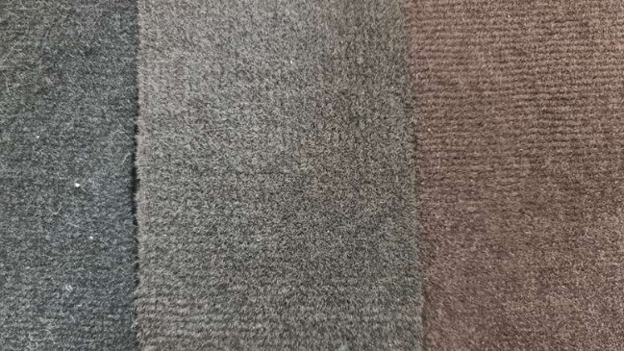
☐ Premium polyamide velour foam backing (Best quality) Black, 16 EUR / m²

☐ Premium Polyamide Velour Foam Backing (Best Quality) Dark Brown, 16 EUR / m²

☐Medium polyamide velour granulate hard back (Medium quality, not suitable for smooth surfaces) Black, 12 EUR / m²

☐ Standard polypropylene velour foam backing (Standard quality of the manufacturer) Dark gray,
9 EUR / m²
Additional option: aluminum footrest blasted and screwed | 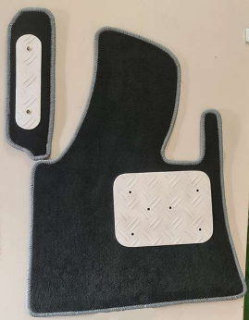
☐ Heel guard driver mat aluminum blasted and screwed
☐ Footrest driver's side (if available in the car model)
☐ Footrest passenger side (if available in car model)

Please select your desired chain color. Please define with light, medium or dark or specify exact color designation. (Example: instead of dark red please specify Bordeaux red)  Klicken oder tippen Sie hier, um Text einzugeben. | 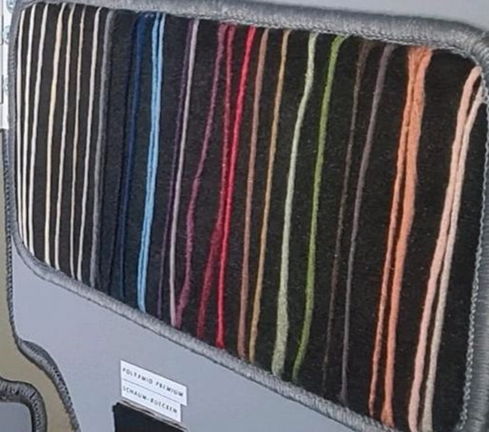
- Final Information
How did you become aware of our goods?
☐Kleinanzeigen.de
☐cpucarpart.com
☐personal contact
Klicken oder tippen Sie hier, um Text einzugeben.
☐other:

Did you ask us the price including PayPal fees and shipping costs?
☐Yes

☐ No, please tell me the transfer amount.

