Slavery and forced labour in the
21st century
In order to be able to talk about slavery and forced labour, you first have to define what these are. Slavery is defined as: “the condition in which one person is owned as property by another and is under the owner’s control, especially in involuntary servitude.” Forced labour on the other hand is “any work or service which people are forced to do against their will, under threat of punishment.”
A lot of people think that, since we live in the 21st century, slavery and forced labour don’t happen anymore, especially since nobody sees them with their own eyes. Formally they don’t exist anymore, but the sad truth is that slavery and forced labour happen all over the world, even where we least expect it: in our own countries. The Global Slavery Index estimated an amount of 40.3 million slaves in 2016 of which 24.9 million endure forced labour and 15.4 million are living in a forced marriage. Women and girls make up 71 percent of all victims.3 These estimates do not include other forms of modern slavery such as organ trafficking, child soldiers and child marriage. The countries with the most slaves are India, China, Pakistan, Bangladesh and Uzbekistan. Together they make up 58% of all worldwide estimated slaves. In India the 18.3 million slaves are forced to work as maids, prostitutes, child soldiers or in the textile industry or agriculture. Many are indentured servants who work to pay off their loans.
Not only are there slaves and forced labourers in less developed countries with bad living standards but also right under our noses. Germany has an estimate of 30,000 victims, mostly prostitutes, household help or unskilled labourers brought from Eastern Europe. Many have no chance to change their current situation due to psychological pressure, language barriers, lack of money or just plain fear. Although slavery and forced labour are against the law, there is no way to be sure slavery has been completely abolished. Sadly, there will always be some cases.
In 2018, 122 countries criminalized human trafficking, 38 countries criminalized forced marriage and 154 countries provide service for victims.3 Furthermore 36 countries are investigating forced labour in private or public supply chains. There is an enormous potential to reduce the number of people in forced labour by tackling government supply chains and governments are additionally strengthening criminal justice responses concerning modern slavery. 118 governments have provided funding to victim support services or shelters since 2016. The cooperative initiative BPGBF combats modern slavery and human trafficking in the Indo-Pacific Region. The following countries are those whose governments took the most action to respond to modern slavery: The Netherlands, United States, United Kingdom, Sweden, and Belgium. They are characterized by high levels of resources, strong political will, and a strong civil society, holding governments accountable for their actions3.
In their Global Slavery Index 2018 the Walk Free Foundation gives countless examples of victims and their situations. I chose two who in my opinion presented the victims’ options as a forced labourer/slave very well:
Princess, 43, trafficked from Nigeria into forced sexual exploitation in Italy: “We saw people return from Europe rich. A woman said she would give me work in a Nigerian restaurant in Italy. When I arrived I was told I had to pay back a £40,000 debt before I could leave. They said they would kill me if I didn’t work as a prostitute. The work was so dangerous. I was stabbed twice. I managed to leave, and now I work to help other women escape. These traffickers take everything from you – all that makes you human.”3
Yum, 29, sold from Cambodia to a Thai fishing boat: “One of my friends said he and a few others were leaving to find work. The next day we got a taxi and headed for Thailand. A man offered us £150 to work on a construction site, but drove us to a busy sea port instead. We sailed for days before they told us we’d been sold to the Thais to work as fishermen. After nine months at sea, I knew I had to escape. Now I have a newborn baby, a wife and no prospects of work. Maybe I will try to find work again in Thailand.”3
Slavery and forced labour have horrible consequences for the victims. They suffer from bad living conditions, no alternatives and cruel bosses. The worst consequence is probably the vicious cycle of replaceability. Because the people are poor, they will take any job they can get, no matter the working conditions, in order to make (usually less than) a minimum wage. And since so many are poor, the bosses have the ability to choose whoever they want, in this case the cheapest labourers. The labourers can not afford to lose their jobs by aggravating their bosses and are therefore silent instead of fighting for better rights. This is also why many children work as child labourers. Their families need the children’s income to just survive.
After reading all these terrible aspects, one might wonder why slavery and forced labour still exist. Well, first of all, as stated above, one can never completely ensure slavery is abolished and, secondly, even the worst things have positive aspects, or at least someone who profits from the misfortune of others. In this case it would be the exploiting bosses/companies and wealthier countries. We are able to buy strawberries when they’re not in season, meat and clothes which cost less than they are worth and overpriced electronics which were assembled by (forced) labourers for way less than a minimum wage.
Last but not least I would like to present options on how you can help end slavery and forced labour:
- Inform others about slavery/forced labour (even via social media)
- Call “Gewalt gegen Frauen” or the police if you suspect someone needs help
- Donate to “Gemeinsam gegen Menschenhandel” or “Free the Slaves” to help end slavery and unfair employment practices worldwide
- Contact your representative in the Land- or Bundestag
- Buy Fairtrade products
- Buy fewer low-quality products
- Raise funds and awareness by organizing an event
Nobody can expect you to do all of these but if you want to make the world a better place or simply think slavery and forced labour is wrong, try to do your part by preventing - or at least reducing it.

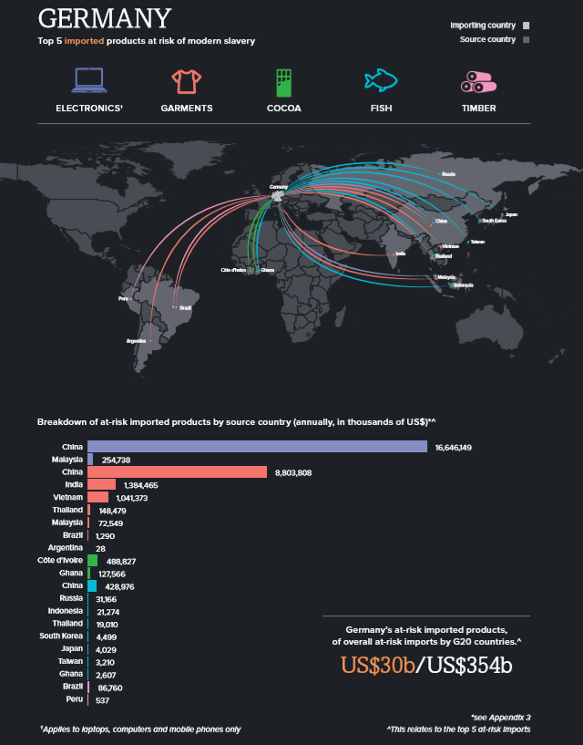

Source: https://www.thefreedictionary.com/slavery (03 June 2020)
Source: https://www.antislavery.org/slavery-today/forced-labour/ (03 June 2020)
Source: https://downloads.globalslaveryindex.org/ephemeral/GSI-2018_FNL_190828_CO_DIGITAL_P-1591258437.pdf (03 June 2020)
Source: https://www.stuttgarter-zeitung.de/inhalt.studie-zur-sklaverei-14500-menschen-in-deutschland-leben-als-sklaven.724ba991-0504-432d-a197-9d4bc0458fff.html (03 June 2020)
Source: https://www.sueddeutsche.de/politik/menschenhandel-sklaven-in-deutschland-1.158601 (03 June 2020)
Source 2013: https://resourcecentre.savethechildren.net/library/global-slavery-index-2013 Source 2014: https://www.dh-cii.eu/0_content/Global_Slavery_Index_2014_final_lowres.pdf Source 2016: https://downloads.globalslaveryindex.org/ephemeral/GSI-2018_FNL_190828_CO_DIGITAL_P-1591188914.pdf

