Name: ____________________ Datum: ____________

5 Minuten-Test: 1 000 zerlegen

· 8

· 5

· 2

· 4

· 1

· 50

· 40

· 20

· 25

· 10

· 100

· 125

· 250

· 500

· 1 000

1 000

1 000

1 000

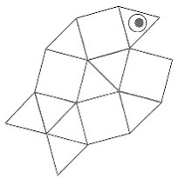
Viel Erfolg !

Name: ____________________ Datum: ____________
5 Minuten-Test: 1 000 zerlegen (2. Versuch)

· 1

· 2

· 5

· 4

· 8

· 50

· 40

· 20

· 25

· 10

· 100

· 125

· 250

· 500

· 1 000

1 000

1 000

1 000

Viel Erfolg !
-
O
+

Bemerkung: ______________________________________________________

_______________________________________________________________

_______________________________________________________________

Datum: __________________
Unterschrift Lehrer/in: ____________________________________

Unterschrift Eltern: _____________________________________

-
O
+

Bemerkung: ______________________________________________________

_______________________________________________________________

_______________________________________________________________

Datum: __________________
Unterschrift Lehrer/in: ____________________________________

Unterschrift Eltern: _____________________________________

