What is Ultimate?
Who gets more air than a basketball player, more floor than a rugby player and pulls at every tournament?
That’s an Ultimate Player.
It’s an exciting, non-contact team sport played by thousands all over the world in Open, Mixed and Women’s teams. Ultimate is a fast-paced game, demanding its players to develop razor sharp throwing skills and immense stamina and agility. It is recognized by the IWGA, all of the UK Sports Councils and the Australian Sports Commission, to just name a few. Ultimate is the only IOC recognized sport to be self-officiating and promote Spirit Of The Game (SOTG); this means players know the game and rules inside out and understand the meaning of fair play.
Ultimate is an intense sport but it’s also very newcomer friendly. The ‘Ultimate community‘ is something people often refer to and you can easily understand why, as the opportunity for beginners to get involved and get competitive at a fun level are widespread in lots of countries. You can hear many Ultimate players refer to their teams as their family, and in some teams you spend almost as much time together as if they were. The rules you need to know in order to start are easy to pick up and most teams cultivate a ‘grown from home’ attitude, meaning they’re willing to absorb you into the team and let team members teach you as you play.
Sound like it’s for you, even slightly? Then come on in…
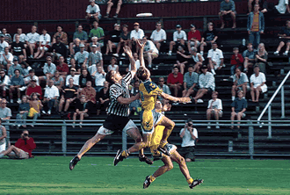Photo by Jon Hope
Oh, and by the way, it’s played with a flying disc (a “Frisbee” to the man in the street).

The Rules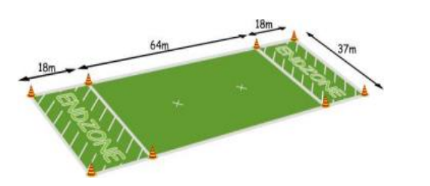
Ultimate in 10 simple rules
- The Field — A rectangular shape with endzones at each end. A regulation field is 64m by 37m, with endzones 18m deep.
- Initiate Play — Each point begins with both teams lining up on the front of their respective endzone line. The defense throws (“pulls”) the disc to the offense. A regulation game has seven players per team.
- Scoring — Each time the offense completes a pass in the defense’s endzone, the offense scores a point. Play is initiated after each score.
- Movement of the Disc — The disc may be advanced in any direction by completing a pass to a teammate. Players may not run with the disc. The person with the disc (“thrower”) has ten seconds to throw the disc. The defender guarding the thrower (“marker”) counts out the stall count.
- Change of possession — When a pass in not completed (e.g. out of bounds, drop, block, interception), the defense immediately takes possession of the disc and becomes the offense.
- Substitutions — Players not in the game may replace players in the game after a score and during an injury timeout.
- Non-contact — No physical contact is allowed between players. Picks and screens are also prohibited. A foul occurs when contact is made.
- Fouls — When a player initiates contact on another player a foul occurs. When a foul disrupts possession, the play resumes as if the possession was retained. If the player committing the foul disagrees with the foul call, the play is redone.
- Self-Refereeing — Players are responsible for their own foul and line calls. Players resolve their own disputes.
- Spirit of the Game — Ultimate stresses sportsmanship and fair play. Competitive play is encouraged, but never at the expense of respect between players, adherence to the rules, and the basic joy of play.

History Of The Game
David Leiwant stood in the Columbia High School parking lot watching the younger players throw, chase, and catch the disc under the bright white lights and the cover of a summer night. “If you squint your eyes, it’s almost like 25 years ago,” said the 42-year-old Leiwant, a 1973 alumnus of Columbia, located in Maplewood, N.J. “Just a rag-tag bunch of guys running around with a Frisbee.”
Leiwant was a 13-year-old seventh-grader in 1968, a tumultuous year for America and the world. Martin Luther King, Jr., and then Bobby Kennedy were assassinated, a war raged in Vietnam and the country was coming to grips with the civil rights and women’s rights revolutions. But, in one corner of the country, in Maplewood, things were changing for the better. That year, staff members of the school’s newspaper, The Colombian, and its Student Council developed an entirely new sport as a gag and an activity for their high school nights. Led by Joel Silver, the willful, if somewhat arrogant, member of the Council and the newspaper, the students adapted the rules of Frisbee Football and ultimately invented the fast-moving team sport we know today. The sport of Ultimate.
“Joel Silver said it was the ultimate sports experience,” Leiwant said. “He said, ‘Someday people all over the world will be playing this game’, and we all said, “Yeah, Joel, right.”
Thirty years after Silver’s prophetic words, Ultimate is played in 42 countries, with programs in Sweden, Norway, and Japan receiving government funding. It is estimated that at least 100,000 people play the sport worldwide, about half in the United States. Ultimate will be a medal sport in the 2001 World Games in Japan.
Silver, who is now the head of Hollywood’s Silver Pictures and was unavailable for comment because he was working on the filming of Lethal Weapon 4, had played Frisbee Football at a camp in Mount Hermon, Massachusetts in the summer of 1967. When he returned home to Maplewood, he continued to throw with his friends, including Bernard “Buzzy” Hellring, the editor of The Colombian, and Jonny Hines, the newspaper’s sports editor. Although Frisbee was not quite as big a fad as the hula hoop in the 1950s and ’60s, discs were beginning to seep into the American consciousness.
“I started throwing a Frisbee in 1961 with my two sisters,” said Ed Summers, who graduated Columbia High in 1972. “It was a big fad. We threw mostly backhands. The other big throw was the overhand wrist flip.”

http://www.sportunterricht.de/ultimate/

