Registration Form
Name: |  |  | Surname:
Address: |  |  | ZIP/Town:
E-Mail: |  |  | Phone:
Date of Birth: |  |  | Company:
Package of hours*: | 4 5 10 20 30 40 50 100
Type*: | AV Standard AV Flexible
E-Mail Support*: | yes no *see the prices at the bottom
Start date: |  |  | Finish date:
Content: | Please, let us know about your needs on page 2
My level: | A0 A1 A2 B1 B2 C1
1 lesson = 50 minutes / timetable to be discussed
Please, send the completed form by e-mail to: info@biku.ch
Accent will get in touch with you shortly.
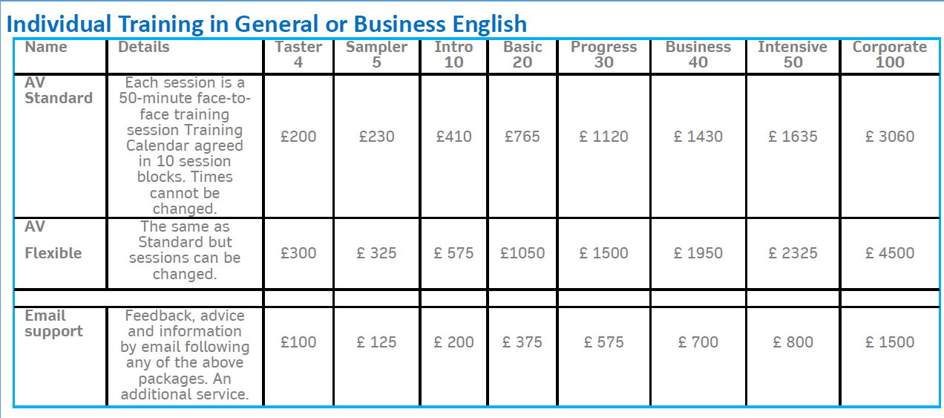

Needs Analysis Questionnaire
This questionnaire is designed to help Accent plan your course and select or design suitable course materials for you. Please complete the questionnaire yourself. Think about each question carefully and then write short answers. Do not worry about writing correctly!

Background
Please write two or three sentences about your job, your responsibilities and your company
Experience with English
Please write two or three sentences about your experience of using English. For example: Have you had lessons recently? Do you use English regularly? Where and when do you study English now?
Needs for English
Please write two or three sentences about why you need to improve your English and about the situations where you will need to use English in the future.
Special Requirement
Please describe here.

