Migmar Bhuti lama
May and June report 2021
Teaching in Hile Nigale, Nepal
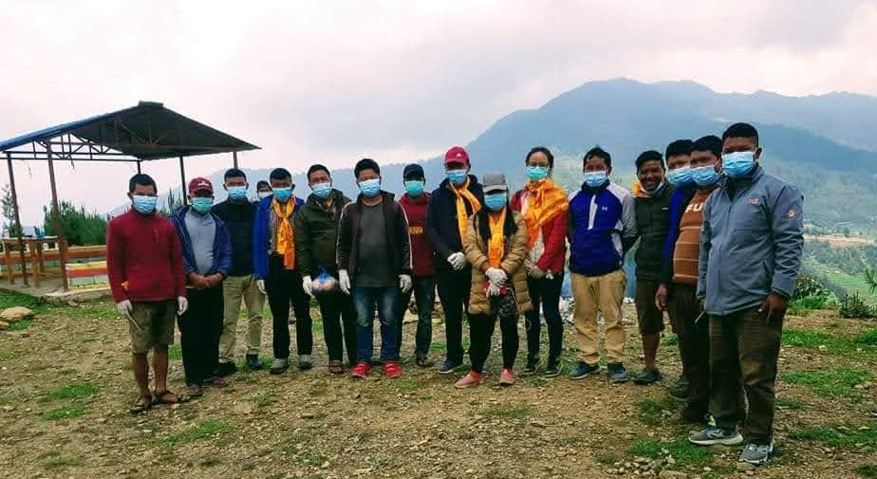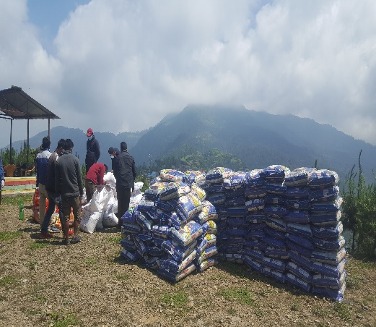
Pandemic food relief Aid
An increase in coronavirus infections around the world is forcing our Community Center to implement lockdown measures to control the spread of the virus. Since there were few infected victims around neighboring villages. We were forced to stay at home and we visited few houses. During those times, we have witnessed that many people were affected financially and mentally especially to the daily wages. So, my friend came up with an idea that let’s try on fundraising for the pandemic food relief in Hile, Nigale Community.
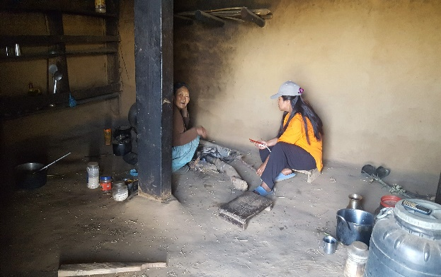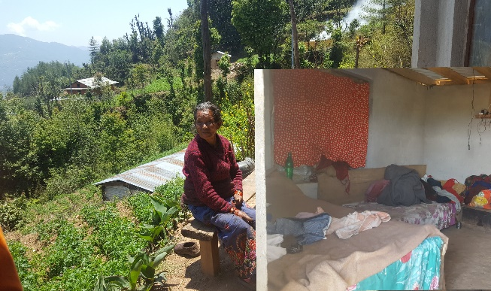
Similarly, without any objections, I supported her idea but we were not sure to get the relief aid. We believed and moved forward spontaneously on the internet and we found one of our friends was providing pandemic food relief aid in Kathmandu. Immediately, we contact one of our teachers whose team was involved in sponsoring food relief aid in Kathmandu. 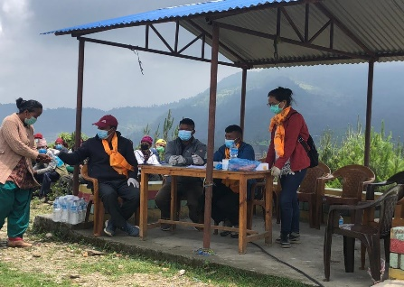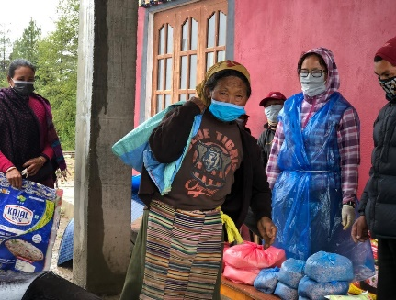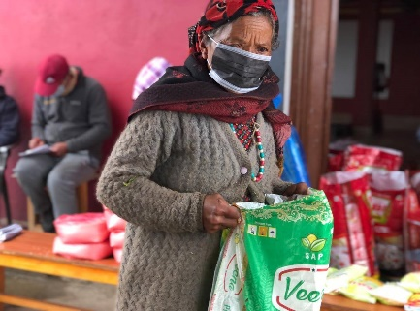
He was accepted and sent financial support in Hile, Nigale Sherpa community at the initiative of me and my friend Pemba. So, we were able to help hand in the situation of food shortage in this community with 5kg of rice, 3kg of lentils, one liter of oil, and 1kg of salt for each household.
Meanwhile, we contacted one of our Tibetan friends who was involved in providing pandemic food relief. He offered help with 12kg of rice, 4kg of lentils, 1-liter oil, 5kg of wheat flour, and one packet of mixed species. We took the initiative and able to feed 85 households in Hile, Nigale community.
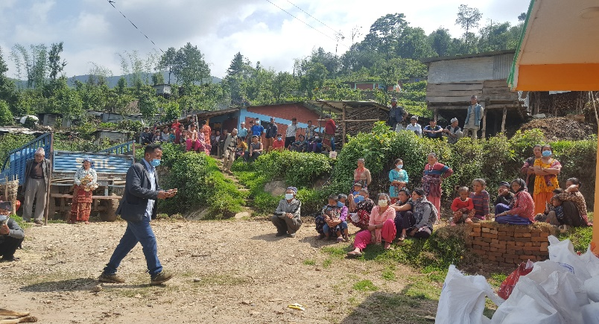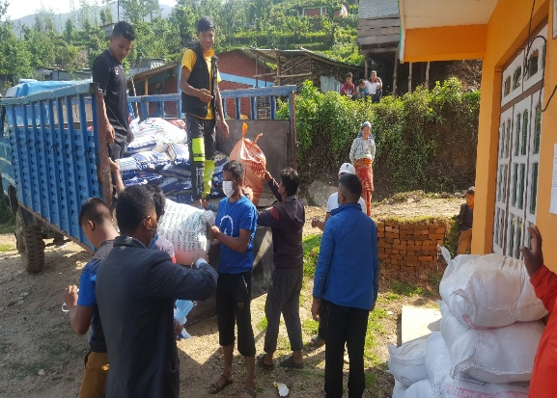
We upload some pictures on social media and one of our Chinese student's mothers saw it. She told us that if we need any help in this pandemic time. Please let me know! We rest for a week and keep on opening our ears around the situation of neighbor’s village. Finally, we thought that it is better to do something than to sit idle. Without any further delay, we request her to help out in neighboring villages. She was happy to deliver a food relief program in the next two different neighboring villages without any doubt at our initiative. We were able to feed 225 households with 25kg of rice, 5kg of lentils, 1 Liter of oil, and 5 kg of wheat flour.

Overall, I felt privileged to serve this community in hard times. Though I cannot do anything from my own side, it’s great that my words and action could please these needy people.

During the Holiday
It is bored to stay a whole day in the house. Therefore, we often visited our empty class to prepare some teaching materials like charts, cards, and assessment or evaluation test papers. I wrote the drama script according to our lesson plan. Currently, the infected cases are decreasing and I hope our community center will resume soon.

