December 2021 report
Migmar Bhuti Lama
Teaching in Hile Nigale

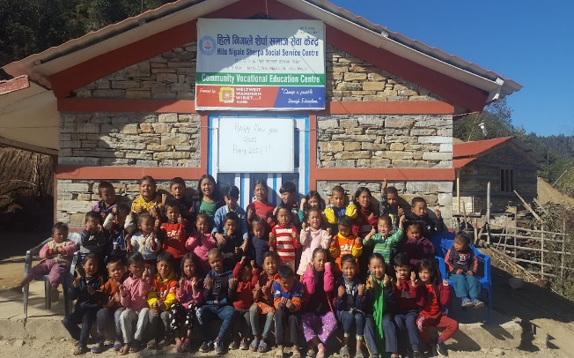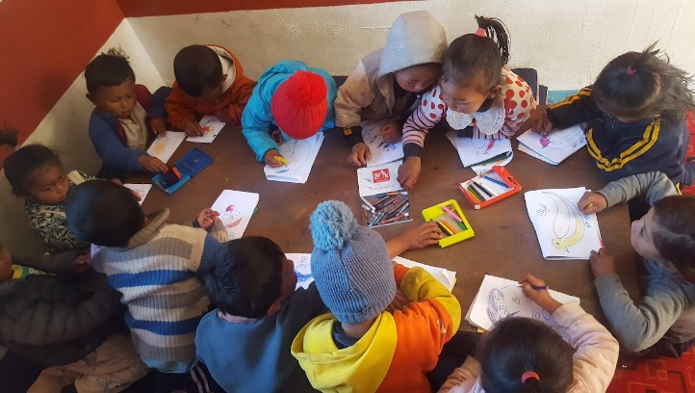
- Daily Schedule
This month, I taught a new lesson on compound words, Wh-questions, and introduced the nouns and their types. I did different activities based on this theme like matching the pictures, filling in the blanks, finding the words in the simple paragraphs, other exercises and videos based on those themes. Besides, I did some artwork and completed one English dance for the program. We learned a few new rhymes. I believe the children enjoyed their time.

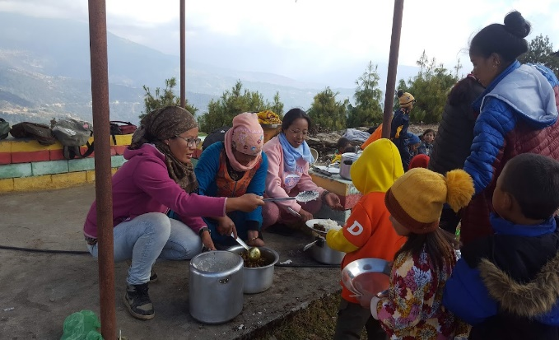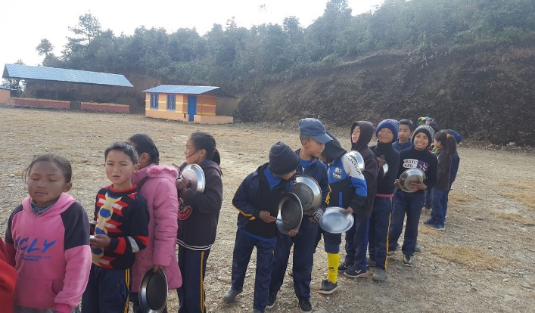

- Children picnic
We had Nepali Festival called Tihar last month. During that time, we performed some dances and songs for the villagers. At the end of our program, they donated a little amount of money for the children. So, we (teachers) decided to invest in a community center picnic. We were waiting for the best time and place. Finally, December 25 seems the best time to take them on a picnic. We decided on a picnic sport where all the children can involve since small children cannot walk. We choose Saturday and take them to the nearby place where everyone can walk and enjoy their time.
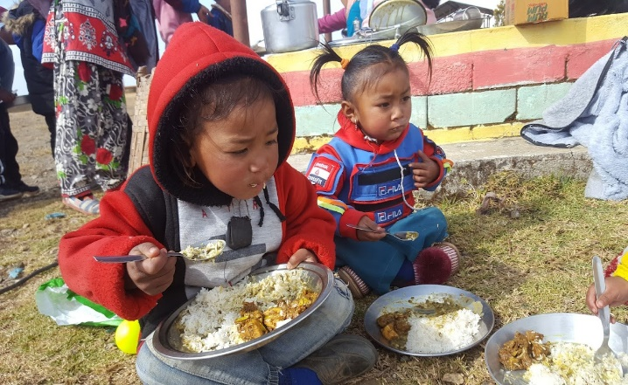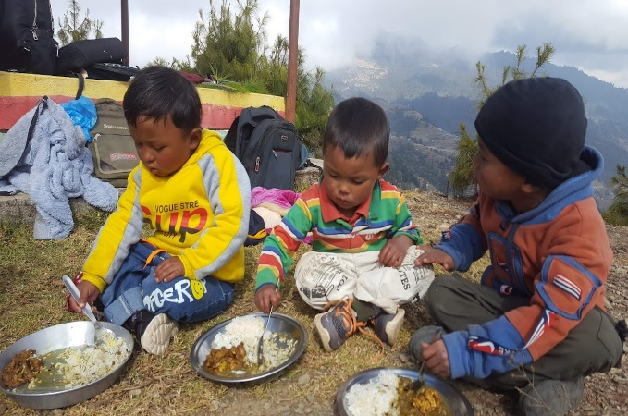
Lunch time during picnic

- Prepared programs for the budget announcement
This month we had a first-ever community center annual budget announcement. So, we decided to organize formally with other entertainment programs. We prepare some dance and songs with adults from the village. We practice this program for two weeks. Unfortunately, the program was postponed because villagers were mourning for one old lady who passed away recently. Probably, they will perform it next month.

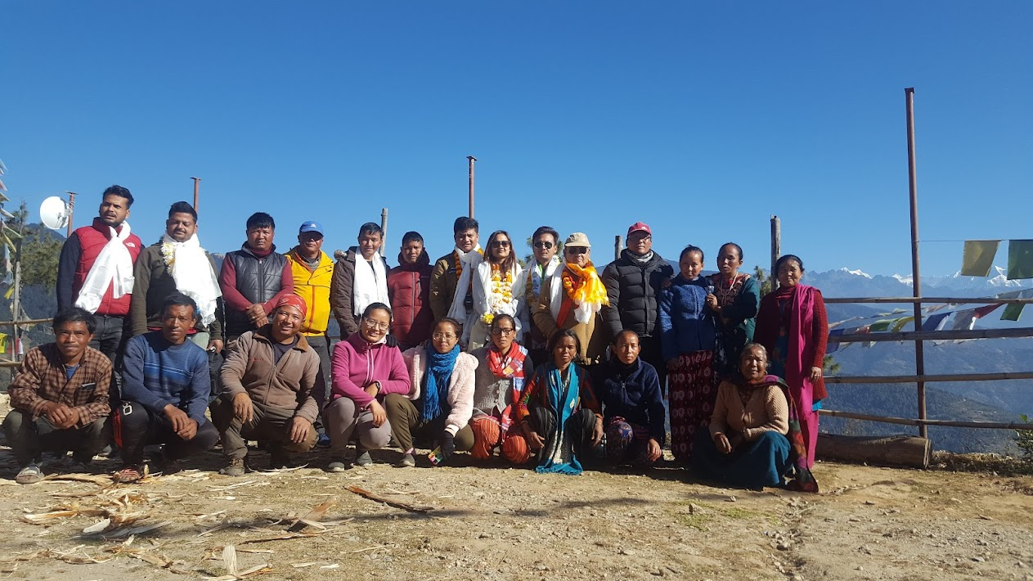

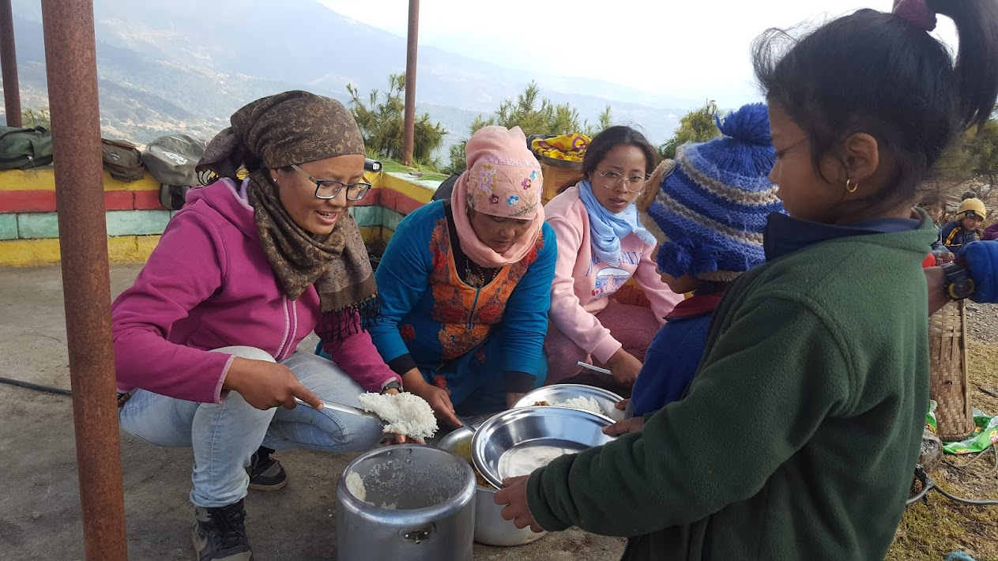
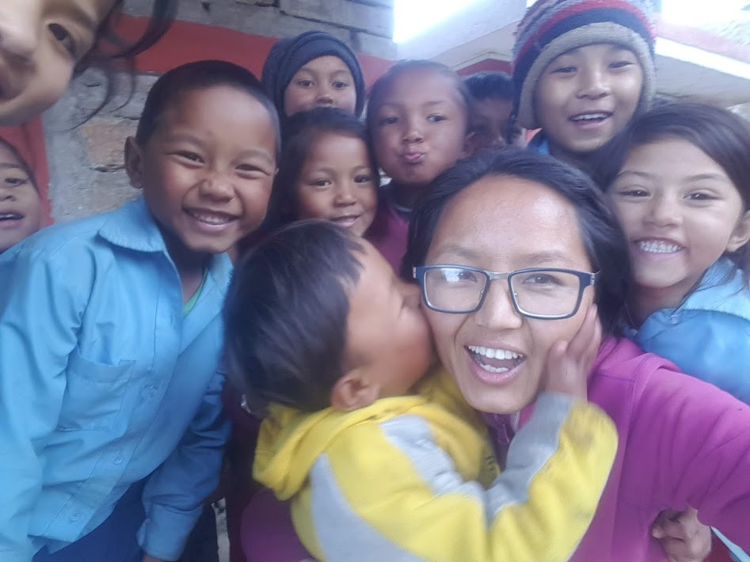
I am going to Miss these children all the time!!!

THANK YOU!!

