**Camel-croquet**

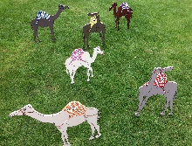

Build a trail with the camels and the turning post.

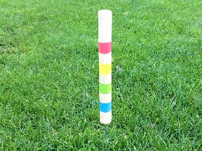

The turning post serves as the start and end point. eindpunt.

The ball must be played under all the camels, around the turning post and back to the starting post.

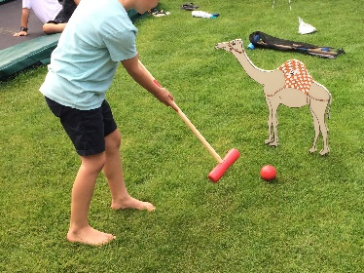

Every player gets a ball and a hammer in the same color.

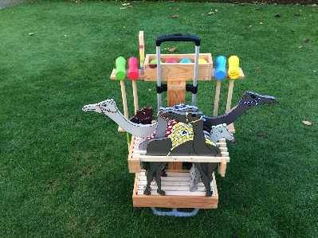

The order of the players is determined by the color of the the starting post.

The player, who first hits the the endpost with the ball after completing the course, is the winner.

Lots of fun!

Info: officeecroa@gmail.com