SUNDAY 10 FEBRUARY
Today we have travelled by plane to The Netherlands. We have met our mates at the airport of Brussels, they were nice. After, Spanish and Dutch students travelled by bus to Landgraaf. When we arrived at the school, we said goodbye to our friends and we went to our mates’ houses, where we had dinner and went to sleep.

MONDAY 11 FEBRUARY
I got up and dressed before I went to have breakfast. In the morning they eat toasts with butter and chocolate chips, it was weird and disgusting, I ate bread with meat and apple juice. After having breakfast, we went to the school… BY BIKE!!! It was very tired, I´m not used to riding a bike at 8 in the morning. And they don´t wear helmets. I was scared because cars drive very fast and very close to us. School is 10 minutes from her house. At school, some teachers welcomed Spanish students and the English teacher explained us what The Netherlands is like and their High School. We had a break at 10:30 and after, we went to the Town Hall. A guy told us some information about Landgraaf and its history. I had a good time because there were some microphones in the room and we played with them. We had lunch at 12, it was weird. In the afternoon, we went orienteering, but for some groups it was a disaster. The groups for this activity were mixed, there were students from Spain and from Netherlands. The Dutch people did not do anything and Spanish people were angry. This was a mess. We arrived in Landgraaf at 4pm. I went again by bike to the house and we had dinner at 5:30 with her grandparents. After dinner, my Dutch mate too me to the bowling alley with some people from the exchange. We arrived at home at 10pm and we went to bed 8without eating nothing).

TUESDAY 12 FEBRUARY
When I got up, I did the same as the day before. At school we took a bus and we went to the sports hall. We went ice skating in groups, the instructors divided us because of the level we had. The lessons were cool. After that, we had some free time and we could skate without instructors. We take a lot of photos. We ate in a restaurant that was in the sports hall. In the afternoon, we went to a court. They divided us by boys and girls, the boys played football and the girls floorball, it was very unfair, a teacher said that the girls couldn´t play football because we were girls. The girls started to say to the teachers that we wanted to play football and we said that the girls could do the same as the boys. Some boys wanted to play floorball. After a lot of time pressing, the teacher allowed us to play what we wanted. After some time doing sports, we returned to Landgraaf by bus. We went back home and we have dinner. In the evening, some people of the exchange met and we went to the Space Jump. It was perfect. At night, we went back home and we went to sleep.

WEDNESDAY 13 FEBRUARY
When I got up, I did the same as yesterday. In the school we had lessons with a Dutch teacher. He told us some of his memories when he was in Spain. Then, Spanish students went to Maastricht. We went on a tour around the city and we saw interesting monuments. After the sightseeing, we had some free time. A friend and I lost a few times, but nothing that the GPS couldn´t solve. We went shopping and we ate lunch in a square. I really had a good time. Next we went back to the houses. In the evening, after having dinner, some friends from the exchange came to my mate´s house and we had some funny time playing with the Wii.

THURSDAY 14 FEBRUARY
When I got up, I did the same as yesterday. In the school we had lessons with a Dutch teacher. He told us a story of a clown in Spanish. We took a bus that drove all exchange students to a sports hall (it was not the same sports hall that Tuesday). Two professionals players of korfball showed us how to play it. The teachers gave us a T-Shirt and we had a good time. We ate is a small restaurant that was in the sports hall. Later, we did an assignment with other Dutch groups about korfball. An hour or two later, we went to the “Three Country Point”, that is the point where Germany, The Netherlands and Belgium join. In the afternoon, we returned to our houses. The Dutch students organised two small parties at night, it was a little disappointing because I couldn´t meet my best friend but the party was great.

FRIDAY 15 FEBRUARY
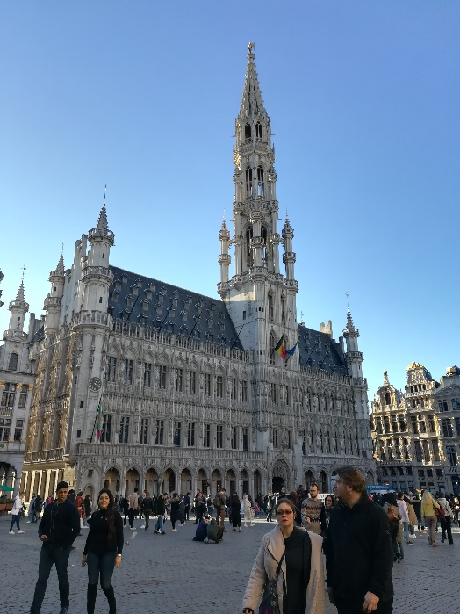
When I got up and I had breakfast, I was nervous because I thought that I had to go to the school by bike with my suitcase, but the dad took us to the school by car. At 8.30, we continued working in the groups of yesterday. In the half morning, a bus took us to Brussels. We visited the Atomium, it was spectacular. I like a lot it because it was very big and the museum that were inside the atom balls was awesome. Later, we went to the centre of Brussels, we visited some important places in the capital city of Belgium and we had some free time. We ate waffles and we went to a shopping centre. The bus took us to the airport and we said goodbye to our exchange mates. Our plane was late and we have had waiting for an hour before we took it. We had dinner at the airport and we called our families. I never flew at night before and it was fine. We saw the Eiffel Tower and Paris because of the lights of the city. We arrived very late at Spain and we weren´t in our houses yet. We took another bus two hours before we arrived in Aguilar. I was very tired but happy.
