I finished packing my suitcase at 10 o’ clock and I took the bus at 11 o´clock. We arrived in Santander and at 3 o´clock we took the plain to the Netherlands. It was the first time that I travelled by plane, it was amazing. The trip was so boring but I liked it. We arrived at 5 o´clock and the Dutch were waiting for us there. All the people were nervous and I found my match, I thought that she was smaller, but she was so tall. At 8:30 I was at home with all the family. I didn´t know what to say. I was so lucky, the parents spoke English and it was so easy to talk with them.

The day started so cool, we went to the school and I was with a Spanish friend, we went to soon. Next to it we went on a tour of the school: we saw videos, we did experiments and we saw a lot of places from this school: the gym, the ICT room, the library…
We went to see the city and the town hall, there we spoke with the Alderman, they gave us a bag and things that would help us. At 1 o´clock we went to practice orientation. When we started, all the groups were ok, but ten minutes later the Dutch people didn´t want to practice this, so some Spanish people continue doing this. Few people finish this. The Spanish classmates were so angry for some things. In the afternoon, my match and I went to play glow golf with other matches. It was so amazing and so funny.

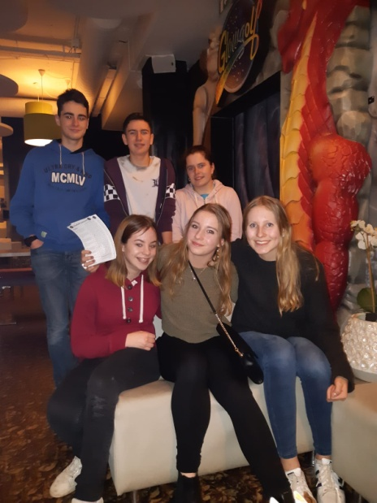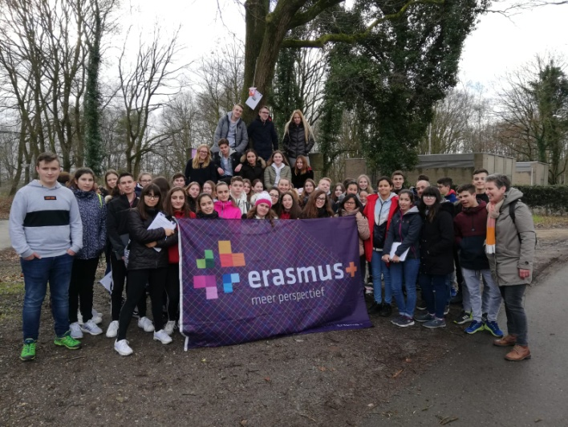

We started the morning going by car to school. There we met a friend and we helped a teacher transporting something to the activity that we were going to do. Next to it, we went to the bus and we went ice skating. we were so happy, we were the Spanish, the Dutch, the German and the English people together. Later, we the boys practiced soccer and the girls hockey. When we finished, we played matches. Then, I twisted my ankle, but I didn’t stop, I continued doing spots. In the afternoon, I was watching my match playing volleyball, I was so bored.

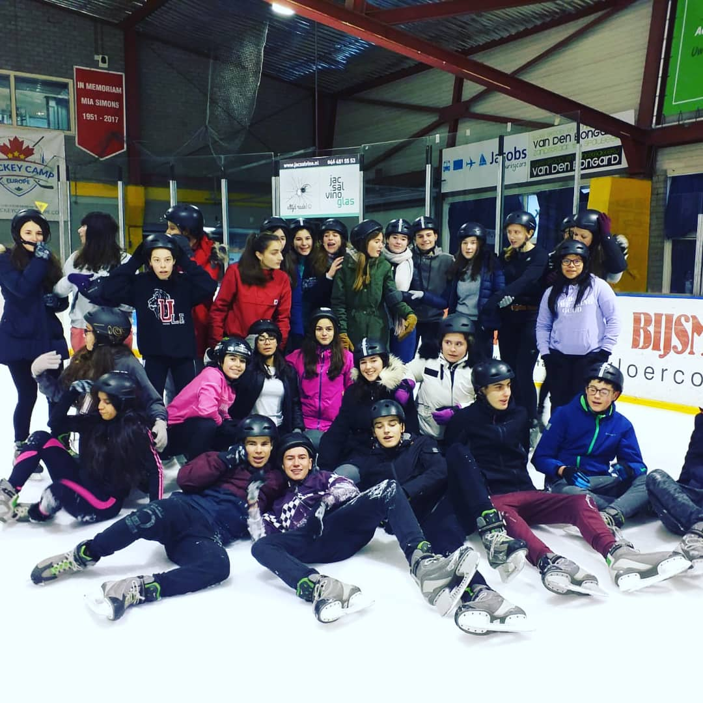

In the morning, we went to the school and a teacher gave us a talk and he told a story. Next to it, we travelled to Maastricht. We walked a lot, we saw a lot of sculptures and important places. When we had free time, we went to have lunch at Burger King, MacDonald's…. We went shopping clothes or things that we needed. We finished and we needed to return to the school. It was so amazing, Maastricht was so amazing and big. In the afternoon, I was watching my match playing volley once again, I was so bored…..

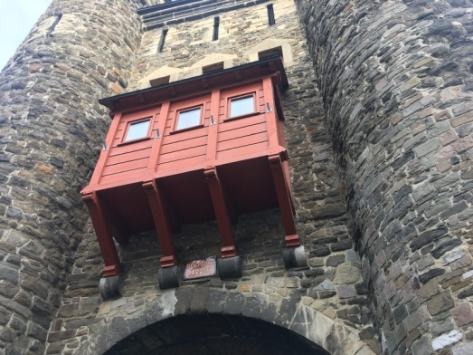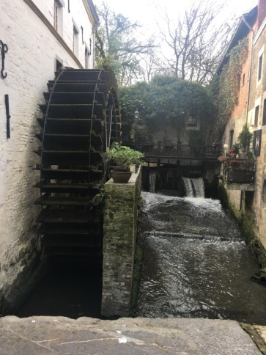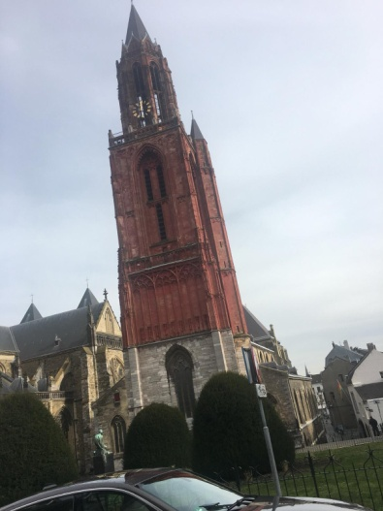

In the morning, all the people met at the school and there we took another lesson. When we finished that, we went to a sports centre to practice korfball. There we had a lesson with two professional players, we practiced the lessons they taught us and later we played a match in groups. When we finished, we played a game in which we had to prevent them from scoring, the one that holds the most time, took a shirt. It was very difficult to get 2 seconds. We had lunch there and we worked in smalls mixes groups. We finished and we when to the bus we were so tired. In the afternoon, a friends , my match and I went to the shopping centre and we laughed a lot. Then, we went home and we were playing and watching films. And we needed to go to the bed. It was so amazing.
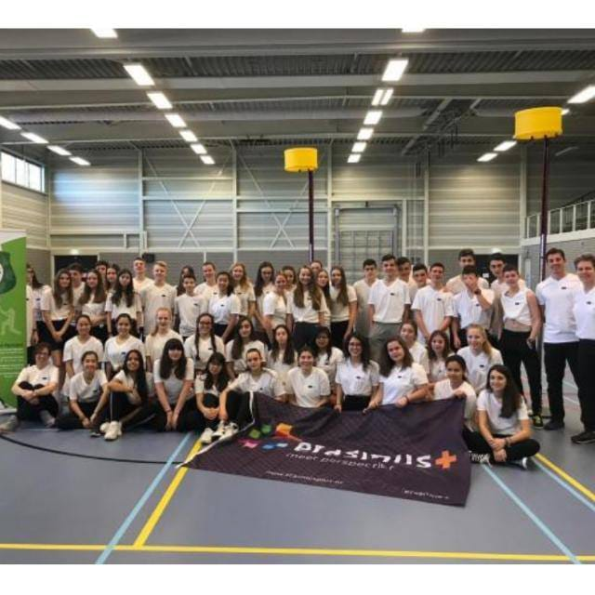

It was the last day, I made my suitcase and I went to their school. We did a work and we went to the bus we were going to go to Belgium. We went to see The Atonium, it is so big, we saw it and we when to Brussels. In Brussels we saw The Grand Place, it was so amazing and we were so excited and we were hallucinating. When we finished, we had free time and my group went to have lunch at MacDonald´s. we ate so quickly and we went to the bus. Later we went to the airport from Brussels and we said goodbye to the Dutch people. We were so sad, we didn´t want to come to Spain, Netherlands is so amazing and precious. In the airport we had dinner and we went to the plane. We were so lucky because we were next to each other. We arrived to Spain and it was too late and we were to tired. We took the bus and we came to our village. I missed Dutch people a lot, but it was so nice.
