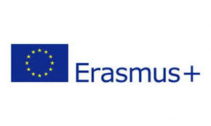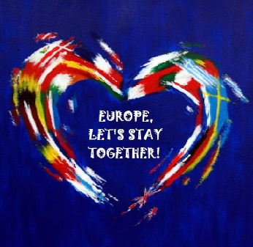

Youth Forum 2020 Manifesto
Concerned by the rising phenomenon of xenophobia and racism and alarmed by the climate crisis we henceforth call upon the EU to
1. Become more environmentally friendly and to start by implementing the following measures:
- By enforcing laws such as forbidding the production and use of single use plastic
- By implementing discussions and special lessons about environmental studies and to make the learning of global warming and climate change mandatory to all schools
- By increasing public transportation and to replace all such transportation that runs on diesel with ones that run on electricity from renewable sources.
- By encouraging all states to sign and adhere to the Paris Agreement and commit to the reduction of carbon emissions and move towards cleaner manufacturing methods.
- Calls upon the UN to re-evaluate the definition of a refugee as stated in Article 1 of the UN convention as to include individuals internally displaced as a result of catastrophic weather conditions owning to human triggered climate change and victims of natural disasters. F basic needs
- The creation of small crisis centres/check points to be able to house climate induced migrants. The centres will provide safe housing, basic provisions, sanitation, medical assistance including mental health providers.

We are also considered about the rise of xenophobia and racism and recommend the following measures:
- A review of European curriculum so as to educate students about the history and privileges associated with the European Union.
- The elimination of all racial, gender and other stereotypes in school books and the inclusion of “forgotten histories” of women, racial and religious minorities and LGBT community
- Securing that positive representations of minorities in the media are promoted and that representation that perpetuate stereotypes are eliminated
- Community programs are introduced to bring students of different ethnic and religious backgrounds together, especially with regards to areas of tension and conflict.
- The development of skills related to empathy starting from primary school.
- All countries must accept refugees depending on the size and population of their countries. Global cooperation should ensure that countries especially in the EU are able to ensure that refugees are treated in an equitable and humane manner.

