Migmar Bhuti lama
November, 2021, Report No. 9
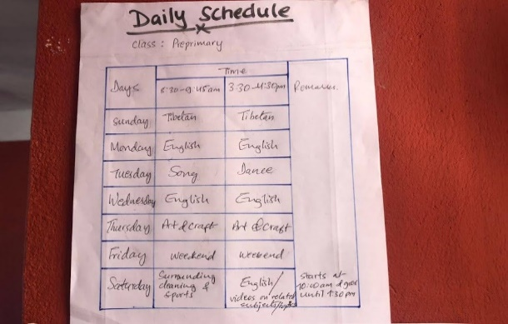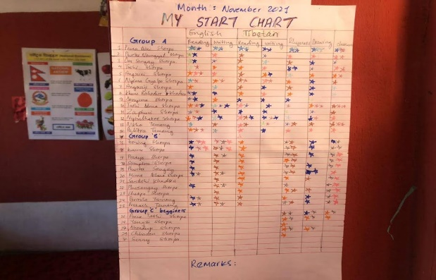
Daily schedule Motivation chart
- On Saturday and public holidays, we start our class at 10 am and it goes on until 1:30 pm. On the rest of the days, we run morning class from 8:30 am to 9:45 am and in the evening, it starts from 3:30 pm to 4:30 pm. During those days, I used the following schedule to take the class. At the end of every evaluation, I put a start on the motivational chart. In the end of each month, we count the starts and one who scores highest start points will win the monthly surprise gifts. It is kind of inspiration and motivate towards the learning. This month I forget to add the cleanliness.

Here, I have explain how my daily class goes..….
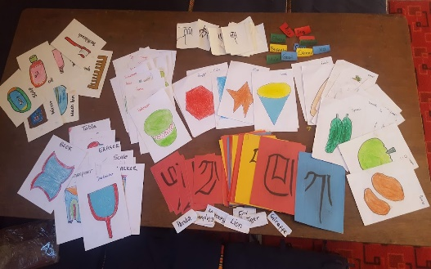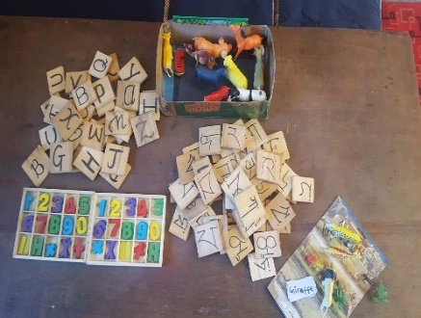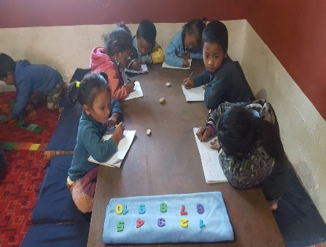
Presentation cards with different theme. Teaching materials way of using

I started my class with circle time, we all come together and sit in a circle for 15-20 minutes. We learn the days of the weeks, months of the year through songs and rhymes in three languages (Tibetan, English and Nepali) and sometimes we do prayers too. I do a presentation on new topics by showing the pictures cards with names on them. Most of all I encourage my students to have a voice in the classroom, ask questions when they come up and be able to participate actively in all conversations regardless of their level of confidence. It will be in turn wise or either raise hands to speak up and have a small ball on the speaker’s hand. I gave them moral lessons and also, I do open-ended questions and they have to answer in their own language.

After circle time, I split up three different groups according to their age and their learning levels. They came from a different class in Hile school. Some of them were from grade two and some of them were below grades one, U.K.G, L.K.G, and Nursery accordingly. So, I have to use multi-level teaching methodologies by preparing three different lesson plans for each period. I gave them equal time in each group with different lessons. E.g. group A. is going to write and read the names of fruits. Group B will be reading the names of colors with me. Group C will color the pictures. The work and time will rotate to each group according to their work.
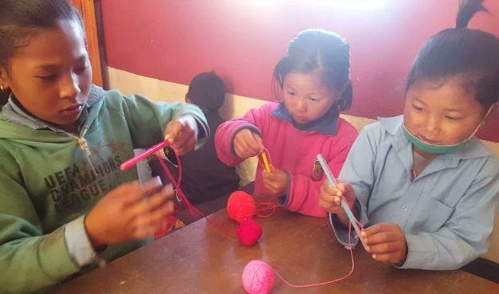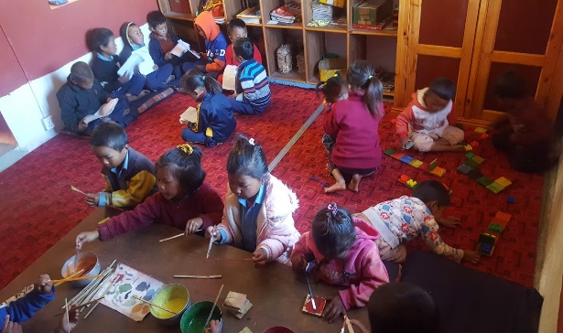
They are making flower out of threat. It is good exercise for concentration.

For the older students (group A) I choose the theme and firstly, I teach them songs in circle time. I go through reading to the students for several times and their meanings. They will jot down in their copy with beautiful handwriting. Children have to read themselves and ask me questions if they are in doubt. I choose one more able student and ask them to lead others (peer teaching). After that, I showed related videos to remember and experience the themes. I draw and let them color it, if possible. In the end, I take the class test and keep the students’ progress records. This is the method that I go through all the themes i.e. names of animals, flowers, colors, vegetables, fruits, classroom things, shapes and so on.

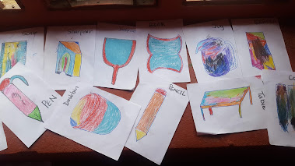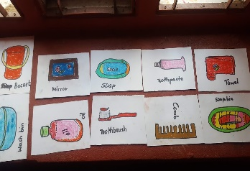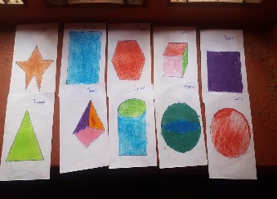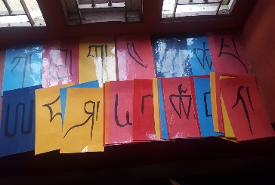
Those are some of materials that I used during the circle time presentation and in the group.

The group ‘B’ student, were well developed in hand and eye coordination. They are five to six years old. They can pronounce well and are eager to learn new things. So, they recognize the letters and learn the way of tracing the letters. They also learned the easy naming words and the rhyming words. They learned the numbers and their names up to 20. Sometimes, they joined the group ‘C’ to play games. They also helped the beginner on how to use the materials properly. They help them in morals too.

For the beginners, I let them play hand and eye coordination games and creative games. In addition to that, I introduce letters and different names for the language. They also learn moral educations and ways of coordination with their classmates.

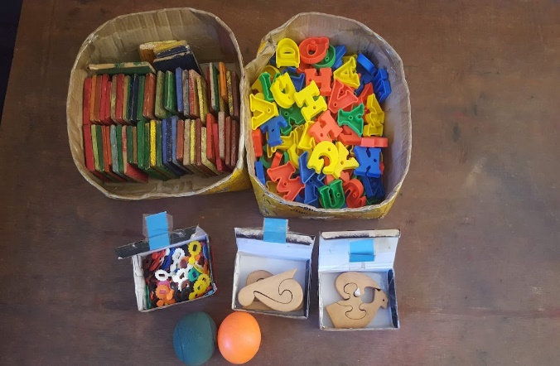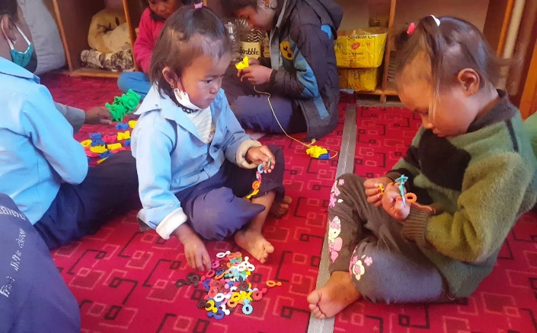
Games for students in order to develop their hand and eye co-ordination.

I used different methodologies according to its theme. Mostly, I used student center learning and cooperative learning center. It can be described as interactive, supportive and transparent. Overall, I am a fun-loving teacher and engage students’ activities like art and music having a theme, show them related videos where they can hear the sound and see the pictures to remember, transforming playtime into opportunities to instill cognitive skills, motor skills and social skills. Lastly, I believe that these children were very young and have to develop their social, emotional, literacy and fine motor skills, which they need to build during their lifetime.

- Children’s Day Celebration
On the 20th of November, we celebrated children’s day at Hile Nigale community Center. Before that, we prepared some dances, songs, games and other programs during our free time. We planned and prepared the decorations, gifts, lunch and charts. Similarly, on the children’s day, we started our program from 10:00 am and it goes on till 3:00 pm. Within that, we organize our program formally with dance, songs and speech. We gave gifts and let them do the free dance for a few minutes. We hired a cook and rest of the things were done by ourself. I believe all the children were enjoyed and felt special for themselves.

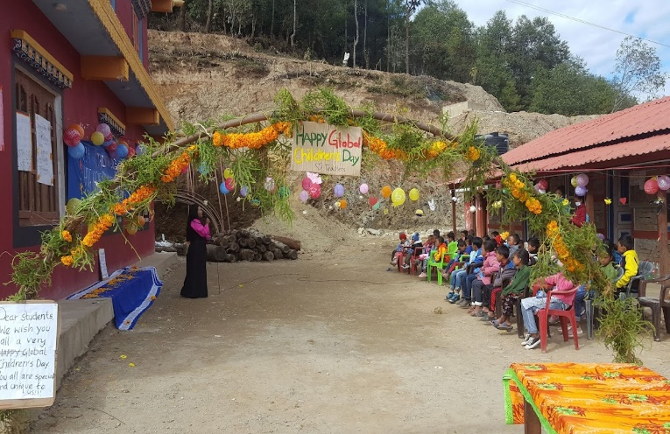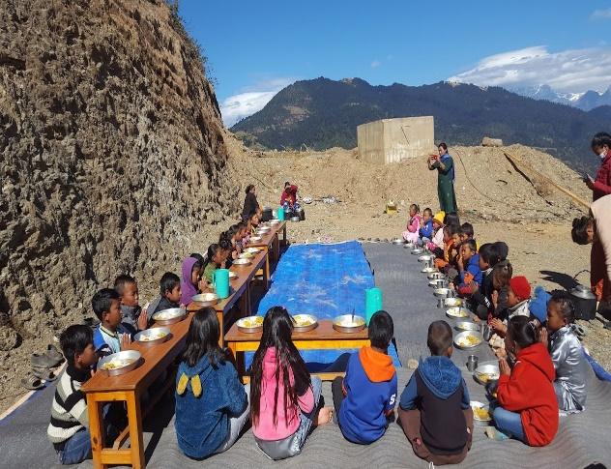

- Parents picnic
We sat meeting twice and decided the place, time and discuss on expenses too. So, the best time for all of us was on 27th November, Saturday since most of their children will be at home. There was someone to feed their animals at home. We order the foodstuff and transportation too. Finally, on the 27th of November, we started our journey from 7:00 am and it took two and half hours on the way. We reached there around 10:45 am and we had lunch. We indulged ourselves in the picnic sport and take a few pictures. We (teachers) organize a few games and dance all together for a while. Lastly, we had snacks and came back home in the evening. I am sure that they love the place and enjoyed it a lot. It seems that they forget their whole year's tension and feel relief from the work. They really appreciate your help. “THANK YOU”!!!
