**ONS Event Signage Policy 2025**

ONS will list your symposia and/or theater presentation on general signage in the event space but does not provide signage for any particular events. If you would like to purchase additional signage to promote your symposia or theater presentation, contact ONSSponsorships@smithbucklin.com for a listing of opportunities.

ONS does not need to preview your signage or give approval. The ONS disclaimer should appear on all signage. Fine print is acceptable.

**If you are not going to be on-site, please communicate this information to your on-site staff team.**

**Presentation Theaters**

You may place a maximum of 2 branded signs directly outside of the Presentation Theater.

**Symposia**

Signage provided by your company can be placed inside your meeting room. Each room will be set with a stanchioned area outside to separate your event’s F&B, registration, etc. All signage, including promotional and directional signage, must be placed within these stanchions. Please see below for a diagram. ONS will provide basic directional signage to designate rooms.

ONS will provide general promotional signage for symposia events as a whole, listing all approved symposia on signage displayed within the Convention Center. Information for this signage will be taken from the completed Online Event Write-Up. If you’d like your session included on this signage, please complete the Event Write-Up by January 10, 2025.

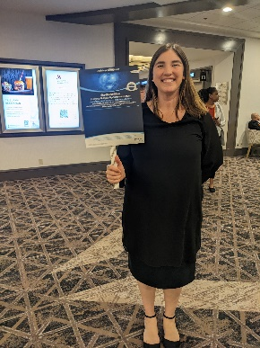

The Hyatt Regency ***does not permit sponsors to place signage in hotel lobbies*** or anywhere else within the exhibit hall or Denver Convention Center. ***Signage placed outside of sanctioned areas will be removed.*** You are free to use lollipop signs (see picture) held by an employee throughout the hotel to assist with human directionals. The sign must be held by the employee at all times.

**Thank you in advance for your compliance with these policies.**

**Sincerely,**

**ONS Show Management**

**Symposia Room Stanchions**

Signage is permitted only within the shaded areas

Centennial A-C: Orange

Centennial DE: Blue

Centennial: F-H