PADDLE
How to play it?
The paddle match is played to the best of three sets. The first pair that makes 6 games wins a set. The score of a game is like tennis, the first point is called 15, the second is 30 and the last is 40 before getting a game. The ball can only bounce once on the court, if it bounces twice it is a point. But on the wall you can bounce all the times.
Materials
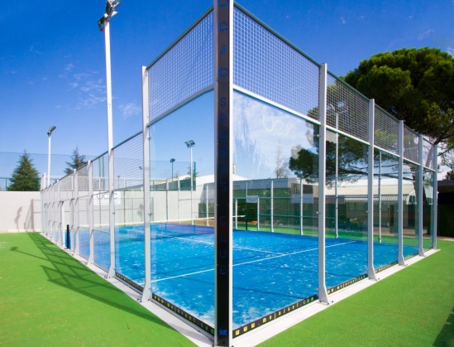
- A special court.
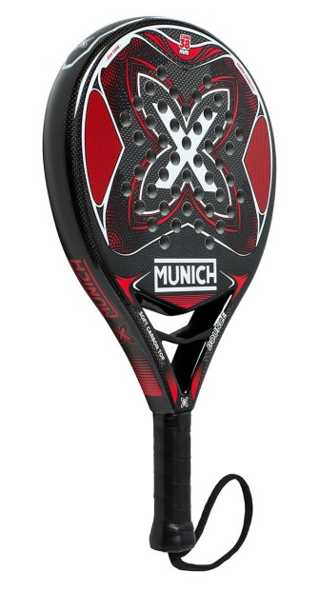
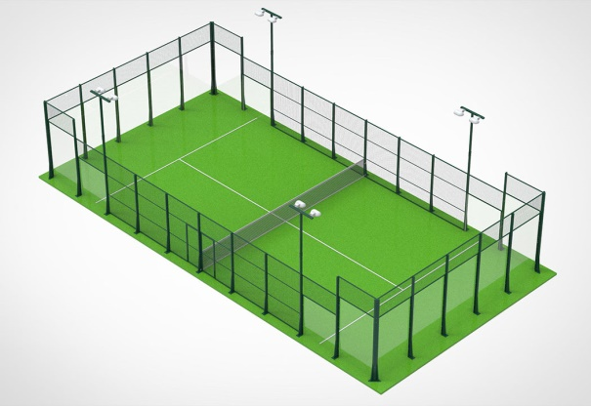
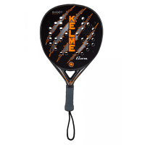
- A paddle racket.

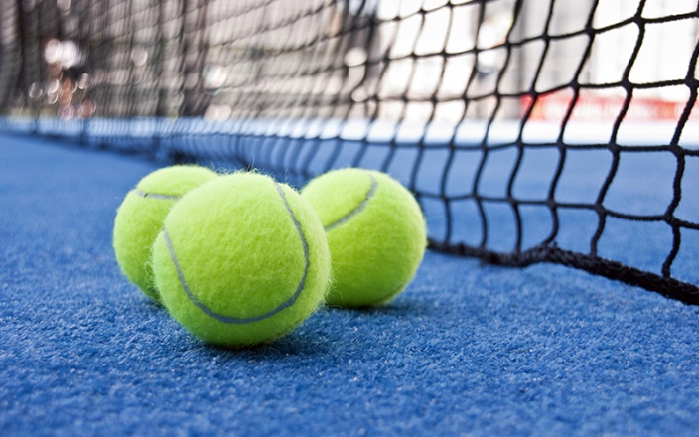
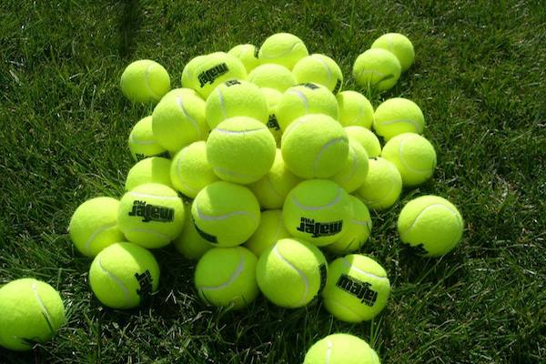
- Paddle balls.

