Spiritual Emergency in the Corona Crisis

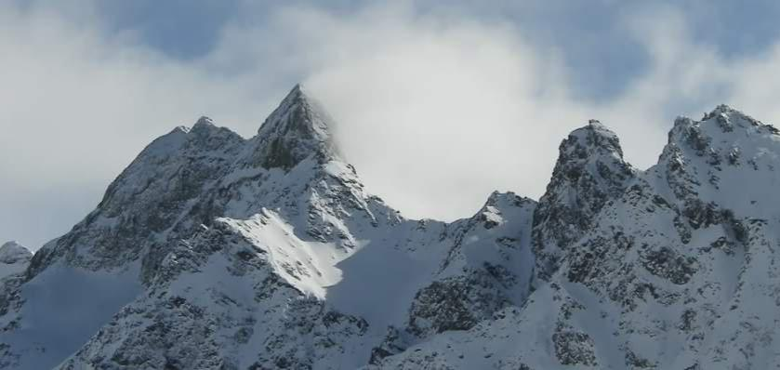

28 Meditations

Let's turn "dark winter" into a white winter. Let us shine through the dark!

by Thomas Mayer, Meditation teacher, civil rights activist, author www.Anthroposophical Meditation. en

- 1 -

Dear Readers, March 2021

in this booklet I present 28 meditations and soul exercises that may strengthen our sovereignty, dignity and spiritual connection and help to heal the collective field. In the final chapter I search for perspective of this process from the humanities.

In Latin, crown means "corona" and halo "Corona radiata". The crown is an expression of an erected and awake crown chakra and connects us with the spiritual world, a particularly strong bond is expressed in the halo.

The Corona Crisis is essentially an attack on the spiritual connection of humanity. Since a spiritual struggle takes place, one should also counter this with spiritual means.

The suggestions in this issue are not only intended for reading, but also for meditating. It is best to do this in a small group and discuss the experiences.

"Darkwinter" was the name of the international conference, in which lockdowns were played out in 2001. Let us turn it into a white winter, let us shine through the dark. I took this as an idea for the images used here.

I have been involved in anthroposophy since my youth and I mainly lead courses and trainings in Anthroposophical Meditation. At the same time, I have always been socially engaged as a civil rights activist, especially for direct democracy through referendums and for a fair socio-economic system. This text is written from this background.

Further texts on digesting and classifying theco rona crisis can be found here:

https://www.anthroposophische-meditation.de/corona-krise
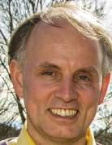

Enjoy reading, meditating and talking about it!
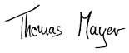

P.S.: This booklet can be ordered against 8,-/pcs on account.

Contact: thomas.mayer@geistesforschung. org Thomas Mayer, Öschstr. 24, D-87437 Kempten

www.Anthroposophische-Meditation.de

- 2 -

Content

Introduction

Basic meditations

Exercise 1: Create Corona-free times and strengthen mental connectivity

Exercise 2: A lot of small meditations and prayers throughout the day

Clarifying the emotional space

Exercise 3: Transforming Anger and Anger into Power and Clarity

Exercise 4: Sort, clarify and perceive feelings

Exercise 5: Healing work with stressful feelings

Enlightening the room of thought

Exercise 6: Strengthening self-thinking and believing in your own insights

Exercise 7: Seeking truth and going to the sources

Exercise 8: Thinking positive ways for dealing with the coronavirus

Exercise 9: Avoid corona hypnosis through media consumption

Clarify positioning in the social

Exercise 10: Meditating different points of view, creating spaces of understanding

Exercise 11: What is the higher meaning of the Corona Crisis?

Exercise 12: Rethinking your own social positioning

Exercise 13: To endure being insulted and denied

- 3 -

Healths tärken

Exercise 14: Understanding Diseases, Creating Disease Biography

Exercise 15: Befriending the body and the organ beings

Exercise 16: Strengthening the immune system meditatively

Exercise 17: Healing Meditation from Sigwart to Eulenburg

Integrating death

Exercise 18: Befriending one's own death

Exercise 19: Become aware of your own small emotional death

Exercise 20: Respect for life raises fear of death

Exercise 21: Maintaining contact with the dead

Exercise 22: What were my circumstances of death like in past incarnation?

Healing

Exercise 23: Silent Rally

Exercise 24: SarsCov2 virus and disease Covid19 mentally improve

Exercise 25: Forming a healing space with angels and freeing fear, manipulation and lying demons

Exercise 26: Bless masks, tests and vaccines and how you can pray

Exercise 27: Spiritually cleanse newspaper articles and films

Exercise 28: Resolutely confront the dark spirits who act in the background and take away their strength or redeem them

Humanities perspectives on the Corona crisis

- Mental perspective: Collective anxiety disorder

- Mental perspective: Collective hypnosis

- Astrological Perspective: As at the beginning of the Reformation: Conjunction of Saturn and Pluto in Capricorn on January 12, 2020

- Historical perspective: 100 yesto the Russian Revolution:

Resurgent of this historical impulse

- Spiritual point of view: 3 x 666 = 1998: assertive action of Soratic spirits

- Spiritual Perspective: Upcoming Incarnation of Ahriman

- Spiritual perspective: Forced mission of religion

Related to Materialism and Transhumanism – What to do?

- 4 -

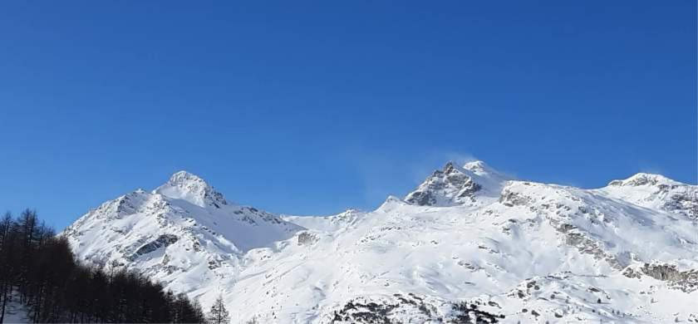

Introduction:

The lockdowns of the Corona Crisis since March 2020 are a spiritual challenge. I experience this as a worldwide attack on human consciousness. An attempt to bind people into fear and cut them off from their sovereign core, the self and the spiritual world. This is a great test.

The main issue now is to retain and maintain sovereignty and spiritual connection. To do this, I will present 28 meditations and soul exercises below. Here we are able to act, not impotent, it is only up to us. We are sovereign. This strengthens our spiritual honor.

The lockdowns from March 2020 surprised with what is suddenly possibleor no longer possible: restriction of fundamental rights, vile defamation of soberly and reasonably arguing people and people who are scientists, and one-sided information in the media. Corona infection is a serious disease, as are other infectionsn, of course. But why this serious intrusion into the foundations of our society? Lockdown is a term used in prison and means the closure of the cell. Entire peoples were imprisoned. There has been a growing sense of living in a George Orwell novel. After a brief détente in the summer of 2020, governments are adopting further grueling lockdowns for months. The damage far exceeds the benefits, worldwide more will die as a consequence of the lockdown than as a result of the disease, but an open discussion does not take place.

- 5 -
Instead, a strong pressure is built up for vaccination and the population is split into two parts. (1)

Many feel like something is driving the world with immeasurable violence, which does not have freedom and love in mind. There is a big, dark, overpowering something looming over our lives and society. That's scary.

An antidote to this is self-reflection and meditation. This strengthens individual strength and creates freedom. And with spiritual-healing deeds, we can take away the spiritual energy of attacks and thus heal the collective thinking and feeling. This will also help social development. Internal deeds and external deeds belong together.

It seems crucial to me never to lose love and spiritual connection. There is a danger that the quite justified criticism of the state measures will give room to the very dark forces that one fears.

The 28 meditations presented here have proved their worth in the last few months. These are best made into several and exchanged experiences. The exchange is very important for digestion. If you are alone, it is good to write down the experiences. You don't have to do the exercises in turn, but you can choose what you think is appropriate. Exercises that you can't access are easy to leave aside.

The following meditations are aimed at people with a spiritual interest, regardless of direction or school. I try to be universally understandable. Whoever is convinced that there is only one material world, the following is not intended, because they will not be able to understand it. For me, the world of souls and spirit is a daily experienced reality and that is the starting point of the exercises.

I have been a teacher in anthropose osophical meditation for almost 20 years. Anthroposophy is the science of spiritual worlds. I can only describe many things here aphoristically. The practice of meditation and the exploration of the spiritual world is a large and complex field. At the end of this text, 'humanities perspectives on the Corona crisis' have been compiled. There will be many unanswered questions, which is a good thing, because that stimulates.

As further aids for digesting the corona crisis, we have posted texts on our website https://www.anthroposophische-me-ditation.de/corona-krise

- 6
These are contributions to the spiritual dimension and to the meditative handling of the coronavirus, texts by Rudolf Steiner and from anthroposophy as well as further links to independent information.

The global lockdowns since March 2020 have been unimaginable and unprecedented to us citizens. However, they were conceived in several international meetings, e.B. at the conference "DarkWinter" 2001. The term "dark winter" or "hard winter" was re-elected by politicians in 2020/21. (2) Spiritually, we can turn it into a white winter. The photos in this booklet are meant to encourage us.

- 7 -

Basic meditations

Exercise 1:

Create corona free times and strengthen mental connection

The corona measures that strongly shape daily life, the fear of illness, the fear of the consequences of the measures, the constant media bombardment, this causes a crushing Corona-permanent stress for many. Every day we need corona-free times in which the subject does not live in the soul, but we prepare ourselves with the building. A walk in the forest, a good book, good conversations, beautiful experiences or a meditation. In everymeditation it is about strengthening the spiritual connection, in the following a simple variant:

Exercise: I put myself in a relaxed upright sitting position, go to myself with the attention and feel myself. How does the body feel, what mood is in the heart, what is going on in the thinking room? After some time of self-perception, I linger in the sentence: "Christ in me". (Or "Buddha in me ", everyone should see to whom the best access exists.) " Christ in me "keep inward space, so that the warming love of Christ (or the sublime serenity of the Buddha) penetrates the soul and the body. In doing so, a gene-genic restlessness and tension can become clearer, that is a good thing. Just stay with Christ (or Buddha) for five minutes or more.
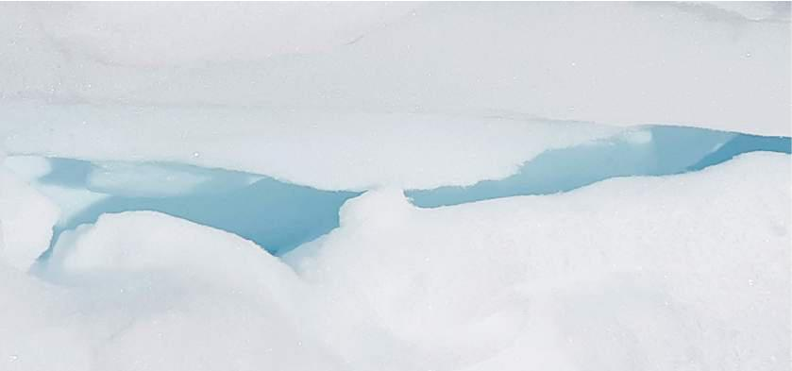

- 8 -

Exercise 2:

Throughout the day, many small meditations and prayers are

Botho Sigwart zu Eulenburg was a talented composer who died in 1915 at the age of 31 in the First World War. His sisters and cousins kept in regular contact with him and wrote down what they learned about him over the tenth of the year. His messages arepublished in two restaurants entitled "Bridge over theStream", very intimate and touching. Sigwart describes in detail his experiences in the nightly life and accompanied his friends through the raven-black times of the first and second world wars. He describes again and again how it is radiant, bright and pure in the higher regions of the spiritualworld, while on the earth and in the lower astral regions, multitudes of dark demons rage and enter into the feelings and thoughts of people. He therefore constantly encourages the maintenance of spiritual connection. In the darktimes, however, it is not enough to meditate or pray twice a day, even three times not enough. Because, given the number of demons, the time gaps are too big and through them they can get in. Siegwart therefore recommends praying, meditating or making a small reflection every hour. Only then would the spiritual protective wall be so closed that the demons can no longer come in.

Exercise: To pray every hour or to linger meditatively in a strengthening thought. Every hour the question arises, am I in good condition and connected with the right spirits?
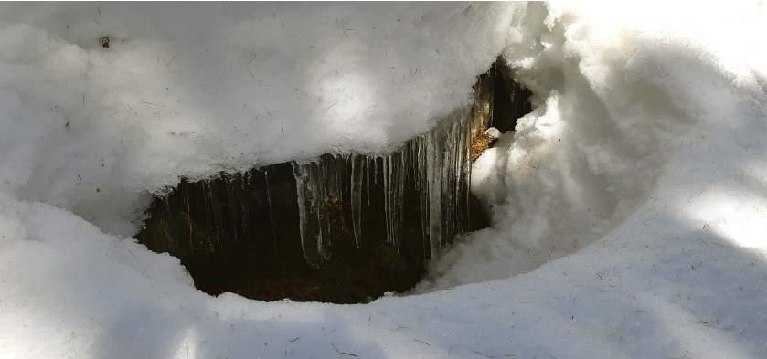

- 9 -

Clarifying the emotional space

Exercise 3:

Transforming anger and anger into strength and clarity

When I think about the lockdowns, it's a huge emotional challenge for me. I remember the situation:

- The lockdowns since March 2020 have wreaked havoc on physical and mental health, economy, public finances, democraty, social confidence, etc.

- What is already certain is that the lockdowns will kill many times more people than the corona infections as a whole. This probably also applies to Germany, but certainly to the Third World, where many millions are affected by it.

  - Many studies show that lockdowns are useless, they do almost nothing to counter the course of infection, as opposed to targeted aid for at-risk groups and voluntary measures. (3)

  - This does not matter to our politicians and themedia, they have abandoned evidence-based politics. The lockdowns are a political decision, as German Chancellor Angela Merkel has explicitly said. (4)

  - It's all so horrible that I can't stand it.
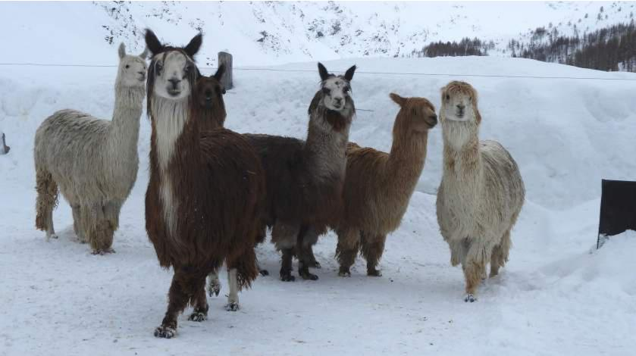

-10-

As I think about it, more and more disappointment, anger and anger accumulate in me. I know that many other people do the same. What do you do with it? The anger hurts me, I feel bad and it robs me ofenergy. But you can also do something productive with it, because there is always a positive will power we can set against trouble.

Exercise: I sit down. The anger rises in me, I experience it, I feel it and greet it. Now I lead the anger through the body, the legs and the feet into the ground. The anger leaves me and so the willpower in it can be released, which now flows up and fills me. I experience the willpower and give it space. In the limbs I feel strength, the head area becomes clearer. I can use this will power later for action, but now it is a matter of penetrating me with this willpower and accumulating it. I am increasingly like an oak. How do I feel, is the anger still there?
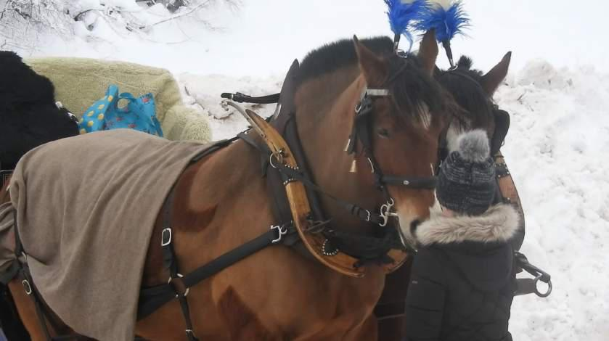

-11-

Exercise 4:

Sorting, clarifying and perceiving feelings

The proposed anger transformation usually only works partially, the soul life is complex. The Corona Lockdowns have caused a lot of feelings in us all.

Socially, the media and politics systematically created a great deal of fear of the Corona virus, which caused already existing hidden fears of people to vibrate, fear of death, fear ofloss of existence, fear of exclusion, fears that are already dormant in the soul. There has been a kind of large-scale traumatization, but fear has been projected onto the virus. This is how one can understand the great excitement, because the virus alone would not have created it. The problem here, however, is that while hidden fears come up and are felt by the soul, there is no digestive process, as the fears are projected onto the virus and released by the actual context. The actual topics are thus again obscured and not considered.

The same mechanism can also take place if, for example, one is afraid of a health dictatorship. It could be, for example, that this triggers unredeemed experiences with an authoritarian father or other traumatic experiences.

Therein lies an opportunity. Through the lockdowns we come into contact with the shadows of the soul and have the opportunity to light up and integrate them.

Übung: I collect and write down the feelings that the lockdowns trigger in me. I try to clarify every feeling by asking. How do I experience it in the body, e.B. tightness, pressure, tension, etc.? What kind of feeling is it, is it anger, despair, angst, fainting, etc.? What specialqualities or colours doesit have? And what does the feeling relate to? For example, if I am afraid, is it fear of illness, of political oppression or of economic annihilation? And with every feeling, I wonder: is a personal theme triggered or do I live with the collective mood? I write down the feelings, respect them, and perceive them, and dwell in them. It is important and to linger with the feelings before making anything further of them.

-12-

Exercise 5:

Healing work with stressful feelings

When sorting feelings, individuals who need help and redemption will emerge. Such soul work is often a long process. In the follow-up a basic exercise.

Exercise: I feel a stressful feeling and take an observer position, for example the point of view of my own angel. I wonder, what does this feeling need, which I have not given him so far? Then I do something good to the stressful feeling and pray, for example, the Lord's Prayer or another prayer in it. Or I give him a beautiful song or melody, which I sing into the feeling. Finally, I look at the feeling again. Has it changed? Does it need anything else?

-13-

Enlightening the room of thought

Exercise 6:

Strengthening self-thinking and believing your own insights

Today we, in contemporary are in a constant flood of media, afire with information, which we cannot penetrate simply because of the sheer quantity and which therefore often sink into us unprocessed. This shrouds and obscures our thinking space.

On the other hand, self-thinking and one's own insights gain a significant spiritual deed. If you pay attention to it, you can notice how your own area of consciousness changes and illuminates. When I think of thoughts that are logical and clear, I experience this like an intimate sunrise in a crystal clear mountainlandscape, it becomes bright, light and clear. For in thought we are already in the spiritual world. Through self-thinking we invite corresponding bright spirits, which then fill our space of consciousness. Thomas Aquinas, the great scholastic of the Middle-Ages, spoke of the fact that thought should be christianized. He still knew that thinking is always also communication with minds.

I now want to make a simple thought exercise into the corona theme. Every year, about 950,000 people die in Germany. The average life expectancy in Germany is 81 years. These figures are supplied by the Federal Statistical Office. Women are getting older on average (83.4 years), men are dying a little earlier (78.6), 81 years are the middle. (5)

What does the number 81 mean? This means that life ends with death, there is no eternal life in the physical body. So seen, this body becomes too rickety and gives up "the spirit", as it is popularly said. In other words, the Spirit is pulling out. Thirty years ago, life expectancy was about 10 years lower, and people are now living longer because of medical progress.

Two more figures: According to the figures of the state-run RKI in Germany, a total of 33,960 people with positive coronatest deaths in 2020 (6), or 3.6 percent of the total of 950,000 deaths. The causes of death, whether with, by or from coro-navirus, are not taken into account here, even if the infection is

-14-

only the drop that causes the barrel of pre-existing diseases to overflow. While 3.6 percent tested positive, 96.4 percent die without a positive test from cardiovascular disease, cancer, inflammation, other infections and countless other illnesses. 3.6 is little compared to 96.4 percent. 3.6 percentindicate that Covid19 is a comparatively insignificant cause of death, most other causes of death are more significant.

The RKI has published that the average age of those who died with positive tests is 84 years (as of January 2021). (7) 84 is three years more than normal life expectancy. This means that, on average, one dies from the usual diseases three years earlier than with Covid19. Thus, the coronavirus does not increase the average mortality, it is not any more dangerous than the other life as usual.

At this point at the latest, it is good to pause: are these transfers and classifications logical on the basis of the available figures? Can I think of them myself? If so, do I have a sense of truth in the conclusion that the corona virus is no more dangerous than other life? If I find this true, I believe it

-15-

too? If so, I will linger in the sense of truth and faith in it. What triggers this? So how do I experience a space of conscious awareness, what quality does it have now?

It could be that immediately resistance to this insight comes up and wipes away the sense of truth. "It cannot be that the coronavirus is no more dangerous than the rest of life, because otherwise there would not be this excitement and the lockdowns with the terrible consequences. This goes against everything that our governments and the major media say on a daily basis, that cannot be true. " Combined with such thoughts, there can be a fear in the soul that one stands alone or is cast out. Or there may be a scare.

Such resistance must be respected. But they have nothing to do with the realization that 84 is more than 81. That's just true, no matter how others think about it, and no matter what emotions this topic has been charged with. The interesting questions now are: Where do these resistances come from? Why do they have such a strong force in our souls? Were they able to anchor themselves in my soul at all?

Exercise: I think through the numbers and their meaning and talk to others about them. I pause again and again and watch what is happening in my soul.

-16-

Exercise 7:

Seeking truth and going to the sources

The constant search for truth is a central spiritual and, of course, scientific attitude. This is not abstract, but one seeks to connect with high, spiritual beings. "I am the way, the truth and the life. " This word of Christ can be taken in real life, the search for truth is, spiritually speaking, about the Christianization of thought. To feel the presence of Christ, of angels or other high-spirits in one's own thinking, is one of the most important experiences of consciousness.

Therefore, one should never give up the search for the truth and never blindly trust it. This has always been the case, but it is particularly important in today's age. Manipulatingis very simple in today's media world, one only has to inform one-sidedly and conceal conflicting facts. That's why you should always look at the sources. In the Corona Crisis, this was a harrowing exercise for me. Let me give you an example.

How to get to the sources? Thanks to the Internet, you have good opportunities today. The blogs of various science journalists were helpful to me here, who deal with the various scientific studies and always link them, so that one can quickly get to the original texts.

Example "asymptomatic-infected"

Until 2019, the state of conventional medicine was that people suffering from viral infections can be contagious, but healthy people cannot. In the case of infections, viruses multiply on a large scale in the body's own cells and then the immune system reacts to them and you get cough, fever or limb pain. Without disease symptoms, there is no particular virus reproduction and therefore no viral load that could be passed on. In the days before the symptoms appear, but the viruses are already multiplying, one can be attached, called "pre-symptomatic contagion". This was state of science until 2019.

But then came the coronavirus and everything was different. Suddenly there are also "asymptomatic sufferers"who are supposed to be contagious and who must be afraid of. People who are "healthy" by the end of 2019 have now been described as "asymptomatic".

-17-

This also turned something else around: not the sick, but the healthy had to be quarantined. For the first time in world history, a worldwide lockdown was imposed because the "asymptomatic sufferers" could infect others. Since one does not see who is "asymptomatic" because there are no symptoms, everyone has to be isolated. This was also the reason for the mask compulsion.

The remarkable thing is that, even after a year of lock-down, there is still no scientific evidence for the contagion of 'asymptomatic sufferers'. There are many studies in which the contacts of individual coronapositive people without symptoms were carefully checked, but no infections were found in their environment. There is even a study of all 10 million inhabitants of Wuhan, an incredibly large study that found virtually no infection by asymptomatic sufferers. (8)

The first "asymptomatic contagioncase" in Deutschland, a Chinese lady on a business trip in January 2020, which Mr. Drosten published in a well-received scientific article, was then
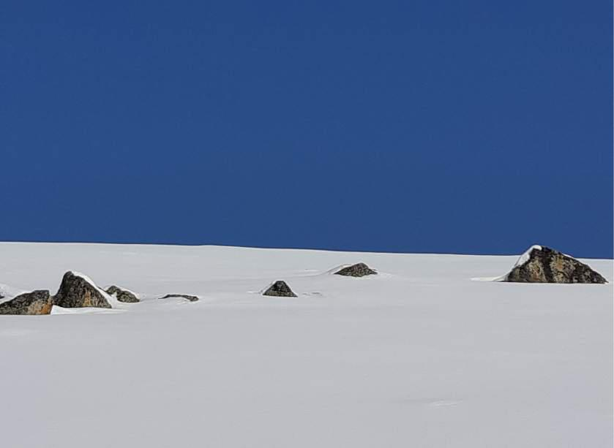

-18-

because the Chinese woman had very well had symptoms and had taken medication to reduce the fever. However, the other studies that claim that there are asymptomatic infections have not proven these contagionins in specific cases and they cannot tell how this should be done if thereis no high viral load in the absence of a high viralload. Instead, these studies argue that it is unclear how the infection took place in many infections. It is then concluded that the persons must have been infected by asymptomatic sufferers. But this is only a presumption and not proof. It was also confirmed by the WHO that there was no evidence of asymptomatic contagion. And the German RKI writes: "These contagions, however, play a subordinate role. " Because of the unproven theory of "asymptomatic contagion" almost the whole world was sent into a lockdown. Puhh, you have to exhale deeply!

Here a fundamental problem becomes visible in modern science. There are many scientists who seek the truth and are therefore interested in the phenomenon and perception and see science as morally embedded.

And then there are more and more scientists who sit mainly in front of the computer and model. These models and extrapolations usually have false assumptions and therefore incorrect results, but this is not so important, because the model replaces perception. It is no longer important that one does not find asymptomatic contagion in actual, concrete investigations, one does not need confirmation in perception at all, the model itself is sufficient for confirmation.

And the fact that this is a fear-mongering argument for paralyzing entire countries through lockdowns does not create a bad conscience either. We are dealing here with an aloof ‘science’ detached from the real world and detached from the moral fabric. And of course, you have to ask yourself, which spirits work here?

How could the unknown routes of infection be explained differently? The trivial idea that you are hit by a virus similar to a bullet from a pistol does not correspond to reality. A virus alone does not work and viruses are everywhere. This is well known in conventional medicine, up to 95 percent of all people, for example, have the Epstein-Barr

-19-

Virus in the body, but hardly anyone gets sick of Pfeiffer's glandular fever. The virus alone does not cause the disease, it is always necessary to have a state of the immune system or weakness in order for an infectious disease to occur. Weakening of the immune system can also be caused by biographical, mental or mental tensions, or life crises. Anxiety and feeling powerless are known to weaken the immune system, making them more susceptible to disease. In order to understand the Covid19 diseases without clear infection pathways, people would have to be examined according to their conception. It is very likely that the stoked corona panic and the lockdown stress is a major cause of many Covid19 diseases. This could also be investigated by appropriate broad psychological studies, but such studies are not carried out.

The study of sources is sobering. In the corona theme, there are such contradictions in many corners between research results and the opinion published in the media. Another example: Since January 2021, the lockdowns have beengreened by mutations of the virus, which are said to be more contagious and dangerous. This is based on modelling. But the reality is different, with a study of 1.5 million tests in England finding that these mutations are just six per cent more infectious, which makes little difference. The number of hospitalisations and deaths fell in Ireland, England and South Africa as well as in other countries despite the mutations. (9) Why do modelers and our governments not care that reality is different from their computer calculations?

I have come to appreciate the true and open science that seeks truth and draws on perceptible reality. In this the Spirit of Christ moves.

Exercise: Believe nothing, not even me, but always remain critical and unbiased. To get used to being an attitude, always go to the sources and check them. This clarifies the room for thought.

-20-

Exercise 8:

Positive waysto think about dealing with the coronavirus

We are confronted by politics with ever-changing, complicated and increasingly nonsensical prohibitions. This involves the people; a lot of conversations take place about it. The problem is that when you get upset about the prohibition web, your own emotional energy is bound and the collective field of fear and coercion is strengthened.

A good way to get out of this negative spiral is never to stop at a negative thought, but always to think and let it pass through the soul, which is a positive possibility. It is not a question of whether there are opportunities for implementation, but of strengthening one's own soul and shaping the collective mental field. Imagine that millions of people keep thinking positive alternatives, what kind of force would that be! Of course, we can only start ourselves and take responsibility for our own thinking.

-21-

Exercise: Think positive alternatives to lockdown mindsets and rules and watch what happens in the soul. With the negative descriptions of the condition, the energy and mood will decrease, with positive thoughts the energy and mood should rise again. Examples:

- Today: Sport is forbidden, everyone should stay at home, thus weakening the immune system.

Think positively: There is a state advertising campaign for a day-to-day one-hour walk in nature. Everyone should go out and move. The cities offer free shuttle buses to nearby areas.

- Today: A high number of infections are portrayed as very bad and threatening.

Think positively: A high number of infections is in a time of flu waves, normal, as it increases immunity in the population.

- Today: The lockdowns since November 2020 have been justified by a threatening overload of hospitals. In fact, in 2020, during the Corona pandemic, 20 hospitals with 2,100 beds were closed and more than 4,000 intensive care beds were taken out of operation, for which the policy is responsible.

Think positively: hospitals are better funded so that they can survive. The pay and attractiveness of the nursing professions will be significantly increased in order to end the nursing emergency in hospitals and care homes.

- Etc.

-22-

Exercise 9:

Avoid corona hypnosis due to media consumption

The ever-running and often semi-conscious streaming of radio, television and smartphone resembles a hypnosis. If you hear. B 20 times a day that the coronavirus is very bad, then you believe it at some point. Thus, beliefs are anchored in souls.

Opinion polls have shown that the population overestimates the risk ofcoronavirus by 300 to 600 times. It is not about double or ten times, but about six-fold! (10) How is this possible?

A psychologist working with hypnosis therapy wrote in a newsletter: "Therefund on Covid-19 has met all the criteria for hypnosis since March 2020. " Since it makes it easier to understand what has happened since March 2020, I quote in more detail:

"Hypnosis is an externally induced trance. Trance means a state of fokussed attention: attention is focused only on one topic or selected aspects of this topic. At the same time, the own control mechanisms are hidden, and what is said no longer has to be logical in order to be accepted. The balance is no longer weighing up, relativization is no longer possible, we no longer ask ourselves: "Is this really true? Or could you see it differently? ".

In psychotherapy, this helps to look beyond one's own horizons and to find newsolutions. But there are also pathological, i.e., unhealthy, trances in which we have a negative tunnel view. This happens to many people quite involuntarily, and without them consciously noticing it!

The most common techniques of hypnosis are:

- The constant repetition of content or certain words that are meant to "become fixed, to sit".

- Activation of as many senses as possible (touching the doorknob (feet). "Will Corona be transmitted over food? " (Taste). Pictures of disinfection agents (smell) reports from the emergency room (seeing and hearing).

- Emotionally charged words (crisis, quarantine, unpredictable, rise, death toll, killer virus, invisible danger, pandemic, spread, harrowing, in tears, …)

-23-

- Constantly new details, so that you can't even think about it.

- And above all: contradictions. Hypnosis works intentionally because contradictions lead to confusion – and in a state of confusion, man is as influential as possible and willing to entrust himself to a supposed or supposed authority. That's what we can see everywhere.

If someone is in corona hypnosis, you can see on the following

Phenomena:

- It is no longer possible to find distance from the subject and to reflect objectively.

- Feelings such as fear or insecurity as well as helplessness dominate.

- New information is constantly being sought, the topic is the focus on every day, every detail confirms the previous opinion. "

In order not to fall into this Corona-Hypnosis yourself, it is recommended:

- "Make an information update once or twice a day and then set the Handy aside.

- The random consumption of media, e.B. by the radio in the car, reduce, also the consumption of social media. It is preferable to search for Information is in a targeted way.

- Make yourself aware of what gives us strength and brings you into contact with the here and now. Replenish the sources of power to be able to act, for example in nature, with friends or in the family, or with our favorite music.

- We seek contact with people who support us in standing up for what we care about, even when it is difficult and requires courage.

- Prevent complaints and whining. Do not focus on what is bad, buton what we can or must do in concrete terms – regardless of whether we already know whether we will succeed, whether we are on the short distance or rather running a Mara-thon. "

But what about other people with Corona Hypnose? Here the psychologist writes:

"Unfortunately, it is not possible to convince people around us who have succumbed to the hypnosis language with logical arguments.

-24-

That is no longer possible. But we can convince by emo-tionsand our own example: casually tell us that we are not worried at all about Corona (this creates confusion because it does not fit with what is constantly communicated and thus also seems hypnotic), remain humorous, remain happy, ask a friend as a matter of course if one can take him in his arms, give security to other people and help them. security. Those who have a positive effect canalso convince those who radiate what people in needsee. The de-hypnosis usually happens through the back door, inconspicuously, as does the hypnosis. "

So, let's start with ourselves. All previous meditations and sea exercises already have an effect on dehypnosis. Let's takecare of our media consumption.

Exercise: Avoid unconscious media consumption, just turn off the radio and TV if you're doing something else. Limit the media information to short periods and inform yourself consciously and always actively process the information. Is it logical? Does this fit with my previous knowledge? What is the author's intention? What does it mean? Encounter any media information with a processing awareness-likeness. So, I'd rather do very little, but that's right.
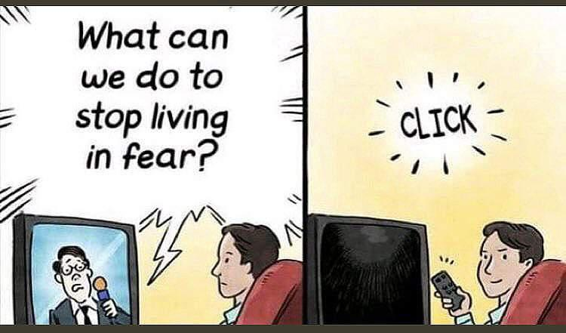

-25-

Clarify positioning in the social

Exercise 10:

Meditating different points of view, creating spaces of understanding

The positions on the lockdowns are very contradictory in society, open conversations rarely take place. Denial of dialogueis a form of exercise of power and should in no case be taken over, but deliberately broken. This is what the following exercise will do. Under no circumstances should the result be overlaid by a pre-existing internal agreement or rejection. This exercise is not about right or wrong, but about taking different points of view.

Exercise: In the first part, one carefully imagines the situation with the lockdowns here in Germany and other neighboring countries in a calm view. Imagine, or cultivate, the feeling that the lockdowns, the restrictions of the government with mask-duty, social distancing, travel restrictions, etc. are experienced in the motive that they are taken with the best intention to protect the individual. One really cultivates the feeling of feeling well and carefully protected by the government and in peace and contemplation.
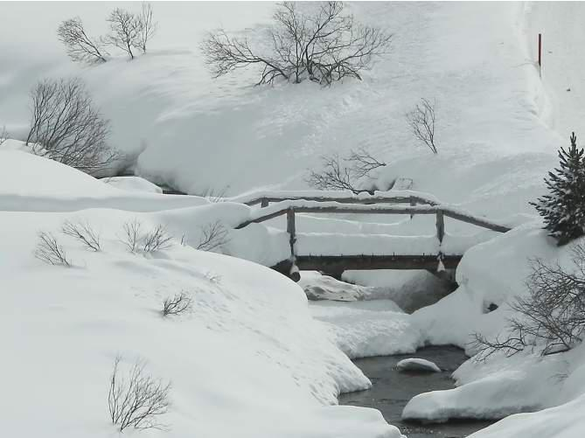

-26-

to trust the measures taken in the best possible sense. Everything is good and necessary in the best sense and after the crisis everything will be returned to its stable and usual safe everyday life. Very carefully, this image should have a sufficient sensory space inside.

In the second part of the exercise, the meditator rebuilds the comprehensive picture of lockdowns and bans. Now, however, he is questioning what is happening, carefully examining the various statements of different positions and studying different views of professionals, closely monitoring the events in person and coming to the conclusion that the relationship between the alleged threat of the virus and the measures taken is completely, even grotesquely disproportionate. He experiences the measures taken and the mediation of the danger of the virus as a deeply suggestive event, which amounts to a lie, but is conveyed to man as the ethically completely correct attitude and the only justifiable way.

In the exercise, it is important to distance yourself from existing internal ‘ifs and buts’ and to establish an openness. How do these two polar images and basic sensations affect and reflect back on the soul, what happens inside the human being?
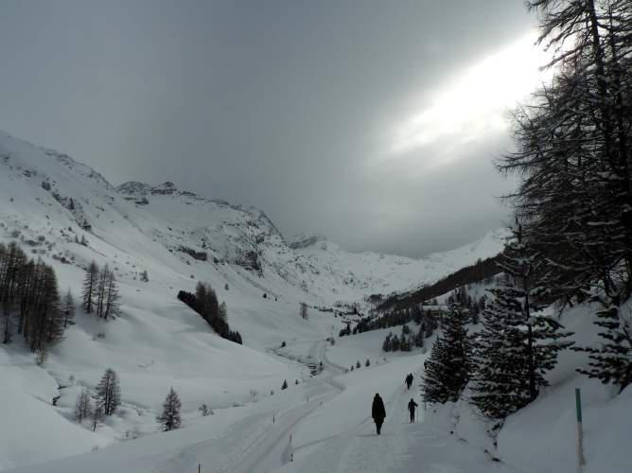

-27-

Exercise 11:

What is the higher meaning of the Corona Crisis?

Many people are concerned with the question of why the spiritual world has allowed the world-wide lockdowns. Have the good gods left us for now? Is a dark age of soulless materialism and state surveillance beginning, replacing the brief historical dawn of enlightenment, human rights and freedom? Or is there a higher sense of the Corona Crisis? Is this intended to stimulate internal growth needs? Are old shadows coming to the surface, which can now be digested? There are no quick and easy answers to this question, it is important to get into a searching gesture of soul.

Exercise: Meditate the question: "What is the higher sense of the Coronacrisis? " In order to take a broader view, connect with special natural places or high spiritual beings and look together with them on this question.

-28-

Exercise 12:

Rethinking your own social positioning

For many people, the lockdowns are a fundamental shake-up of their social reference system. It is important to digest, feel and re-position yourself.

Exercise: Think through and feel thefollowingquestions.

- What is my supporting human community?

- What is my relationship of trust with the state? Has anything changed here?

- Am I prepared to stand by democracy, freedom of expression and fundamental rights and to let them radiate from me, regardless of how much of these values exist in society?

- Which media do I want to support with subscriptions or attention?

- What is important to me for a party to become acceptable to me?

- What does the new risk factor of lockdowns mean for my economic activities? Lockdowns were unthinkable as late as early 2020, and now there is a constant threat of recurrence, because new viruses and mutations are available every year. How can I secure myself financially against this new danger?

- Etc.
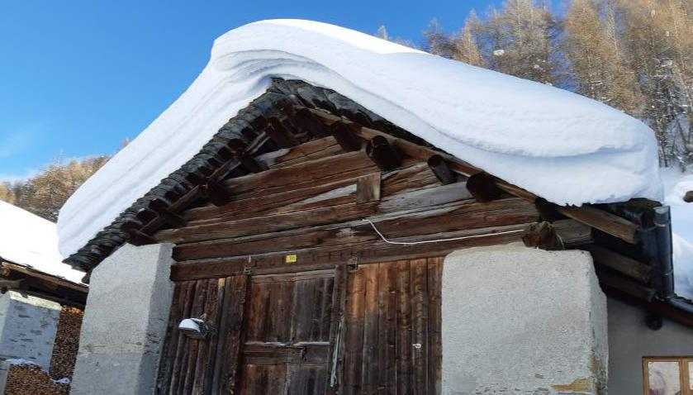

-29-

Exercise 13:

To be abused and denied

If you proceed thoroughly, you will notice many inconsistencies in official Corona-Politics. Critical discussions, however, have taken place in the public since March 2020 almost only in alternative media and small scientific blogs. If one was critical of the public and questioned the proportionality of the prohibitions and restrictions on fundamental rights, hatred and exclusion, they were excluded. This has been fuelled by governments and the leading media. To help us feel into this, here's an example.

In Berlin, a large cross-thinking demonstration with 100,000 to 120,000 people took place in the Tiergarten on 29.8.2020. The speeches at the rally were serious, criticized the Corona measures as unsustainable and called for respect for fundamental rights. The participants were from the middle of society, many academics, many self-employed, many voters of the Greens and the SPD. The demonstration
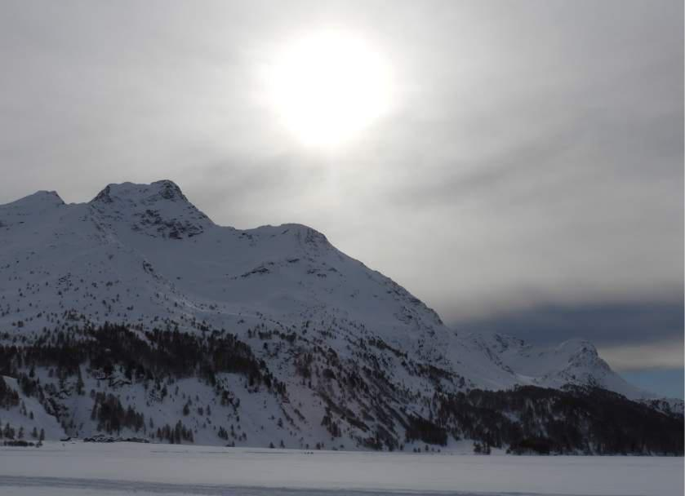

-30-

reminiscent of the peace movement or environmental movement from the early days of the Greens. Everything was peaceful. Everyone on the videos can see this for themselves.

This demonstration was initially banned by Berlin's interior senator Andreas Geisel on the grounds that he did not want to provide a stage for right-wing extremists and conspiracy theorists. This ban has been overturned.

On 2 September 2020, there were further small demonstrations in Berlin, which were not banned by the senator, including a demonstration directly in front of the Berlin Reichstag, which was registered by Rüdiger Hoffmann. Rüdiger Hoffmann is a right-wing extremist convicted of attempted murderwho organised an attack on an asylum seeker's home with Molotow cocktails. Hoffmann has been organizing an annual "Storm on the Reichstag" since 2013. (11) This demonstration in the Bann-mile was even unlawfully authorised by the Interior Ministry, since it should have obtained the consent of the Federal Ministry of the Interior, but this did not happen, as it later transpired. The Reichstag staircase was guarded only by three policemen. This is the background to the "opening of the Reichstag"; in fact, it was a photo shoot on the steps, no one invaded the Reichstag itself.

With this the framing trap had been set, in the media only the "storm on the Reichstag" was reported, all the ruling parties outbid each other in excitement, for the three brave policemen there was a special honour in the Bundestag. There was no media report on the fundamental rights defenders in the Tiergar-ten, who had nothing to do with the other demonstration in front of the Reichstag and always distanced themselves from extreme thoughts. The millions of people in front of the televisions only heard that the ‘lateral thinkers’ were "right-wing extremists" and had tried to storm the Reichstag. This staged lie publicly defamed criticism of the Corona measures and poisoned the mood across the country.

This is just one example of how the core of democracy, namely respect for the other, has been radically violated. Instead of a conversation, there was framing and discrimination.

Lies are always a psychological murder, the victims and those affected experience it this way. It is a spiritual contempt and transgression, an attack on dignity.

-31-

You need a very thick mental skin to endure such challenges.

Such discriminatory behaviors are not new in world history. That's why there are ways to take solace. I used to wonder why there is comfort twice mentioned in the Gospels. Now I understand it better, it is really necessary and I can only recommend it as a meditation substance.

Exercise: Meditate the soul verses from the Matthew Gospel, in the case in turn to the last three:

- Blessed are those who make peace; for they will be called children of God.

- Blessed are those who are persecuted for the sake of righteousness; for the kingdom of heaven is heard to them.

- Blessed are you when you are reviled and persecuted, and all evile speaks against you for my sake. Rejoice and rejoice: for your reward will be great in heaven. Thus, the prophets were persecuted before you.
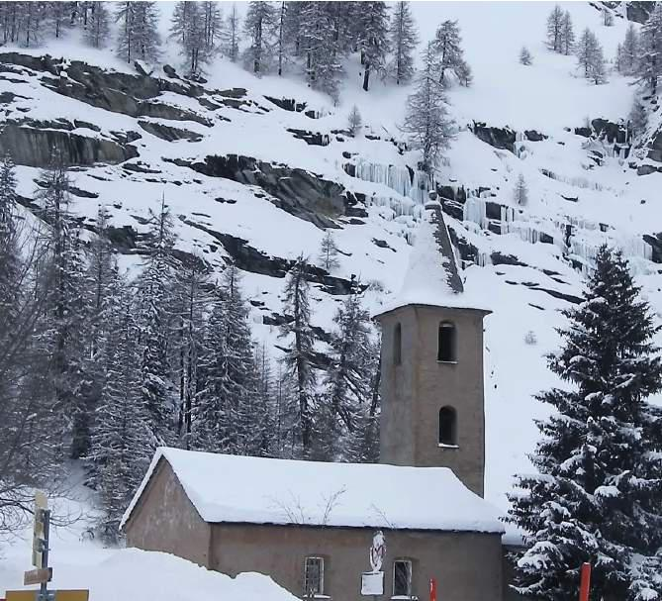

-32-

Strengthening health

Exercise 14:

Understanding Diseases, CreatingSickness Biography

With the Corona Crisis, we are being indoctrinated by the state and the media with a materialist understanding of the disease, only ‘this’ counts and is the guiding principle for the state coercive measures. Soul and Mind and a holistic understanding of health no longer exist in public discussion. Not even scientific knowledge about the immune system plays a role. Our regulations were never concerned with strengthening the immune system and a healthy lifestyle, but always only with prohibitions and vaccinations.

It is important to strengthen the holistic understanding of health and to take it personally. A disease always has mental-spiritual and biographical reasons, these can be individual, or are based on family or society. Understanding and feeling this is very important for one's own health.

Exercise: I remember my illnesses in my life and wonder:

- What was the point of the sick?

- What was it like before and after?

- Were there mental or mental causes?

-33-

Exercise 15:

Befriending the body and the organ being

A friendly and open relationship with one's own body is one of the most important sources of health. In fact, the body and its organs have soul and mind. This can be taken very concretely and opened up to the idea that each institution is administered by an organ. This organ being can be welcomed in meditation andobserved. Here, a playful approach makes sense.

Exercise: Imagine that each organ and body part is animated and managed by elemental beings. Sit down in meditation posture and walk inwardly through the organs with joyful greeting and smiles and greet the organ beings. "Dear lunges, it's so beautiful that you're there. I hope you're fine, here you get a big smile from me. " "Dear liver, I greet you. What do you look like today? I'll caress you a little bit. " Pay attention to the reactions, how does the body feeling and mood change? For example, will a joyful greeting come back? It may also be that an organ we see is in a bad way, then take care of it, ask what it needs and give it to him immediately. In the case of diseases, the organ system needs special attention.
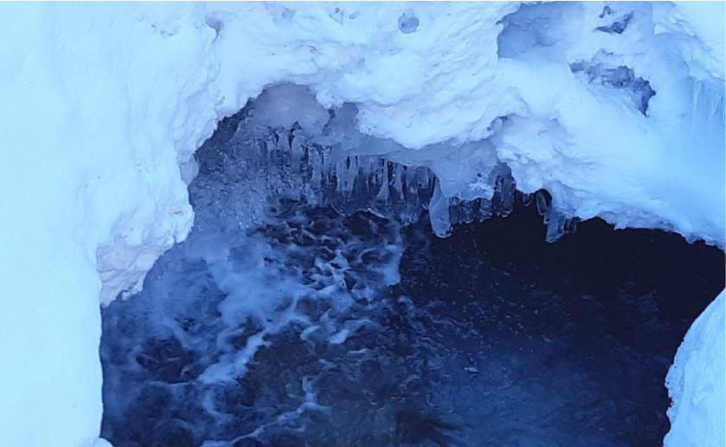

-34-

Exercise 16:

Strengthen the immune system meditatively

There are many ways to strengthen the immune system, vitamin D and C, zinc, healthynutrition, exercise, fresh air, social contacts, singen, sufficient sleep, etc. The following is a meditative possibility. The immune system is the physical expression of the self that belongs to the spiritual part of man.

Exercise: Remember your self in the Meditation. In the pure power of memory, you are close to the I. If you feel like I, your “I Am” spiritually spreading into all body regions from head to toe, permeating the whole body with it. With this I -penetrated, you come close to the Immune System and strengthen it. The immune system is also managed by many elementary beings. Thank you to these beings for their tireless work. For example: "Dear immune system, dear immune beings, I am so grateful to you for taking care, day and night of me. Here I acknowledge your beneficial work. "
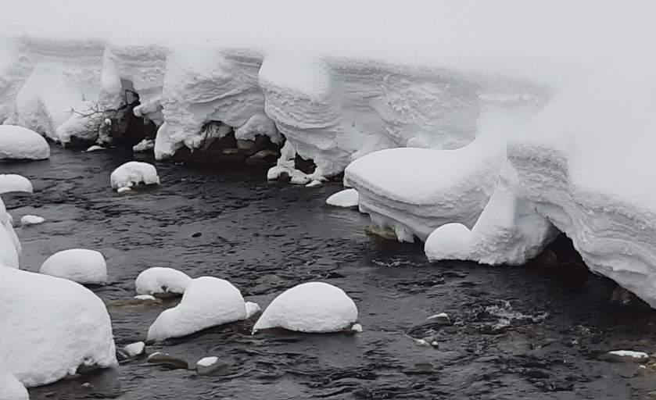

-35-

Exercise 17:

Healing Meditation from Sigwart to Eulenburg

From Sigwart to Eulenburg, which was already mentioned in Exercise 2, there is a very beautiful meditation that serves to stimulate the self-healing powers. You can use them to support you with any disease and if you do it intensively, you can also achieve a lot.

"Saying for the stimulation of the self-healing powers (daily morning and evening):

... Imagine the troublesome spot exactly, as if you approached it from the inside, not from the outside. Then it becomes translucent so much until it dissolves into light before your eyes, so it is almost dematerialized. Say and think vividly the words in a very concentrated way:

You God, that rests in me,

Thee do I call ! -

Power of your power,

Light of Your Light -

be my own healing power!

Through this power I pass through obscure matter to the disease and place it under the transforming rays of the primal power of God, which works through me! -

All darkness becomes light matter, flowing through the breath purified by the Godhead, and from now on it will unceasingly fulfill the sacred law of harmony, which means "health" for matter.

(from the book "Bridge over the Strom", the messages of Sigwart of 30 June and 1 July 1931)

-36-

Integrating death

Exercise 18:

Befriending one's own death

Fear of death is a major trigger in the Corona crisis. From morning to night, the media is all about avoiding death. In order to avoid death, life is shut down.

This is a futile effort, because every life ends with death. This was already clear at the beginning of the birth. Nevertheless, one can observe that especially younger people do not know that one dies. They already know it in theory, of course, but they have not felt it and integrated it, but secretly dream of eternal life and are then shocked when confronted with death. Many older people are more realistic, they have lived their lives and know that they will die.

What about the right to die? Who has the right to determine the time of death, as the individual himself and alone? Raphael Bonelli, an Austrian psychotherapist, recounted in a video an experience of his father, who was a doctor in a clinic. A nearly 90-year-old man was admitted to hospital with heart problems. He was stable. The next day, he had

-37-

a heart attack. Mr Bonelli's father ran in, the elderly man was laid on the floor and the doctor revived him with a heart massage. Two days later, the same thing. When the man came back to himself, he said to the doctor: "Lord, let me finally die! " The doctor drove back and finally the man could die. This gave the doctor something to think about and should also make us think.

The fear of death makes us unfree and able to be manipulated. The fear of death is the entry door for a flood of irrational fears. On the other hand, an emotional preparation for one's own death makes us more resilient and calmer. Life becomes more intense when you reconcile yourself with death.

With every step you take to reduce the fear of death, you help social relaxation.

Exercise: Play through your own death meditatively. Suppose you know you're going to die in a few weeks. How does that feel? Where do you want to die? How do you want to die? What else do you want to do beforehand? What burdens you, what you really want to clarify before you change sides? How do you want to hand over your estate? How should your loved one behave to you when you die? What are your ideas about what you experience and do after your death?
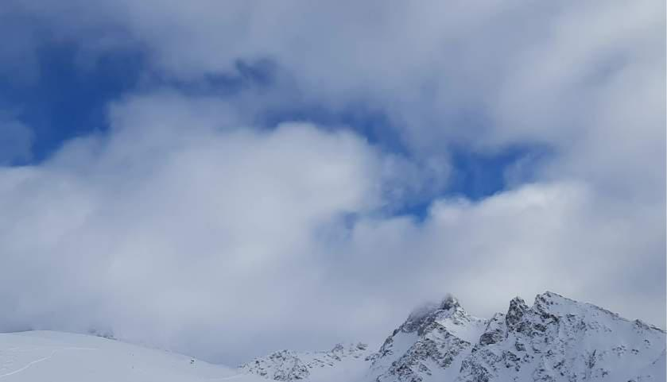

-38-

Exercise 19:

Becoming aware of your own little emotional death

Death is not a one-off process, but an ongoing process. In a biography, you usually die several times. Removals, separations, strokes of fate, after that everything is different, the soul has died and was born again. Sometimes, after serious illnesses, the body is also reborn.

Exercise: Do you realize how many small deaths you have already died in this life? What were the causes of death? How did the rebirth take place? Who was an obstetrician? What has changed?
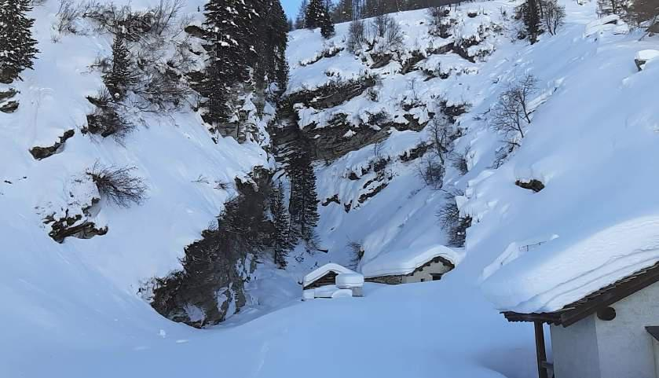

-39-

Exercise 20:

Respect for life raises fear of death

A friend sent me the following exciting impulse: "If we respect life more and more, the fear of death will heal. We can all ask ourselves very honestly, very honestly, whether we really have enough respect for life? I found that the moment I thought intensely of respect for life and created the feeling in my heart, EVERY fear of death was gone. "

Exercise: Imagine and create in your heart the feeling of deepest respect and reverence for life. Now watch what happens to the fear of death?
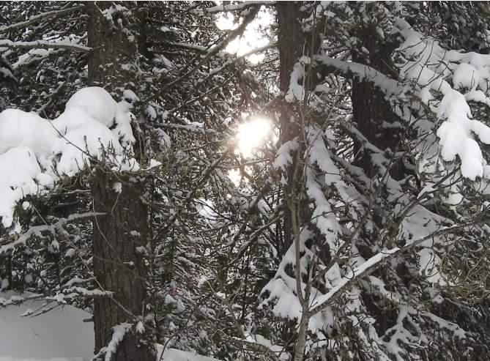

-40-

Exercise 21:

Maintaining contact with the dead

Our relationship with death is also so glued together, because we have lost thenatural relationship with the deceased. When you maintain contacts with the deceased and it becomes commonplace for them to live with us, inspire us, persevere us and love us, then the attitude to death changes by itself. The stages of post-moronlife and contact with the deceased is, of course, a very big issue that cannot be dealt with here. But I would like to introduce a one-time basic exercise.

Exercise: Collect yourself, go into your quiet center. Now think of the deceased, the one that comes to mind now. Stay with him and watch what feelings and impulses appear? Perhaps there is also an inner conversation. Say goodbye with a heartfelt greeting. Now think of another deceased, stay with him and pay attention to the feelings and impulses that occur. Are there any differences between the two deceased?
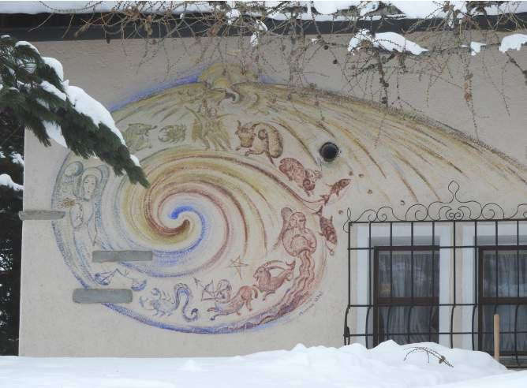

-41-

Exercise 22:

What were my circumstances of death in past incarnations?

I had inhibitions to present this exercise here, because a lot of people will feel overwhelmed with it. But there are also many people who have memories of earlier terrestrial life, usually only in fragments, of course. In the course of a spiritual training and the uplifting of one's own shadows, such memories of earlier incarnations or prenatal life naturally arise. Today, more and more people are using it as a natural gift. Of course, this is not an easy area and there are various possibilities of misinterpretation. But that is not what it is about now, but about getting a more fluid relationship with dying.

Exercise: Meditate the question: How many times have I died in the past in-carnations? And what were the death scares? It is not a question of precise answers, but of clues and everything that happens inwardly in the context of these questions. If you have put yourself in the position that you have already died 20 times, for example, and that is supported by a blade in the soul, death becomes an increasing natural process and not a one-off catastrophe.

-42-

Healing

The following meditations are inspired by the reality of the spiritual world. This is not a theory, but a real experience of the people who have trained themselves for supernatural perceptions. The training of corresponding perceptual organs usually requires a long practice, but there are also more and more people whobring diese sensitivity from birth. You look deeper into the backgrounds of the physical world and life.

In the spiritual worlds one can not only perceive, but also work actively, if this is carried out by higher spiritbeings. Experience shows that this is effective. The world is changing in the backgrounds, relaxation, peace and freedom swell, which has a fine and unconscious effect on everyone.

Exercise 23:

Silent rally

The silent rally was proposed by Marko Pogasnik:

"Since public protests are forbidden in many countries, we want to express our will in silence. Choose two to three of the proposed affirmations every day and repeat them as often as possible in Stille. Say about the bottom of your abdominal cavity and with the power of your heart.

In addition, we suggest that we meet every Friday at 5:00 p.m. in your time zone for a silent demonstration. Imagine that we come together under the tree of life and read the affirmationsbelowoneby one. Give each affirmation a moment of time and inner attention.

Together we can create better and healthier circumstances for ourselves, our children and all beings onearth.

- Freedom is our birthright!

- We demand peace on earth!

- Democracy is our irrevocable right!

- All efforts for a healthy earth!

- We demand freedom of movement!

- We respect viruses and microbes!

-43-

- We standfor free choices!

- We support fair and honest politicians!

- For creative coexistence with the earth and all beings!

- Heart-to-heart education for all children!

- We support diversity at all levels!

- Truthful information withoutany contriwhat!

- We stand for the balance of female and male!

The expression of hatred is not allowed. You can also repeat these affirmations in the first-me-form, as I, as your inner decisions. You can redistribute this suggestion, so that our silence is heard. "
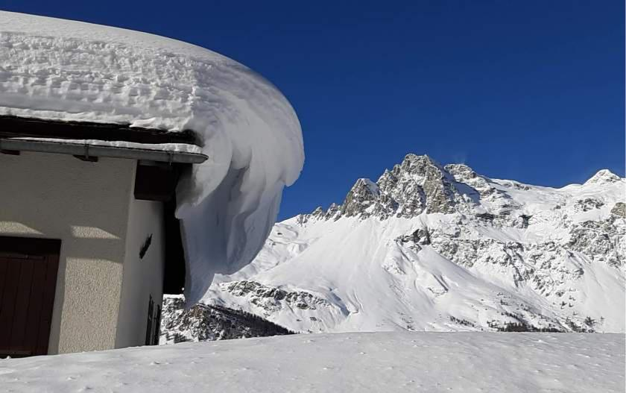

-44-

Exercise 24:

SarsCov2 virus and disease Covid19 mentally improve

For all that exists, there are living primal images in the spiritual world in the lower Devachan, i.e., the outerregions of the spiritual world, and in the astral world beings who implement the original images. This can also be found for viruses and diseases and you can experience differences.

With the SarsCov2 virus, I discovered two peculiarities in mental perception at the beginning of March 2020 that distinguished it from other viruses (Influ-enza, Epstein-Barr, etc.). First, it was heavily occupied by dark impulses coming from the human sphere. Second, it was cut off from the normal angelic hierarchies and elementalworlds of nature. I wrote at the time: "Obviously, the coronavirus is more frightened than other diseases that kill more people but not scare us so much. So, there is a lot of work to be done. "

These two peculiarities suggest that the virus and disease come not only from a natural development, but also from human manipulations. Interestingly, there was also a discussion from the outset as to whether the virus originated in the laboratory in Wuhan, where corona viruses were tampered with. There are a lot of external indications for this, which were compiled by the microbiologist Rossana Segreto (Uni Insbruck) and Prof. Roland Wiesendanger (University of Hamburg). (12) Politically, it is necessary to ban dangerous changes in viruses by laboratories.

Spiritually, it is necessary to reintegrate the SarsCov2 virus and the disease and to free it from dark impulses. For me, this was a meditative focus in the spring of 2020 and fortunately some friends also took part in it, which greatly increased the strength. The dark impulses on the mental virus became increasingly weak and from June 2020 no longer perceptible. In the outer world, the disease became more harmless and less deadly.

The problem was not solved, but later dark impulses reappeared. So, it makes sense to stay on it.

Exercise: It is good to connect with one's own angel, the angelic hierarchies and Christ at the beginning ofmeditation and to thus unite. This gives you a safe position.

-45-

Then, with a positive attitude, meet the coronavirus beings and show them the Christ, show them the natural beings and pray with a Lord's Prayer.

One can also describe the various aspects as a word meditation and observe what one perceives. For example:

- Coronavirus (virus family, there are different varieties that were already in the middle ofcolds.)

- SARS-CoV-2 (name of the new coronavirus of the current infection wave)

- COVID-19 (infectious disease caused by SARS-CoV-2)

A friend wrote to us what we like to share as a suggestion: "I think your approach is great and the only right one: that you have to try to integrate these viruses into earth development. I now also do a daily salvation meditation.

I think of the following words:

"You coronaviruses, look at the Christ, see the love of Christ, see the primal power of love. And look at the natural beings!

Let yourself be positively integrated into earth development!

For you I pray the Father-ours."

I pray that out loud.
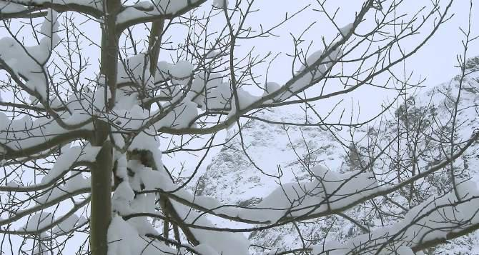

-46-

Exercise 25:

Forming a healing space with angels andfreeing death, tampering and lying demons

Since 2020, powerful waves of fear have been running through humanity. These beings are nourished from different sides. There are fears of illness and death, fears of existence due to economic shutdown, fear of a health dictatorship. These fears often rise from lower regions and mist the heart and head.

In the meditative view, the fears often appear as damo-nes, which exist not only individually, but collectively. There are verygreat demons in the astral world that overshadow entire cities and push themselves into the human souls. There are also demons that transport manipulatives and lies. The hypnosis described above is, spiritually speaking, carried by such demonsthat overshadow and displace ‘the I’ in the soul.

I see again and again that in large cities the number of such demons is much higher than in the countryside. In remote villages, one feels free from corona stress and gets a feeling of normal, i.e., demon-free life.

These demons permeate us and affect our soul life. Rudolf Steiner describes it this way: "Everything you do involuntarily, al-les, which you are urged to do, happens through the actionof otherbeings. It doesn't happen out of nowhere. "

And where do these demons come from? There are several sources. First, they are unconsciously made by us human beings through lies and

False thoughts: "Beings that you yourself create through you or create false thoughts are those that gradually grow into demons. There are good demons that start from good thoughts. But bad thoughts, especially untrue, lying, they create demonic figures of the most fearfuland horrible kind, who spike the astral body [i.e., the body of the soul], if one is allowed to express oneself in this way. " These are enormous dimensions, the daily worldwide number of lies and false thoughts is immeasurable.

Such demons created by ahuman being, however, not only remain with this one, but they flow into the surroundings, shape the stiminuation of houses and cities and also go into other people.

-47-

A second important reason is unjust, bad sentences: "All things, such as unjust, bad laws, which incorrectly punish, bad institutions in a social community, which we return to the ethereal body [i.e., life-forces], that in the ethereal slander those beings that are only laughed at today in the superstitious time. These beings are spectra, ghosts. " (Rudolf Steiner, GA 98, p. 105 ff.) There are many unjust, bad laws, the confusing Corona bans are especially part of it, resulting in floods of ghosts and demons.

A third reason for its creation is the conscious production of demons, for example through propaganda, intrigue and public incitement, but also through targeted dark magical work.

Unfortunately, these fears, deceiving and lying demons are created on a large scale and systematically, and it is therefore important to dismantle and dissolve them systematically and daily. Here, of course, you feel overwhelmed, but every hike starts with small steps.

In the following I present a method that is hygienic, since one stays with one's own essence sores in a protected space, so that the risk of something getting stuck on one is low. I am resonated with the Christian Angel hierarchies to work together, those for whom

-48-

this is foreign, the meditation should be redesigned as it best suits.

Exercise: I connect with my angel and feel it. When the connection is clear, I let my angel to pass on my request to the higher angel hierarchies to build a healing space in front of me. In particular, the flocks of Michael (face of Christ, power of passing through) and the flocks of Raphael (healing) form the noblehealing space from theirbodies. I look at this from the outside. Now I ask the angel hierarchies to introduce demons of fear, lies and manipulation into the healing room. I watch as the mood and colouring of the healing room changes. When I give the impression that the demons intended for now have arrived in the healing room, I ask the angel hierarchies to dissolve them. I reflect on Christ and send the power of Christ into the healing room, for which a pictorial depiction of Christ can help greatly. Finally, I send a Lord's Prayer into the healing room. During all these steps, I remain in my position outside the healing room. I observe whether the healing room is changing and being cleared or if something is still needed. If there is still something necessary, I do it. Finally, I ask my angel to pass on my request to the Angelic Hierarchies to dissolve the healing room again.
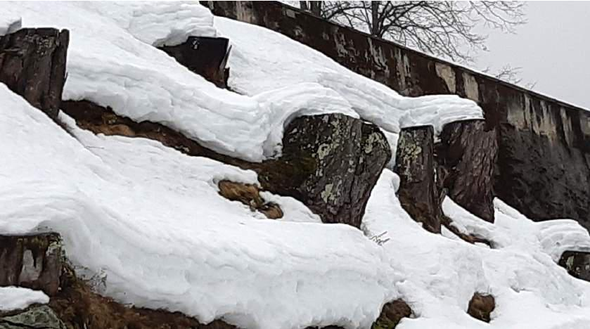

-49-

Exercise 26:

Bless and pray for masks, tests and vaccines

Unfortunately, many of the Corona measures areassociated with dark spiritual impulses. On masks and tests we found dark impulses and curses, which can lead to a weakening of the beings and a weakening of the self, which brings you out of the middle and makes you strained. It seems important to me to reckon with this and not to fall blindly into it. This problem can usually be eliminated through prayer and blessing.

Vaccines not only have side effects on physical health, but they can alsoaffect mental and mental health. Rudolf Steiner pointed out this serious problem. He said in 1917 that "... perhaps in the not-so-distant future find a vaccine through which the organism processesd in as early adolasm as possible, if possible, at birth, that this human body does not come to the thought: there is a soul and a spirit." (GA 177, p. 97). Man would only be able to think about the physical world and remain trapped in the material.

The supernatural study of the new Covid19 vaccines repeatedly showed that most actually have the effect of cutting off the connection to the angel and thus to the spiritual world and to confuse the essence members (ether, body, astral body, etc.). In some of the deceased after vaccination, we observed that the effect of vaccination on the ether body led to severe blockages in after-death life. There is a serious social problem here. Individually, this can be rectified by medical accompaniment and mental work and a conscious restoration of the spiritual connection, at least after some time.

Exercise: In any case, you should bless the various tests and the FFP2 masks in some way, for example with a father-ours, before using them. This is usually sufficient to redeem a possible dark impulse that sits mentally on the mask or the test. This does not seem necessary for self-sewn and medical blue masks. Unfortunately, it is more complicated with the vaccines, a blessing is probably not enough here, but it is in any case good.

-50-

Exercise 27:

Spiritually cleanse newspaper articles and films

Newspapers and films are also filled with spirit beings. The spread of the fear and manipulation demons runs strongly through the media. As soon as you see a film, a corresponding demon has slipped into your own soul. It's not necessarily about the content of the film or article, but about the energy and spirituality with which it is charged. Often this fits with the content, but not always.

Exercise: Stay vigilant when it comes to media consumption. As soon as you are negatively touched by a movie or article, stop and make a healing act in the direction of the movie or article. This can be a positive thought, a blessing gesture, or a prayer. Watch if it changes your feelings.
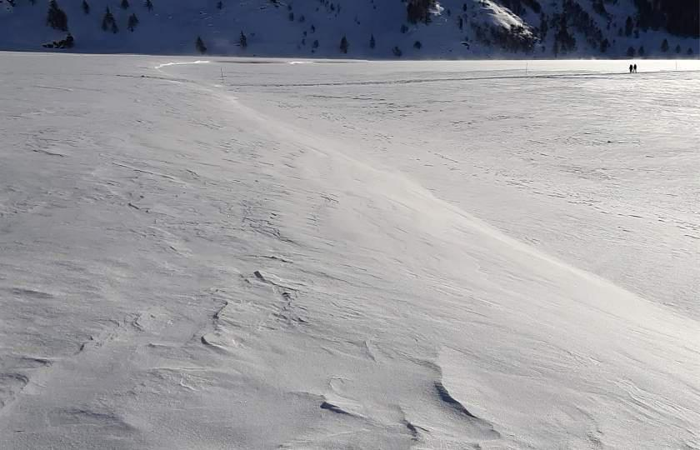

-51-

Exercise 28:

Resolutely the dark spirits who confront in the background and take away the power or redeem them

With the exercises so far, a good basis for spiritual self-defense in the corona crisis has been laid. One can go deeper spiritually and meet and work with the causant spirits behind the demons described.

The impact of the Corona Crisis 2020 is a profound attack on human consciousness. It is also an opportunity, because many unredeemed residues from historical developments are drifting to the surface. I hope that each and every one will use their own special spiritual possibilities so that we as humanity can face this challenge.
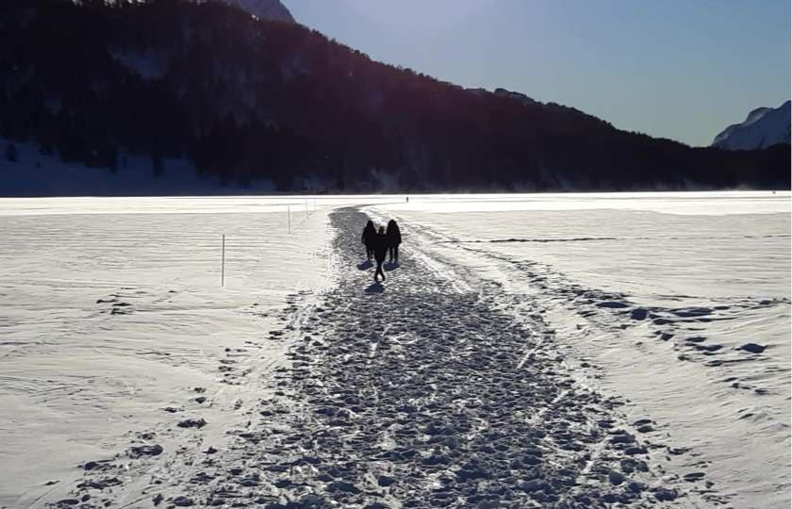

-52-

Humanities perspectives on the Corona crisis

In the following I want to aphoristically summarize the most important points of view on the spiritual classification of the corona crisis. These are different, complementary layers of understanding. I can't elaborate on this here, if necessary. Some material about this is on our homepage: https://www.anthroposophische-meditation.de/corona-krise

Mental perspective:

Collective anxiety disorder

Thepublic handling of the coronavirus is surprisingly similar to the structure of an anxiety disorder, as it is described in psychology: initial shock experience, increasingly sophisticated protective measures, but with it the fear is heightened, zoom vision auf theproblem, suppression of trivial facts, etc. This is further explained in this video: https://www.youtube.com/watch?v=kowfTxqnpuw&t=1026s

Mental perspective:

Collective hypnosis

The mechanisms of collective hypnosis were described in exercise 9.

Astrological angle:

As at the beginning of the Reformation: Conjunction of Saturn and Pluto in Capricorn on January 12, 2020

This particular conjunction on 12 January 2020 was described in ster-nenkundiger circles as very important and as an indentationof a turning time. The astrologer Yuri Viktor Stork wrote, for example: "Saturn and Pluto were last in Cojunti-on in Capricorn in 1517. It was the beginning of the Reformation, during which the centuries-old secular machinitiesof the Roman Church were called into question and ultimately limited. It was a shock in society, the effects of which can still be felt to this day. The question that is now being asked today is the same as it was then: who has the Meight, and on which

-53-

basis is based on this? Is the claim to power still justified? Who makes the rules of society, and who enforces them? " (13)

Today, it is also a war of faith. Do you believe in Corona? Do you wear a mask? Doyou go to materialistic medicine? Do you have the right setting? The question of social power is also on the table. (See "The Great Reseat" ", an initiative of the World Economic Forum (WEF) to reshape global societyand the economy following the COVID-19 pandemic.)

-54-

Historical perspective:

100 Years of the Russian Revolution: Resurgence of this historical impulse

Rudolf Steiner describes the historical law that historical impulses can emerge more clearly after 33 1/3 and after 100 years. "A generation of humans of thirty-three years matures a seed-of-thought, to germination-of-action. Once it is mature, it will continue to work in the historical development through the following sixty-six years. One knows the intensity of an impulse that man places into the historical becoming, also in its effectiveness through three generations, through a whole century." (Rudolf Steiner, 26.12.1917, in GA 180, p. 60)

What was 100 years before the Corona crisis and global lock-downs? In 1920, in the Russian Civil War, the Bolsheviks defeated the Mensheviks, thus beginning the era of dictatorial socialism that shaped the 20th century. Lenin and Stalin established their totalitarian regimes in Russia. In Germany followed in 1933 the National Socialists, who fought the Communists, but established a forced regime with methods and goals similar to those of the Russian revolutionaries. Mao Zedong proclaimed the "People's Republic" in 1949 after a civil war in China, and in many other states there were "socialist revolutions".

This was always accompanied by a re-education of the people and the elimination of the "enemies of the state" for the communist final goal of the "ideal- society". In the "Black Book Communism" the historian Courtois estimates that the Communists each killed so many people: Soviet Union 20 million, China 65 million, Vietnam 1 million, North Korea 2 million, Cambodia 2 million, Africa 1.7 million, Afghanistan 1.5 million, etc. About 25 million people died under the Nazis. This, of course, is just the tip of the iceberg. The populations were brainwashed, under constant surveillance and often severely traumatized. The "anti-communist" reactions were often no better, such as the McCarthy-era witch-hunts at the beginning of the Cold War in the US.

In the symptomatic of the state and social reactions to the corona crisis, a resurgent of this communist shift impulse catches the eye: China's rabid lockdown is praised and made a global model. State coercion dominates economic and cultural life. We all need to comply with the higher level of "enforced

-55-

"solidarity" is defined by the state. Those who are not ‘in solidarity' and, for example, those who might meet with a couple of friends or play football, are prosecuted by the police and severely punished. Free and fundamental rights become worthless and must submit to 'state solidarity'. All people are treated equally, all get curfews, no contact bans, travel bans and vaccination, no matter how useful it is. The media switch to propaganda, and dissenting slogans find almost no place. Since there are still freedom of expression on social media, censorship takes place there too. Dissenters are defamed, demonised and excluded with corresponding social and economic consequences. State Governance takes place worldwide, in line with the goal of the "world revolution". Proponents of lockdowns do not want to see all this, but this is also one of the socialist symptoms, the great swirling fog of obfuscation.

The question arises: if this really is the case, how do we deal with it?

-56-

Spiritual perspective:

3 x 666 = 1998: strong action of Soratic spirits

In anthroposophy there are very differentiated descriptions of adversariesof ghostly and fallen angels who constitute us human beings. The "ahriman beings"are the spirits of materialism, coldness and darkness, the "luciferian beings"are the spirits ofarrogance, egomania and dazzling light, the"asuric beings"are the spirits of fragmentation and self-dissolution. (In Sanskrit, the term Asuras is referred to as the "evil spirit of " or "opponent of the gods", i.e., as an umbrella term, while Rudolf Steiner thus denotes a special kind of fallen angel.) All these adversaries listen to our universe and, when redeemed and transformed with Christ's power, that is, I-power, have very positive effects. There is a fourth group, whichcome from areas of mind outside of theuniversity and have nothing to look for in the spirit space of the earth, the sorical beings. These can seduce people because they promise power. Power-addicted people easily fall for Soratic beings who are the inspirers of evil. (You can find more detailed descriptions on www.anthrowiki.at.)

I would like to emphasize that this is not a theory or a belief system, but in supernatural perception one constantly encounters these beings. It is a condition of a healthyspiritual training path that one learns to deal with these beings.

Rudolf Steiner describes that at the rhythm of 666 years since the birth of Christ, there has been an increased historical influence of sorical impulses. This was the spiritualreason for the destruction of the Templar in 1312, which was an important milestone of the Inquisition that began at that time. This is not about the exact year, but about a period of time.

3 x 666 is 1998. This is our period. What can bedone here?

- The above-mentioned inhuman dictatorships of the 20th century were huge runways of sorical beings. We are all still in the middle of these issues.

- At the end of the 20th century, new technologies were introduced, digitalisation, mobile communications technology and genetic engineering. Di-

-57-

ese techniques shape people deeply and can have a destructive effect on the soul and consciousness. These technologies, too, are large runways of somatic beings, which is a result ofsupernatural research that has been confirmed over decades. Highly sensitive people also feel this and often react very strongly to mobile radio beams, not because of the physical rays, but because they experience the soratic effects that are dominant there.

-58-

Spiritual perspective:

Upcoming incarnation of Ahriman

I know that the "imminent incarnation of Ahriman" is an imposition for someone who is not more deeply involved with anthroposophy. To understand, you need basics that you have to work out first. With this in mind, I would generously encourage you to read on.

In 1909 Rudolf Steiner spoke of the danger of an "unbearable tyranny" which would result from the political exploitation and abuse of the fear of bacteria: "Thus one of the greatest goods of human life [health], is at the mercy of party-political polemics [...] What would be ahead of humanity, for example, if the bacteria [or virus] fear were to be exploited and legal provisions against the fight against bacteria [or viruses] were to be created? [...] it would lead to impossible conditions, to an intolerable tyranny." (Rudolf Steiner, München, March 6, 1909, not in the GA, Source: steinerdatenbank.de)

In 1919 Rudolf Steiner described in several lectures that the incarnation of Ahriman was imminent in the beginning of the 3rd millennium. When you read your descriptions, you actually feel transported to the present day. Rudolf Steiner indicates some currents that prepare the incarnation of Ahriman. These include scientific materialism, an economic-driven intellectual life, the preservation of knowledge in libraries and today on electronic dates, belief in the omnipotence of numbers and statistics, the emphasis on party antagonisms, the establishment of a world government, etc.

The incarnation of Ahriman must be thought of as a protracted process, the Ahriman spirits descending wisely into the beings of men. When Ahriman penetrates the I, one no longer experiences it, one is absorbed by the outside world. This has been the case for centuries. In meditation, religion, art or intensive thinking, one can overcome his work of Ahriman. When Ahriman beings cover up the mind, one gets abstract, unliving thoughts. This is now regarded by many as a standard, the space of thought has already been set to a large extent by the Ahrimanic beings. In our age, the Ahriman beings fight especially for the space of human feeling, the more the incarnation of Ahriman progresses in the emotional space, the more emotionally impoverished or more insensitive one becomes. But also, the Ahrimanisation of life

-59-

people have already begun. The already visible result is the machine man with artificial intelligence, the ideal of transhumanism.

The incarnation of Ahriman is a necessary event in human history. However, it can take place in different ways. There would be the possibility that we humans could learn to deal with it and absorb and process the Ahrimanic impulses without losing the self, the soul-spiritual connection. This would also redeem the Ahrimanic beings. But there is also the other variant that we humans lose our humanity and become machines. This is all the more the case when the incarnation of Ahriman is used by Soratic action andtakes place prematurely. This seems to be the case with the current somatic culmination. Rudolf Steiner foresaw this. His descriptions of the incarnation of Ahriman and the establishment of a political world domination, including the misdirection and brainwashing away from self-directed thinking, thinking for oneself, and vaccination in order to prevent the connection to the spiritual world, correspond to this variant.
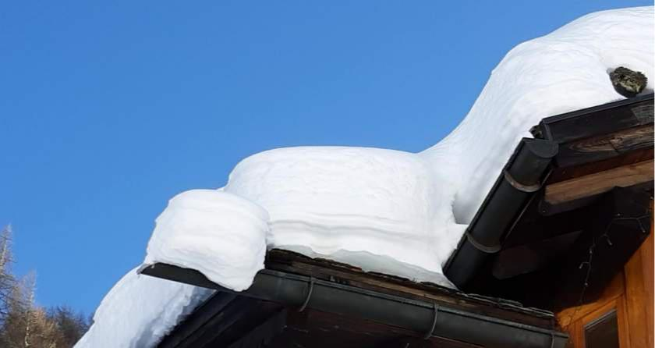

-60-

Spiritual perspective:

Forced mission of the religion of materialism and transhumanism

The astonishing developments in the Corona Crisis since January 2020 make sense when you look at them from the point of view of a modern religious war. The new materialistic world religion carries out a worldwide forced mission with religious zeal. The worshipped goddesses are the Soratic-Ahrimanic spirits. But this is cleverly concealed and not recognizable at first glance. This religion appears as a "self-obvious truth" and is not organised as a formal religious community. An ideological spearhead is transhumanism, in which the goal of the transition of man to the machine is formulated.

This dimension came starkly into view, when 2020 the dead at times didn't receive a last rites and even Easter was cancelled, there were no church services and instead on Easter Sunday, the most important Christian holiday, the day of salvation, the day of Christ's resurrection, Bill Gates gave a long TV interview in prime time and said that now all seven billion people will be vaccinated and thus saved. In religious wars, old holidays are assimilated and filled with new content. Bill Gates acted like a prophet of a new religion without realising it.

The unspoken confession of the materialistic world religion is roughly:

- There is no spiritual world, only the material world. (This is precisely the inspiration of the Ahriman spirits, who themselves claim not to be ghosts.)

- Sickness is the Devil, Dying is Hell. Both must be avoided.

- Our heaven is Survival. We want eternal life on Earth.

- Our Redeemer and Saviour are technical medicine and vaccines.

- Since we consist only of matter, our bodies can be replaced by technical technology.

- We receive eternal life when our brains are also replaced by a computer. (What transhumanists are actually working toward today.)

-61-

- Other people are dangerous virus carriers. Fear thy Neighbor!

- Our religious rituals are ‘social distancing’ and ‘the masquerade’.

- Nature is annoying and exhausting. We no longer want to be dependent on it. We no longer want to look into nature, but into screens. We build Test-tube cities, also the food is to be produced artificially.

- Science must serve only our gods!

- The other religions are allowed to continue superficially if they serve our gods in the core.

- We won’t tell anyone that this is a religion, so that no one comes up with the idea that you could turn away from it and connect with other gods.

-62-

What to do?

Before this question "what to do? "We've been standing for decades, but with the Coronakrise it became very burning. I see two main things:

First, it is important to stand up to maintaining the connection to the real- greedy world, even if it is lost for much of humanity. This has to be carried through, komme what would like, so that in the future it can be reconnected when the necessary learning processes have been completed. It is about mental resilience and, as a result, of course, also about social resilience. All the exercises described in this booklet are used for this purpose.

Secondly, it is a question of redeeming the Soratic action by means of spiritual healing and of freeing the Ahriman spirits from it. This is possible, because Christ, the multitude of Michael and many other spirits can handle it well and are willing to do so. Deeper ingessing here is a task for specialists, one should not burden one another if one does not feel called to do so. But through prayers and spiritual work, everyone can support this.
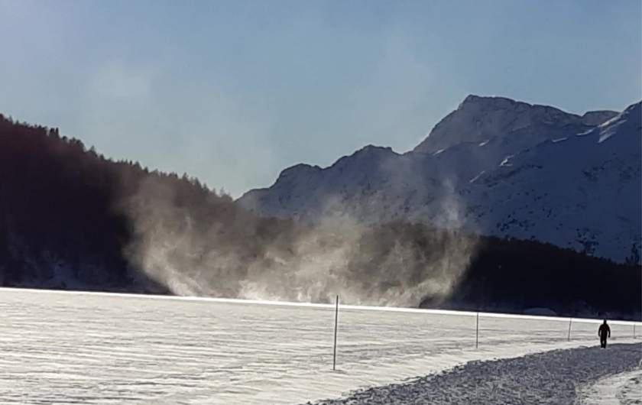

-63-

Comments:

- https://www.preprints.org/manuscript/202010.0330/v2 https://macdonaldlaurier.ca/files/pdf/20201209_Rethinking_lockdowns_Joffe_COMMEN-TARY_FWeb.pdf
(2) Z.B. Angela Merkel: https://www.focus.de/politik/deutschland/corona-schock-fuer-kanz-lerin-merkel-raeumt-in-interner-schalte-ein-us-ist-das-ding-entglitten_id_12909341.html
- https://tkp.at/2021/01/11/stanford-studie-mit-top-medizin-wissenschaftler-ioannidis-zeigt-keinen-nutzen-von-lockdowns/?fbclid=IwAR0vb0LE3LnM1iYJ_Obh57M8IlowBg_3BM yvERDdTRAH9hIbvaBdebTOU_8)
- https://reitschuster.de/post/merkel-harter-corona-kurs-ist-politische-entscheidung/

- https://www.destatis.de/DE/Themen/Gesellschaft-Umwelt/Bevoelkerung/Sterbefaelle

Lebenserwartung/_inhalt.html

- https://www.rki.de/DE/Content/InfAZ/N/Neuartiges_Coronavirus/Situation Reports/ Jan_2021/2021-01-02-en.pdf?__blob=publicationFile
- https://www.rki.de/DE/Content/InfAZ/N/Neuartiges_Coronavirus/Situationsberichte/ Jan_2021/2021-01-19-en.pdf?__blob=publicationFile
- https://tkp.at/2021/01/17/no-evidence-for-contagation-by-asymptomatic-per-onen/https://tkp.at/2020/12/21/gibt-es-beweise-fuer-asymptomatische-ansteckung/ https://tkp.at/2020/10/27/coronavirus-so-ansteckend-sind-asymptomatisch-infizierte/ https://tkp.at/2020/08/20/asympt-ometic-transmission-there-the-studies/https://sciencefiles.org/2020/12/28/explosive-studie-asymptomatische-falle-nicht-anste-ckend-no-grund-for-lockdowns/?highlight=asymptomatichttps://sciencefiles.org/2020/12/22/vorsatzlich-sittenwidrig-geschadet-christian-drosten-with-a-leg-before-court ansition.org/symptomlose-seien-nun-die-treiber-der-pandemie-die-who-widerspricht https://corona-transition.org/who-corona-infizierte-ohne-symptome-sind-keine-ubertrager https://sciencefiles.org/2020/12/28/das-asymptomatische-sars-karten-haus-sturzt-ein-nachste-studie-findet-kaum-asymptomatische-ubertragung/?highlight=asymptomatisch https://corona-tr/?

- https://tkp.at/2021/02/15/propaganda-der-regierung-zu-gefaehrlichen-mutationen-wahr-oof untrue/ https://tkp.at/2021/02/14/epidemiologe-virus-varianten-machen-nicht-mehr-krank/ https://tkp.at/2021/02/12/varianten-in-suedafrika-und-england-haben-rueckgang-nicht-auf-halten-koennen/

-64-

- https://www.kekstcnc.com/media/2793/kekstcnc_research_covid-19_opinion_tracker_ wave-4.pdf?fbclid=IwAR0hMcddEZUPlCYBWNPRwSlCf8SaZ32RPFkW_Bzuz5qmiLG2TZU-P88L6N5A https://www.spiegel.de/psychologie/die-angst-vor-corona-ist-groesser-als-das-tatsaech-liche-risiko-a-80c1a0c8-c5c3-46f2-ba45-22a6270e1db8

- https:/wiki.sonnenstaatland.com/wiki/R%C3%BCdiger_Hoffmann?fbclid=IwAR13z6o bkZvznaWldQ73i3HLqzoyktEqFt_XLQXXuuVDOU4wPjA49RcUlWs-Sturm_auf_den_Reichs-tag_und_andere_Veranstaltungen
- https://www.heise.de/tp/features/Kommt-Sars-CoV-2-aus-dem-Labor-5030073.html ps://www.researchgate.net/publication/349302406_Studie_zum_Ursprung_der_Corona-virus pandemic
- https://spuren.ch/content/single-ansicht-news/datum////tanz-auf-der-schwelle.html

All rights for text and images are with the author.

www.Anthroposophical-Meditation.de
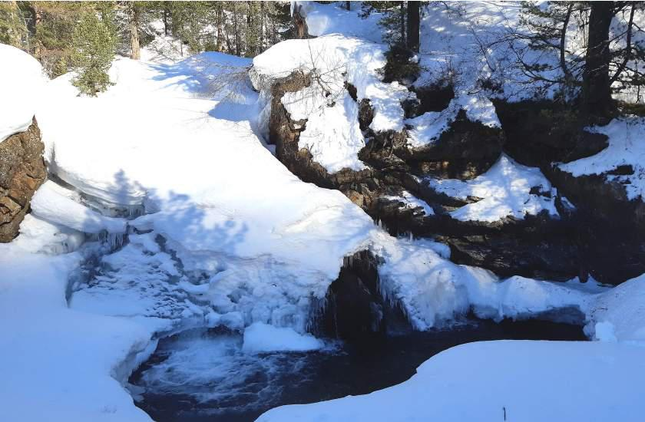

-65-

Rudolf Steiner on Fear and Healing Power

“As we know, people today are haunted by a fear we can compare with the medieval fear of ghosts. It is the fear of germs. Objectively, both states of fear are the same. Both fit their respective age: People of the Middle Ages held a certain belief in the spiritual world; therefore quite naturally they had a fear of spiritual beings. The modern age has lost this belief in the spiritual world; it believes in material things. It therefore has a fear of material beings, be they ever so small.

Objectively speaking, the greatest difference we might find between the two periods is that ghosts are at any rate sizable and respectable. The tiny germs, on the other hand, are nothing much to write home about as far as frightening people is concerned. Now of course I do not mean to imply by this that we should encourage germs, and that it is good to have as many as possible. That is certainly not the implication. Still, germs certainly exist and ghosts existed also, especially as far as those people who held a real belief in the spiritual world are concerned. Thus, they do not even differ in terms of reality. However, the important point we want to make today is that germs can become dangerous only if they are allowed to flourish. Germs should not be allowed to flourish. Even materialists will agree with this statement, but they will no longer agree with us if we proceed further and, from the standpoint of proper spiritual science, speak about the most favorable conditions for germs.

Germs flourish most intensively when we take nothing but materialistic thoughts into sleep with us. There is no better way to encourage them to flourish than to enter sleep with only materialistic ideas, and then to work from the spiritual world with the ego and the astral body on those organs that are not part of the blood and the nervous system.

The only other method that is just as good is to live in the center of an epidemic or endemic illness and to think of nothing but the sickness all around, filled only with a fear of getting sick. That would be equally effective. If fear of the illness is the only thing created in such a place and one goes to sleep at night with that thought, it produces after images, Imaginations impregnated with fear. That is a good method of cultivating and nurturing germs.

If this fear can be reduced even a little by, for example, active love and, while tending the sick, forgetting for a time that one might also be infected, the conditions are far less favorable for the germs.

These issues are not raised in anthroposophy merely to play on human egotism, but to describe the facts of the spiritual world. This concrete case demonstrates that in real life we cannot avoid dealing with the spiritual world, because it is the basis for our actions between going to sleep and waking up. If people were given thoughts that lead them away from materialism and spur them on to active love out of the spirit, it would serve the future of humanity better. Then infinitely more productive work could be achieved than through all the preparations now being developed by materialistic science against germs.”

(Rudolf Steiner in Basel on May 5, 1914, GA 154)

-66-

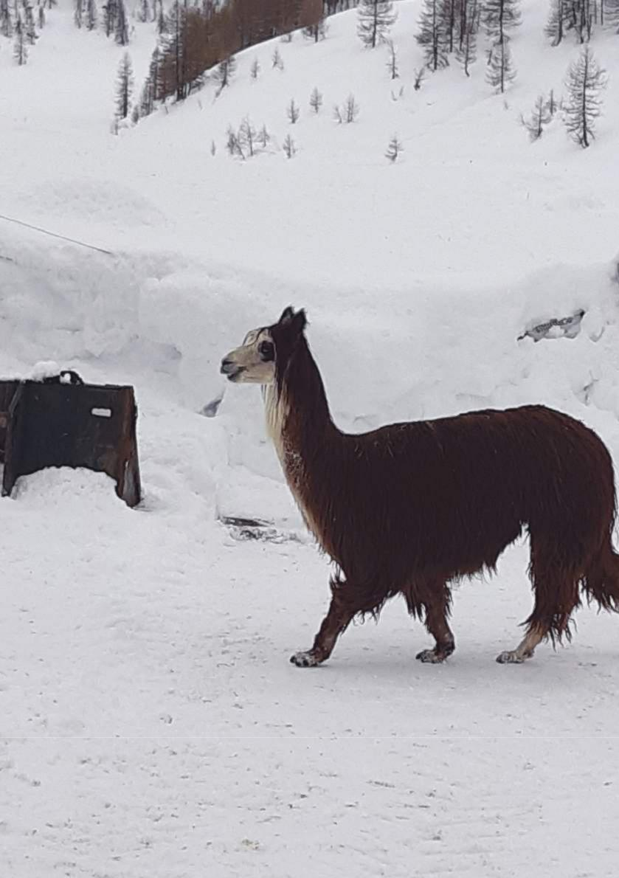

-67-

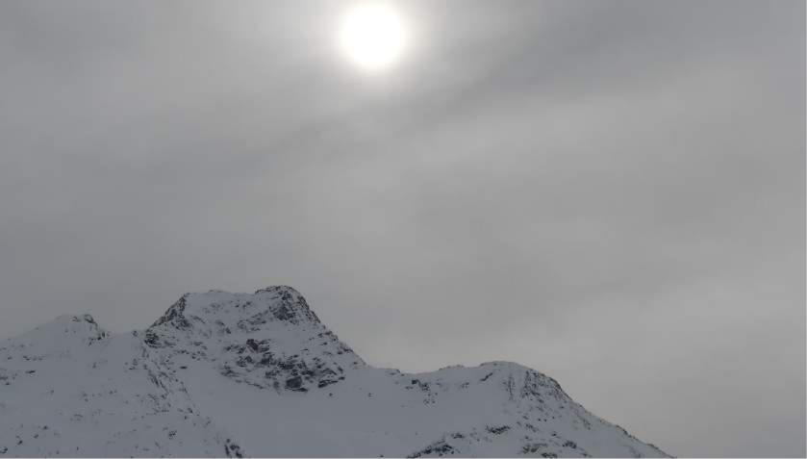

Rudolf Steiner:

"If the courage is not to sink ... "

"We must eradicate with the root from the soul fear and horror of that which is coming upon man form the future.

Serenity in relation to all feelings and feelings towards the future, man must acquire. Looking forward with absolute equanimity to all that may come, and only think that whatever may come, comes to us through the wise guidance of the world. We have the right thing to do at any given moment and leave everything else to the next.

It is part of what we must learn in this time to live by pure trust, without any security of existence, from trust in the ever-present help from the spiritual world. Truly, there is no other way today if courage is not to sink. Let us take our will under control and seek the revival from within, every morning and every evening."

(Rudolf Steiner on November27, 1910 in Bremen)

-68-

