Title , style (Calibri (body text) 16 bold, centered – if necessary, separate subtitles from the title with a hyphen)

First name_author 1 last name_author_11, first name_author_2 last name_author_22,  
First name_last author, last name_last author   
please write the first name and last name of an author always in the same line,

1Instiution of the first author, e.g. German Sports University Cologne, 2Institution of the second author

(style: Calibri (body) 12 italic, centered)

Introduction (style: Calibri 14, bold, no number in front: no „1. Introduction“ and no colon)

Your articel should contain the points introduction, methods, results and discussion. Conclusions are optional. In total, the article should be a maximum of 8 pages.

The formatting of this line corresponds to the formatting of the text of the article: **Style of the text:** Calibri (body) 12; paragraph formatting: justified, indent left 0 cm, indent right 0 cm, single line spacing, before paragraph 0 pt., after paragraph 6 pt.!

* Please do not use manual hyphens under any circumstances! If you are bothered by large word spacing, you can activate the automatic hyphenation.
* Please do not compensate spacing with multiple spaces!
* If possible, please use only SI units and separate the number from the physical unit by a protected space (keys CTRL, SHIFT, space), e.g. 56 km
* Please do not use text fields in the manuscript, as they may be lost when imported into layout programs.

The following explains how to format formulas, figures, tables, references, footnotes, and lists/enumerations.

The next heading "Formulas" is the next heading level. This is not indented to the right, please do not use colons after headings!

Formulas (style: Calibri 13 bold)

Please number formulas consecutively and explain the formula symbols used:

|  |  |
| --- | --- |
| $$F=m⋅a$$ | (1) |

$F \left[N\right]$ is the force, $m\left[kg\right]$ the mass and $a\left[\frac{m}{s²}\right]$ the acceleration.

Or:

$F \left[N\right]$…force

$m\left[kg\right]$…mass

$a\left[\frac{m}{s²}\right]$…acceleration.

The continuous text continues here.

Images

It is very important that you own the license rights to use the images and, if necessary, name the respective copyright holder (photographer/designer/creator/...). It is essential that you observe the German copyright law in order to avoid warnings. Besides photographs, graphics, paintings, technical drawings, maps, also combinations of different works on websites and multimedia applications (also screenshots thereof) as well as databases and software (also screenshots thereof) are protected.

Since an e-book is planned, the illustrations may be in color.

Please add figure captions to the figures as follows (cf. Figure. 1):

* please write out the word "figure" in the figure caption and in the text referring to the figure,
* please number the figures consecutively,
* no text to the right or left of the figure
* if possible no frame around the figure

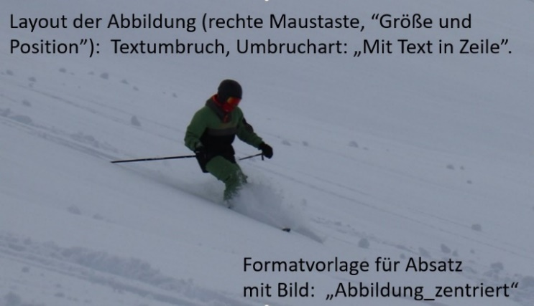

Figure 1: Figure Caption, **style:** Calibri (body) 10, paragraph: justified, hanging by 2.5 cm, single line spacing, spacing before paragraph 6 pt, after paragraph 12 pt. Please write out "Figure". Please number the figures consecutively.

After the image the text continues here, do not insert a blank line after the image.

Tables

Please include tables in the text with table headings as follows (cf. Table 1):

Please write out the word "table" in the table heading and in the text referring to the table,

* please number the tables,
* no vertical lines,
* horizontal lines only:
  + between the table heading and the column headings
  + between the column heading and the first line with the table elements and
  + after the last line of the table

table 1: table title, **style:** Please write out the word "table". Calibri (body text) 10, paragraph: justified, hanging by 2.5 cm. Text in the table cells, style: Calibri (body text) 10

|  |  |  |
| --- | --- | --- |
| **Kasus** | **Singular** | **Plural** |
| Nominativ | hortus | horti |
| Genitiv | horti | hortorum |
| Dativ | horto | hortis |
| Akkusativ | hortum | hortos |
| Ablativ | horto | hortis |

After the table please insert a blank line (style "Text") before the text continues here, even if a heading follows directly after the table.

***References***

Please cite all citations and sources appropriately <http://www.apastyle.org/>.

Examples of references in the text:

… to solve problems is, according to Ottmann & Widmayer (1996), the central …

… to solve problems is (cf. Ottmann & Widmayer, 1996) the central …

… the classification of data (Nauck et al., 1996).

Footnotes

Footnotes (References->Insert Footnote) can be used, please do not use endnotes. Format the footnote text with the "Footnotes" style sheet.

Examples: Audio[1], audis[2], audit[3], audimus[4], auditis audiunt. Audiebam, audiebas, audiebat, audiebamus, audiebatis, audiebant. Audiam, audies, audiet, audiemus, audietis, audient. Audivi, audivisti, audivit, audivimus, audivistis, audiverunt. Audiveram, audiveras, audiverat, audiveramus, audiveratis, audiverant. Audivero, audiveris, audiverit, audiverimus, audiveritis, audiverint. Audiam, audias, audiat, audiamus, audiatis, audient. Audirem, audires, audiret, audiremus, audiretis, audirent. Audiverim, audiveris, audiverit, audiverimus, audiveritis, audiverint. Audivissem, audivisses, audivisset, audivissemus, audivissetis, audivissent.

Lists/Enumerations

When using bulleted lists or lists, please use the "List Paragraph" style and use it to indent the list to the right: Calibri (body) 12

* Paragraph: Left indent 0.63 cm; Special indent: Hanging 0.63 cm; Spacing: before 0 pt. after 3 pt., single line spacing.
* Replace the bullets (black dot) with numbering as needed:
  1. example of numbering, here one level further indented, therefore here indent from left 1.9 cm.
  2. second line numbering
* Last line of the list/enumeration

Methods

Audio, audis, audit, audimus, auditis audiunt. Audiebam, audiebas, audiebat, audiebamus, audiebatis, audiebant. Audiam, audies, audiet, audiemus, audietis, audient. Audivi, audivisti, audivit, audivimus, audivistis, audiverunt. Audiveram, audiveras, audiverat, audiveramus, audiveratis, audiverant. Audivero, audiveris, audiverit, audiverimus, audiveritis, audiverint. Audiam, audias, audiat, audiamus, audiatis, audient. Audirem, audires, audiret, audiremus, audiretis, audirent. Audiverim, audiveris, audiverit, audiverimus, audiveritis, audiverint. Audivissem, audivisses, audivisset, audivissemus, audivissetis, audivissent.

Results

Audio, audis, audit, audimus, auditis audiunt. Audiebam, audiebas, audiebat, audiebamus, audiebatis, audiebant. Audiam, audies, audiet, audiemus, audietis, audient. Audivi, audivisti, audivit, audivimus, audivistis, audiverunt. Audiveram, audiveras, audiverat, audiveramus, audiveratis, audiverant. Audivero, audiveris, audiverit, audiverimus, audiveritis, audiverint. Audiam, audias, audiat, audiamus, audiatis, audient. Audirem, audires, audiret, audiremus, audiretis, audirent. Audiverim, audiveris, audiverit, audiverimus, audiveritis, audiverint. Audivissem, audivisses, audivisset, audivissemus, audivissetis, audivissent.

Discussion

Audio, audis, audit, audimus, auditis audiunt. Audiebam, audiebas, audiebat, audiebamus, audiebatis, audiebant. Audiam, audies, audiet, audiemus, audietis, audient. Audivi, audivisti, audivit, audivimus, audivistis, audiverunt. Audiveram, audiveras, audiverat, audiveramus, audiveratis, audiverant. Audivero, audiveris, audiverit, audiverimus, audiveritis, audiverint. Audiam, audias, audiat, audiamus, audiatis, audient. Audirem, audires, audiret, audiremus, audiretis, audirent. Audiverim, audiveris, audiverit, audiverimus, audiveritis, audiverint. Audivissem, audivisses, audivisset, audivissemus, audivissetis, audivissent.

Conclusion

Audio, audis, audit, audimus, auditis audiunt. Audiebam, audiebas, audiebat, audiebamus, audiebatis, audiebant. Audiam, audies, audiet, audiemus, audietis, audient. Audivi, audivisti, audivit, audivimus, audivistis, audiverunt. Audiveram, audiveras, audiverat, audiveramus, audiveratis, audiverant. Audivero, audiveris, audiverit, audiverimus, audiveritis, audiverint. Audiam, audias, audiat, audiamus, audiatis, audient. Audirem, audires, audiret, audiremus, audiretis, audirent. Audiverim, audiveris, audiverit, audiverimus, audiveritis, audiverint. Audivissem, audivisses, audivisset, audivissemus, audivissetis, audivissent.

Literature

All citations and source references please accordingly <http://www.apastyle.org/>. Use the "Sources_References" style sheet for the source references: Calibri (body) 12; Paragraph formatting: justified, hanging by 1.25 cm, single line spacing, before paragraph 0 pt., after paragraph 0 pt.!

Bland, J. M., & Altman, D. G. (1999). Measuring agreement in method comparison studies. *Statistical Methods in Medical Research, 8*(2), 135–160. <https://doi.org/10.1177/096228029900800204>

1. ich höre. **Style:**Calibri (body) 10, Absatz: justified, single line spacing.
2. du hörst
3. er hört
4. wir hören