*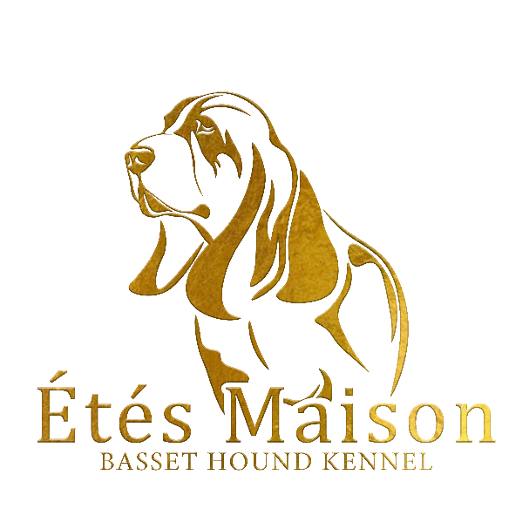*

*Belle beau Étés Maison*

02-03 IDS Martinidogshow - Groningen - HOLLAND CUP Junior class Excellent

31-03 Junior & Veteran Belgie Junior class 1 Excellent

13-04 IDS KV Rijnland Junior class 2 Excellent

09-06 Dogshow Eindhoven CAC Junior class 1 Excellent Res CAC

30-06 NBHC Clubshow Intermediate class 1 Excellent

31-08 IDS Bosnië Intermediate class 3x BOB

And 2x BIS

14-09 Zwolle CAC Champion class 2 Excellent

05-10 Winner and EDS Slovenië Intermediate class 2x 1 Excellent

RES CAC and EDS 3 Excellent

Belle Beau Étés Maison is now,

Slovenian and Bosnian Champion